July 12, 2001

Mr. Dave Fuller
Enron Transportation & Storage
P. O. Box 1188
Houston, TX 77251

Dear Dave:

Attached for your review and consideration is the CDWR's July 2nd GISB Cover Page and Special Provisions Addendum. After further negotiations and legal review, the Department has made several modifications to its original GISB document. The following is a summary of those modifications:

Cover Page:

Section 1.2 - Transaction Procedure Oral; standard GISB language acceptable

Section 2.4 – Confirm Deadline Two business days after receipt

Section 2.5 – Confirming Party Both seller and buyer, to provide confirmation. All transactions require written confirmation, including daily transactions.

Section 6 – Taxes Buyer pays at and after delivery point.

Special Provisions:

- Requirement that oral agreement not be binding until exchange on non-conflicting written Transaction Confirmations has been deleted.

- Section 1.3 Requirement to change GISB language has been deleted. Transaction Confirmations have GISB priority in disputes.

- Section 10.3 language has been expanded for seller's credit protection.

- Section 10.5 has been enhanced to note that bond and indenture documents will reflect O&M expense priority of payment.

Please make note of these modifications. Once you have had an opportunity to review these new documents, please call me at 925-243-0350.

Sincerely,
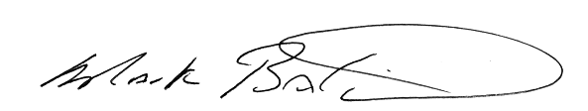

Mark Baldwin
Interstate Gas Services, Inc.

MAB/gjs
Attachment

