June 19, 2001

Ms. Kim Ward
Enron
1400 Smith Street, 3206A
Houston, TX 77024

SUBJECT: CALIFORNIA DEPARTMENT OF WATER RESOURCES (CDWR) GISB CONTRACT

Dear Kim:

Enclosed for your review and consideration is the CDWR GISB natural gas purchase agreement. This GISB contract reflects several provisions that the Department will require in order to consummate a natural gas purchase agreement with your organization. I would like to draw your attention to Section 2.4, Section 2.5, Section 10, and Section 13.5. If you would like to discuss these provisions further, please contact me at (925) 243-0350. If you have already submitted a GISB contract, our task now is to reconcile the two GISB agreements into a single format. The Department has authorized IGS, and specifically myself, to negotiate these contract provisions.

Please contact me at your earliest convenience to start the process as the Department is anticipating purchasing natural gas for July 1 deliveries. Thank you for your time and consideration.

Sincerely,

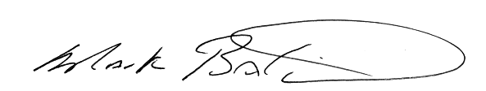
Mark A. Baldwin
President
Interstate Gas Services, Inc.

MAB/gjs
Enclosure
cc: Chuck Toney, Department of Water Resources
Alex Catto, Legal Counsel
John Pirog, Legal Counsel

