June 19, 2001

Ms. Kim Ward
Enron
1400 Smith Street, 3206A
Houston, TX 77024

SUBJECT: CALIFORNIA DEPARTMENT OF WATER RESOURCES (CDWR) CREDIT

Dear Kim:

Thank you for your time and consideration in reviewing the credit requirements for the CDWR natural gas purchase agreement. CDWR natural gas credit assurances reside in the Department of Water Resources Electric Power Fund (DWREPF). Attached for your review and consideration is a June 15, 2001 letter addressed to market participants that summarizes the creation of the fund and the recent history of the fund's performance. This letter and the accompanying information and the special provisions in the GISB contract that define credit assurances embody the full capacity of CDWR to assure payment for their natural gas purchases. After you have had a chance to review the material, both myself and Mr. Jim Olson, Deputy Controller of CDWR, are available to satisfy your questions regarding credit. I can be reached at (925) 243-0350 and Mr. Olson can be reached at (916) 574-1297. Mr. Olson will be the primary contact for credit.

IGS on behalf of the CDWR is providing this information for DWR's anticipated purchase of natural gas with the understanding that the parties agree to treat this information as both sensitive and confidential. The sole use of this information is to establish appropriate credit levels to the CDWR/Enron natural gas purchase agreement.

Please call if you have any questions or need further information.

Sincerely,

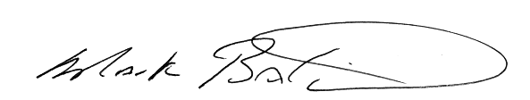
Mark A. Baldwin
President
Interstate Gas Services, Inc.

MAB/gjs
Enclosure
cc: Chuck Toney, Department of Water Resources
Jim Olson, Department of Water Resources

