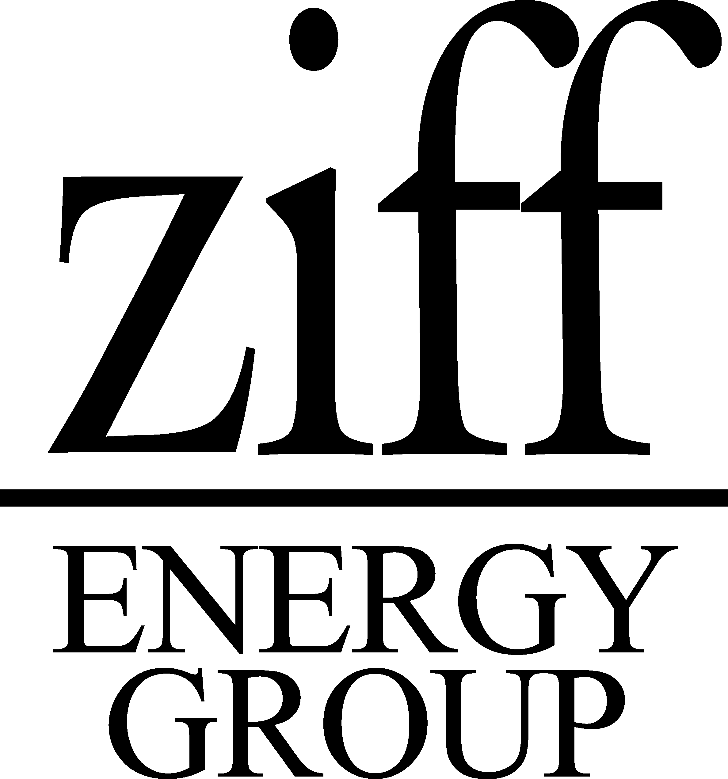
May 28, 2001

File #: 01CC-1001

Enron Corporation
P.O. Box 1188
Houston, Texas 77002
Klay@enron.com

Attention: Mr. K.L. Lay
Chairman of the Board

Dear Ken:

Re: North American Gas Strategies Conference
November 5 & 6, 2001, Calgary – Keynote Speaker Invitation

It has been many years since the energy industry, and more specifically the natural gas industry, has been in the spotlight as it is now. Whether it’s the current administration’s Energy Plan or the California situation, now there is front page attention most days. In this environment it is critical that the industry’s views are heard. One of the challenges is to make sure the story being told properly reflects the actual marketplace. Enron, as one of the premier energy companies, understands the market dynamics and industry participants would benefit by hearing your perspective. (Tom Peters highlighted your success at a SPE event last week in Houston.) We would be honored to have you present your views as our Keynote Speaker at our major Conference in Calgary in November. Before I elaborate on the invitation I would like to tell you a little about our Conferences and the executive-level attendees.

As you may be aware, our major gas conferences, held in several North American locations, are designed to assist our gas and E & P clients regarding key future issues. Some attached comments from attendees will demonstrate why these forums are now regarded as the highest quality venues for discussion of gas issues in North America. We are pleased to have had strong participation by many of your colleagues in our past conferences,, e.g. Enron speakers include Jeff Skilling, as a Keynote speaker (Calgary ’96); Margaret Carson (Houston ’98); Julie Gomez (Houston ’99); and Greg Piper (Calgary ’99). Many Enron executives have attended our past conferences.

We are now designing our fall 2001 conference program in Calgary. Day l focuses on the basic issues of supply, markets, and price outlook for natural gas in North America. Day 2 focuses on the outlook for Canadian gas supply.

As you know, the recent surge in gas prices has caused concerns about the future competitiveness of gas, particularly for electricity generation. For example, Wisconsin Electric recently announced plans to order three new coal-fired power plants, and oil consumption in some Atlantic Coast states has begun to grow at the expense of gas. A new coal generation plant is being constructed in Pennsylvania, and Cement LaFarge is converting to coal from gas in Alberta. While near-term future prices for light oil on the NYMEX now exceed Henry Hub prices, by late 2002, future gas prices exceed oil prices. A critical uncertainty facing the gas industry is to what degree the recent electric and gas price surges indicate an upward shift in gas prices that could affect long-term growth prospects.

I would like to invite you to deliver the Keynote address in conjunction with the Market Panel on Monday, November 5. We would look forward to your views of the natural gas marketplace in North America and how Enron views the future of this competitive industry. Areas of interest would be the gas/electric convergence, the proliferation and impact of electronic trading and the view of gas as a competitive fuel in the years ahead. The Market Panel will be will be discussing the developing competition for North American gas production in the North American gas market. We would like you to speak for 25 minutes, and then respond to audience questions.

We hold a VIP/Speaker’s dinner the Sunday evening preceding (November 4) that would provide you an excellent opportunity to meet or reacquaint with many senior executives in the Canadian E & P industry, and senior government regulators (e.g. NEB, Alberta EUB).

Our objective, Ken, is to present the best gas conference in North America in terms of speakers, topics and calibre of attendees. Enclosed are some examples of the excellent response from our recent conferences. We expect over 350 attendees from a wide range of companies in the gas value chain (E&P, midstream, pipelines, LDC’s, cogen’s/IPP’s) many at the CEO or President level, with about representatives from all major North American energy media (25+). Our gas conferences also attract senior investment industry analysts. I can assure you that Ziff Energy will dedicate considerable effort to ensure that this opportunity is worthwhile for Enron in terms of the number and seniority of North American gas audience attending to hear your message.

We hope that you are able to join our roster of senior North American energy executives speaking in Calgary and look forward to your early response to our invitation. If you are able to participate, we would appreciate your confirmation by Friday, June 15. I can be reached at 403-265-0600 or by return email: pziff@ziffenergy.com or alternately, contact Ziff’s Conference Director, Shelley Soles, at 403-234-4285 or ssoles@ziffenergy.com. We look forward to hearing from you.

Sincerely,

ZIFF ENERGY GROUP

Paul Ziff

Paul Ziff
CEO

(PZ/ss)

Enclosures: Conference Brochure, Houston, April 2/3
Conference Testimonials

