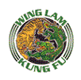

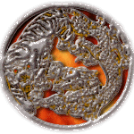 | The Wing Lam Kung Fu  Lion Dance Team  ...traditional Hung Gar Lion Dance!
Correspondence Training | Seminars | Student Links | Contact Info
 | 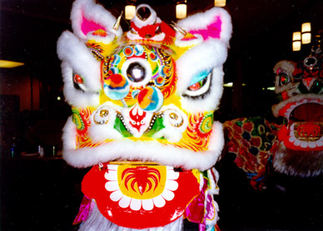  The Wing Lam Kung Fu Lion Dance Team performs traditional Southern style Lion Dance for Weddings, Banquets, Store Openings, and of course, Chinese Lunar New Year Celebrations. For information on booking a liondance for your event, please contact Lynn Lam at (408) 244-2831in the South Bay Area. In the North Bay Area, please contact Marc Velez at (707) 793-0397.  Recent Photographs  Club 369  Macys  Monterey  Women's World Cup  San Francisco
  

