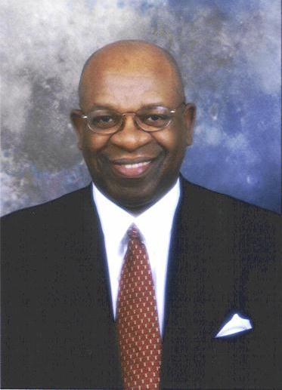
LIMAS JEFFERSON
Chairman & CEO
JEFFERSON ePeople
1002 Gemini, Suite 140
Houston, Texas 77058
Office (281) 286-4000 ext. 106
Fax (281) 286-1048
Email Ljefferson@jefferson-usa.com

RESUME

Limas Jefferson is Chairman of the Board of Unity National Bank. Unity Bank is the only African-American owned and operated Bank in Houston/Harris County and the State of Texas. Mr. Jefferson organized and led an investor group including two Churches, to acquire Unity National Bank in February 1989. He presently serves as Chairman of the Board and its major stockholder.

Limas Jefferson is Chairman and CEO of Jefferson Associates, Inc. Mr. Jefferson founded the Corporation in 1974 to provide Business solutions, Technology Staffing and General Personnel Services to private corporations and government agencies. Since founding of the corporation over 25 years ago, Mr. Jefferson has developed the company into one of the most respected and successful small businesses in the Houston and Harris County area. The corporation was awarded the City of Houston Minority/Business Enterprise Contractor of the Year award in 1992.

He began his professional career as a System Engineer with NASA/Marshall Space Flight Center at Huntsville, Alabama in 1964. He later joined TRW systems Group, a NASA Contractor in 1966 in Houston, Texas. In 1970-1975 he served with the City of Houston as Deputy Director, and manager in charge of Management Information Systems.

Mr. Jefferson has developed and owned other small business enterprises such as Limas Construction Co., The Spearhead Group, and J.D. Building & Maintenance Co. He is known for his efforts to enhance small business development and minority entrepreneurship.

Mr. Jefferson has been recognized on numerous occasions for his achievements as an entrepreneur and for his participation and leadership as a volunteer in service to the Houston community. He has served on numerous advisory boards for the benefit of educational institutions, minority community organizations, economic development agencies and business enterprise associations. He presently serves as a member of the Sam Houston Area Council Boy Scouts of America, the Houston Minority Business Council, Chair of the Board of Unity National Bank, Governing Board of the Texas Department of Economic Development and the Houston Technology Center.

Mr. Jefferson received a Bachelor's Degree in Mathematics from Southern University Baton Rouge, Louisiana in 1964. He was an Urban Fellow with the Urban Affairs Institute, Goddard College graduate Program at Los Angeles, California in 1971.

