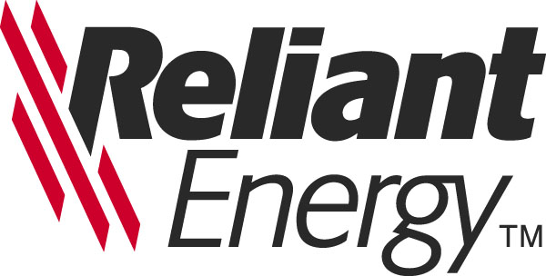

December 10, 2001

Mr. Gerald Nemec
LRCI, Inc.
1400 Smith Street
Houston, Texas 77002

Re: Post closing survey and price adjustment for Napoleonville Property

Dear Mr. Nemec:

The referenced letter agreement executed on November 26, 2001 by LRCI, Inc. and Reliant Energy Gas Storage, LLC requires that Reliant “complete a new survey of the Property utilizing a mutually acceptable land surveyor”. We intend to use one or both of the following firms: 1) Miller Engineers & Associates, Inc. located at 601 Main Street in Franklin, Louisiana and/or 2) Hydro Consultants, Inc. located at 10275 Siegen Lane, Baton Rouge, Louisiana. Please indicate your agreement to Reliant’s use of these firms by signing the space provided below.

Please contact me at 713/207-1164 if you have any questions. Your assistance is greatly appreciated.

Sincerely,

John Florence
Director
Gas Asset Development

AGREED TO this ____ day of November, 2001

LRCI, Inc.

By: __________________________
Title: _________________________

LRCI Survey Letter 12.10.01

