12” Port Lavaca Loop Line
5/00 Leak

The following photos are of the holes found on the 12” pipe at the Port Lavaca Loop. All of the holes were on the bottom of the pipe within a 20’ span. Each hole was measured with a micrometer to determine their size. There were additional holes not measured, that the corrosion technicians may have caused during their investigation.

HOLE #1

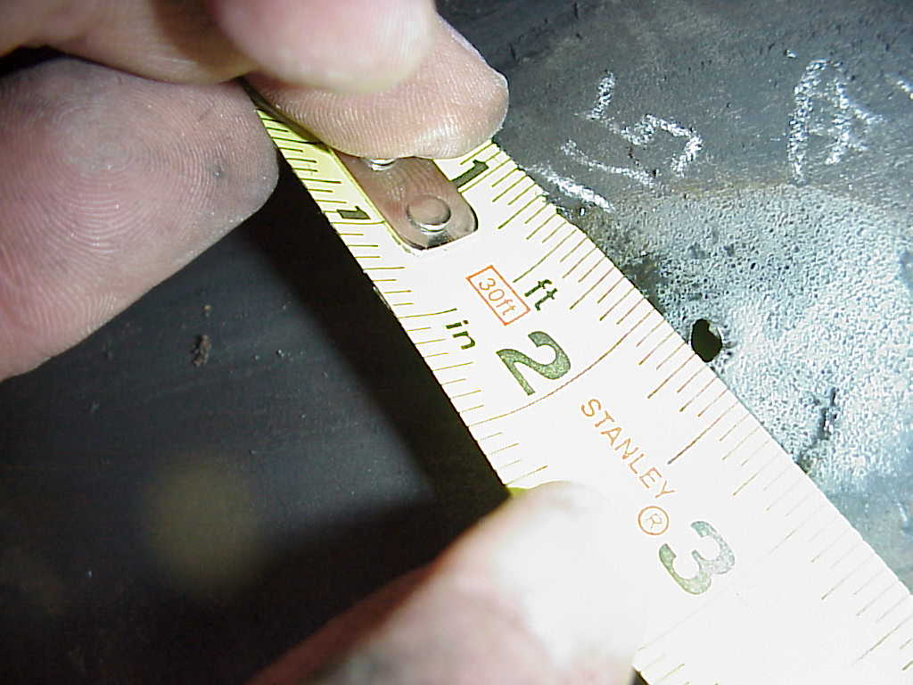

MEASSURED SIZE ID 0.115”

HOLE #2

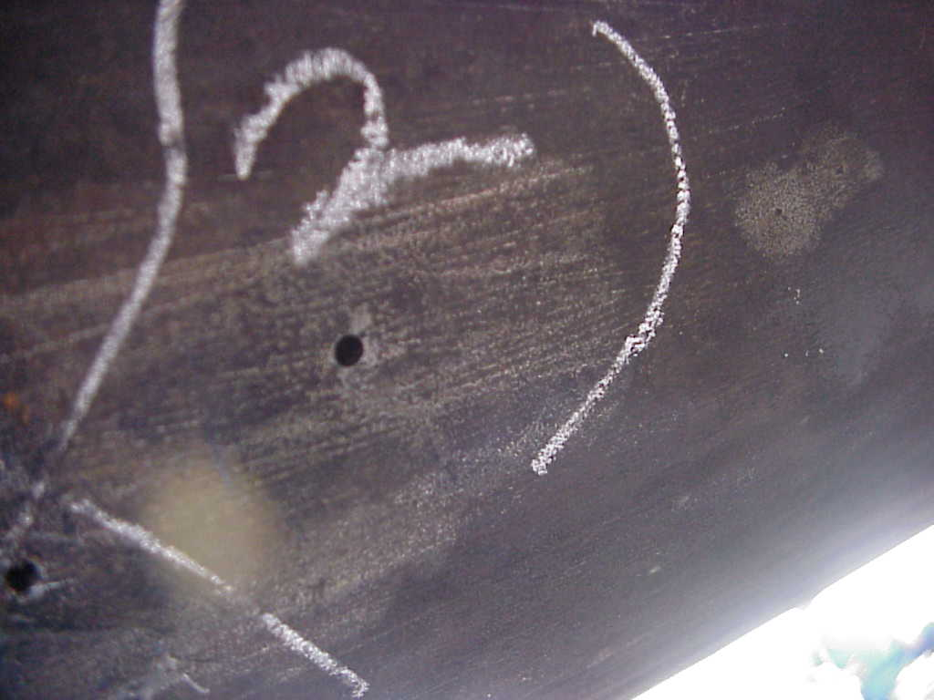

MEASURED SIZE ID 0.122”

HOLE #3,4 &5

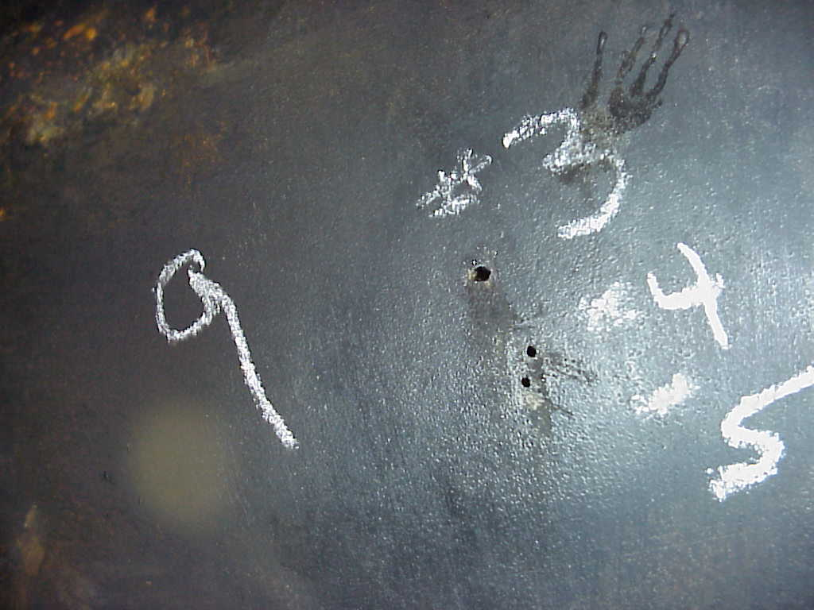

MEASURED SIZE ID
HOLE #3 – 0.077”
HOLE #4 – 0.027”
HOLE #5 – 0.027”

HOLE #6,7,8, & 9

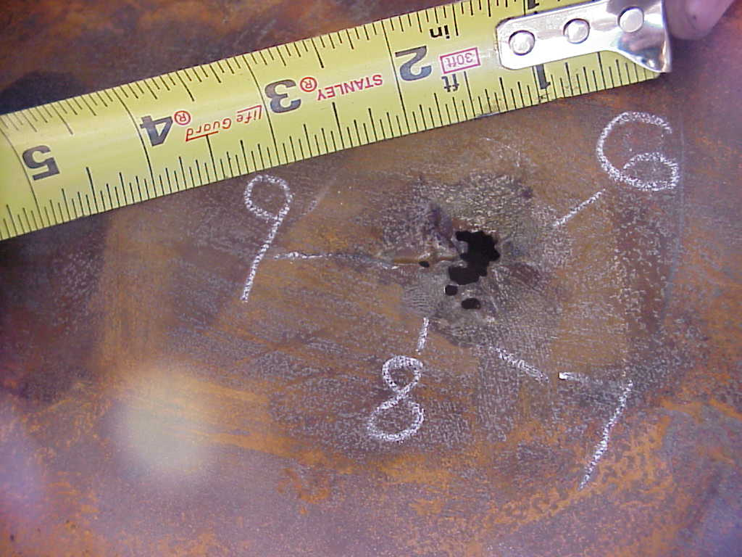

MEASURED SIZE

HOLE #6 – LENGTH - 0.4085”
WIDTH – 0.344”
0.13”
0.27”
MEAN AVG. – 0.23825”

HOLE #7 – LENGTH – 0.1165”
WIDTH – 0.068”

HOLE #8 – LENGTH – 0.075”
WIDTH – 0.067”

HOLE #9 – LENGTH – 0.057”
WIDTH – 0.048”

HOLE #10

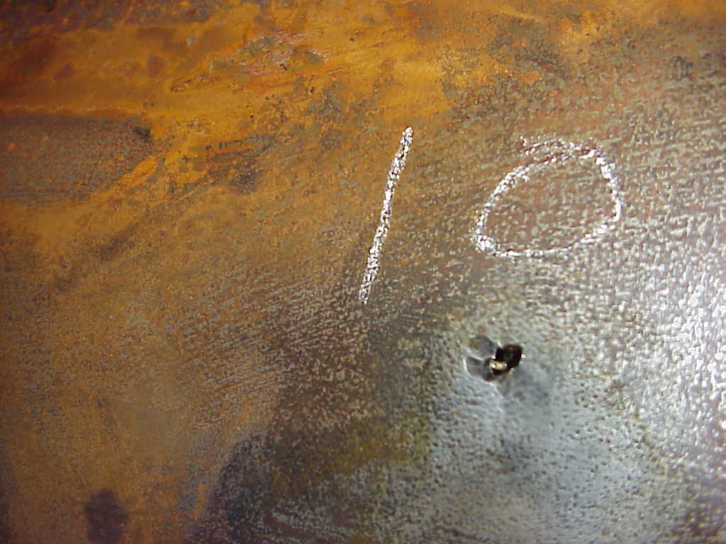

MEASURED SIZE

LENGTH – 0.148”
WIDTH – 0.09”

HOLE #11

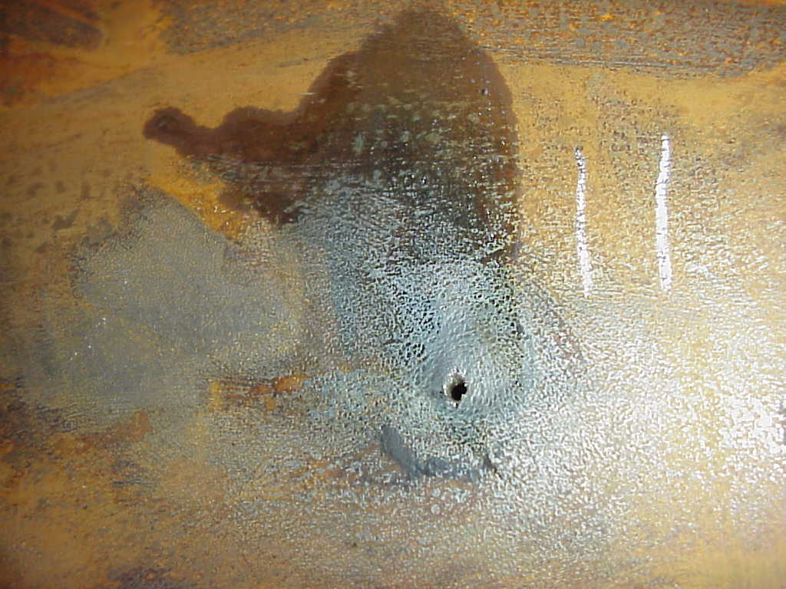

MEASURED SIZE

LENGTH – 0.144”
WIDTH – 0.072”

HOLE #12

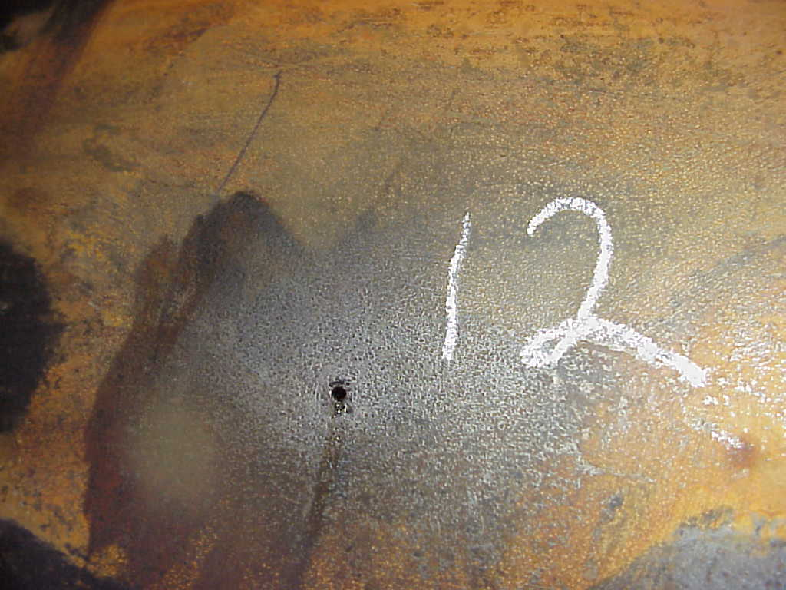

MEASURED SIZE

LENGTH – 0.071”
WIDTH – 0.051”

HOLE #13

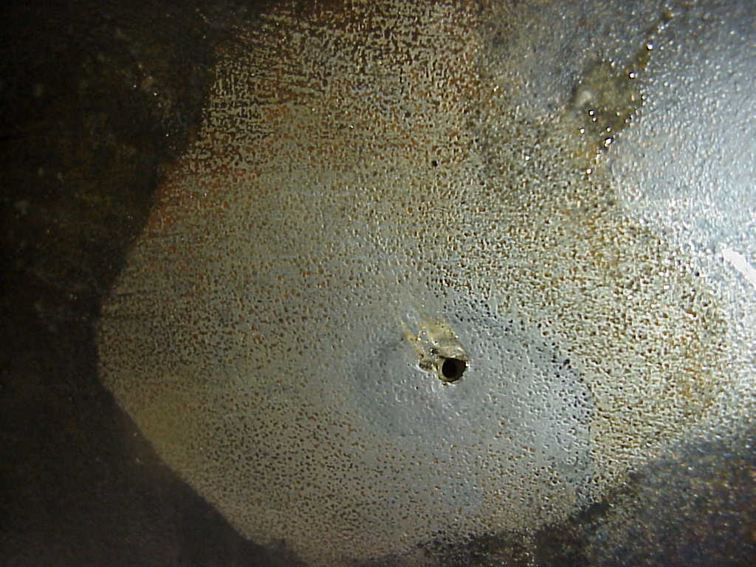

MEASURED SIZE

LENGTH – 0.092”
WIDTH – 0.086”

HOLE #14, & 15

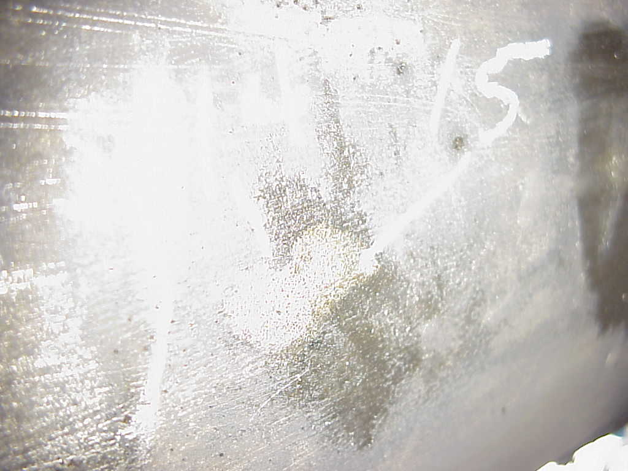

MEASURED ID

HOLE #14 – 0.03”
HOLE #15 – 0.03”

HOLE #16

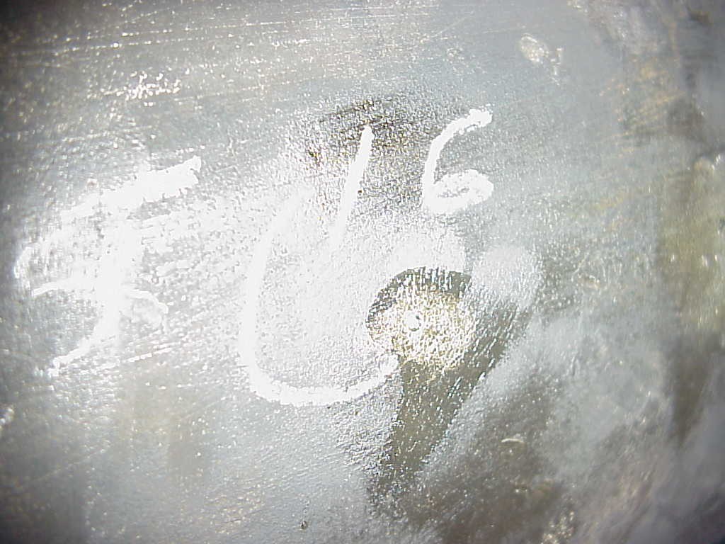

MEASURED ID – 0.0695”

HOLE #17

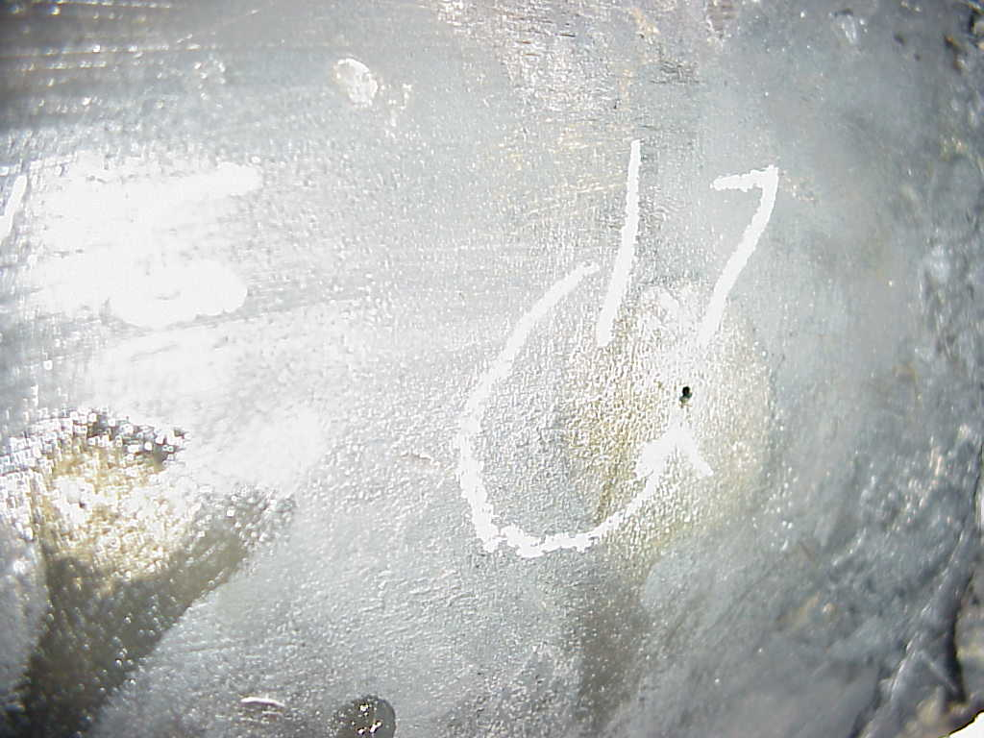

MEASURED ID – 0.088”

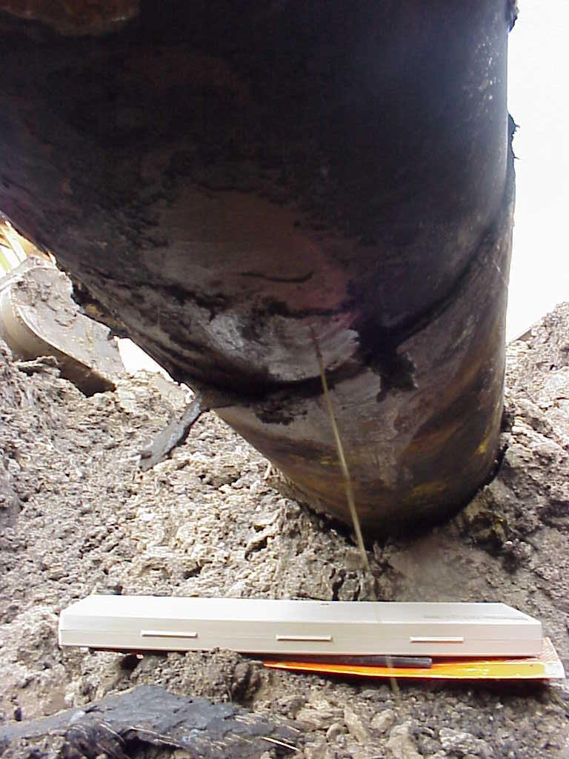

PICTURE SHOW WATER COMING OUT OF ONE OF THE HOLES DURING OUR INSPECTION.
THE HOLES WHERE FOUND BETWEEN THE 20’ SECTION IN THE PICTURE ABOVE.

