Kovair SRM Platform
Technical Overview
Dr. Kumar Goswami, President and CTO

Introduction

Kovair’s VIPCenter solution allows you to easily and quickly create direct, truly intimate connections with each key customer and partner. As a result, you dramatically lower daily customer support costs while you create a revolutionary barrier to entry (and exit!) for greater revenues and increased valuation. Building and maintaining such critical business relationships in this consistent, coordinated, continuous context is called Strategic Relationship Management (SRM).

Kovair’s VIPCenter solution is the SRM milestone. It has everything your complex business needs to maintain its critical B2B relationships. VIPCenter is the multi-directional, B2B relationship portal. With it, you build personalized web destinations, complete with your company branding, for each key customer and partner. An out-of-the-box solution, VIPCenter gives you and your customers secure, role-based, single sign-on access to all the content and interactions needed to conduct day-to-day business together.

VIPCenter innovations, such as our extensible presentation layer and HTTP integration harness, ensure the solution will serve your needs far into the future. (For more information, see the VIPCenter data sheet.)

More importantly, VIPCenter is built on top of Kovair’s SRM Platform. A robust, scalable, extensible SRM framework, it allows you to tailor VIPCenter to your company-specific requirements. Through it, you can leverage your existing extranet solutions, web-based applications, as well as back-office, front-office and third-party systems such as Siebel, SAP, Remedy and Clarify. With Kovair’s SRM Platform, you plug them into one secure, single sign-on solution – making life ever easier for your customers and account teams.

This technical overview discusses Kovair’s SRM Platform architecture

The Kovair SRM Platform: Web Application Structure Designed for Scalability and Flexibility
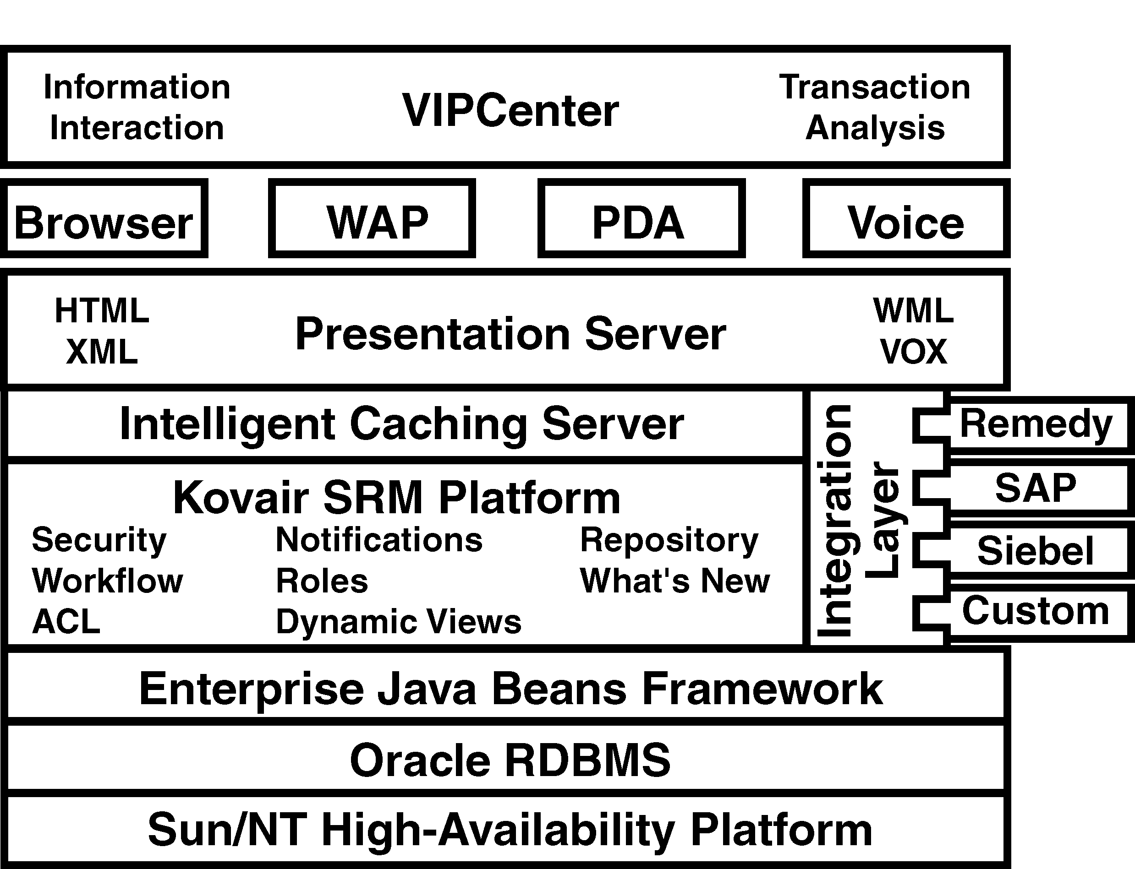
The Kovair SRM platform is a services-based architecture, sometimes referred to as n-tiered. This architecture creates many generic services, potentially running on many different machines, talking to many different databases. The Kovair SRM platform is built on highly scalable and flexible components, allowing any company to truly tailor the services it provides its customers. Built into this platform are a variety of the services that are the heart of the VIPCenter solution:

Security – The presentation, authentication and authorization services are managed by the SRM platform. Kovair’s SRM platform uses 128-bit Secure Sockets Layer (SSL) over HTTPS to ensure that every bit of data flowing between the user and the server is encrypted with the highest level of commercial encryption. This is the secure “private/public” technology used to protect nuclear missile codes. Kovair uses Verisign’s digital certificates for encryption and service authentication. The security layer is also responsible for authorization. For every action or request made by the user, the security layer compares the nature of the request or action with the identity of the person logged in and completes the request only if the person has the appropriate access privileges to conduct that action or request. This individual-request-level authorization is seldom found in most commercial systems.
Bottom line: Kovair’s action level validation ensures the highest level of security even when other applications are plugged in. Even if those applications don’t come with security, Kovair’s SRM platform protects access to these systems via a standards-based system.

- Workflow – Workflow enables content review and approval by specified personnel (such as account managers) before they are posted to a VIPCenter. When a member posts a content piece subject to workflow approval, that content piece goes into a staging area. The approver is automatically notified via email that the content is awaiting their approval. Once the item is approved, it automatically is routed from the staging area to the appropriate VIPCenter.
Bottom line: Kovair’s SRM Platform allows the account manager to control the information delivered to the customer by his or her account team. This ensures the customer receives what they are meant to receive, while empowering the account team to provide the information.

- Role-based privileges – To control who can see what and who can do what, Kovair uses roles. A role is an entity that has specified permissions and privileges. To assign what different parties can see and do, you can assign each person in the organization a role. Roles allow easy management of the user population and automate administration. The Kovair SRM platform instructs the VIPCenter to provide a different set of privileges based on the role played by the user on the account. For example, a person assigned to the Account Manager role would have the ability to add or remove people from an account and post content. If that person were assigned to the Account Contributor role, he or she would only be able to post content.
Bottom Line: Kovair’s SRM Platform is an intuitive system that automatically applies various levels of access based on assigned role. That means no more mucking with rules engines. So, administration is a snap!

- Access Control (ACL) – Access control policies are uniformly implemented across all services. Access control is a feature that allows managers to restrict privileges on VIPCenter facilities such as documents, email discussions, or task items. For example, you may assign a role to a person allowing them to post and read all documents or to view the order system. However, you can use the ACL feature to prevent that person from viewing a particular document or from viewing orders other than his or her own. Access control can be done at the group-level, role-level, or individual-user-level.
Bottom line: Kovair’s SRM platform provides the “fine grain” control you need to manage complex relationships. And, again, unlike rules, Kovair’s ACL feature is intuitive.

- Notifications – Built in to the SRM Platform, members of the team can receive automatic email notifications on a variety of actions. For example, you can specify members to receive notifications of new posted content, action items, or task due dates.
Bottom line: Kovair’s SRM platform keeps your account teams in constant communications with the customer, building stronger relationships through more “face time” with less effort. It also keeps account members in sync.

- Dynamic Views –Views are generated that are specific to each user. When customer users log into the VIPCenter, they get a unique view of the VIPCenter based on the specific privileges assigned to each of them by the account team. For example, a decision maker on the customer side may see sensitive information such as pricing discounts that the rest of his or her team may not. This keeps content relevant to the user and enforces corporate policies automatically.
Bottom Line: Kovair’s SRM Platform gives access on a “need-to-know” basis for a high level of personalization.

- Repository – The repository is a single, enterprise-wide place where documents can be stored. This repository is indexed and searchable making it easy to find the information. It’s also geared to automate VIPCenter publishing. When you “post” an item to a particular VIPCenter, it creates a virtual link to the item in the repository. This means that if you wish to modify an item (such as a price list) posted to 50 VIPCenters, you need only change the item in the repository, and it will be automatically updated across all the VIPCenters.
Bottom Line: Kovair’s SRM Platform allows you to leverage enterprise information across different relationships easily.

- What’s New – This feature allows users to get an instant “at a glance” view of all the latest activity in the VIPCenter, such as new content, new tasks, and new customer meetings. This ensures that new site content is always visible to the company and customer teams, which keeps the site fresh and up-to-date.
Bottom Line: Kovair’s SRM Platform makes staying current easy.

EJB Framework, Enterprise-Class Database, and High-Availability Platform
The Kovair SRM platform runs on an Enterprise Java Beans (EJB) framework, enterprise-class database, and high-availability platform. Kovair’s embedded EJB framework means that the system has the ability to work on NT, Solaris, or other Unix systems. It supports RMI over JRMP and IIOP. Java clients are supported via RMI, while Corba clients are supported via IIOP and Web clients through servlets and JSP.

All data is stored in Oracle8i, an enterprise-class database. Built on a highly scalable and robust platform, the database architecture has been designed to provide the highest level of data integrity, security and availability. We recommend running the entire system on a Sun or NT high-availability platform for superior performance.

Intelligent Caching Server
The intelligent caching server is a proprietary architecture optimized for the EJB environment and designed to work with the SRM platform to deliver rapid response, even under heavy loads, ensuring flexibility and extensibility. The intelligent caching server proprietary architecture optimized for the EJB environment dynamically caches content as users add new content. Content includes meetings, tasks, documents, and so forth. Additionally, intelligent caching algorithms that take advantage of the common functionality of an SRM solution have been devised to further optimize performance. These algorithms include pre-fetching of content, pooling and reusing of objects.

Presentation Layer
Many web-based solutions are specifically designed to only handle HTML and thus can only be used with HTML browsers. But because of today’s rapid changing technology, Kovair’s SRM platform was designed to separate the data from the display format. This allows rapid deployment of the VIPCenter to new technologies. Today, a VIPCenter can be accessed via a desktop browser or a cell phone browser. Soon, it will be voice-accessible via a regular telephone. It is this type of forward thinking design built into the VIPCenter solution that will help you stay ahead of the technology curve.

Integration Layer
The Kovair SRM platform’s integration layer offers rapid access to different pieces of enterprise data, enforcing any enterprise-level business rules, including roles and security. Kovair’s Integration Layer has two levels of integration: Web Application Integration (WAI), which allows the creation of real-time dynamic links and dynamic embedding of web-based applications, and API-level integration for non-web-based applications.

Kovair’s integration layer allows the user access to all your back-office, front-office, and other systems with a single sign-on, regardless of whether they are web-enabled or not. For more details, see the Integration White Paper.

Conclusion
Kovair's VIPCenter is a secure B2B relationship portal, personalized for each of your key customers and partners. It was engineered to provide the on-demand information, communication, and transactions critical to strategic relationship management. Best of all, it is an out-of-the-box solution that can be up and running in days and it is an extensible system so that you can leverage your existing investments and provide a seamless, unified and yet controlled access to your backend ERP, legacy and custom designed systems.

Most importantly, the VIPCenter solution is the first 100% web-based solution for strategic relationship management. It was designed from the ground-up specifically to leverage the power of the internet to provide an intimate, highly personalized customer connection. Innovations such as our extensible presentation layer and HTTP integration harness ensure that the solution will continue to serve your needs for years to come.

