Kovair Security and Authorization

Technical White Paper
September 2000

Kovair, Inc.
2665 N. First St
San Jose, CA 95134
408-546-2000
www.kovair.com

Title, Subject, Last Updated Date, Reference Number, and Version are marked by a Word Bookmark so that they can be easily reproduced in the header and footer of documents. When you change any of these values, be careful not to accidentally delete the bookmark. You can make bookmarks visible by selecting Tools->Options…View and checking the Bookmarks option in the Show region.
To add additional approval lines, press [Tab] from the last cell in the table above.
You can delete any elements of this cover page that you do not need for your document. For example, Copy Number is only required if this is a controlled document and you need to track each copy that you distribute.

Contents

Contents ii
Introduction 3
The Kovair SRM Platform: Web Application Structure Designed for Scalability and Flexibility 4
Kovair Business Services: Overview 4
Kovair Business Services: Fundamental Services 5
Single Sign-on Security and Authorization 6
Customizable Authentication Service (CAS) 7
Roles and Access Control Lists 7
3rd Party Integration with a Single Sign-on 8
Conclusion 8

Introduction

The Kovair VIPCenter enables you to easily and quickly create a direct, truly intimate customer connection. The VIPCenter solution is the first out-of-the-box, 100% web-based solution for Strategic Relationship Management (SRM).

Strategic business-to-business relationships are those complex relationships that are crucial to a company’s business; either because they account for a large portion of the company’s revenues, or because they carry significant mind share.

Examples of strategic relationships are:
- Global accounts – Key customer and partner relationships that span the globe.
- Strategic Alliances – Major customers, partners, and System Integrator relationships.
- OEM relationships – Relationships in which a partner bundles and resells your product as an integrated part of their offering.
- Key suppliers – Major suppliers that are crucial to your business.
- Key distributors – National, global or major distributors where the relationships are long-term.

The VIPCenter acts as a Relationship-Specific Window that brings the people, information, and relationship-specific applications together in one place. It is a multi-directional, B2B relationship portal that allows you to build a special environment on the web, branded and tailored by you for each of your key customers.
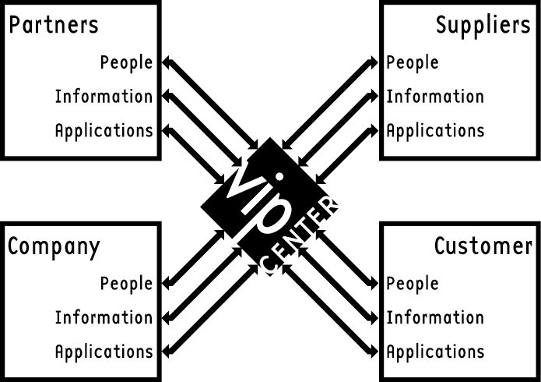

Through this portal, you can collaborate, interact, and transact. It gives you, your customers, and partners secure, role-based access to the content and functionality you all need to do business with each other.

The Kovair SRM Platform: Web Application Structure Designed for Scalability and Flexibility

Today’s successful applications are built of flexible, interoperable modules. The Kovair SRM platform is a services-based architecture, sometimes referred to as n-tiered. Unlike the first two solutions, the services are not tied to a specific application. This architecture creates many generic services, potentially running on a single or multiple machines, talking to many different databases.

The Kovair VIPCenter product consists of:
- A Business Server that provides the business logic and the fundamental services needed for SRM solutions. Fundamental services provide authentication and authorization.
- A Presentation Server that manages the application flow, caching to reduce response times and increase throughput, and UI engines that provides multiple modes of access to the VIPCenter. It outputs the information in HTML, WML, and other formats.
- Kovair’s Open Interperability Engine (KOIE) that allows a company to expose their backend systems, their custom applications and even their partner’s systems in a unified, seamless and controlled manner.
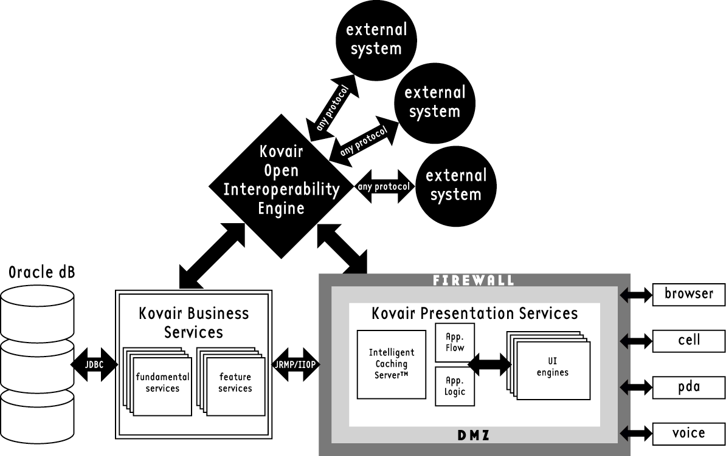

For a detailed description of the SRM Platform, please refer to the general Architecture white paper.

Kovair Business Services: Overview

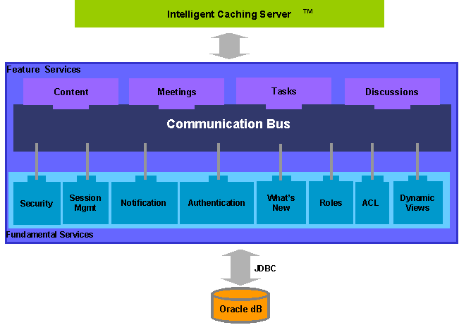
The Business Server is divided into two main components – Fundamental Services and Feature Services. Fundamental Services are the building blocks for SRM features, which include security and authentication. Feature Services are the visible features of the VIPCenter Application (tasks, meetings, etc), and are built from the Fundamental Services.
By separating the Fundamental Services from the Feature Services, the SRM platform allows for customization with minimal effort and impact. For example, if you change the authentication service to use LDAP, all of the Feature Services will automatically use LDAP for authentication.
Both Fundamental and Feature Services can be distributed across multiple systems. This provides a scalable, enterprise-class solution.

Kovair Business Services: Fundamental Services

Fundamental Services are composed of many services, including those that are responsible for security. For a description of other Fundamental Services, see the VIPCenter Technical Architecture White Paper.

- Authentication and Authorization – The default scheme uses 128-bit encryption and Verisign certificates to authenticate the server. Every request performed by a user is authorized before the response is generated. VIPCenter comes with its own usernamepassword authentication scheme. However, the authentication module can be replaced with LDAP authentication or any other scheme.
- Access Control (ACL) – Access control policies are uniformly implemented across all services. Access control is a feature that allows managers to restrict privileges on VIPCenter facilities such as documents, email discussions, or task items. Access control can be done at the group-level, role-level, or individual-user-level.
- Role-based privileges – Roles allow easy management of the user population and virtually eliminate any administration. The Kovair SRM platform instructs the VIPCenter to provide a different set of privileges based on the role played by the user on the account e.g. an Account Manager has the ability to add or remove people from an account and post content. An account contributor can only post content.
- Dynamic Views –Views are generated that are specific to each user. When customer users log into the VIPCenter, they get a unique view of the VIPCenter based on the specific privileges assigned to each of them by the account team. For example, a decision maker on the customer side may see sensitive information such as pricing discounts that the rest of his or her team may not. This keeps content relevant to the user and enforces corporate policies automatically.

Single Sign-on Security and Authorization

Kovair’s Fundamental Services, contained within the Business Server, incorporate sophisticated security and authentication schemes. This allows single sign-on across all of a user’s VIPCenters, standard features, custom VIPCenter features, and third party systems that have been tied into the VIPCenter.

Security is key to any SRM solution. In basic HTTP authentication, passwords are transmitted “in the clear”, with no encryption. In Digest HTTP authentication, tokens are passed rather than actual passwords, but these tokens can be replayed. Also, in both cases, tokens are passed automatically --- there is no way to completely log out.

Kovair’s approach is signficantly more secure than either of these. User authentication is done over an encrypted line, so that logins and passwords are never revealed. Kovair’s SRM platform uses 128-bit Secure Sockets Layer (SSL) over HTTPS to ensure that every bit of data flowing between the user and the server is encrypted with the highest level of commercial encryption. This is the secure “private/public” technology used to protect nuclear missile codes.

Kovair uses VeriSign’s digital certificates for encryption. By using a Secure Server ID, available from VeriSign, we are enabling our site to conduct authenticated, encrypted on-line commerce. Users visiting our site will be able to submit credit card numbers or other personal information to our site, with assurance that they are really doing business with us (and not an impostor) and that the information that they are sending to us can not be intercepted or decrypted by anyone other than the intended recipient. All transmissions that subsequently occur proceed in this superior, fully encrypted fashion.

In addition to authentication, the security layer is also responsible for authorization. For every action or request made by the user, the security layer compares the nature of the request or action with the identity of the person logged in and completes the request only if the person has the appropriate access privileges to conduct that action or request. This individual-request-level authorization is seldom found in most commercial systems.

Customizable Authentication Service (CAS)

To integrate with your corporate authentication systems, the CAS is comprised of a standard interface for authentication, combined with pluggable authenticators that can be selected in real-time. This approach allows for integration with corporate authentication schemes such as LDAP, RADIUS, Security Dynamics, retinal scans, and so forth. The authenticators pull the appropriate data (such as username and password for the Kovair schema and Secure ID from Security Dynamics) from the appropriate data store. It then feeds this data to the Authentication Engine.
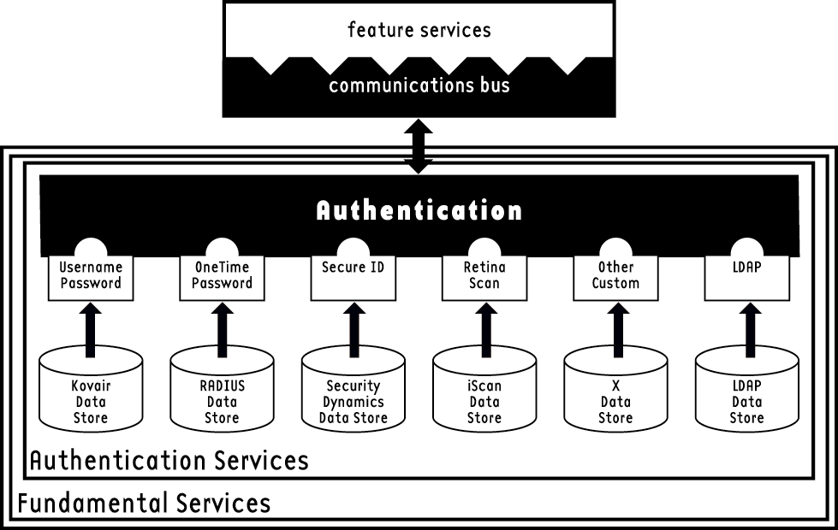
The Authentication Flow proceeds according to the drawing below:
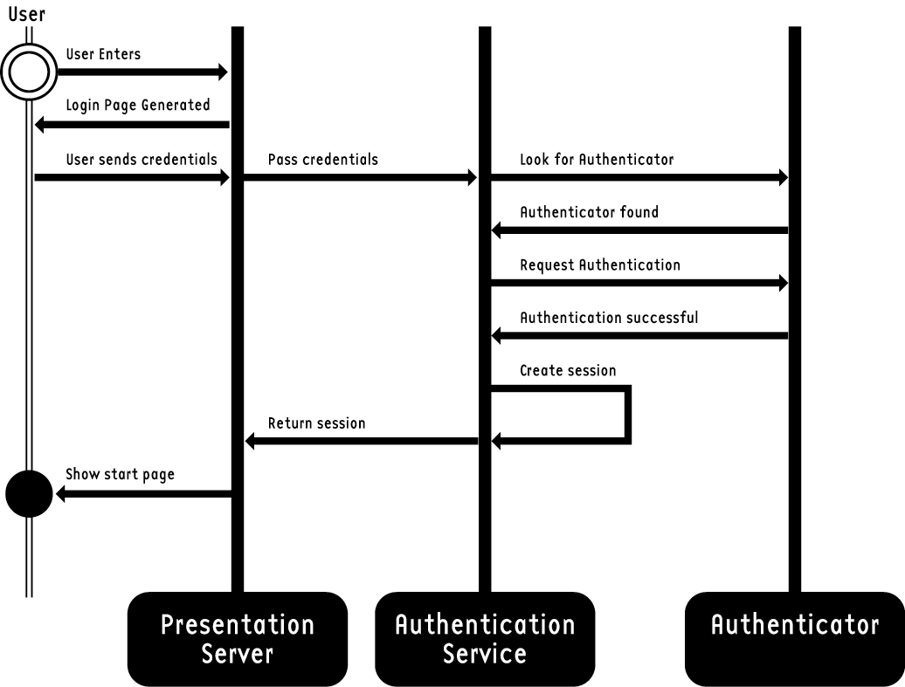

Roles and Access Control Lists

To control who can see what and who can do what, Kovair uses roles. A role is an entity that has specified permissions and privileges. To assign what different parties can see and do, you can assign each person in the organization a role. Roles allow easy management of the user population and automate administration. The Kovair SRM platform instructs the VIPCenter to provide a different set of privileges based on the role played by the user on the account. For example, a person assigned to the Account Manager role would have the ability to add or remove people from an account and post content. If that person were assigned to the account contributor role, he or she would only be able to post content. With roles, you can predict with 100% certainty what a party can see and do.

Access Control Lists (ACL), based on the Java security model, are uniformly implemented across all services. Access control is a feature that allows managers to restrict privileges on VIPCenter facilities such as documents, email discussions, task items, or third-party systems.

For example, I may assign a role to a person allowing them to post and read all documents or to view the order system. However, I can use the ACL feature to prevent that person from viewing a particular document or from viewing orders other than their own. Access control can be done at the group-level, role-level, or individual-user-level.

3rd Party Integration with a Single Sign-on

The Kovair SRM platform’s integration modules offer rapid access to different pieces of enterprise data from legacy, web-based, and other third-party systems, automatically enforcing any enterprise-level business rules, including roles and security. It provides 24x7 access to all services with a single sign-on. For an in-depth look at Kovair’s Interoperability Modules, see the Interoperability White Paper.

Conclusion

The VIPCenter solution is engineered to provide the on-demand information, communication, and transactions critical to strategic relationship management. Best of all, it is an out-of-the-box solution that can be up and running in days and it is an extensible system so that you can leverage your existing investments and provide a seamless, unified and yet controlled access to your backend ERP, legacy and custom designed systems.

Most importantly, the VIPCenter solution is the first 100% web-based solution for strategic relationship management. It was designed from the ground-up specifically to leverage the power of the Internet to provide an intimate, highly personalized customer connection. Innovations such as our Customizable Authentication Service ensure that the solution will continue to serve your needs for years to come.

