Jeff Shankman
Enron Emissions Trading Desk
1400 Smith Street
Houston, TX 77002-7361
USA
Düsseldorf, 28. September 2025
confidential
EUROFORUM Expert Conference:
Emissions trading
CO₂ certificates - a tremendous opportunity for the world of business and the
environment!?
11th and 12th Dezember 2000, Dorint Hotel, Cologne

Dear Mr. Shankman,

further to my very pleasant telephone call with you, I would now like to send you the draft programme of "Emission trading", an expert conference, EUROFORUM is in the process of organising and to which we would like to invite you as a speaker.

Trading CO₂ certificates is not just a mere vision anymore. However, HEW AG have
already initiated a pilot certificate trade. Companies such as BP and Shell have been looking into emission trading for quite some time now. And the United States and some European countries, e.g. the Netherlands, have already gained practical experience in this area. When will Germany be ready? What will be the results of the negotiations taking place in the Hague in November of this year? These and other questions will be at the focus of our conference.

You may find the title we should like to suggest for your presentation under item no. 16 in the draft programme. All titles are still working titles and may be changed in the framework of the given context. Your presentation is supposed to take place in Cologne on 12th December, 2000 and should last appr. 30 minutes.
We should be delighted to welcome you as a speaker at this conference and I will take the liberty to contact you by phone within the next few days.

Yours sincerely
EUROFORUM Deutschland GmbH
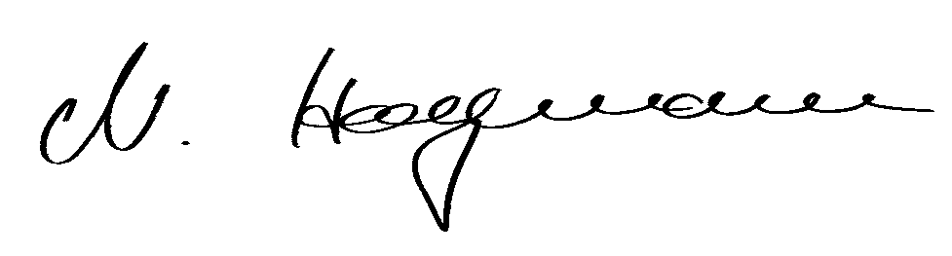
Nicole Hagemann, Conference Manager Energy/Environment
Tel.: ++49 211/ 9686-429, Fax.: ++49 211/ 9686 94-429
e-mail: nicole.hagemann@euroforum.com

EUROFORUM Expert Conference:
Emissions trading
CO₂ certificates - a tremendous opportunity for the world of business
and the environment!?

11th and 12th. December 2000, Dorint Hotel, Cologne

Topics
- Climate protection objectives set in Kyoto and The Hague - Latest results
- European and U.S. American experiences gained in certificate trading
- Ways to reduce CO₂ emissions in Germany
- Perspectives for certificate trading
- Possible rules to govern an international certificate trade
- The balance between economic and ecological efficiency
- Certificate trading as a means to increase the market potential for CHP
- Efficient CO₂ tools from the point of view of an energy supplier
- What are the advantages of certificate trading for industry
- Joint Implementation - practical reports
- Clean Development Mechanism (CDM)
- Virtual trading of greenhouse certificates

Target group
Members of boards and executive managements, directors, plant managers and managerial staff responsible for
- Environmental management
- Corporate strategy and development
- Corporate finance
- Legal affairs
representing
- Energy supply companies (regional, multi-utilities)
- Energy intensive industries
- Banks
- Insurances
as well as
associations, environmental agencies, consulting and law firms with a focus on the environment.

EUROFORUM Expert Conference:
Emissions trading
CO₂ certificates - a tremendous opportunity for the world of business
and the environment!?

Private and confidential

11th and 12th December 2000, Dorint Hotel, Cologne

Monday, 11th December 2000

Chair: Jörn von Bornstädt, Berater Umwelt, PricewaterhouseCoopers Umweltberatung GmbH, Berlin (confirmed)

Everything around emission trading – Latest results from October

1) Kyoto - First steps on the way to climate protection
Prof. Dr. Klaus Hasselmann, Max-Planck-Institut für Meterologie, Hamburg
(invited)

2) Trends and state of affairs in respect of CO₂reductions in Europe
Jos Delbeke, Referatsleiter Klimaveränderungen, Europäische Kommission, Brüssel (invited)

3) Ways to reduce CO₂ emissions in Germany - the point of view of the Ministry for Economic Affairs and Technology
Dr. Erich Wallenwein , Bundesministerium für Wirtschaft und Technologie, Berlin
(invited)

4) Future perspectives for certificate trading from the point of view of the BDI
( German Association of National Industries)
Dr. Joachim Hein, Abteilung Umweltpolitik, BDI, Berlin (invited)

5) Possible rules to govern emission trading
Dr. Franz Josef Schaffhausen, Bundesministerium für Umwelt, Berlin (confirmed)

6) Panel discussion:
Certificate trading - the balance between economic and ecological interests

Dr. Franz Josef Schaffhausen, BMU (confirmed)
Dr. Erich Wallenwein, BMWi (invited)
Dr. Joachim Hein, BDI (invited)
Karsten Smid, Klima-Experte, Greenpeace e.V., Hamburg (invited)

Practical organisation of emission trading

7) Why emission trading? - How do climate changes impact national
economies
Thomas Loster, Münchener Rückversicherungs AG, München (invited))

8) Advantages of certificate trading from the point of view of an energy
supplier
Dr. Klaus-Robert Kabelitz, Bereichsleiter Volkswirtschaft/Energiewirtschaft, Ruhrgas AG, Essen (confirmed)

9) Requirements for efficient CO₂ tools from the point of view of industry
Prof. Dr. Bernd Greiner, InfraServ-Hoechst, Hattersheim (invited)

Tuesday, 12th December 2000

Chair: Barbara Wieler, Beraterin Corporate Finance, PwC Deutsche Revision AG, Berlin (confirmed)

State of Affairs

10) Greenhouse and Energy Trading Simulation

John Scowcroft, Head of Environment and Sustainable Development, Eurelectric, Vereinigung der Stromproduzenten und –versorger in Europa, Brüssel (invited)

11) Development of derivatives for CO₂ emission certificates
Barbara Wieler (confirmed)

Practical examples based on the Kyoto mechanisms

12) The example of Shell: emission trading in practice
Peter Knoedel, Mitglied des Vorstandes, BP Oil Deutschland GmbH, Hamburg (invited)

13) CO₂ trading - experiences gained in the United States
Garth Edwards, Head of GHG Trading, Natsource,New York, USA (invited)

14) „Prototype Carbon Fund“ (PCF) - World Bank's climate change programme
Bettina Klump-Bickert, Koordinationsstelle Umwelt, Deutsche Bank AG, Frankfurt a.M. (invited)

15) Green Label Trading in the Netherlands
Dr. W.-F. G. Metzelaar, Market Strategy Advisor, Nuon, Niederlande (invited)

16) Joint Implementation and Clean Development Mechanism (CDM) as business opportunity
Jeff Shankman, Enron Emissions Trading Desk, Houston/Texas, USA (invited)

17) CO₂ emissions in Germany– HEW and TransAlta
Dr. Helmuth Groscurth, Leiter HEW-Projektgruppe Umweltzertifikate, HEW – Hamburgische Electricitäts-Werke AG, Hamburg (invited)

The assignment procedure – verification, certification and monitoring

18) Monitoring – checking whether industry abides by its voluntary commitment
Prof. Dr. Paul Klemmer, Inhaber des Lehrstuhls Wirtschaftspolitik, Universität Bochum und Präsident des Rheinisch-Westfälischen Instituts für Wirtschaftsforschung (invited)

19) Verification and certification
Bernhard Grimm,TÜV Süddeutschland, München (confirmed)

Should you have any queries please contact:
RAin Nicole Hagemann, Conference Manager Energy/Environment
Tel: ++49 211/ 9686-429
Fax.: ++49 211/ 9686 94-429
e-mail: nicole.hagemann@euroforum.com
EUROFORUM Deutschland GmbH, Hans-Günther-Sohl-Str. 7, 40235 Düsseldorf

Sponsoring and exhibition opportunities
Should you be interested in using this expert conference as a forum to present your company please do not hesitate to contact Ms Christina Westenberger on ++49 211/9686-597, e-mail: christina.westenberger@euroforum.com

