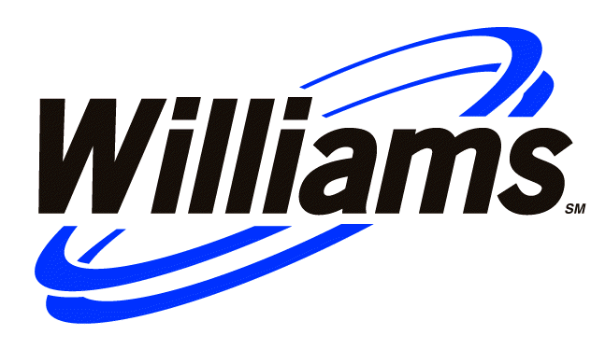
KEITH E. BAILEY
Chairman of the Board and
Chief Executive Officer One Williams Center
918/ 573-3258 P.O. Box 2400
918/ 573-3905 office fax Tulsa, Oklahoma 74102
keith.bailey@williams.com 918/ 573-2000

October 26, 2001

Senator Frank H. Murkowski
Ranking Member
Committee on Energy and Natural Resources
United States Senate
364 Dirksen Senate Office Building
Washington, D.C. 20510

Dear Senator Murkowski:

Thank you for your letter of October 15, 2001, following up on the October 2 hearing of the Committee on Energy and Natural Resources concerning the development of a pipeline system to transport Alaska’s North Slope natural gas to markets in the continental United States. Williams welcomes your very timely request that we provide any legislative suggestions that we think are necessary or appropriate to facilitate an Alaska gas transportation system.

As I explained in my statement for the October 2 hearing, Williams has a long history of involvement in efforts to bring Alaska gas to the Lower 48 states and has extensive investments in Alaska’s energy infrastructure. We believe that satisfying North American demand for natural gas during the current decade will require the development of Arctic gas. Accordingly, Williams has activated its Arctic gas project team and has several studies underway to evaluate the current economics of developing a pipeline from the North Slope to the Lower 48. We are also exploring the development of an associated value-added petrochemical complex and the benefits this new industry would bring to the state of Alaska. We likewise have met with the Alaska producer group, other pipeline companies, federal, state and provincial governmental representatives and native communities as we endeavor to advance this project.

Williams continues to believe that successful development of an Alaska gas pipeline project will require cooperation among all affected parties in industry and government and that the Alaska Natural Gas Transportation Act (ANGTA) continues to provide a viable framework for achieving that objective in the shortest possible time. The fundamental premises that underlay ANGTA have not changed. We also think it could be less productive if legislative action were to get too far ahead of resolution of the substantial commercial issues that remain to be resolved before the scope and structure of the project can be defined. Rather, at this point, a better solution would be to allow the former ANGTS partners, North Slope producers and other interested parties to work together using existing legislation to establish a viable structure to move a project forward. If present efforts are not fruitful, Congress could still act, if it deems it appropriate or necessary, on legislation to facilitate alternative projects and little time will have been lost. Therefore, we do not believe that replacement of, or even significant revision to, ANGTA is presently warranted or needed.

Senator Frank Murkowski
October 26, 2001
Page 2

In our view, the Committee and the Congress currently can best assist timely development of a project by action that reaffirms the basic principles and structure of the ANGTA, while clarifying how the statute should be applied as the project moves forward. We suggest that any legislation should be “stand-alone,” rather than in the form of amendments to ANGTA, and should employ the terminology of ANGTA in order to avoid any discrepancies between the existing and new statutes. In our view, any such legislation should be limited to the following matters:

- Clarifying, in accord with Section 9 of ANGTA, that any federal officer or agency, including the FERC, that is responsible for granting or issuing any certificate, permit, right-of-way, lease or other authorization necessary or related to the construction and initial operation of the ANGTS shall take the action(s) required of it at the earliest practical date after the ANGTS sponsor has presented to it a complete application or request for the action.

- At the request of the ANGTS sponsor and in order to ensure that terms and conditions applicable to the project reflect current economic, environmental and technical circumstances, Federal officers or agencies, including the FERC, should be allowed to add to, amend, or abrogate any term or condition of a certificate, permit, right-of-way, lease or other authorization necessary or related to the construction and initial operation of the ANGTS, provided that any such actions may not, as provided by Section 9 of ANGTA, compel a change in the basic nature or general route of the Alaska segment of the ANGTS.

- Legislation relating to the above items would confirm the continuing application of the provisions of ANGTA that mandate expedited action on matters necessary to the project’s development, but which limit agencies’ ability to alter the basic structure of the ANGTS.

- Upon finding at the request of the ANGTS sponsor that such changes are required by the public convenience and necessity and are consistent with sound, current natural gas pipeline technology and its current regulatory policies, allow FERC to amend terms of the President’s Decision that prescribe certain aspects of the design of the ANGTS and that require the Commission to establish a variable rate of return on equity for the project.

- Such a provision would give FERC the necessary flexibility to modify the design and rate of return terms of the 1977 President’s Decision in order to conform the terms and conditions of the ANGTS certificate with modern pipeline design considerations and current FERC regulatory policies. The President’s Decision contains very specific terms about certain design parameters for the ANGTS, including pipe diameter and the locations and horsepower of the system’s compression and cooling facilities. Current technologies may indicate that a somewhat different design would be more efficient and cost-effective, but it is unclear whether FERC has authority under ANGTA to depart from the terms of the President’s Decision. Similarly, the Decision requires FERC to establish an incentive rate of return mechanism for the ANGTS to discourage cost overruns relative to pre-construction estimates. Such a mechanism probably is not appropriate in today’s much more market-oriented regulatory environment. FERC now, under a 1999 statement of policy, expressly encourages
Senator Frank Murkowski
October 26, 2001
Page 3

- pipelines to negotiate allocation of the risk of cost overruns with shippers before presenting an application for a certificate to build a new project.

- Establish procedures for developing and prescribing the terms and conditions for the protection of environmental resources during construction and operation of the ANGTS and confirming that compliance with these procedures will preserve the determination by the Congress in Public Law 98-158 regarding the legal sufficiency of the environmental impact statement concerning the ANGTS project. Williams generally could support the establishment of an interagency group (including the Departments of Energy, Transportation, the Interior and Commerce, the Environmental Protection Agency, the Secretary of the Army and the FERC) that would be responsible for establishing construction and environmental standards for the ANGTS.

- It is important to provide a mechanism for updating the environmental review of the ANGTS without requiring that all previous work be duplicated unnecessarily. Establishing an interagency group such as suggested here would ensure that current environmental requirements and values are fully taken into account without opening a potentially litigious NEPA compliance process that Congress determined in ANGTA should be avoided.

We hope that these suggestions will be helpful to you and your staff. Williams will be happy to make available our Arctic project team to answer any questions or to provide more background concerning any of these items.

I read your recent announcement regarding the governorship of Alaska with much interest and mixed feelings. We will certainly miss your leadership in the Senate but certainly, as a major corporate citizen of the state, would look forward to working with you in that capacity. Thank you again for the opportunity to share with you Williams’ views on this important matter and for your consideration of our suggestions.
Very truly yours,
Keith E. Bailey

