July 2001 Short Circuits - Electricity by Rita Hartfield
Short Circuits

During 2000 total U.S. retail sales of electricity reached nearly 3,400 billion kWhs and generated $226.5 billion in retail revenue. According to EIA's Electric Power Monthly, competitive power suppliers generated 930 billion kWhs or 28% of total generation.

Every consuming segment except commercial experienced an increase in the average rate per kWh in 2000.
¢ per kWh
Segment 2000 1999
Residential 8.21¢ 8.16¢
Commercial 7.20¢ 7.26¢
Industrial 4.19¢ 4.45¢
Other 6.37¢ 6.35¢

Electricity growth in the United States is non-cyclical and has, historically, been relatively constant at about 2% annually. A key metric used to measure adequate industry supply is capacity margin, defined as the difference between peak summer electricity demand (MW) and peak summer supply capacity (MW) divided by capacity. Generally, a 15% – 18% capacity margin is desirable to ensure electric grid reliability in case of unplanned plant outages and during needed plant maintenance outages. Based on NERC calculations, the U.S. reached a dangerously low 7.1% capacity margin in 1999, the lowest level experienced since the 1970s.

Analyst from Morgan Stanley Dean Witter (MSDW) believe that US capacity margin will remain in shortage mode below the 15% to 18% range through 2002, and then within the 15% to 18% range through 2004.
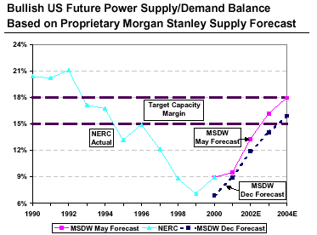

New Generation Plants

In the U.S., 24.2 GWs of nameplate capacity were added during 2000. 14.2 GWs are peaker plants and 10 GWs are baseload plants.
Sophisticated developers site 2–3 times as many plants as they actually intend to build to account for inevitable permitting difficulties and to retain their flexibility as power market dynamics change.

CERA estimates that the U.S. will require about 150 GW of new power generation capacity over the next 10 years.

MSDW estimates that between 150 GWs to 165 GWs of new generating capacity will be added in the U.S. between 2001 and 2004. MSDW's forecast [see following chart] excludes over-committed sites and incorporates data from their research which indicates that only about 60% of the expected new capacity for a given year is actually brought on line that year.

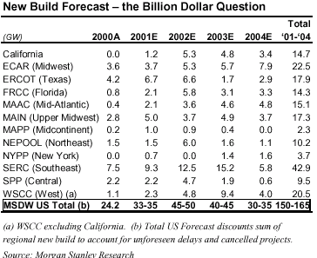
The majority of these new builds are likely to be natural-gas fired, however coal is expected to fuel about 10% to 20%. In 2000, coal-fired plants accounted for 52% of the electricity generated in the U.S. Nuclear plants accounted for 20%; natural gas fired plants, 16%; hydro, 7%; petroleum, 3%; and renewables, 2%.

Regionally, fuel distribution is much more variable. The NPPC region, New England including New York, relied on natural gas for about 40% of its power generation in 2000 followed by SPP (primarily Oklahoma) with about 33%. The distribution of fuels consumed in 2000 and the total production costs by fuel for 1995 to 2000 are below.
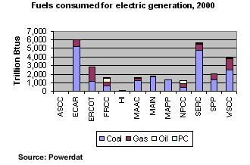
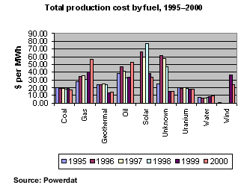
Stealth Megawatts

De-bottlenecking existing power plants is another power source. Analyst at DRI-WEFA believe that the derating of U.S. power plants to defer maintenance expenses took 10% to 20% of capacity out of the system between 1987-1997. Using a 350 GW coal fleet, this could translate into 35 to 70 GW. Nuclear plants can experience at least a 5% uprate without a big capital layout. Exelon Nuclear looks to add a full 1,000 MW of power utilizing a systemwide uprating by the summer of 2004.

DRI-WEFA estimates that nearly all capacity lost to derating can be recovered at a cost of under $125/kW.

Alternative Generation Sources

Fuel cells, wind power, and photovoltaic (solar) material cost reductions and technological breakthroughs have increased their near-term likelihood of commercial feasibility. Advances in industrial gas turbines and pulverized coal plants will reduced their production costs between now and 2015.
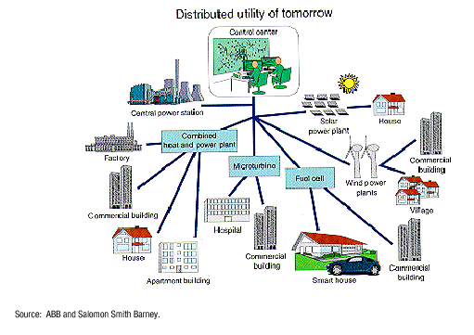
2000–2015 Generating Capacity Cost Estimates
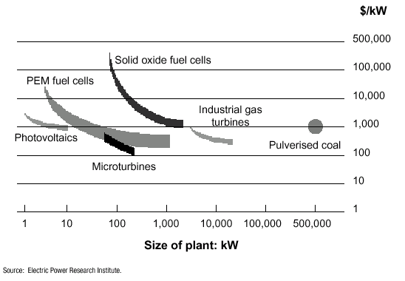
Source: MSDW, Electric Utilities/Unregulated Power, June 1, 2001; Merrill Lynch, Capital Goods, May 17, 2001; MSDW, Power Meters Still a Seller's Market, June 6, 2001; CERA , Coal's Role in New Power Generation - Rebirth by Default, June 2001. RDI Energy Insight

