July 2001 Gas Flows - Natural Gas by Rita Hartfield
Gas Flows

Record prices for natural gas have resulted in a surge in gas-related drilling which reached a record level of 1,068 rigs in mid-July. This is significantly up from the 800 to 850 active rigs in the fourth quarter of 2000.
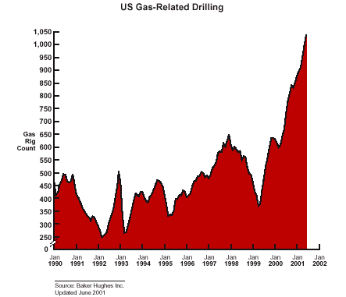
Production from the increasing rig counts during the first half of 2001 will being to appear in late summer into winter.

Production increases have occurred in some areas even though much of the drilling has been directed toward inexpensive, low capacity wells. Drilling has been targeted at infill wells, deeper drilling in existing wells and fields, reservoir expansions, and coal seam methane. New drilling and completion techniques have resulted in higher initial bursts of peak production followed by higher decline rates. Production data for the Gulf of Mexico through December 2000 continues to show declining production in all areas except those in deepwater, which include East Breaks in Texas and Mississippi Canyon, Viosca Knoll, Green Canyon, Garden Banks, and Ewing Bank offshore Louisiana.

The E&P industry's push towards growing returns on capital has reduced the drilling level in deeper, high capacity gas plays.

The top 40 domestic natural gas producers account for nearly 50% of domestic natural gas production. BP Amoco continues to be the largest domestic natural gas producer averaging 3.5 Bcf/d for 1Q01. ExxonMobil produced 2.8 Bcf/d, Texaco/Burlington Resources produced 2.6 Bcf/d, and Shell and Chevron each produced 1.6 .Bcf/d.

CERA expects a combination of US lower-48 activity, growth in Canadian supply, and growth in LNG imports to add 8.95 Bcf/d of production by 2005. This production growth could be disrupted by many factors including an excessive price correction that chokes off activity in the United States and Canada.
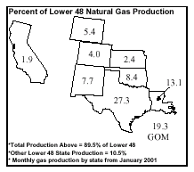

Natural Gas Pipelines

Over the past 2 years, more than 60 natural gas pipeline construction projects (35 in 1999 and 28 in 2000) have been completed and placed in service in the United States, accounting for more than 12.3 Bcf/d of new pipeline capacity, an increase of 15% over 1998 capacity levels.

From 1990 through the end of 2000, more than 20 billion cubic feet per day of interregional capacity has been added, a 27% increase. The natural gas pipeline network has also become more interconnected, its routings more complex, and business operations more efficient.

Additions to U.S. Natural Gas Pipeline Capacity, 1991-2000, and Estimated Additions, 2001-2002
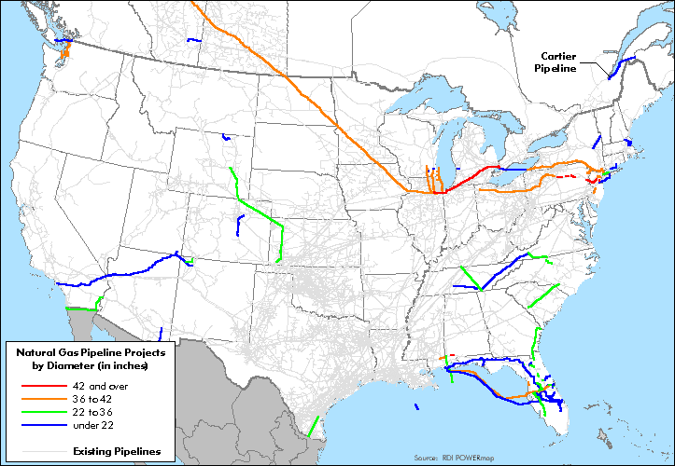

Pipeline development annual expenditures were $1.4 billion in 1997, $2.4 billion in 1998 and $2.2 billion (each year) in 1999 and 2000.

In 1999 the largest share of expenditures, totaling $1.1 billion, was for projects terminating in the Northeast. In 2000, projects terminating in the Midwest accounted for the largest share of expenditures at $1.8 billion. Because of the cold weather, the Alliance Pipeline began operation at close to full capacity shortly after service was inaugurated in December 2000. The EIA predicts that demand in the Midwest is still growing and some of the capacity currently serving the region will be needed to serve the Northeast in 2002. As a result, additional capacity to the Midwest region will be needed.

Natural Gas Storage

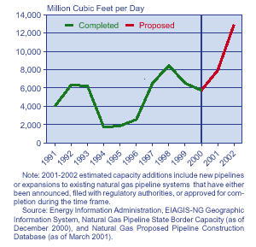
The U.S. underground natural gas storage sector began the 2000-2001 heating season prepared for a winter similar to the preceding two heating seasons but encountered a winter more like 1995-1996, which had resulted in record-low
1,725
8,460
storage stocks by the end of the season.

AGA's reported a total of 2,126 Bcf of natural gas in storage as of July 20, 2001.

7/20/01 One Yr
Region Bcf Ago Bcf
Producing 621 608
Consuming East 1,143 1,083
Consuming West 362 370
Total U.S. 2,126 2,042
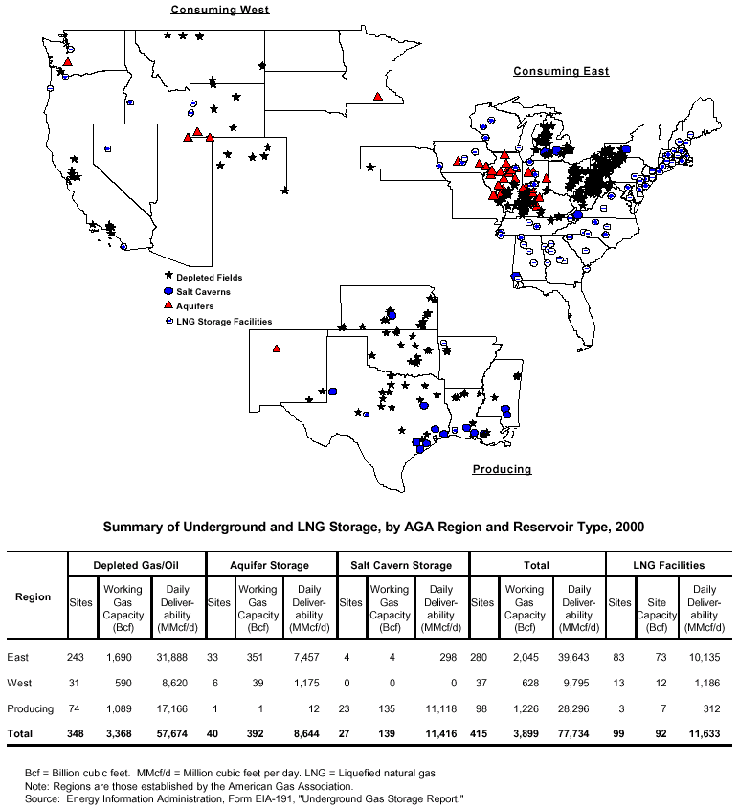

Source: AGA's Website; EIA Natural Gas Monthly, October 2000; EIA Natural Gas Storage Trends; CERA North America Natural Gas Productive Capacity, July 16, 2001; Salomon Smith Barney, Natural Gas Weekly Monitor, June 21, 2001.

