Management Recruiters® of Portland, Inc.
Lloyd Center—Suite 2020

Portland, OR 97232

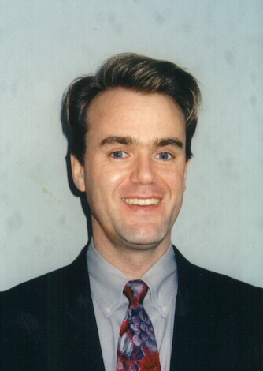
This letter is in response to our conversation regarding the advantages of working with me as an energy industry specialist with Management Recruiters of Portland (MRI). As you know, searching for the right candidate can be time-consuming and costly. I have a proven track record for providing highly qualified responsive candidates for many integrated Top-10 energy corporations. As a nationwide specialist in energy, my successful searches include professionals in power & gas marketing, power & gas trading, risk management, risk analysis, sales analysis, trading control, quantitative research and development, plant management, mid-office, and more.
Objective:
My objective is to serve my clients, as well as my candidates with the highest level of respect, professionalism, and confidentiality. I deliver to my clients professionals who can immediately impact a company’s bottom line, candidates for whom many companies don’t have access to. In addition, my objective includes creating a hiring process where everyone involved saves time and money.

Johan C. Dahl
Phone: 503-287-8701
Fax: 503-282-4380
E-mail: jdahl@mrportland.com
Web: www.mrportland.com

The main objective is to be the key player in the hiring process!
My 14 years of sales, marketing, management, training, and staffing experience contribute to my success as a professional recruiter. In addition, recruiting has been part of my professional career since 1989.

- Make a conscious effort to understand your company’s culture, business needs and goals.

- Be very thorough in defining your specific hiring needs and set up a realistic hiring process.

- Deliver well-screened, qualified candidates with additional information beyond the resumes.

- Display insight and understanding about the industry and the marketing aspect.

- Made accurate presentations of candidate’s qualifications and credentials.

- Provide you as my client with quick feedback from interviewed candidates.

- Conduct the whole process from start to finish in an ethical and honest manner.

Management Recruiters of Portland is the largest single site search and recruiting agency in the U.S. In the past fifteen years our office has been named National Office of the Year eleven times leading to the ultimate recognition as OFFICE OF THE DECADE. Visit our web site for more details.

Sincerely, References are available upon request.

Johan C. Dahl

