2001 – A YPO ODYSSEY



You are cordially invited to attend the YPO
“Raising Responsible Children” Program

Some say children are what life is all about. Others say raising children is the most daunting task adults face. In today’s world where both parent and child confront so many opportunities and obstacles in the quest for a fulfilling and rewarding life, the job of parenting becomes all the more stressful.

Come hear our speaker, Dr. Jay Zink, who has been training parents in effective child and teen management techniques for nearly 25 years. Dr. Zink will also speak on the subject of raising children, especially in perilous times.

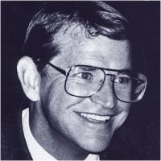

DATE: Tuesday, October 30, 2001

TIME: 5:30 PM Cocktails
6:00 PM Program
8:00 PM Dinner

LOCATION: River Oaks Country Club Ballroom
1600 River Oaks Boulevard
Houston, Texas

DRESS: Business Attire

RSVP: Gail Glidewell – 713-361-7205, or fax 713-361-7280
gailg@morgangroup.com
(Please RSVP no later than October 24, 2001)

