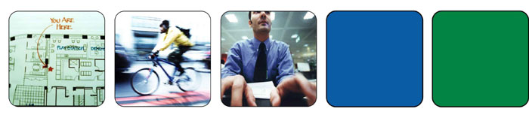

STEP INTO THE FAST LANE

Your Guide to Interviewing at Enron

Welcome to the dynamic world of Enron. We have been named Fortune's Most Innovative Company for six straight years. This honor wasn't achieved by standing still. Things move fast here, and candidates sometimes need a little assistance getting acclimated to our environment. Remember that the interview process is just as much about us making an impression on you as it is about you making an impression on us. We have included some information below that we hope will help make your initial Enron experience a positive one.

Your interview schedule is attached along with this guide. Usually things will go as planned; however, please be mindful that at Enron, our environment rewards flexibility. One of our competitive advantages is the speed at which we can move, but sometimes this means that schedules can change at the last minute. This does not mean that we do not value you as a candidate; it only means that unexpected circumstances have forced a change.

Lydia Delgado will be your guide though this process; if you have any questions please feel free to contact her at 713-853-9338.

Parking

Enron’s corporate office is located at 1400 Smith Street in downtown Houston. When you arrive for your interview, please park in the Allen Center Garage, which is connected to the Enron Building and Three Allen Center via a skywalk on the third floor of the garage. Turn from Bagby Street onto Clay Street and enter at the red sign denoting Visitors Parking. Bring your parking ticket in with you, and the scheduler escorting you on your interviews will validate it. It is best to allow 15 - 30 minutes to park, navigate security, and make it up on the elevators to the 36th floor.

Security Passes

As you enter the lobby of the Enron Building, the Reception Desk is directly in front of you. Inform the reception personnel that you are here for an interview, and they will give you a Visitor’s Pass and direct you to the elevators for the 36th floor. Please inform the receptionist on the 36th floor that you are here for interviews, and she will notify the correct scheduler. You will be asked to arrive approximately 30 minutes prior to your first interview in order to give you time to complete the Employment Application. Please be sure to bring any past work and reference information with you to assist in the completion of this form.

Getting to the Appointment

You will be escorted to your first interview by the scheduler. From that point on, you will either be escorted by the scheduler or by one of the assistants in the department in which you are interviewing.

Meeting the Team

Enron has a business casual dress code. This means that you will see everything from coats and ties or jacketed dresses to jeans and tennis shoes. You will probably never know where someone works or who they are based on clothing choices. We suggest that you dress for the interview and not for the job. Remember that the interview is a two-way process, so please be sure to ask all the questions you have about Enron as you meet your interviewers. We want to ensure that you leave Enron with a good feel for what we do here, and the culture that we represent. If you would like additional information about Enron’s businesses follow the link below>

www.enron.com

The Feedback Process

We value communication here. When you have completed our interview process, we encourage you to contact your recruiter to let them know what your thoughts are on your interviews. The recruiter will be meeting with your interviewers to determine the next steps in the process. We will contact you to let you know the results of the interviewers’ feedback.

