UPS Online Internet Ship 3.0 User Guide

Table of Contents

- Getting Started…………………………2

- Registration……………………..………2

- Shipping…………………………………5

- Supply Ordering………………………..9

- Drop-Off Locations……………………12

- Frequently Asked Questions…………14

Internet Ship 3.0

Getting Started
- Click on your web browser icon
- In the address box, type in www.ups.com
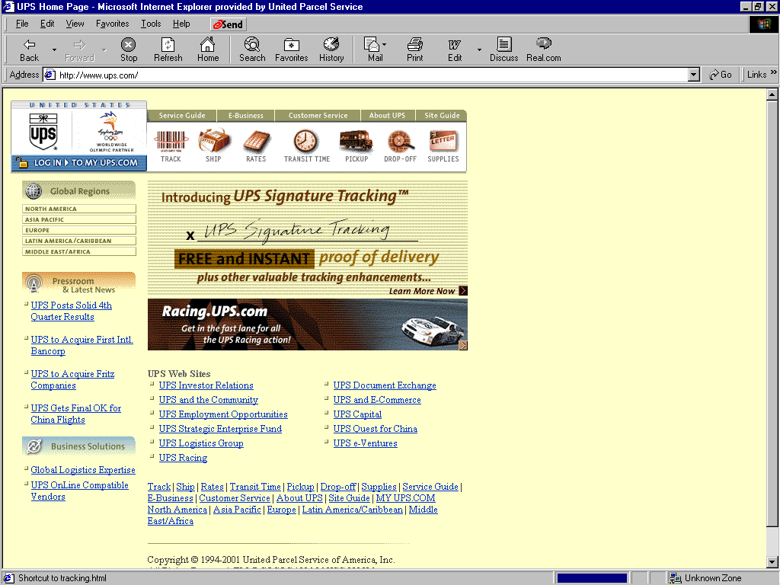

- Point and click on Log In To My UPS.COM

Registration
- If you are not currently a registered user, will need to follow the steps 2 – 11 to Register. If you are currently a registered user, go to Shipping.
- In the Log In screen point and click on Register Now.

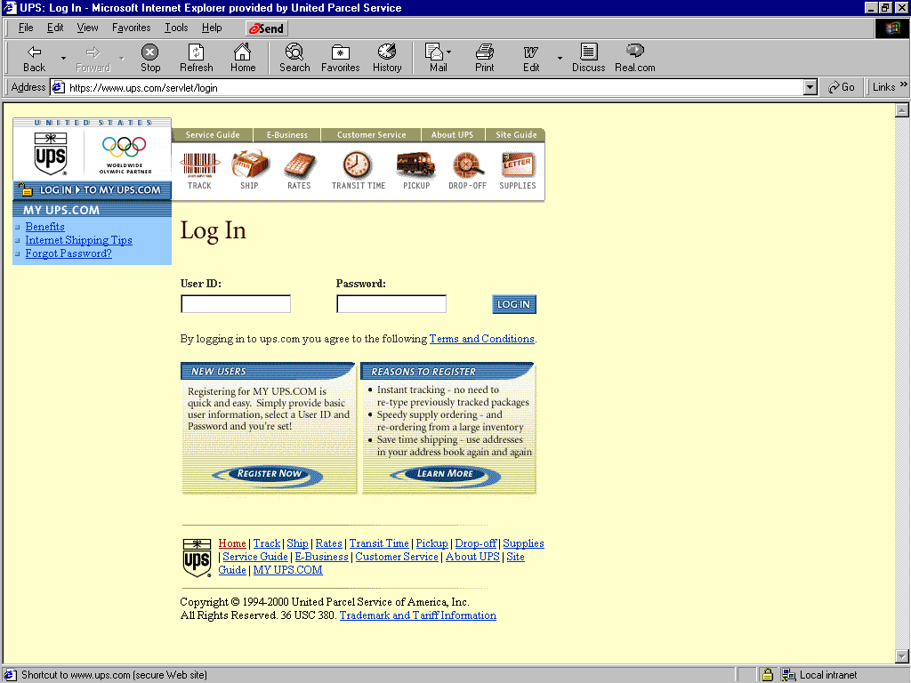

- This will bring up the Registration Screen
- Key enter your information (all fields with bold text must be populated), then point and click on Register
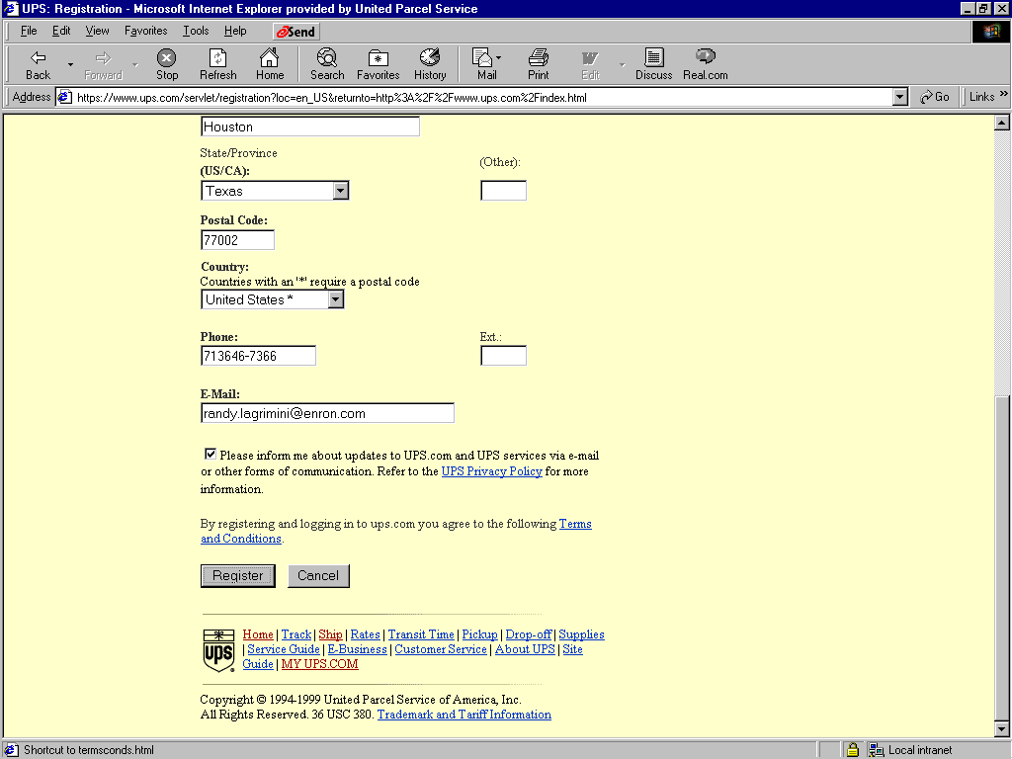
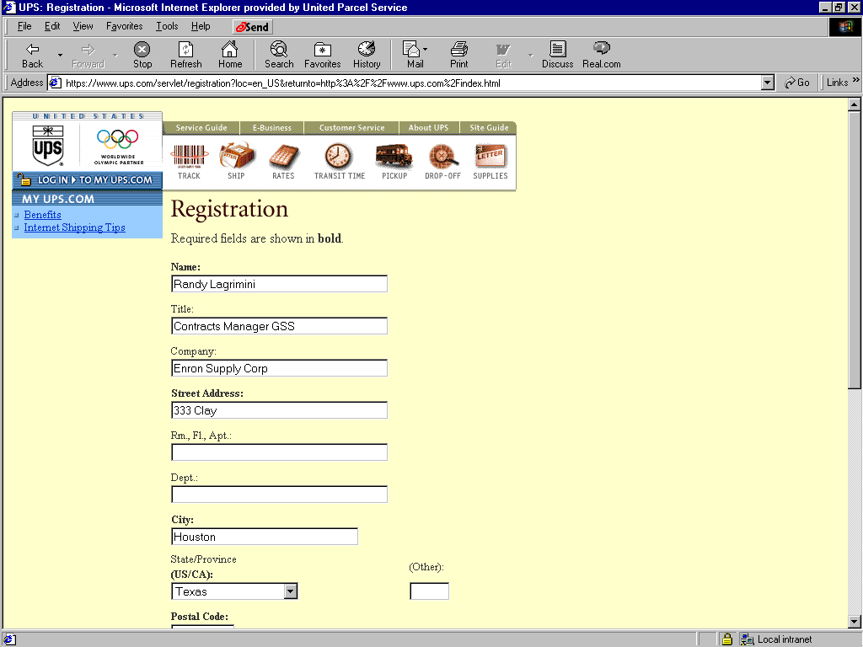

- A second Registration Screen will appear
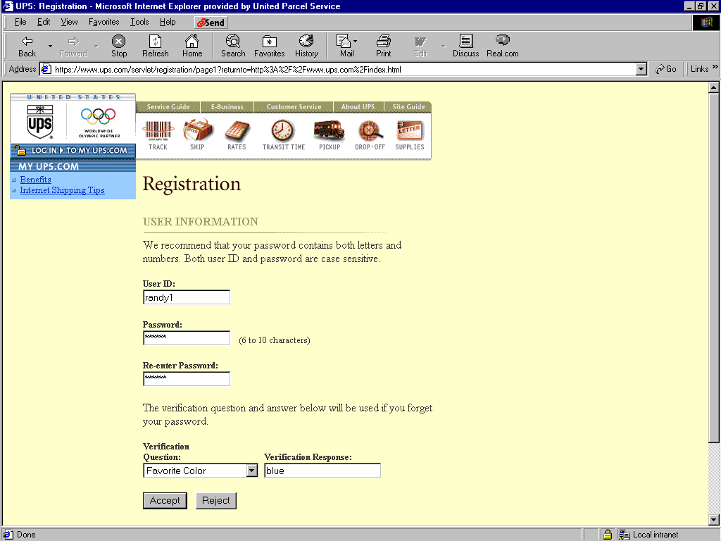

- Key enter a User ID of your choice and a Password (twice to confirm)
- Select your verification question and enter your response
- Then point and click on Accept
- Congratulations, the Registration process is now complete
- You are now ready to log In
- Click Log In
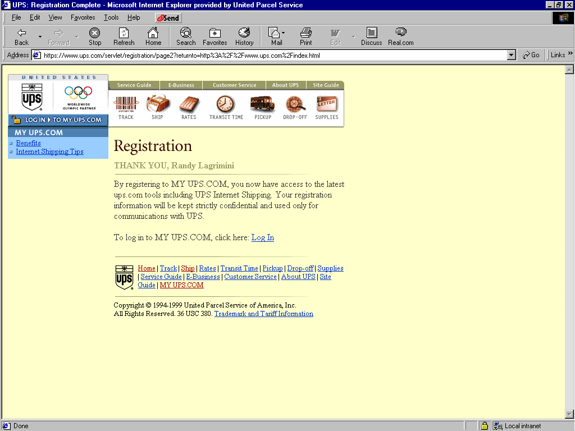

Shipping
- Registered Users continue to next step

- Type in your User ID and Password
- Point and click on Log In
- Point and click Yes to the Security Alert which will appears.
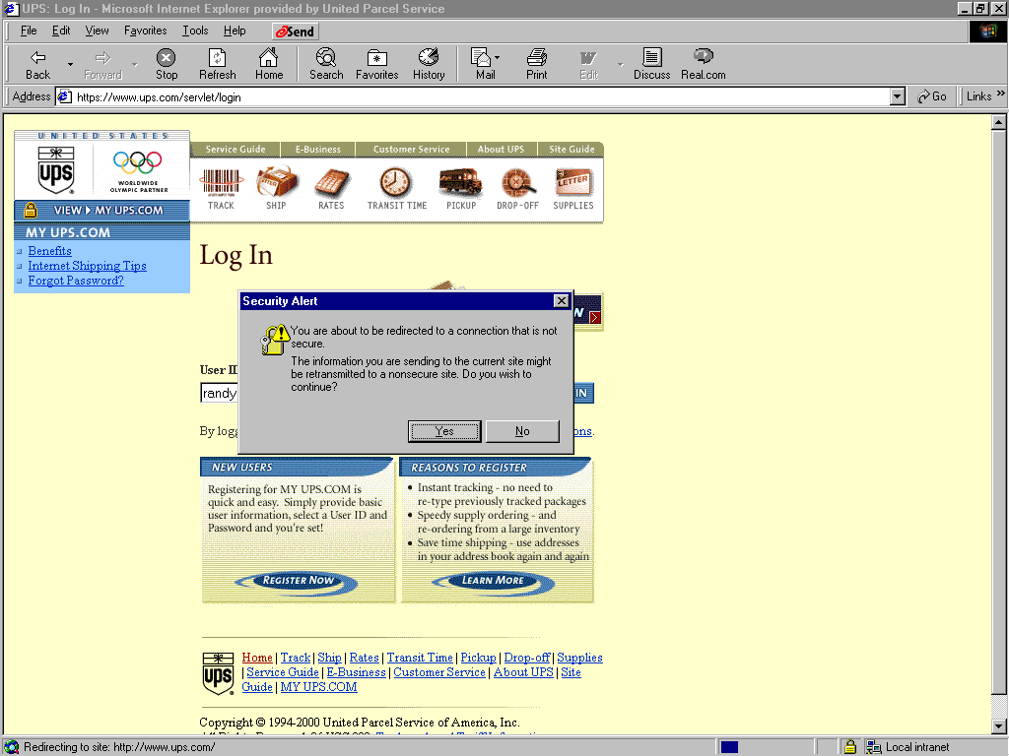
h

Notice that the Log In to My UPS.COM changes to View My UPS.COM

- Point and click the Ship button
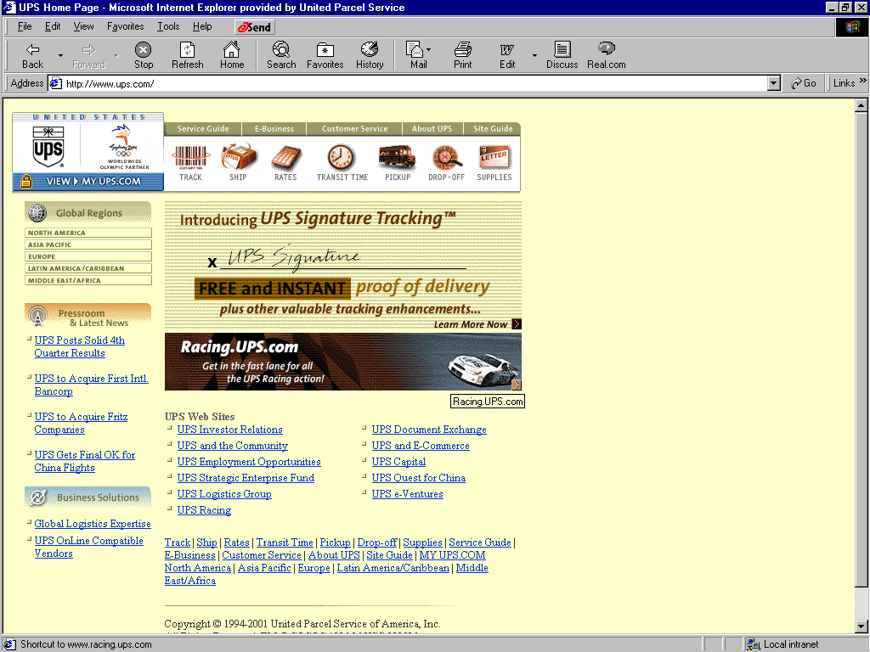

- Then the UPS Internet Shipping Agreement will appear
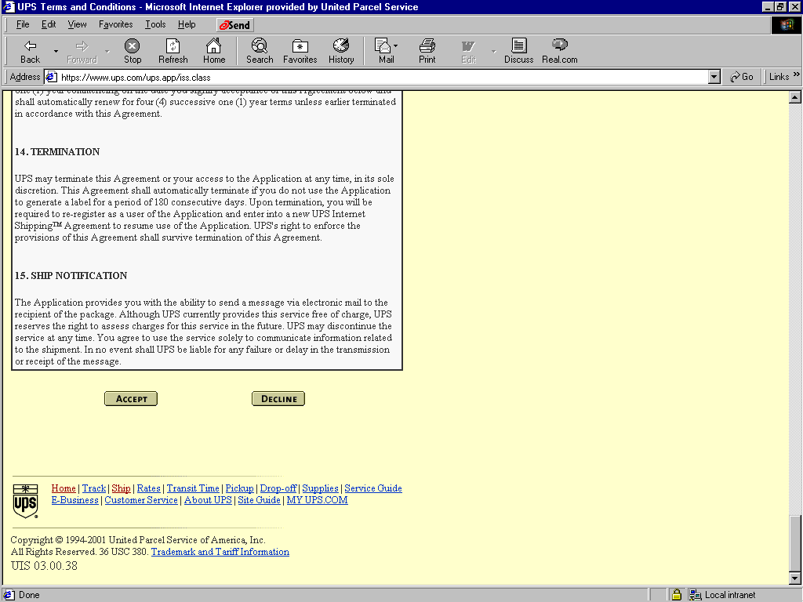
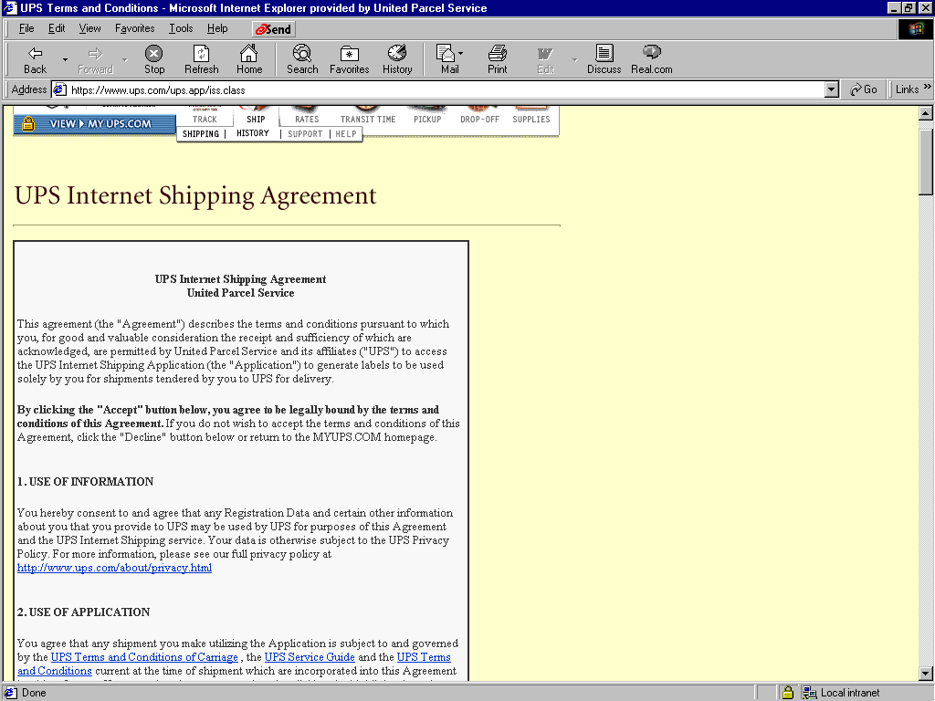

- Upon reading the agreement, point and click on Accept

- Point and click on Set Preference Now

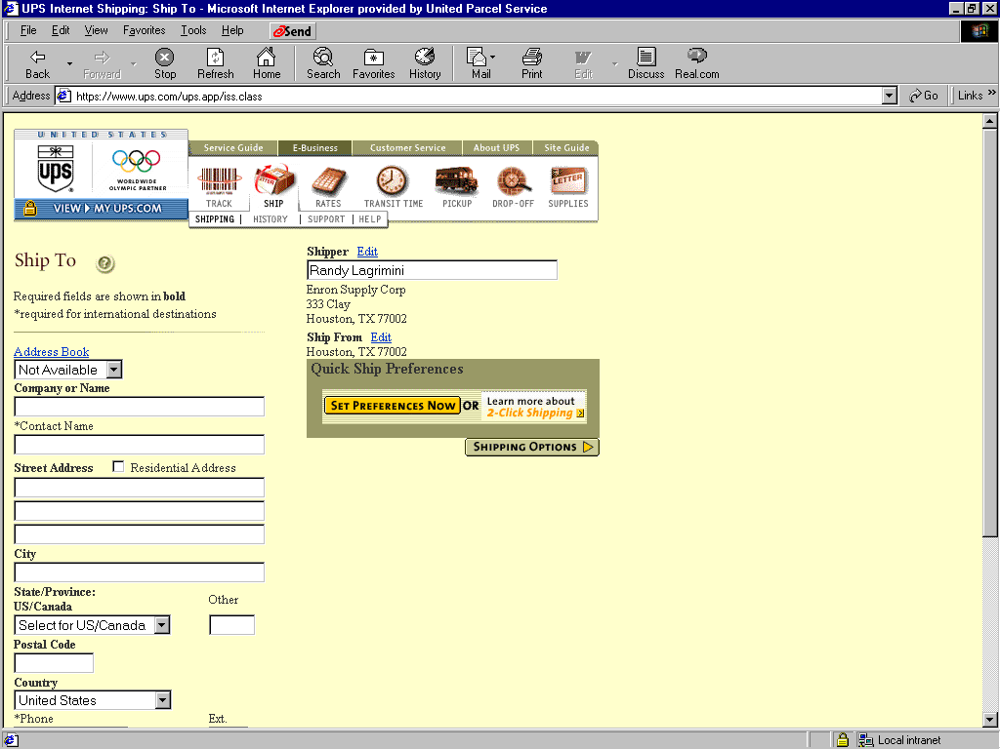

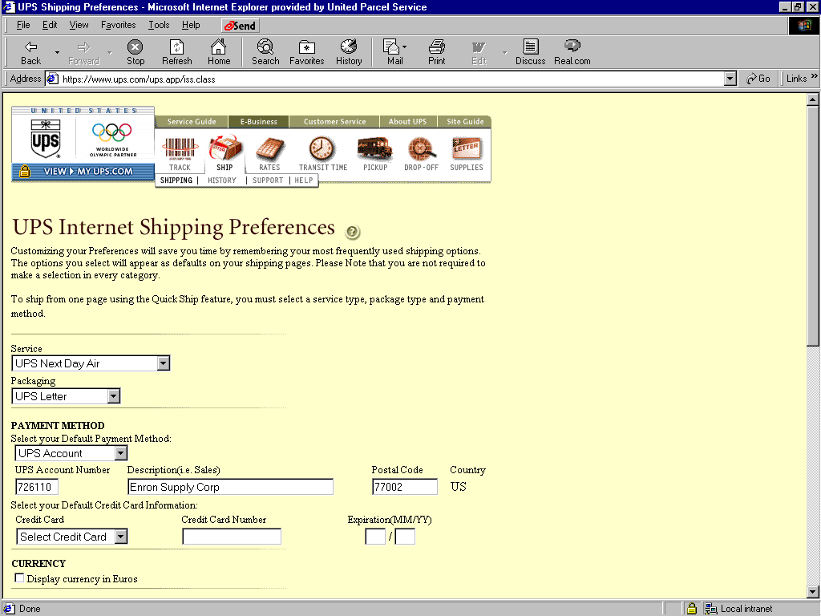
- Select the default service you desire (NDA, 2DA,etc…)
- Select the default packaging you desire (UPS Letter, UPS Tube, etc…)
- Select UPS account as your Method of Payment
- On the next line, enter your UPS Account Number (726110), Description (Enron Supply Corp)and Postal Code (77002)

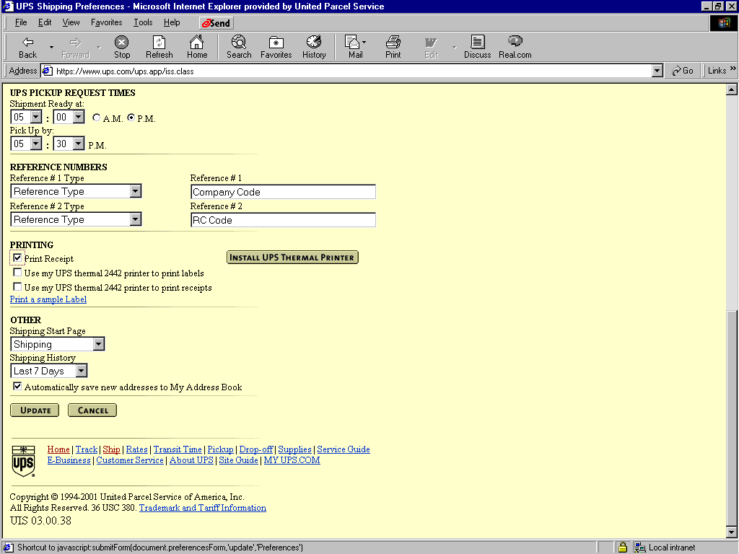

- Scroll down and set Pickup Request Times (Ready at 5:00p/ Pickup at 5:30p)
- In the Reference Numbers section, type in your Company Code in the Reference # 1 field and type in your R C code in the Reference # 2 field. (this will automatically populate these numbers into the shipping screens)
- Scroll down to Printing and select Print Receipt
- Scroll down and click on Automatically save new addresses to My Address Book
- Point and click on UPDATE
- Now you are ready to ship

Notice that the Set Preference Now has change to Ship Now.
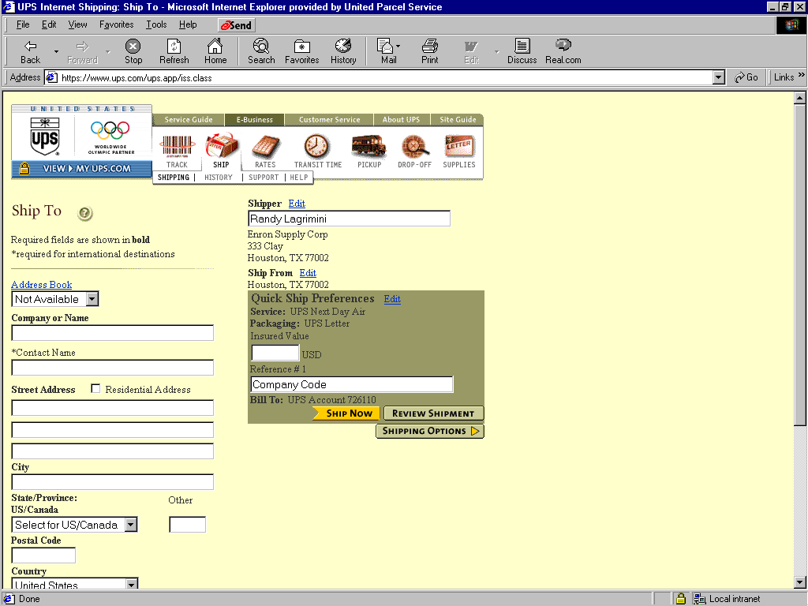

- Enter the Address information
- At this point, you are ready to proceed to Ship Now, Review Shipment or go to the Shipping option.

Supply Ordering

After you have logged in to MY UPS.COM, point and click on Supplies

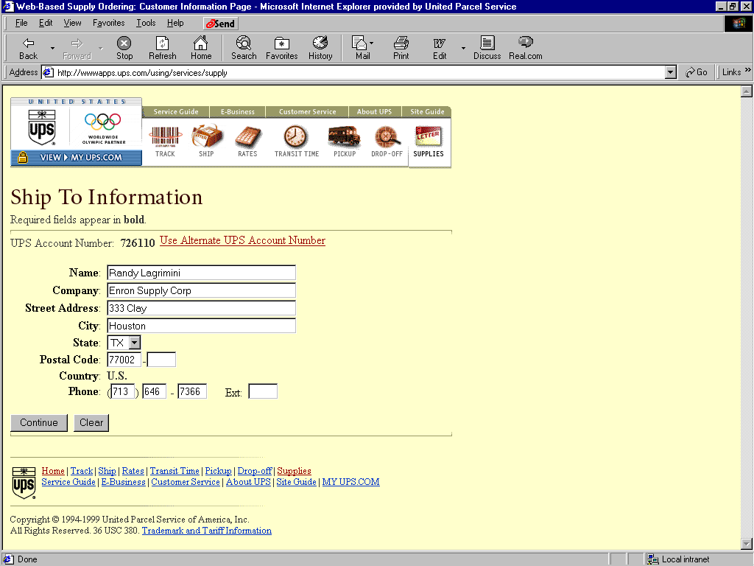
- The Ship To Information screen appears, verify that the address is where you want the supplies to be delivered. If this information is correct, click Continue. If not, then correct the address and then click Continue.

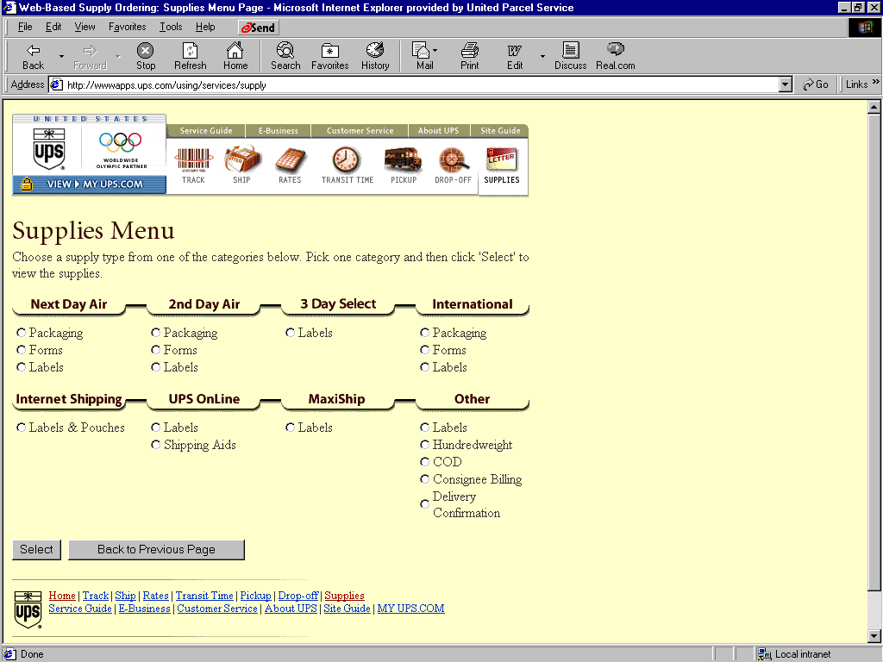
- Next, the Supplies Menu will appear. Select Label & Pouches under Internet Shipping. Then click on Select.

- Under Internet Shipping – Labels & Pouches, enter your quantity in the Quantity box. Then click Add/View Order
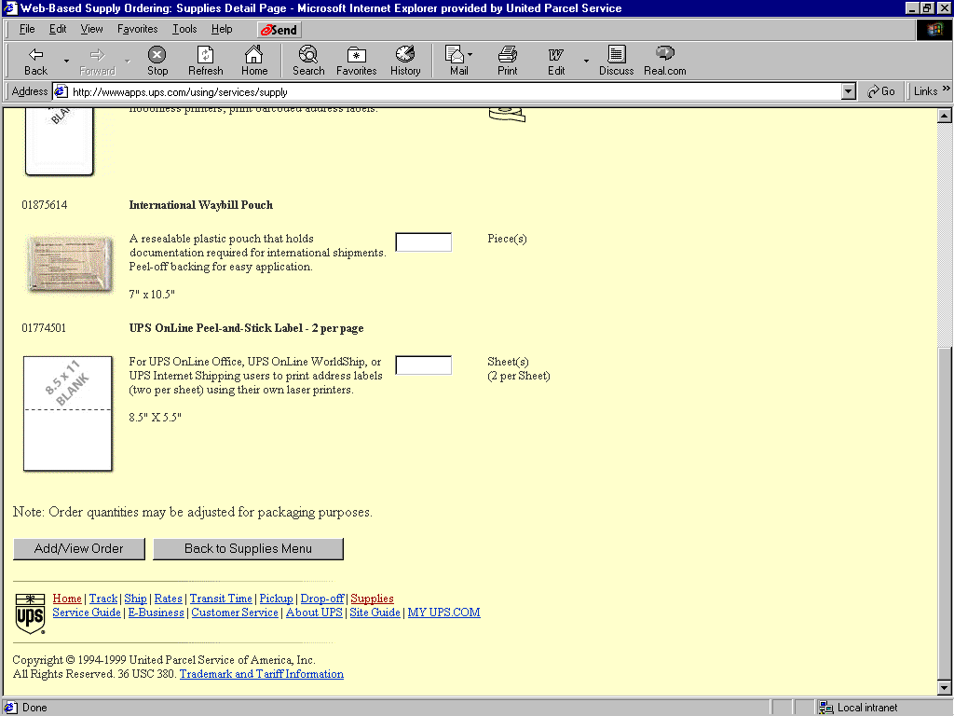
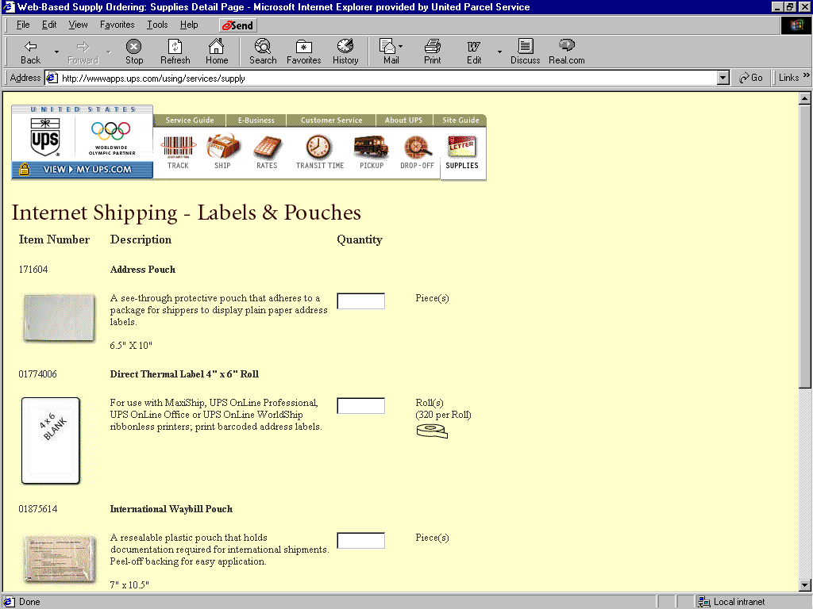

- The Verify Order screen will appear. If you are satisfied with your selection, click Submit Order
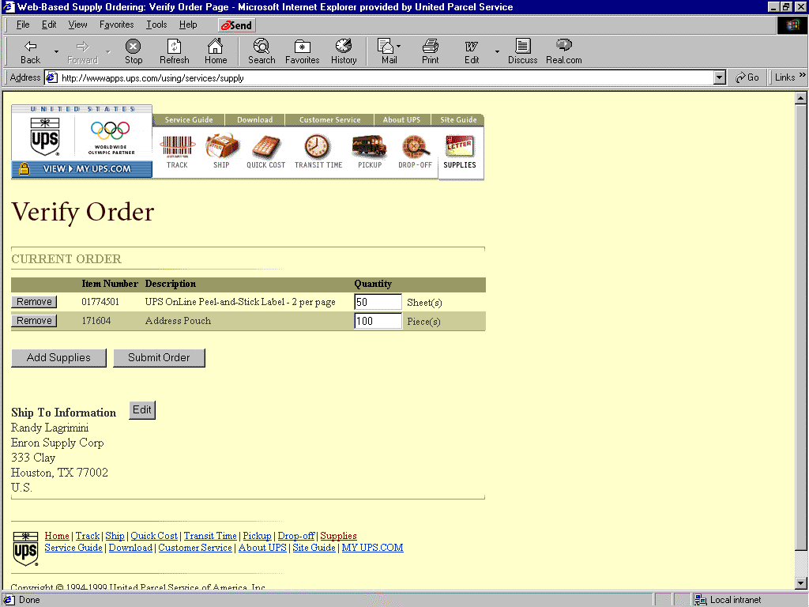

- Congratulation, after the Confirmation screen appears, the Supply Ordering process is complete. If you have any question about your order call, Customer Service at 1-800-PICK-UPS.
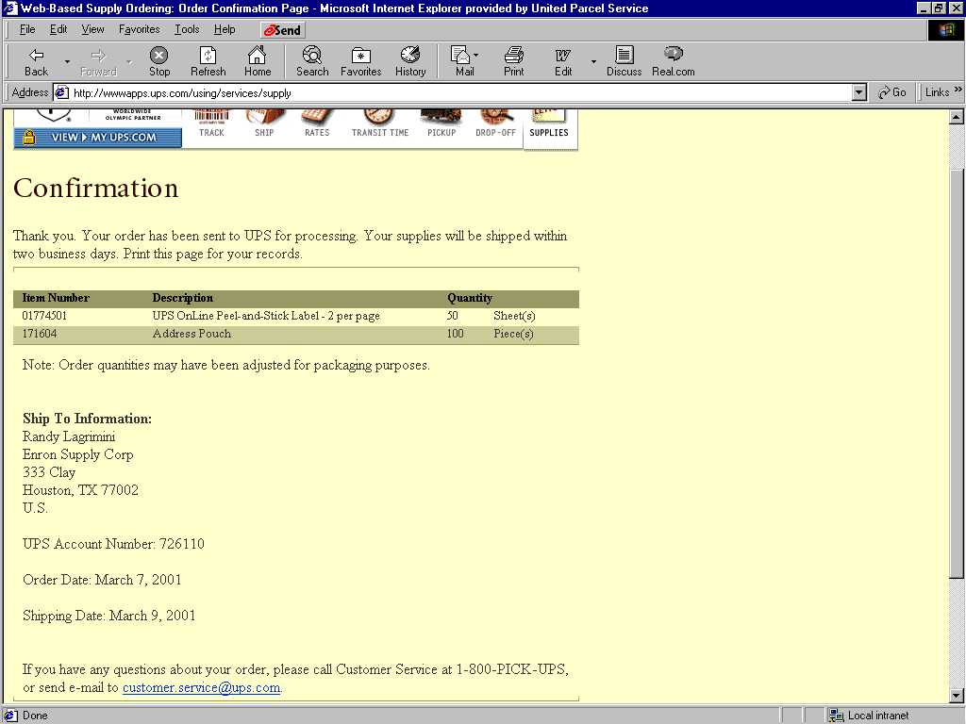

Drop-Off Locators
- After you have log in to MY UPS.COM, point and click the DROP-OFF button

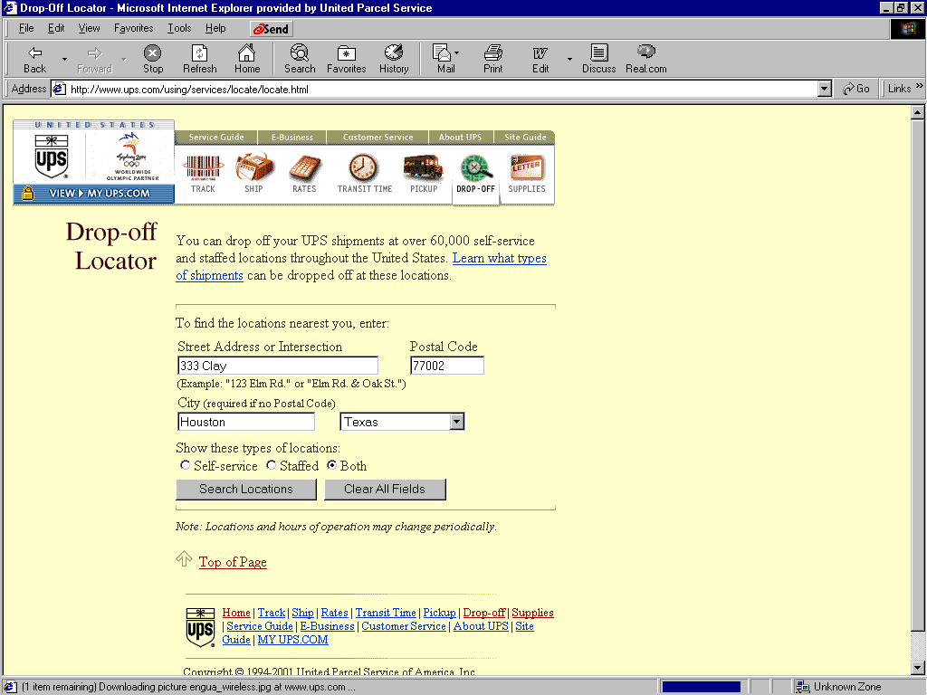
- The Drop-off Locator screen appears. Verify that location is correct. To find the nearest drop-off location, click Search Locations. If this is not your location, click on the Clear All Fields and input the correct information.

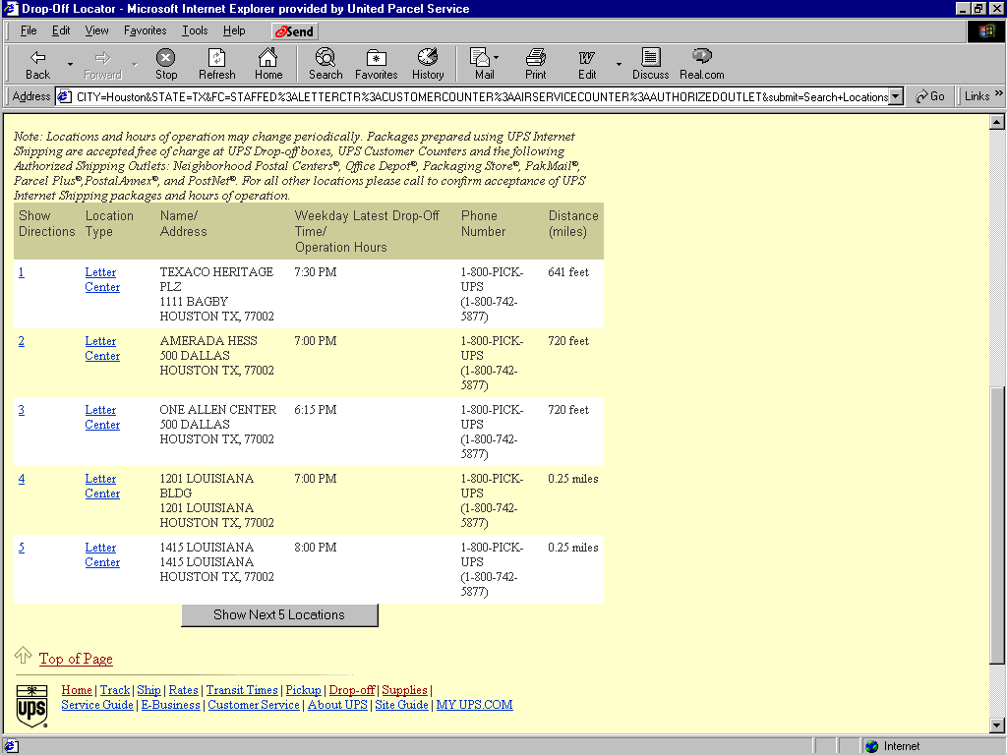
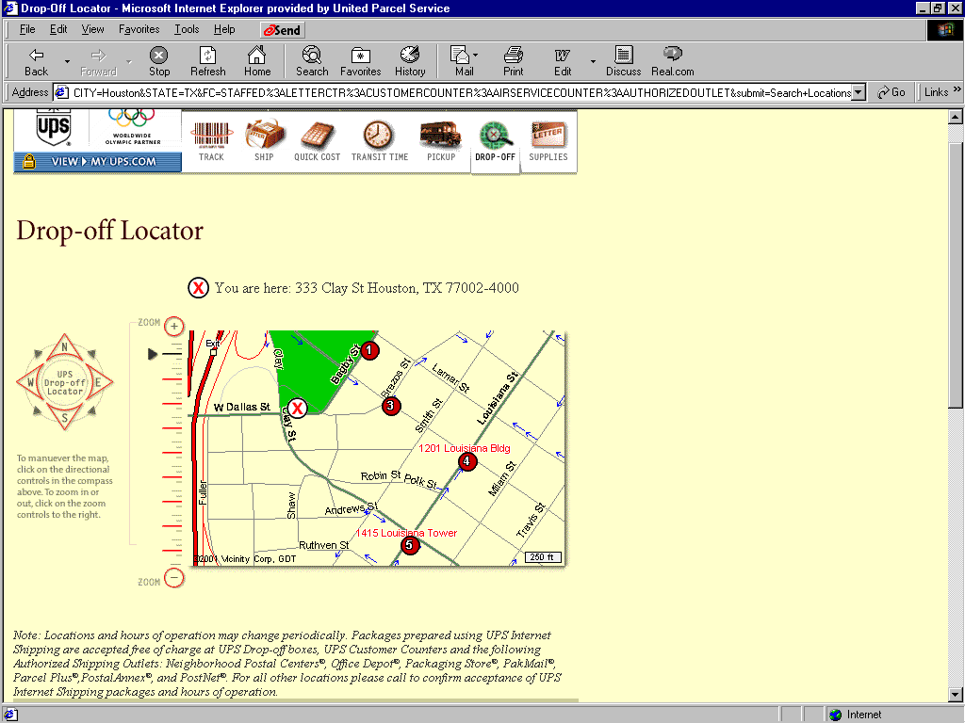
- At the Drop-off Locator screen, you will see the closest drop-off points in reference to the your location. The points are number 1-5 from near to far. The Show Next 5 Locations button, will give you 5 more locations. The information received will give you the Location Type, Name /Address, Weekday latest Drop-off Time/Operational Hours, Phone Number and the Distance.

Frequently Asked Questions

Does UPS ship overnight packages?

Yes, UPS delivers the following air products:
UPS Next Day Air Early A.M. 8:00/8:30 a.m. to selected Zip Codes
UPS Next Day Air - guaranteed by 10:30 a.m.
UPS Next Day Air Saver -guaranteed by 10:30 a.m.
UPS 2nd Day Air A.M.-guaranteed by 12:00 p.m.
UPS 2nd Day Air - guaranteed by end of second day
UPS 3 Day Select - guaranteed by end of third day
UPS International Service- World Wide Express Plus, by 8:30 a.m. to select cities in Europe
UPS World Wide Express - delivery by second business day

How do I process my packages?

You can process your packages via the Internet by going to the UPS.com web page.

Select UPS on your shipping ticket; take package to mailroom.

Complete Air Shipping Document (Internet process preferred over this method).

How do I track my packages?

Internet: Go to ups.com web page; click on the "track" icon. Enter tracking number to get response.
Or
Contact Preferred Customer Associate: Verna Molandes is the UPS (PCA) dedicated the Enron account.
Houston 281-847-6769 Outside of Houston 800-432-2877

Where can I drop off my packages?

You can drop off your packages in the mailroom at 1400 Smith.
Or
Within the 333 Clay building, UPS picks up on the
5th floor 5:30 p.m.
18th floor 5:30 p.m.
32nd floor 5:30 p.m.

Go to ups.com web page and select "drop off locator"
Enter your current location (address and zip code).
Select your nearest drop off point.

How do I obtain supplies?

Pick up supplies from mailroom 1400 Smith

Call Preferred Customer Associate (PCA) 281-847-6769
Outside of Houston 800 432-2877

Go to ups.com web page and click on "supplies" icon.

What is the latest time I can drop off my packages?

The pick-up time at the 1400 Smith building is 6:00 p.m.
The Clay building pick-up time is 5:30 p.m. on the 5th, 18th, 32nd floors.
The Bank One building on the corner of Walker and Milam is open until 9:00 p.m.
Call 1-800-pick-ups (742-5877) by 5:00 p.m. for a pick-up by 6:00 p.m.

