Instructions to install Internet Explorer 5.01

CLOSE ALL programs before running the install !!!!

Click on the “Start” button then choose “Run”

Next to open type: U:\common\ie5\i386\setup.exe

Click “OK”
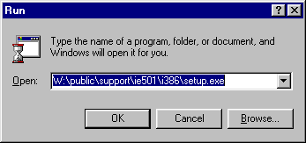
U:\common\ie5\1386\setup.exe

The Following windows will open

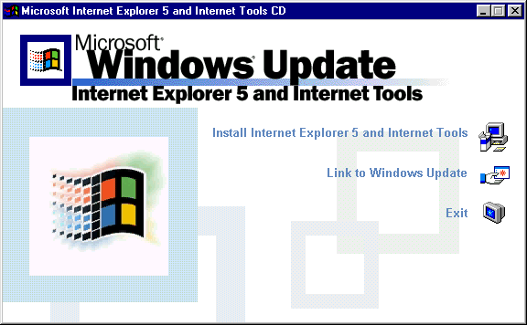

Click on “Install Internet Explorer 5 and the Internet Tools” (CLICK ONLY ONCE)

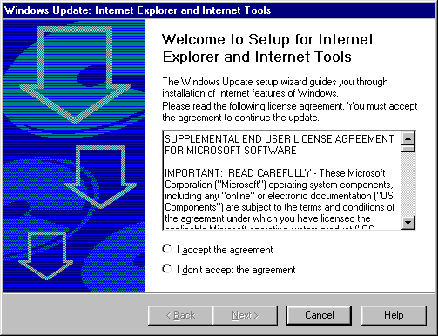
Choose “I accept the agreement”

Click Next
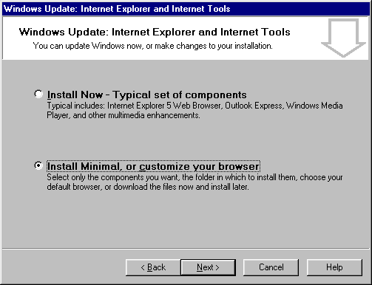
Choose “Install Minimal, or customize your browser”

Click Next

No Changes are made on this screen. Accept the defaults

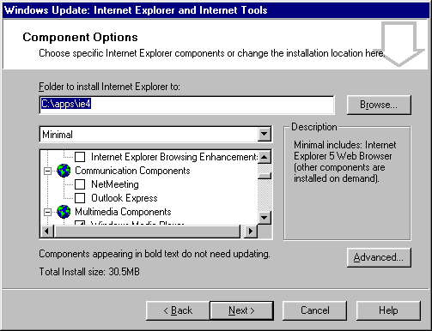

Click next

The installation process will begin, once it is finished the screen below will open
Click on finished – this will restart your computer

It may take a few moments for you computer to restart.

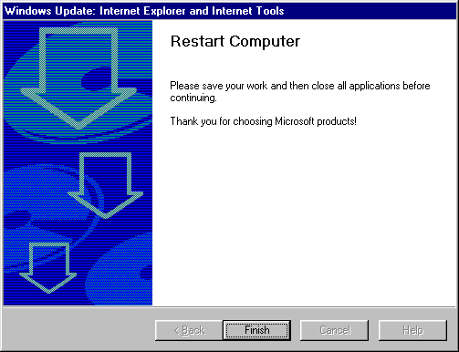

The computer will restart on its own.

Once the computer restarts, delete the following Icon (click once on the Icon then hit your delete key on the keyboard.)

If you have more than one Internet Explorer Icon on your desktop delete all of them that have a
In the lower left hand corner – If you have any doubts about this step, Skip it!!!

Open Internet Explorer

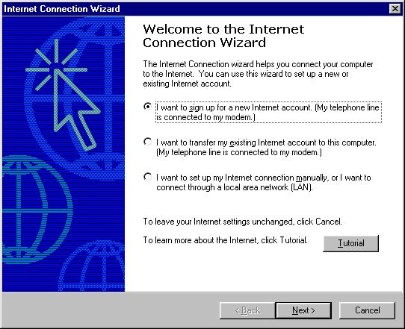

Select the 3rd option

Click Next.

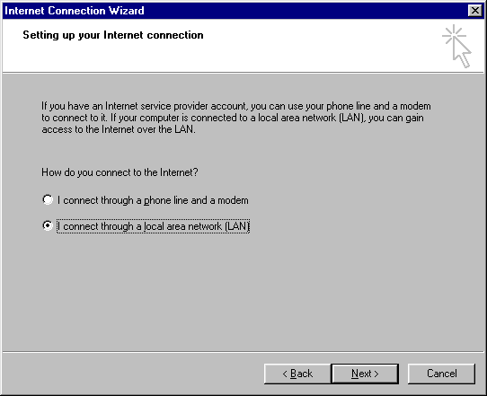

Choose the second option

Click next

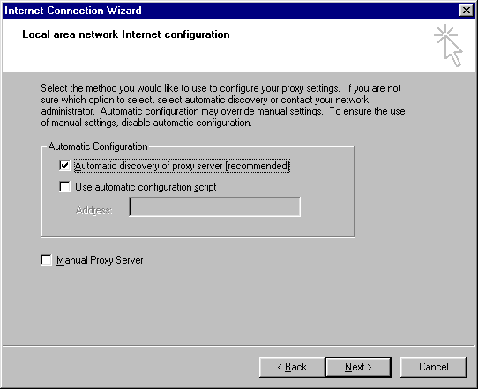

Select the first option

Click Next

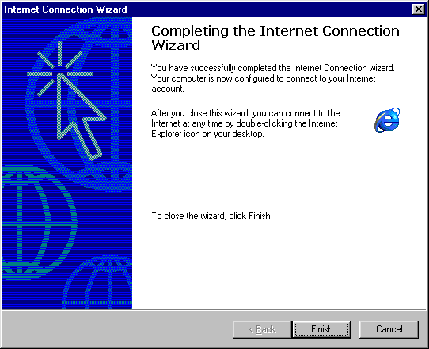

Click Finished

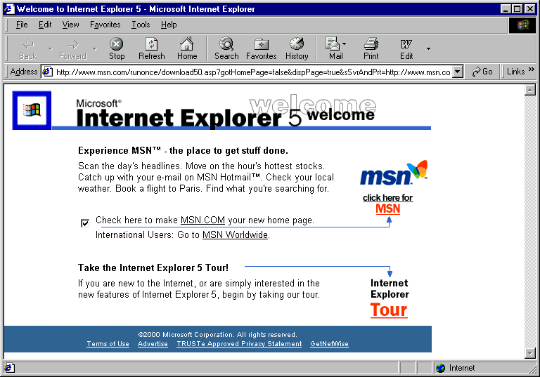

The first time your Browser opens it will open on the “Internet Explorer 5 welcome” Page

Close the browser and open it again. It will open on your old home page.

