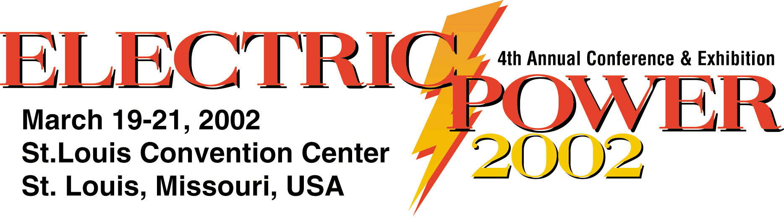
Final Paper/Presentation - Instructions

SUBMISSION OF PRINTED MATERIALS

All presenters must submit written materials for publication on the Electric Power 2002 Web site, www.electricpowerexpo.com and the CD Rom Proceedings.

An ADOBE Acrobat file is preferable, however you can also submit your manuscript in any Microsoft application or Text format. Please e-mail your presentation/manuscript to Carrie Shapiro at carries@tradefairgroup.com by January 31, 2002. If you are participating in a panel session, please see below for instructions on submitting power point presentations.

If you are unable to meet this deadline or have specific questions about the format, please contact Carrie Shapiro, Conference Manager at 713-463-9595 x 307.

Speakers/panelists who represent suppliers must avoid commercial presentations. Delegates can receive this information from a salesperson in the comfort of their offices at no charge. This will also reflect negatively on both your organization and the conference. Speakers who use the formal sessions as a platform for blatant sales promotion risk exclusion from future conferences.
All presentations must be free from company logos or advertising!

Adobe Acrobat Guidelines
If you have the software available, we prefer final presentations to be submitted in the format of an ADOBE Acrobat File. You may e-mail the final version to Carrie Shapiro, Conference Manager, carries@tradefairgroup.com by January 31, 2002. Conference Management will also e-mail an ELECTRIC POWER logo or other co-located conference logos if applicable, for you to incorporate in your presentation. You should receive the logo(s) by December 15, 2001.

Standard Manuscript Guidelines
Please follow the instructions listed to ensure your presentation will be published correctly on the Electric Power 2002 web site and CD Rom Proceedings. Any discrepancy may cause delays, incorrect publication or exclusion from the web site and proceedings.
- Single column format (Do not use multiple columns).
- 12-pt. Times New Roman font throughout document - Use bold type for subheadings.
- Do not number pages.
- Separate the abstract and/or biographical information from the actual presentation.
- Please follow this format for the first page of your document:
↑
One Inch Margin
↓
TITLE OF MANUSCRIPT IN ALL CAPS, BOLD FACE
PRINT, 14 PT. TIMES FONT AND CENTERED

Author(s) Name, Company
Address, Phone/Fax, E-mail

Text text text text text text text text text text text text, etc

Power Point Presentation Guidelines
If you are participating in a panel discussion, then you probably will not have a formal paper. For panel sessions, please prepare a Power Point Slide Show and e-mail your presentation to Carrie Shapiro carries@tradefairgroup.com by January 31, 2002 for inclusion on the ELECTRIC POWER 2002 CD Rom Proceedings. You must use a standard Power Point Template that will be supplied by Conference Management. By December 15, you will receive a Power Point Master Slide by e-mail for you to use as a Presentation Template (no company logos are aloud). Please remember, you are responsible for bringing your presentation to the conference on your laptop or CD Rom/Diskette.

If you cannot e-mail your presentation for some reason, please make arrangements to mail a diskette or CD Rom of your presentation by the due date of January 31, 2002. Please notify Conference Management if you will be sending in your presentation by mail.

Mail diskettes/CD Roms to: Carrie Shapiro, Conference Manager, % ELECTRIC POWER 2002, 1220 Blalock, Suite 310, Houston, TX. 77055, USA

