Initial Beachfire comments on ISDA RFP

18 December 2000

Purpose
This document is a commentary on the ISDA RFP for a Document Information and Management System, dated 27 July 2000. We recognize that the deadline for responses was 8 September 2000, and that there are current RFP respondents. However, the section of the RFP entitled “Negotiation Facility” is of particular interest to Beachfire, since we are a supplier of collaborative negotiation solutions that can complement and enhance traditional document management systems. We wish to offer some observations on possible approaches to the negotiation facility, in hopes of a continuing dialogue with ISDA and potential participation in the development of the new system.
Our comments follow the outline of the RFP, covering in turn Electronic ISDA documents, Detailed Guidance and Advice, and the Negotiation Facility. We discuss briefly a recommended implementation strategy and conclude with suggested next steps.

Electronic ISDA Documents
The key technical requirement implicit in this RFP is to strongly separate document content from presentation. Existing ISDA documents, examples of which are on the ISDA web site and which we have examined, consist of richly structured documents in which specific sections are cross-referenced and for which some documents are forms, the fields of which dealers must complete within more or less strict constraints.
ISDA needs a document management facility in which the structure of these documents are captured using XML Schema and XML, respectively, and in which the rendering of these documents for different purposes is accomplished through transformations to HTML, PDF, and other future formats. Information such as cross-references is easily represented in XML in such a way that allows it to be rendered to almost any target platform and format. Figure 1 is a sketch of the overall information flow in such a system. With an XML-centric infrastructure in place, many more opportunities for using electronic ISDA documents will exist than if ISDA were to settle on a primary document format that is essentially presentation-oriented.

Detailed Guidance and Advice
In addition to the technical requirements for the Electronic ISDA Documents, the detailed guidance and advice will require a strong change management and change control facility, so that existing documents’ linkage to underlying advice is both robust (the links don’t break) and dynamic (the most up-to-date approved guidance is found at the moment the user seeks it, rather than being hard-coded into the document).

Negotiation Facility
There are several technical requirements of a successful online negotiation facility:
- Secure, centralized, neutral hosting of documents. Today’s e-mail and fax-based transfers of successive draft agreements should be replaced by a single, mutually accessible and highly available draft with added value features such as redlining, section-by-section tracking, and ease of import.
- Strong authentication, non-repudiation, integrity, and access control. Establishing trust sufficient to allow online signature and execution requires infrastructure that is designed from the outset to support these features in a cross-enterprise environment.
- Centralized, managed discussion. The ability to carry on discussions asynchronously has been shown to be a key feature enabling more timely resolution of issues. Enhancing this with tracking which allows each negotiator view at a glance the status of each part of the document is key.
- Team management. In complex deals, achieving timely execution of the deal depends on managing participation from different domain experts no matter what their geographic location or availability, without compromising the privacy of the essentials of the deal.
An ideal negotiation facility for ISDA would take advantage of the structure of the draft agreement itself, represented in XML, and through the use of form templates, version control, and redlining, direct users’ attention to their key tasks and drive the deal to completion. These are the key features of the negotiation solution that Beachfire is currently developing. The appendix shows a mockup of an ISDA agreement rendered as an HTML form in Figure 2. Figures 3 and 4 show how an ISDA agreement might be rendered within the Beachfire Negotiation Table, a product currently under development.
Note that the Beachfire product is designed for customizability of layout and presentation, as well as ease of integration with existing databases and other applications. Hence, the specifics of layout and rendering of documents is entirely open to customization. By the time the ISDA implementation is under way in the spring or summer of 2001, the Beachfire Negotiation Table will be a licensed software product, and only the intellectual property specific to customizations needed for installation at ISDA would be owned by ISDA.

Implementation Strategy
Successful systems development and integration projects almost invariably follow a rigorous methodology with clear process steps, decision points and accountability for results. Figure 5 shows our general framework, which aligns with most successful methodologies. Our experience at Beachfire has been that most projects prematurely commit to incompletely documented requirements, while failing to account adequately for the continuing work of converting existing data and documents and easing the transition for new users by integrating the system into the existing environment by ensuring that true “pain points” are addressed and proposed benefits are actually realized. In the specific case of the negotiation facility, we observe that online negotiation will never begin to occur among the user community without a realistic quantitative assessment of its value to members, and without a realistic understanding of the human and systems factors involved that would make the facility a compelling solution.

Suggested next steps
Should the Beachfire approach to Negotiation Table be of interest to ISDA, we look forward to discussing with you a variety of possible next steps:
- Beachfire is prepared to work with ISDA on a diagnostic survey of process costs and opportunities in swaps and derivatives trading that could be addressed by a negotiation facility. ISDA would benefit by having a quantitative assessment of the value to its members and to the marketplace of using an ISDA sponsored negotiation facility instead of current approaches such as courier, fax and email.
- Beachfire is prepared to support ISDA by assisting in the development of detailed requirements for the negotiation facility, independently of any current RFP respondent. ISDA would benefit by having an objective outside party with specialized expertise in negotiation ensure that the system will be accepted by its target end users.
- Beachfire is prepared to assist ISDA in the functional and technical review of current RFP responses with respect to the negotiation facility in particular.
- Beachfire is prepared to work with any of your current proposal respondents to the RFP on clarifying and enhancing their understanding and capabilities with respect to negotiation, provided that suitable non-disclosure and non-compete agreements can be executed with these respondents.
Figure 1. Overall information flow in ISDA System.
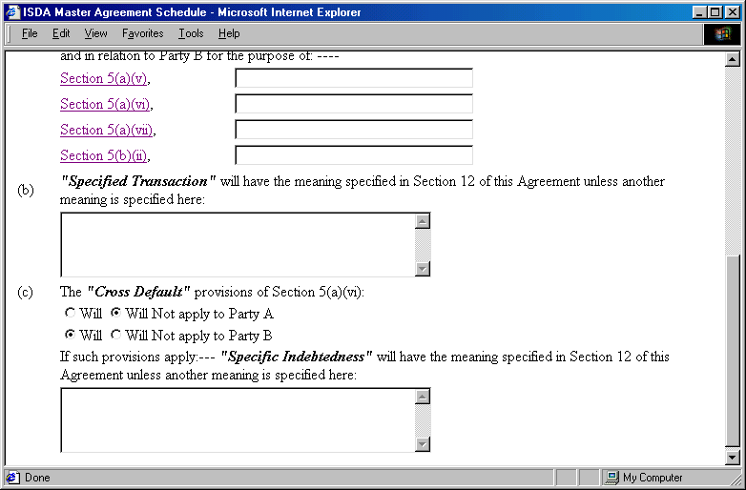
Figure 2. ISDA Master Agreement Schedule rendered as an HTML form.
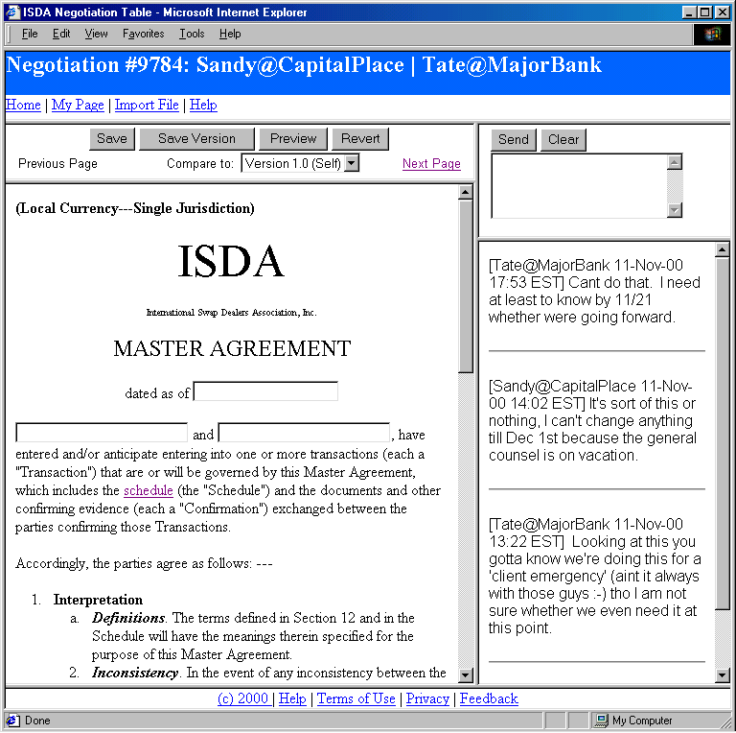Figure 3. Master Agreement within a Beachfire Negotiation Table.
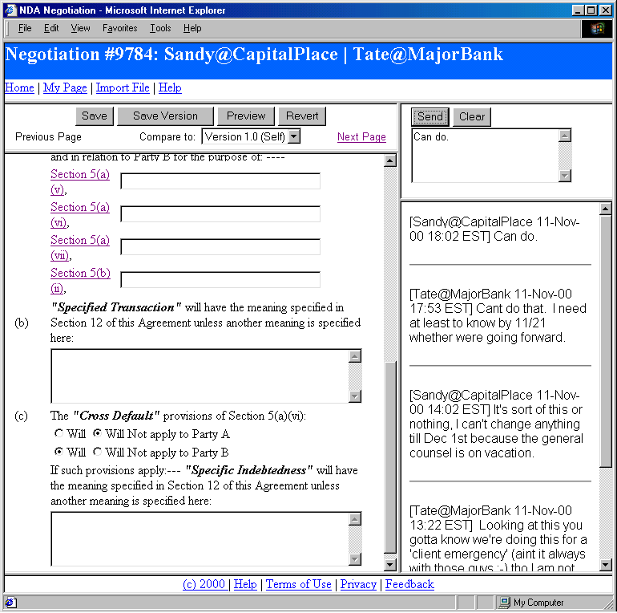
Figure 4. Master Agreement Schedule within a Beachfire Negotiation Table.

Figure 5. Beachfire Implementation Approach.

