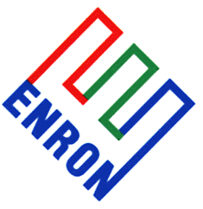


Proposal for Capacity and Energy
In Response to

IDAHO POWER COMPANY’S

August 4, 2000

REQUEST FOR PROPOSALS

Submitted

September 29, 2000

By

ENRON NORTH AMERICA CORPORATION
121 SW Salmon St. 3WTC0306
Portland, OR 97204

