INVESTIGATION OF W501FD ROW 7 COMPRESSOR BLADE FAILURE AT ENRON GLEASON UNIT 1

October 12, 2000

ABSTRACT

The most probable mode of fracture of a row 7 compressor rotor blade airfoil was high cycle fatigue (HCF). Cracking initiated at the leading edge (LE) of the airfoil in an area of mechanical damage. The mechanical damage appeared to be due to impact of FOD during engine operation, prior to the initiation of the fatigue.

- BACKGROUND

A large fragment of an Enron Gleason Unit 1 W501FD Row 7 compressor rotor blade, PN 2072J8/2072J21, position #22 that had fractured through the airfoil was found in the turbine exhaust system. This report only deals with the loss of a row 7 compressor rotor blade.

- GENERAL INFORMATION

Customer Enron
Site Gleason, Tennessee
Unit 1
Frame W501FD
Unit S.O.# 37A8046
Date of discovery July 12, 2000
Component name Rotor blade
Row 7
Component PN 2072J8/2072J21
Position # 22
Total load hours 139
Attempted starts 53
Successful starts 38
Normal shutdowns 35
Fast shutdowns 20
Trips 9

- DESCRIPTION OF FAILURE

The airfoil fracture was located ~75 mm (3.0 inches) above the root platform (Figure 1). The region of mechanical damage at the airfoil LE measured ~1.3 mm (0.050”) in the span-wise direction and ~1.8 mm (0.070”) in the chord-wise direction (Figure 2). The damage appeared to be the result of an impact on the airfoil pressure side leading edge, with a
~0.5 mm (0.020”) deep depression. The directionality of the impact damage was consistent with engine operation and it appeared to have occurred prior to the initiation of fatigue. The HCF failure initiated at this FOD location and the fatigue portion of the fracture extended ~65 mm (2.6”) from the leading edge (Figure 3). As expected, the final fracture of the airfoil was due to overstress.

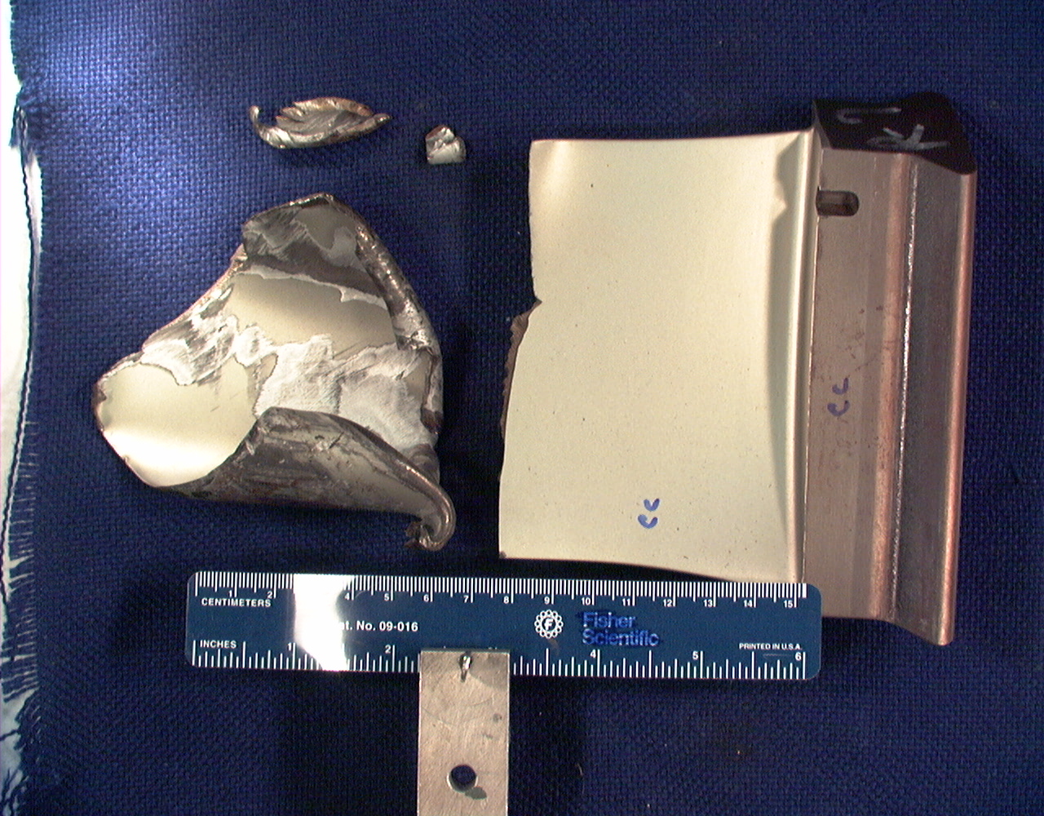

Figure 1: Photograph showing the recovered portions of the Row 7 compressor blade #22 and the fracture height.
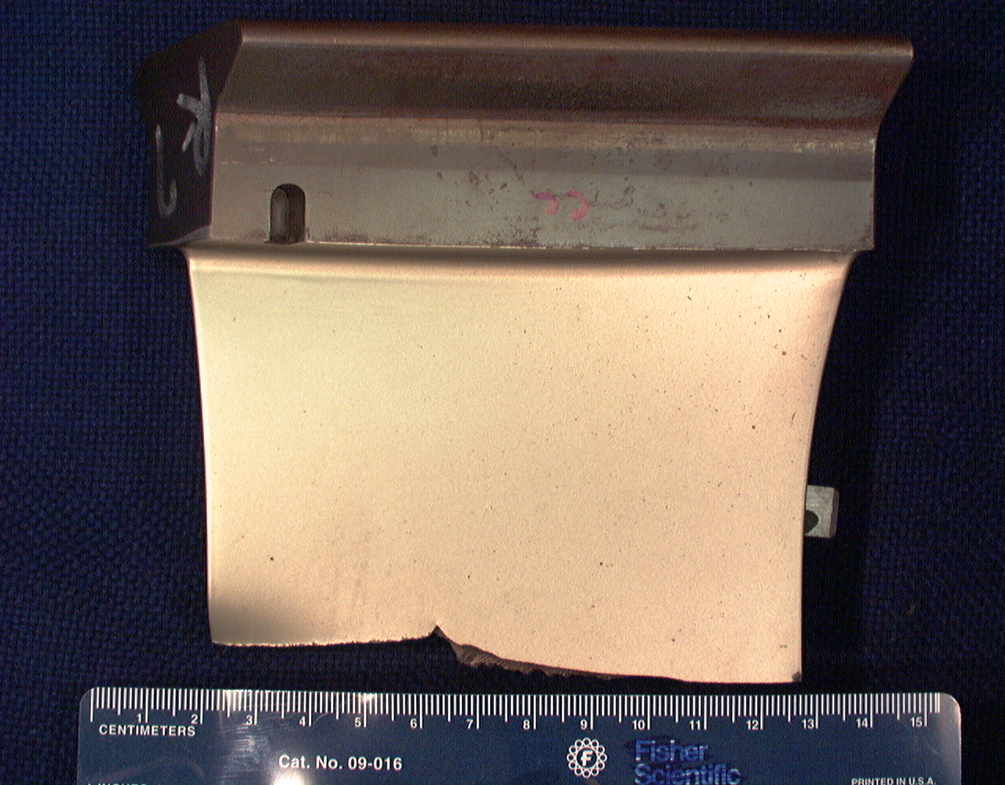
Fatigue Fracture

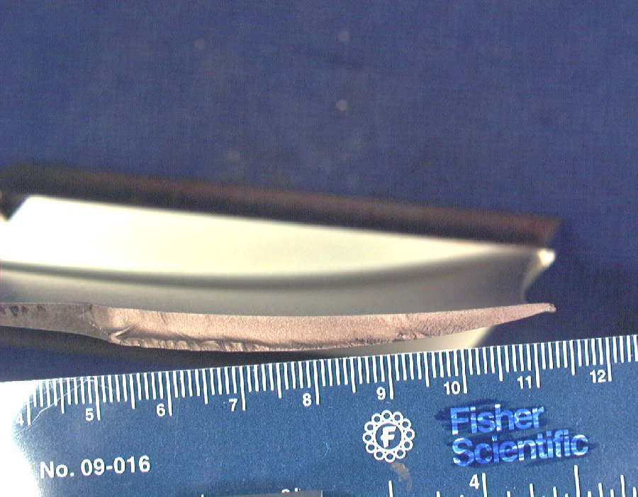
Fatigue Fracture

Figure 2: Photographs showing the fatigue fracture length.

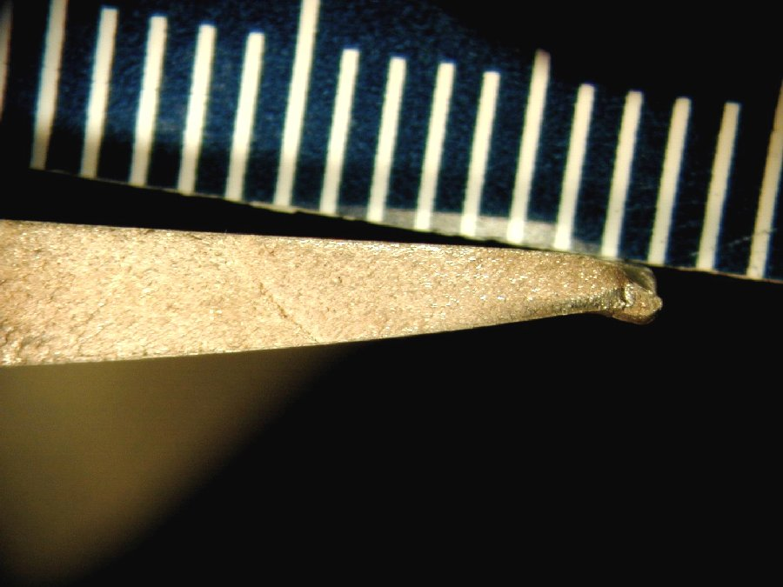

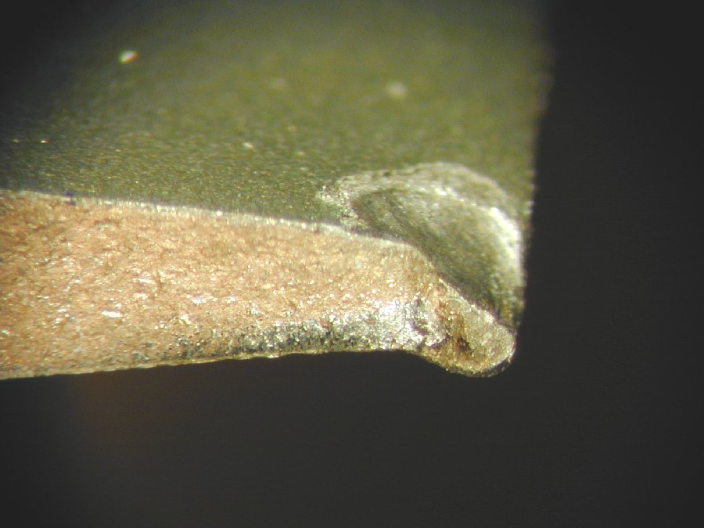

Figure 3: Photographs showing the mechanical damage on the airfoil LE.

- INVESTIGATION

ANALYTICAL MODELING

Analyses were performed in order to determine the source of the HCF failure. With the mechanical damage at the airfoil LE the analytical model illustrates that the airfoil is susceptible to fatigue fracture at this location.

MANUFACTURING HISTORY

Row 7 compressor blades are manufactured from PD-Spec 10705BR (AISI 616) martensitic stainless steel and receive an aluminum-rich coating per Process Specification 83342NU. The Enron Gleason Unit 1 row 7 blade that fractured throughout meets the above specification. There are no rotor blade related non-conformances listed for these parts.

METALLOGRAPHIC EXAMINATION

Scanning electron microscope (SEM) examination of the fatigue surface (Figure 4) confirmed features indicative of HCF. A potential transverse tear resulting form the impact damage was observed. Metallographic examination of a planar section through the airfoil LE fracture surface (Figure 5) revealed a transgranular crack path typical of fatigue.

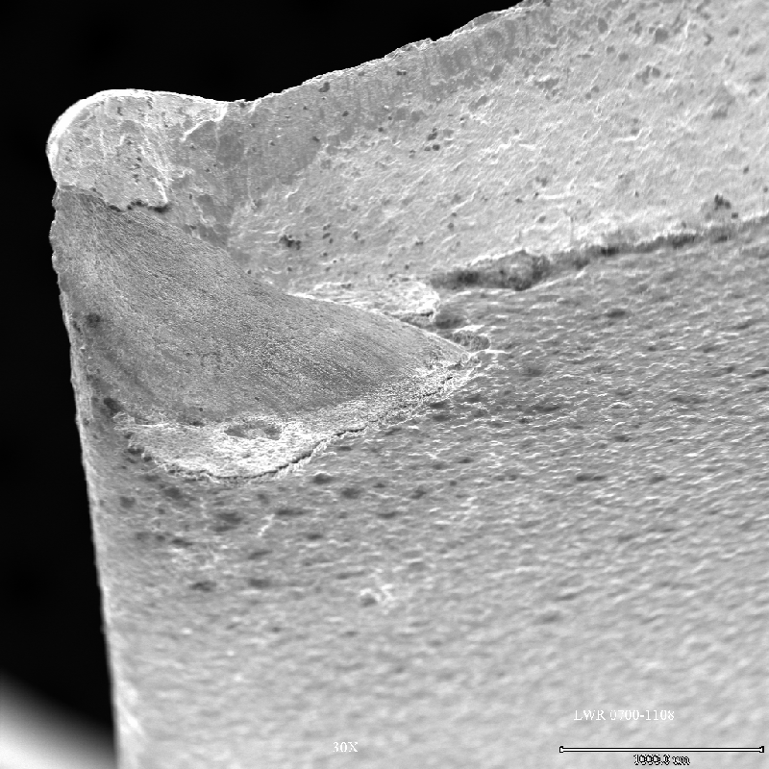

Figure 4: SEM photographs of mechanical damage at airfoil LE. Arrow indicates direction of fatigue progression.
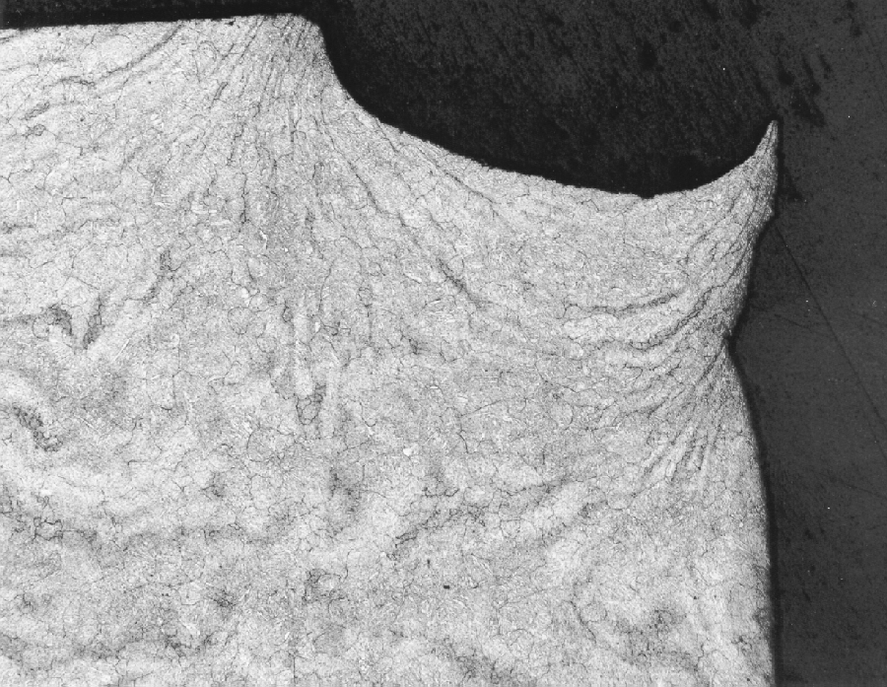
Mechanical Damage

Figure 5: Optical photomicrographs of planar metallographic section through airfoil fatigue fracture surface and mechanical damage at leading edge.

