ATTACHMENT "A"

A Study of Marketing Affiliate and Other Affiliate Holdings of Firm Capacity on Interstate Natural Gas Pipelines and the Effects on Natural Gas Markets

by

John R. Morris
Economists Incorporated
1200 New Hampshire Avenue, NW
Washington, DC 20036
(202) 223-4700

April 30, 2001

for

Interstate Natural Gas Association of America
10 G Street, NE
Washington, DC 20002
(202) 216-5900

On November 22, 2000, the Federal Energy Regulatory Commission (Commission) issued a notice of a Staff Conference “to discuss how the changes in the natural gas market affect the way in which the Commission should regulate transportation transactions between pipelines and their affiliates, as well as between pipeline capacity holders and their affiliates, capacity managers and agents.” The Commission held the conference on March 15, 2001. In connection with this, the Interstate Natural Gas Association of America (INGAA) requested that Economists Incorporated provide a report concerning the current state of natural gas markets, in particular, the relationship between regulated interstate natural gas pipelines and their affiliated entities that hold capacity on those pipelines.
INGAA specifically sought the answers to the following questions concerning the effects of the Commission's affiliate regulations:
- Have the current marketing affiliate rules allowed affiliates to gain undue market shares by virtue of their affiliated status?
- Do marketing affiliates hold substantial shares of interstate pipeline capacity?
- Do generation affiliates hold substantial shares of pipeline capacity?
- Have affiliate positions on pipelines increased significantly in recent years?
- Have current marketing affiliate rules permitted pipeline marketing affiliates to gain market power in gas commodity markets?
If the answers to these questions are negative, then the Commission would not have reason to expand the scope of marketing affiliate rules. Negative answers may mean that gas markets are becoming increasingly competitive, companies have achieved market positions on competitive merits, the amounts of capacity held by affiliates are not increasing, and, in fact, the amounts of capacity held by corporate affiliates are too small to adversely affect natural gas markets. Expanding the marketing affiliate rules would impose additional costs on some market participants with little or no expected benefits. As shown below, the answer to each of these questions is negative.
The report is divided into four sections. Section I is an overview of the report. As discussed in Section I, if pipeline marketing affiliates receive unfair or undue preferences on any systematic basis, the effects of those preferences should be revealed in the natural gas commodity market. Undue preferences favoring marketing affiliates will be revealed in marketing affiliates gaining market share vis-à-vis nonaffiliated gas marketing companies. If market data do not reveal preferences, then it is unlikely that expansions of the marketing affiliate rules would produce market benefits. Rather, additional rules would simply impede affiliated companies from competing on equal terms with nonaffiliates, at a direct cost to consumers.
Section II of the report examines data from natural gas markets.
Part A of Section II reviews the national market shares of the largest gas marketing companies, comparing the changes in the market shares of major interstate pipeline marketing affiliates with changes in the market shares of non-affiliated marketers from 1995 to 2000. Changes in market shares over this time period do not reveal any preferences or advantages for marketing affiliates. During this period, for both groups, some marketers gained share while others lost share. Changes in market shares are consistent with very competitive gas commodity markets. Thus, this data provides no support for an expansion of the marketing affiliate rules.
Part B of Section II reviews Index of Customer data on firm shippers holding primary firm transportation capacity on interstate pipelines. These data show that marketing affiliates do not hold significant shares of primary firm transportation capacity on pipelines. Marketing affiliates on only five pipelines held more than a 10 percent share of contracted capacity in 2000, and marketing affiliates accounted for only 5.3 percent of capacity for pipelines as a group. With one exception, pipelines constructed to serve affiliated local distribution companies are the only pipelines with more than a 25 percent share of capacity controlled by all affiliated companies. Many of these corporate affiliate relationships, which are subject to extensive state regulations, were in place well before the Commission adopted its current marketing affiliate conduct rules. Therefore, these relationships are not new and their presence does not warrant an expansion of the rules. In addition, as shown by the data referenced in the report, these relationships have not prevented the development of competitive gas commodity markets.
Part C of Section II compares the changes in the market shares of the gas marketing companies discussed in Part A to the amount of primary firm transportation capacity held by marketing affiliates on interstate pipelines discussed in Part B. These data show no relationship between the changes in market shares and the amount of capacity held by marketing affiliates on affiliated pipelines. In other words, the competitive rank of gas marketing companies is independent of the amount of capacity held by marketing affiliates on affiliated pipelines. These facts do not provide support for an expansion of the marketing affiliate rules.
Part D of Section II examines the amount of primary firm transportation capacity held by generation affiliates on interstate pipelines. Generation affiliates control no more than 3 percent of the total contracted firm capacity on any pipeline. In fact, only 5 of 28 pipelines had generation affiliates that held primary firm transportation capacity on their pipeline. These percentages are too small to have any competitive impact on gas commodity markets. Moreover, the amount of primary firm transportation capacity held by generation affiliates is too small to substantially affect electric power markets.
Section III examines the potential for all corporate affiliates of a pipeline to exercise market power. It provides an economic approach to examining the capacity positions held by all corporate affiliates on affiliated pipeline companies. This approach examines the competitive significance of an industry-recognized shipper to an area. This section examines the concentration of all firm transportation capacity holders in five industry-recognized destination areas—New England, New York City, Northern Illinois, Florida, and California—and three industry-recognized production areas—Anadarko Basin, San Juan Basin, and the Gulf Coast. In studying these areas, the Herfindahl-Hirschman Index (HHI) was used as an indication of concentration. Only one area, New York City, had an HHI above 1,800. This was due to the holdings of local distribution companies not affiliated with pipeline companies and not due to the holdings of corporate affiliates of a pipeline. Even when accounting for capacity releases, all corporate affiliates of a pipeline hold less than 5 percent of the primary firm transportation capacity to this market. All other areas have HHIs below 1,800, and no single pipeline parent company holds more than 28 percent of capacity in a market. In addition, even if corporate affiliates had substantial shares of primary capacity on the pipeline, they would not have the ability to exercise market power because a pipeline is required to offer any unused capacity as interruptible transportation service at the maximum tariff rate. This analysis indicates that corporate affiliates' shares of capacity on pipelines are so low that affiliated shippers do not have the incentive or the ability to exercise market power in gas commodity markets.
Section IV concludes, based on the foregoing, that there is no support for an expansion of the Commission’s marketing affiliate rules.

Overview of Study
The effects of any systematic undue marketing affiliate preferences should ultimately be revealed in changed behavior in the natural gas markets. For example, if pipelines favored their marketing affiliates, then marketing affiliates over time would become more successful than marketing companies not affiliated with pipelines. Therefore, one can examine data in natural gas markets to see if marketing affiliates are receiving undue preferences.
If data from natural gas markets do not reveal marketing affiliates benefiting relative to nonaffiliated companies, then one may conclude that pipelines do not systematically favor their marketing affiliates. That is, evidence that affiliated and nonaffiliated marketing companies are competing equally well in natural gas markets provides evidence that affiliation per se provides no substantial benefits. For example, the fact that the gas commodity market shares of marketing affiliates have changed in the same manner as the market shares of non-affiliated marketing companies is consistent with pipelines not providing preferences to affiliates.
Expanding or enhancing current marketing affiliate rules is unnecessary when the market data do not reveal preferences. The diversity of capacity holders indicates that gas producers and end-users do not need additional protection from unfair, anticompetitive activities by pipelines. Additional rules would simply impede marketing and other affiliates from competing on equal terms with nonaffiliates without providing any real market benefits.
This method of examining market data provides an indirect but powerful test of current rules. Using one set of market data to infer other information about the market is a traditional analytical method in economics and Commission practice. The most obvious example of such a method is the use of market shares and market concentration to infer the potential for a firm or firms to exercise market power. In fact, the Commission uses this method as a screening device when it examines market power in merger cases. Here we are using the market activities of pipeline affiliates and competitors to determine whether expansion of the Commission’s marketing affiliate rules is necessary to prevent pipelines from favoring corporate affiliates. However, the evidence reviewed here cannot prove that expansion of the marketing affiliate rules is necessary. If market evidence shows that marketing affiliates are gaining share or market position vis-à-vis nonaffiliates, it would only be an indication that more inquiry would be warranted. In other words, the evidence provides a screening device, and a finding that no market effects are occurring is similar to the Commission’s finding, in a merger case, that a market is unconcentrated.
This method is designed to uncover any systematic, competitively significant evidence of corporate affiliate preference. If a corporate affiliate receives any competitive significant preferences on a systematic basis, then over time one would see effects in the market as corporate affiliates gain market share against competitors. Stated differently, the capacity holdings of corporate affiliates would have increased substantially.

Examination of Natural Gas Markets
This section examines market data to see if pipeline marketing and other affiliates are growing at the expense of nonaffiliates.

Marketing Affiliates Have Not Gained Market Share Unfairly
The size and positions of all marketing companies indicate that there is currently vibrant competition among gas marketing companies. If current marketing affiliate rules were ineffective, then we would expect marketing affiliate shares in the gas commodity sales market to increase significantly. Table 1 shows the positions of the largest gas marketers in 1995 and 2000, the earliest and latest complete years for which we found data. The table shows that major U.S. interstate pipelines’ marketing affiliates accounted for 46 percent of the gas sold by leading marketing firms in 1995. The data show that no firm had more than an 11 percent share of the gas sold by leading marketers in 1995. The overall picture has changed little since 1995. No firm, other than Enron, has more than an 8 percent share of the gas sold by leading marketers in 2000. Enron’s market share increased from 10 percent in 1999 to 16 percent in 2000 due to the success of Enron Online. Enron Online brought gas commodity trading to the Internet, and its success resulted in a substantial increase in reported trade for Enron. Major U.S. interstate pipelines’ marketing affiliates accounted for about 49.7 percent of the sales by the largest marketers in 2000. In other words, other than the growth of Enron Online, non-affiliated marketers gained share relative to affiliated gas marketers.
The changes in the shares of gas marketing companies appear unrelated to whether a company is a pipeline marketing affiliate or not. Figure 1 plots 2000 shares of gas marketing companies against the 1995 share levels. The shares of marketing affiliates are plotted with an "×" for marketing affiliates and a "•" for non-affiliated gas marketing companies. Rising across the middle of the figure is an equality line showing where the 2000 share equals the 1995 shares. Points above the line represent companies that increased their share and the points below the line represent companies whose shares declined.
If pipelines gave preferences to their marketing affiliates, then the marketing affiliates’ shares would increase relative to other shares. In terms of Figure 1, affiliate shares ("×"s) would generally fall above the equality line and nonaffiliated shares ("•") would fall below the line.

Table 1 – Leading Gas Marketers in 2000 and 1995
As Figure 1 shows, in fact both affiliates and nonaffiliates fall both above and below the line. Four affiliated marketers lie above the equality line, four affiliated marketers fall below the line, and one lies on the line. Although five nonaffiliated marketers lie above the line and eight nonaffiliated marketers lie below the equality line, the overall decline was less than Enron Online’s increase in share. The fact that both affiliated and nonaffiliated marketers are split between those with higher shares in 2000 and those with lower shares in 2000 is consistent with a vibrant gas commodity market where pipeline affiliation does not determine competitive success. In other words, there is no reason to expand the current marketing affiliate rules since there exists today, with the rules, efficient competitive markets.
Figure 1 –Shares of Gas Marketers, 1995 and 2000
The share data also show that marketing is unconcentrated. By unconcentrated, we mean that the Herfindahl-Hirschman Index (HHI) measure of concentration is less than 1,000. The HHI is calculated as the sum of squared shares of individual suppliers. For example, if the market contains four equal-sized firms, each 25 percent share squared is 625, and the HHI is 2,500. (25² x 4 = 625 x 4 = 2,500) The Commission has indicated that markets with HHI’s below 1,800 are not highly concentrated and unlikely to present concerns of market power. In other words, a HHI below 1,800 indicates that no further market power review is needed. When the HHI is below 1,000, the general presumption is that the market is likely to behave as a perfectly competitive market.
In 1995 the HHI for gas marketing was below 600, indicating that no gas marketing company is likely to have market power on a national level. The company with the greatest share, Enron, had less than an 11 percent share. Even with the increased share of Enron in 2000, the picture remains very competitive in 2000 with an HHI of only 700. These results are also consistent with vibrant gas marketing markets and support a finding that broader marketing affiliate rules are unnecessary to protect competitive gas markets.

Affiliate Share of Pipeline Capacity Has Not Increased Significantly in the Industry
For major interstate pipelines as a whole, corporate affiliate shares of primary capacity contracts on pipelines has not increased over the past four years. Table 2 compares Index of Customer data for April of 1996, the earliest date available on the Commission web site, with Index of Customer data for July of 2000, the last submission consistent with the April 1996 data format. The table shows the pipeline company, the share of primary contracted volume accounted for by marketing affiliates, the share of total contracted volume accounted for by other affiliates of the pipeline, the share of total contracted volume accounted for by all corporate affiliates of the pipeline, and the pipeline’s total contracted volume for 2000 and 1996. On the right it also shows the changes in shares of contracted volumes and quantities.
Table 2 shows that in 1996 all corporate affiliates account for 15 percent of pipeline capacity for the group. All of the pipeline companies with more than 15 percent of capacity controlled by corporate affiliates in 1996 were systems that were originally designed to supply gas to affiliated local distribution companies. These pipelines include Columbia Gas, Columbia Gulf, Dominion Transmission, National Fuel Gas Supply, PG&E Gas Transmission, Reliant Energy Gas Transmission, and Questar Pipeline Company. Affiliated marketers account for 4 percent of the total capacity for the group in 1996. Gulf South Pipeline, Natural Gas Pipeline Company of America, PG&E Gas Transmission, and Reliant Energy Gas Transmission are the only pipeline companies in 1996 with an affiliated marketer accounting for more than 10 percent of capacity. Of these pipelines, PG&E Gas Transmission is the only with a share above 20 percent. Its local distribution company affiliate, PG&E, is classified as a marketing affiliate, which accounts for the high share. No other marketing affiliate accounts for more than 13.4 percent of contracted capacity, a share well below concerns for market power.
Table 2 — Affiliate Shares on Major Interstate Pipelines
Affiliate holdings for the group changed little between 1996 and 2000. Corporate affiliates’ share remains virtually identical in year 2000 compared to 1996. Marketing affiliates’ share of firm pipeline capacity increased slightly in 2000 – marketing affiliates account for only 5.3 percent of total contracted capacity in 2000 compared to 4.1 percent in 1996. Other affiliates’ share of total contracted firm capacity decreased slightly from 1996. Compared to 1996, three additional pipelines have marketing affiliate shares greater than 10 percent: El Paso Natural Gas, Mississippi River Transmission, and Northern Border. Most of the capacity contracted to affiliates on El Paso was previously contracted to other gas marketers prior to when El Paso–Merchant Energy acquired the capacity at a significant discount. Merchant Energy’s contracts were only for 15 months, and Merchant Energy will have substantially less capacity after May 31, 2001. Reliant Energy Services took about 300 thousand Dekatherms per day (MDth/d) of capacity on Mississippi River Transmission to haul gas from the Anadarko and Arkoma Basins to the Perryville hub. The only other notable increase in affiliate holdings is on Trunkline. Trunkline was purchased by CMS Energy, and CMS Energy already had capacity holdings on Trunkline to supply its local distribution company and electric utility units.
Further, it is important to note that in year 2000, PG&E Gas Transmission’s marketing affiliate, PG&E, a combined local distribution company and electric utility, did not engage in any “marketing” transactions as defined in Order No. 497; that is, the capacity was not used for off-system customers.

Relationship Between Marketing Position and Affiliated Position on Pipelines
If marketing affiliates received competitive benefits from systematically receiving undue preferences on affiliated pipelines, then we would expect to see a relation between the market shares of marketing affiliates in Table 1 and the information on contracted pipeline capacity in Table 2. The plots in Figures 2 through 5 show relationships between the changes in market shares in Table 1 and the affiliate positions in pipelines in Table 2.
Figure 2 shows the relationship between the change in marketing affiliates’ shares in Table 1 and the marketing affiliate shares of contracted pipeline volumes in 1996. If holding capacity on affiliated pipelines provided a competitive advantage to gas marketing companies, then we would expect a positive relationship between the change in market share in Table 1 and the share of capacity held on affiliate pipelines in Table 2. In terms of Figure 2, we would expect an upward sloping pattern of points in the figure. But in fact, as Figure 2 shows, the points are scattered, indicating that changes in market share of total gas sold are unrelated to holding capacity on affiliated pipelines. In words, success in gas commodity markets is unrelated to share of capacity held by marketing companies on affiliated pipelines.
Figure 2 — Changes in Shares of Affiliated Gas Marketers
and Marketing Affiliate Contracted Capacity
Figure 3 shows the relationship between the change in marketing affiliates’ shares in Table 1 and the changes in marketing affiliates’ shares of contracted pipeline volumes between 1996 and 2000 from Table 2. If holding capacity on affiliated pipelines provided a competitive advantage to gas marketing companies, then we would expect a positive relationship between the change in market share in Table 1 and the change in share of capacity held on affiliate pipelines reported in Table 2. In terms of Figure 3, we would expect an upward sloping pattern of points in the figure. But in fact, as Figure 3 shows, the points are scattered indicating changes in market share of total gas sold are unrelated to the change in capacity held on affiliated pipelines. In other words, success in gas commodity markets is unrelated to changes in the share of capacity held by marketing companies on affiliated pipelines.
Figure 3 — Changes in Shares of Affiliated Gas Marketers
and Changes in Marketing Affiliate Contracted Capacity

Figures 2 and 3 relate changes in market shares of marketing affiliates to their capacity on affiliated interstate pipelines. But total affiliate holding may be a better measure of marketing company success. For example, local distribution companies commonly release capacity to their affiliated marketers. Therefore, Figures 4 and 5 show the relationships between changes in shares of marketing affiliates and total corporate affiliate shares on pipelines.
Figure 4 shows the relationship between the change in marketing affiliates’ shares in Table 1 and the total affiliate shares of contracted pipeline volumes in 1996 from Table 2. If holding capacity on affiliated pipelines provided a competitive advantage to gas marketing companies, then we would expect a positive relationship between the change in market share in Table 1 and the share of capacity held on affiliated pipelines in Table 2. In terms of Figure 4, we would expect an upward sloping pattern of points in the figure. But in fact, as Figure 4 shows, the points are scattered indicating changes in market share of total gas sold are unrelated to the share of capacity held by all corporate affiliates. Success in gas commodity markets is, again, unrelated to share of total capacity held by affiliates on pipelines. The two companies with the greatest total affiliate shares did increase share between 1995 and 1999. PG&E Trading was not a leading marketer in 1995 and had over a 6 percent share in 1999. But this gain was largely unrelated to its affiliation with PG&E Gas Transmission—Northwest. Its gain was mainly from the acquisition of Valero in Texas, which it has now sold again. Reliant Energy Services gained about 3 percentage points and its Reliant Energy affiliates held about 52 percent of capacity on Reliant Energy Gas Transmission. But Reliant has announced its intention to spin-off unregulated operations as a separate company. So, Reliant must not view affiliation as a substantial competitive benefit to unregulated businesses.
Figure 4 — Changes in Shares of Affiliated Gas Marketers
and Total Affiliate Contracted Capacity
Figure 5 shows the relationship between the change in marketing affiliates’ shares in Table 1 and the changes in total corporate affiliate shares of contracted pipeline volumes between 1996 and 2000 from Table 2. If holding capacity on affiliated pipelines provided a competitive advantage to gas marketing companies, then we would expect a positive relationship between the change in market share in Table 1 and the change in share of total affiliate capacity held on pipelines reported in Table 2. In terms of Figure 5, we would expect an upward sloping pattern of points in the figure. But in fact, as Figure 5 shows, the points are scattered indicating changes in share of total gas sold are unrelated to the change in total corporate affiliate capacity held on pipelines. Success in gas commodity markets is unrelated to changes in the total share of capacity held by affiliates on pipelines.
Figure 5 — Changes in Market Shares of Affiliated Gas Marketers
and Changes in Total Affiliate Contracted Capacity

Generation Affiliate Share of Contracted Capacity
One issue raised by the Commission is the need for stricter corporate affiliate rules governing a pipeline’s relationships with its electric generation affiliates. For example, in approving the El Paso/Coastal, NiSource/Columbia, Entergy/Koch and El Paso/Sonat mergers under Section 203 of the Federal Power Act, the Commission did not impose expanded affiliate conduct rules. However, in approving the Enova/Pacific Enterprises and Dominion/CNG mergers, the Commission required that the merging parties extend Part 161 marketing affiliate rules to electric generation affiliates. Are these situations case-specific or should the Commission extend, generically, the marketing affiliate conduct rules to electric generation affiliates? To answer this question we examine whether interstate pipelines have generation affiliates with substantial capacity on their pipelines.
Table 3 shows the amount of capacity contracted by generation affiliates on interstate pipelines. As the table shows, generation affiliates have contracted for relatively small shares of capacity. Indeed, no pipeline company has contracted for more than 3 percent of capacity to generation affiliates, and the average for all the major pipelines is less than 1 percent. These volumes are too small to have any significant competitive effects in gas commodity markets. Many pipelines have substantial volumes of capacity releases greater than the capacity held by generation affiliates. For example, ANR had contracted 57 MDth/d to generation affiliates. In comparison, in its market areas ANR had at least 21 capacity releases that were 57 MDth/d or more in effect on November 1, 2000, and these releases totaled more than 2,122 MDth/d. Therefore, nonaffiliated generation companies can receive transportation from many sources other than the pipeline company. The volumes of firm transportation held by generation affiliates are also too small to effect electric power markets. The ANR generation affiliate capacity, 57 MDth/d, is about enough to supply only one 300 MW combined-cycle unit.
One reason for the small amounts of firm capacity contracted to generation affiliates is that generation companies often buy gas from affiliated and nonaffiliated gas marketing companies. In these cases, the marketing company acquires capacity on interstate pipelines, and those transactions would already be covered under the current marketing affiliate rules. Given the small amount of capacity held by electric generation affiliates, gas commodity markets and electric power markets are unlikely to be affected by affiliated transactions between electric generation companies and interstate pipelines.
Table 3 — Share of Primary Pipeline Capacity Held by Generation Affiliates on Major Interstate Pipelines

Table 3 also shows the generation affiliate shares for 1996. A comparison between 1996 and 2000 reveals minor increases in generation affiliate shares, from 0.1 percent for the group in 1996 to 0.2 percent in 2000. In fact, only 5 of the 28 pipelines had generation affiliates contracting for capacity in 2000. The increase in share for the most part is not a result of new plants being sited near affiliated pipelines. Rather, most of the increases are from mergers and acquisitions in which one merging company happened to own generation served by the other’s pipeline. This explains the increases in generation affiliate shares on Florida Gas Transmission and Tennessee Gas Pipeline.
In summary, this review of Index of Customer data does not find any evidence that interstate pipelines have favored generation affiliates. Generation affiliates hold small shares of interstate pipelines capacity, and their shares of contracted pipeline capacity have not increased significantly. Generation affiliate capacity is too small to influence either gas commodity markets or electric power markets. Accordingly, extending marketing affiliate conduct rules to generation affiliates would provide no benefits to the market.

Capacity Held By Marketing Affiliates and Other Affiliates By Geographic Area
The data presented in Section II show that natural gas commodity markets are competitive, marketing affiliate shares of contracted capacity are small, competitive success of marketing affiliates is unrelated to affiliate capacity on interstate pipelines, generation affiliate shares are small, and corporate affiliate shares have not substantial increased between 1996 and 2000 (in fact, they have not increased at all). All of these findings support a conclusion that expansion of current marketing affiliate rules is unnecessary.
As a further test of whether it is necessary to expand the scope of the marketing affiliate rules we will examine whether corporate affiliates of pipelines have market power. If pipelines systematically favored their affiliates we would expect to see some evidence of this in the form of market power. This section examines whether corporate affiliates have market power by examining their shares in eight geographic regions. As we will see, corporate affiliates do not possess market power in their geographic regions.

Description of Method
This section examines five destination areas and three production areas. These areas are representative of the variety of markets throughout the country, but they clearly are not exhaustive. The areas that have been selected are based upon how either the Commission or the industry refers to a region of the country. The destination areas are New England, New York City, Northern Illinois, Florida, and California. The production areas are the Anadarko Basin, San Juan Basin, and Gulf Coast. For purposes of this analysis, we have deemed each of these areas to be a geographic market. We have also determined that the appropriate product market is delivered gas for destination areas and is gas purchases for production areas.
After establishing relevant product and geographic markets, the next step is to identify the suppliers to each market. For a pipeline affiliate to exercise market power in gas commodity markets, it must hold capacity on pipelines. In other words, shippers holding capacity on pipelines must have competitive significance in gas commodity markets. Because capacity within a pipeline is comparable, and the natural gas commodity across pipelines is fungible, firm shippers holding capacity are considered good alternatives for this study. Accordingly, we considered firm shippers as suppliers to the markets.
For each relevant area, we determined the pipelines that can provide natural gas transportation. We then used Index of Customer data to determine which shippers hold capacity into or from a particular area, and therefore are able to sell or purchase gas in the area. We then aggregated all capacity by parent company. Based upon this data, we calculated market share and the HHI.
We then calculated a second HHI to account for capacity release. When a firm shipper releases capacity, we assumed in our calculations that the replacement has control of the capacity. Therefore, the replacement shipper has the ability to sell or buy gas. Given that capacity can be released for various durations and with different recall rights, some assumptions are necessary about transfer of control. To find the greatest impact of capacity releases, we include all releases in effect as of November 1, 2000 regardless of duration or recall rights. Therefore, if affiliates have acquired capacity for any duration, the capacity acquisition should be reflected in the data.
We also calculated a third set of HHI’s to impute control of pipeline capacity to a shipper’s agent. This is often a very conservative assumption because agency agreements vary widely. Some agreements are little more than administrative billing arrangements where the firm shipper retains full control of the capacity. At the other end of the spectrum are asset management agreements where the agent/asset manager has the right to nominate the capacity and release capacity provided that the primary holder receives specified gas supplies when requested. Under these arrangements, the primary shipper gives the asset manager increased capacity. Accordingly, under such agreements, the asset manager should be included in a market concentration analysis. Because agents often do not have competitively meaningful incentives or powers, this third set of HHI’s is the most conservative reflection of an agent’s ability to affect markets. In most cases, this concentration measure simply is not meaningful.

Commission Standards
The Commission has not directly addressed when capacity holdings on interstate pipelines would potentially cause a competitive concern. The Commission’s thresholds in screening electric utility mergers provide one potential set of standards. When screening for vertical market power in electric utility mergers, the Commission has recognized that markets must be highly concentrated in both upstream and downstream markets. Furthermore, the Commission uses a HHI of 1,800 to assess whether a market is highly concentrated. This study uses the 1,800 HHI standard for determining when market may likely be exercised. When the HHI is below 1,800, market power typically is not a concern.
Market concentration measures the overall competitiveness of a market based upon the number of and size of firms. It considers all the firms. In addition to an overall concern within a market, it is possible that a single firm might exercise market power regardless of the number and size of others. Although there is no clear standard on the market share necessary to create a concern, there is consensus that at least a 50 percent share is necessary before a company would have “monopoly power.” The DOJ/FTC Horizontal Merger Guidelines use a conservative share of 35 percent before they begin to presume that a company would have unilateral market power. This study uses the 35 percent in determining when pipeline affiliates may have unilateral market power.
When markets are not highly concentrated and no firm has a market share above 35 percent, economists generally agree that market power is unlikely to be a competitive concern.

Destination Areas
For destination areas, the relevant product market in which to measure market concentration is delivered gas. That is, the relevant product is the short-term delivery of gas to the area. The Commission has previously used this market for measuring competition among gas suppliers. For example, in its initial order in the Enova/Pacific Enterprises merger, the Commission stated that “In the upstream (or input) market, the [relevant] product is delivered gas.” For the relevant geographic area, we examine relevant areas where shippers compete in delivering supplies to the region.

New England
The New England market consists of the states of Maine, New Hampshire, Vermont, Massachusetts, Rhode Island, and Connecticut. The pipelines delivering gas to the region interconnect, and the shippers on them compete with each other in delivering gas. From the perspective of buyers of gas, the pipelines are good alternatives for delivering supplies to the market area. Figure 6 shows of map of New England and the pipelines delivering gas.
Figure 6 — New England Market
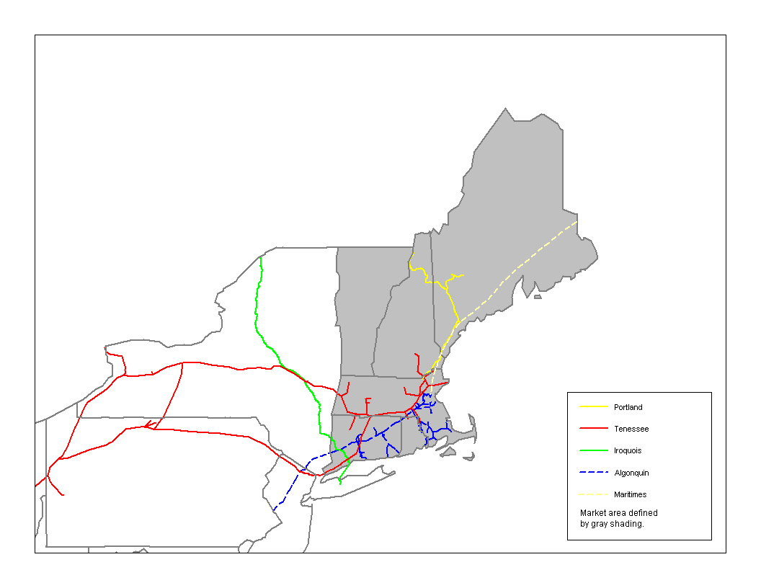
Tennessee Gas Pipeline (Tennessee), Algonquin Gas Transmission Company (Algonquin), Iroquois Gas Transmission System (Iroquois), Maritimes & Northeast Pipeline (Maritimes), and Portland Natural Gas Transmission System (Portland) currently transport natural gas to New England. Tennessee, wholly owned by El Paso, is fully subscribed into New England with 1,290 MDth/d of contracted capacity. Algonquin, a subsidiary of Duke Energy, is fully subscribed and has 1,124 MDth/d of capacity into New England. Iroquois has many owners. Given the voting block control of Iroquois, FERC has ruled that only TransCanada has a controlling interest in the pipeline. Accordingly, only affiliates of TransCanada are considered affiliates of Iroquois for this study. Iroquois is fully subscribed into New England and has 471 MDth/d of contracted capacity for this study. Maritimes is owned by Duke Energy (37.5 percent), WestCoast Energy (37.5 percent), Exxon-Mobil (12.5 percent), and Nova Scotia Power Holdings (12.5 percent). Affiliates of each owner are considered affiliates for this study. Maritimes is nearly fully subscribed into New England and has 459 MDth/d of contracted capacity for this study. Portland is owned by TransCanada (21.41 percent), El Paso (19.06 percent), Gaz Metropolitan (19.06 percent), Nisource (19.06 percent), MCN Energy Group (16.41 percent), and Northeast Utilities (5 percent). Affiliates of TransCanada, El Paso, Gaz Metropolitan, and NiSource are considered affiliates for this study. Portland is fully subscribed into New England and has 212 MDth/d of contracted capacity.
Table 4 shows the market concentration based upon primary holdings of capacity. As the table indicates, Keyspan Energy is the only shipper with more than a 10 percent share of capacity and the market concentration is only 917. This market concentration is below 1,000; therefore, the market is considered unconcentrated with no market power concerns. Even combining the shares of pipeline corporate affiliates, corporate affiliates have 22 percent of capacity and no affiliate has more than 10 percent of capacity. Capacity controlled by marketing affiliates on affiliated pipelines accounts for only about 8 percent of capacity to the market.
Table 4 — Concentration of Primary Shipper Capacity in New England
As shown by comparing Tables 4 and 5, marketing affiliates of interstate pipelines are active in capacity release transactions in New England. All corporate affiliates acquired about 11 percent of capacity in capacity release transactions effective November 1, 2000. This difference is calculated by taking the total corporate affiliate share from Table 5 and subtracting the total corporate affiliate share from Table 4. Marketing affiliates on affiliated pipelines account for all of the increase. Despite this activity, the information reveals no market power concerns. The market still is not concentrated with an HHI of only 626. Moreover, no pipeline’s affiliate has more than a 14 percent share of the market. These shares and the low market concentration are well below threshold levels for competitive concerns.
Table 5 — Concentration of Shipper Capacity in New England Accounting for Released Capacity
Table 6 shows the market concentration if agents held capacity. Duke Energy has an agency agreement for 129 MDth/d and El Paso is listed as an agent for 248 MDth/d, which increases their shares to 3.6 and 11.4 percent. Market concentration is only 630, substantially below 1,000. These shares and market concentration are substantially below levels that would indicate the potential exercise of market power.
Table 6 — Concentration of Shipper Capacity in New England if Agents Held Capacity

New York City
New York City and Long Island is another area in which we measure the shares and concentration of holders of firm capacity. Figure 7 shows the New York City market and the pipelines serving New York.
Figure 7 — Pipelines Serving New York City and Long Island
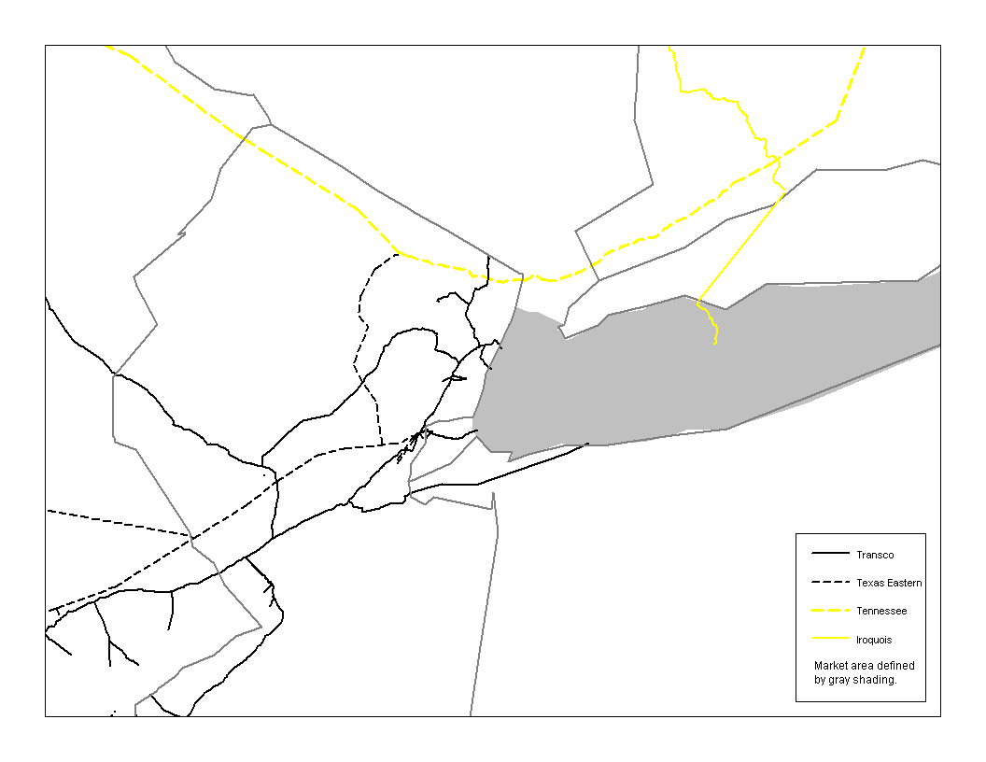
Transcontinental Gas Pipe Line (Transco), Texas Eastern Transmission (Texas Eastern), Iroquois Gas Transmission System (Iroquois), and Tennessee Gas Pipeline (Tennessee) currently transport natural gas to New York City. Transco, which is owned by The Williams Companies (Williams), is fully subscribed into New York City with 899 MDth/d of contracted capacity. Texas Eastern, wholly owned by Duke Energy, is fully subscribed into New York City with 549 MDth/d of contracted capacity. As discussed above, only affiliates of TransCanada are considered affiliates of Iroquois. Iroquois is fully subscribed into New York and has 277 MDth/d of contracted capacity. Tennessee, wholly owned by El Paso, is fully subscribed into New York City with 218 MDth/d of contracted capacity.
Table 7 shows the market concentration gas deliveries to New York City based upon primary holdings of capacity. As the table indicates, Keyspan Energy and Consolidated Edison are the only shippers with more than a 10 percent share of capacity. These are the historical local distribution companies that are regulated by the New York State Public Service Commission. The level of market concentration is unrelated to pipeline affiliates. Duke Energy and El Paso Corporations the only pipeline owners with a share, and their combined share is only 2.5 percent. This share clearly would not give it market power. Duke Energy Trade & Marketing capacity held on Texas Eastern accounts for only 1.3 percent of market capacity.
Table 7 — Concentration of Primary Shipper Capacity in New York City
A comparison of Tables 7 and 8 shows that pipeline corporate affiliates have acquired only 2.2 percent of pipeline capacity into New York City through capacity release. This difference is calculated by taking the total corporate affiliate share from Table 8 and subtracting the total corporate affiliate share from Table 7. In total, affiliates have less than 5 percent of capacity. Therefore, pipeline affiliates to not have market power into the New York City market.
Table 8 — Concentration of Shipper Capacity in New York Accounting for Released Capacity
Table 9 shows market concentration of pipeline capacity to New York City if agents held capacity. Order. No. 637 required that the pipeline’s Index of Customers be expanded to indicate whether a marketing affiliate is an agent for capacity. The regulations do not define the phrase agent. The text of Order No. 637 suggests that an agent is a party with control of capacity. Therefore, competitive inference cannot be drawn from the agency designation on the Index of Customers. Inclusion of agency arrangements without an understanding of the role of such agents can significantly overstate market concentration. Where the agent performs an administrative role as set forth in the pipeline tariff, the agent designation has no competitive significance. Market shares and HHI calculations using agent designations provide a “worse case” scenario concerning agents.
Table 9 shows that Coral, a subsidiary of Shell, has an agency relationship with Keyspan Energy. The effect is to lower concentration somewhat compared to just looking at the primary shippers. No interstate pipeline affiliates have agency agreements for capacity into New York City.
Table 9 — Concentration of Shipper Capacity in New York City if Agents Held Capacity

Northern Illinois
Northern Illinois is another market that we have examined. The geographic market consists of those pipelines delivering gas to the Nicor Energy (Nicor), Peoples Gas Light & Coke Co., and North Shore Gas Company distribution systems or to the Joliet hub. Peoples Gas Light & Coke Co. and North Shore Gas Company have a common owner and are operated jointly. Many pipelines connect to the distribution systems and are good alternatives for gas supplies at the margin. In addition, many pipelines are interconnected through connections to storage or hubbing facilities at the Joliet hub within the area. Accordingly, these pipeline systems provide good alternatives for those wishing to take gas supplies from the hub. Figure 8 shows the Northern Illinois market.
Figure 8 — Northern Illinois Market
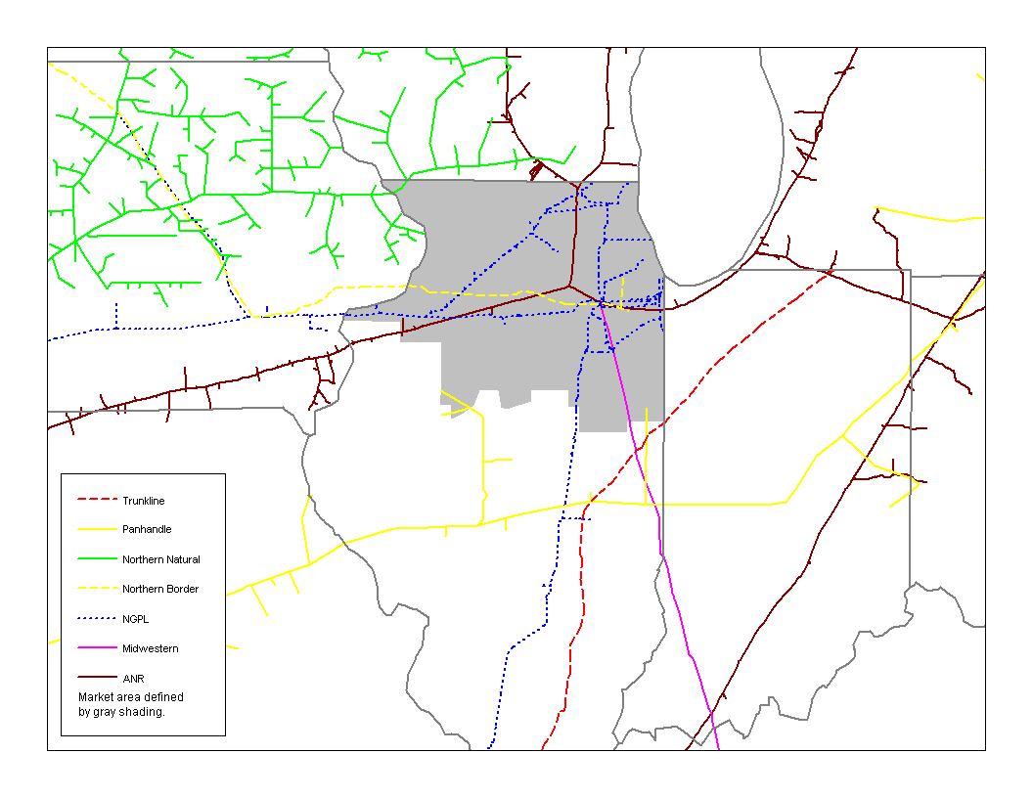
Natural Gas Pipeline Company of America (NGPL), ANR Pipeline (ANR), Northern Border Pipeline (Northern Border), Midwestern Gas Transmission (Midwestern), Northern Natural Gas (Northern Natural), CMS Trunkline Gas (Trunkline), and CMS Panhandle Eastern Pipe Line (Panhandle) currently transport natural gas to Northern Illinois. NGPL, owned by Kinder-Morgan, has 2,938 MDth/d of contracted capacity for this study. ANR, owned by El Paso Corporation, has about 1,268 MDth/d of contracted capacity into or through Northern Illinois. Northern Border is a general partnership owned by subsidiaries of Northern Border Partners, L.P. and TransCanada PipeLines Limited. Northern Plains Natural Gas Company, an Enron subsidiary, operates Northern Border. Affiliates of TransCanada, Northern Border Partners, and Enron are considered affiliates for this study. Northern Border is fully subscribed into Northern Illinois and has 623 MDth/d of contracted capacity. Midwestern is owned by El Paso and has 458 MDth/d of contracted capacity to Northern Illinois. Midwestern is considered part of El Paso in this report because its new purchaser, Northern Border, was not announced when concentration was calculated. Northern Natural is owned by Enron. Northern Natural is fully subscribed into the Nicor system during the heating season with 206 MDth/d of contracted capacity. Trunkline and Panhandle are both owned by CMS Energy. Trunkline is connected to the People’s Gas Light & Coke system with 142 MDth/d of contracted capacity, and Panhandle is connected to the Nicor system with 33 MDth/d of contracted capacity.
Table 10 shows the market concentration based upon primary holdings of capacity. As the table indicates, Nicor and Peoples Energy Corporation are the only shippers with more than a 10 percent share of capacity and the market concentration is only 1,007. This market concentration is near 1,000; therefore the market is not highly concentrated. Even combining the shares of pipeline affiliates, affiliates have 5.9 percent of capacity and no affiliate has more than 4 percent of capacity. Capacity controlled by marketing affiliates on affiliated pipelines accounts for less than 2 percent of capacity to the market.
Table 10 — Concentration of Primary Shipper Capacity in Northern Illinois
A comparison of Tables 10 and 11 shows that pipeline corporate affiliates have acquired 6.3 percent of pipeline capacity into Northern Illinois through capacity release. This difference is calculated by taking the total corporate affiliate share from Table 11 and subtracting the total corporate affiliate share from Table 10. In total, affiliates have 12.2 percent of capacity when accounting for capacity release. Therefore, pipeline affiliates do not have market power into the Northern Illinois market.
Table 11 — Concentration of Shipper Capacity in Northern Illinois Accounting for Released Capacity
Table 12 shows the market concentration if agents held capacity. As discussed above, inclusion of agency arrangements without an understanding of the role of such agents can significantly overstate market concentration. Where the agent performs an administrative role as set forth in the pipeline tariff, the agent designation has no competitive significance. Market shares and HHI calculations using agent designations provide a “worse case” scenario concerning agents.
El Paso and Enron both serve as agents for capacity to Northern Illinois. But even accounting for these agreements, the combined affiliate share is only 6.6 percent and the market concentration is below 1000. These shares and market concentration are substantially below levels of market power concern. Moreover, the agency agreements are on non-affiliated pipelines.
Table 12 — Concentration of Shipper Capacity in Northern Illinois if Agents Held Capacity

Florida
The relevant geographic market is deliveries of natural gas to Florida. By Florida, we mean for current purposes, the Florida Reliability Coordinating Council (FRCC) section of the state of Florida. One reason for using this geographic area is that electric power generation is the major demand for natural gas in Florida. The FRCC usually operates as one electric power market and competition among generation companies “over the wires” also means that that natural gas delivered at one location within Florida often must compete with natural gas delivered at another location. This market excludes the far-western panhandle section of the State of Florida, which is supplied by other pipelines (such as Gulf South) that do not provide a good alternative for most of the state. Figure 9 shows the pipelines supplying gas to Florida and the geographic boundary of the market.
Figure 9 — Florida Market
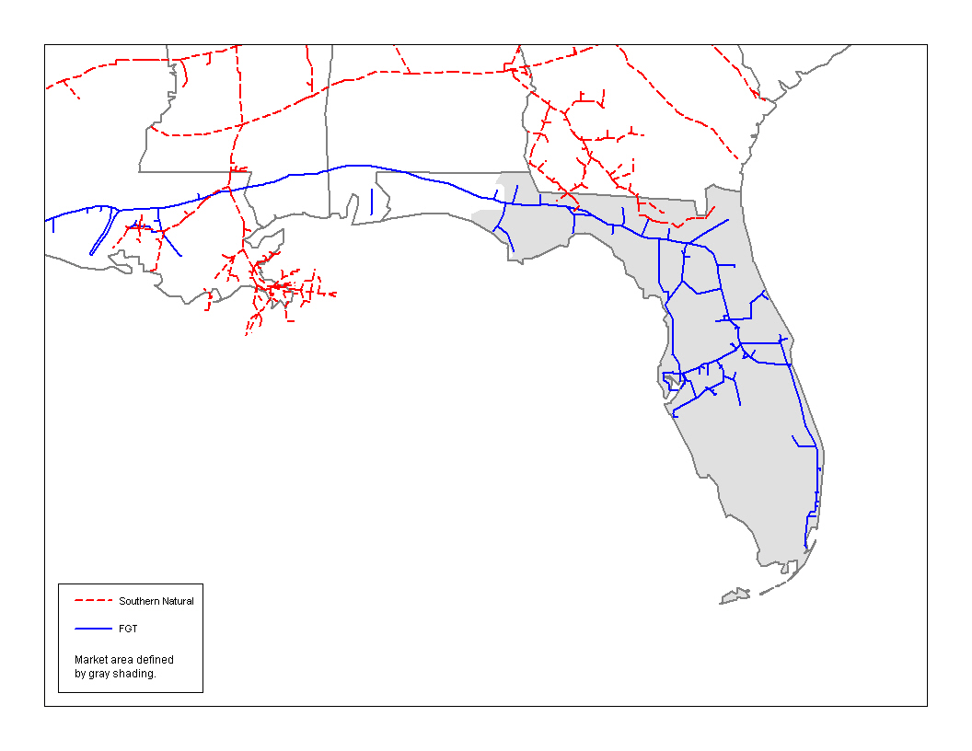
Florida Gas Transmission (FGT) and Southern Natural Gas (Southern Natural) currently transport natural gas to the FRCC part of Florida (Florida). FGT is fully subscribed and has about 1,345 MDth/d of capacity to Florida. FGT is owned by Citrus Corporation, which in turn is owned 50 percent by Enron and 50 percent by El Paso. Enron has 31 MDth/d shipping on FGT. El Paso has 36 MDth/d shipping on FGT. Southern Natural is also fully subscribed into Florida and has 49 MDth/d of capacity. El Paso owns Southern Natural.
Table 13 shows the market concentration based upon primary holdings of capacity. As the table indicates, Florida Power & Light and TECO Energy are the only shippers with more than a 10 percent share of capacity and the market concentration is 1,754. This market concentration is below 1,800, indicating no substantial market power concern. Even combining the shares of corporate affiliates, Enron and El Paso Corporation affiliates have less than 5 percent of capacity. And most of the capacity of affiliates is in the hands of marketing affiliates. The only affiliated capacity other than marketing affiliates is for electric power production facilities jointly owned by El Paso and other partners.
Table 13 — Concentration of Primary Shipper Capacity in Florida
Comparing Tables 13 and 14 reveals that released capacity does not substantially change the positions of affiliates in Florida. Although corporate affiliate shares increase slightly when accounting for capacity acquired through capacity release, the total share of all corporate affiliates is only 6.2 percent and no single affiliate has a share above 4 percent. Market concentration of capacity holders remains below 1,800. Accordingly, accounting for capacity releases does not change the conclusion that market power by natural gas pipeline affiliates is not a concern within Florida.
Table 14 — Concentration of Shipper Capacity in Florida Accounting for Released Capacity
Table 15 shows market concentration percentages including capacity for which an affiliated agent is involved; however, these figures probably do not accurately depict control of capacity. There are many types of agency arrangements, including administrative agents that play a role in submitting electronic or EDI nominations. Therefore, competitive inference cannot be drawn from the agency designation on the Index of Customers. FGT agents illustrate this point. Section 10 E of the General Terms and Conditions of FGT's tariff specify that a shipper may name designees to nominate, confirm or perform other administrative duties. Marketing affiliates of FGT, Enron North America and Citrus Trading Corporation, are listed as designees for nominations for Florida Power & Light and accordingly are listed as agents on such capacity in the Index of Customers. If such quantities are included in the market concentration calculation, affiliates appear to have a significant share of capacity.
Inclusion of agency arrangements without an understanding of the role of such agents can significantly overstate market concentration. Where the agent performs an administrative role as set forth in the pipeline tariff, the agent designation has no competitive significance. Market shares and HHI calculations using agent designations provide a “worse case” scenario concerning agents. Further investigation would often reveal the agents do not hold or control shipper capacity.
As Table 15 indicates, Enron and El Paso would have substantial shares within Florida if their agent agreements were tantamount to holding capacity. This is because they perform their administrative agent functions on behalf of the largest primary shipper, Florida Power & Light. However, market concentration actually falls in this view of the situation. The reason is that the Florida Power & Light's share is split between Enron and El Paso because of the joint ownership in Citrus Trading.
Table 15 — Concentration of Shipper Capacity in Florida if Agents Held Capacity

California
Delivery of gas to California is a market that has received much recent media attention. The California market, which we have examined, runs from compressor station 14 on PG&E Gas Transmission—Northwest to the California/Nevada and California/Arizona Borders on the east. The Commission has accepted California as a relevant market in prior orders. Figure 10 shows the California market.
Figure 10 — California Market
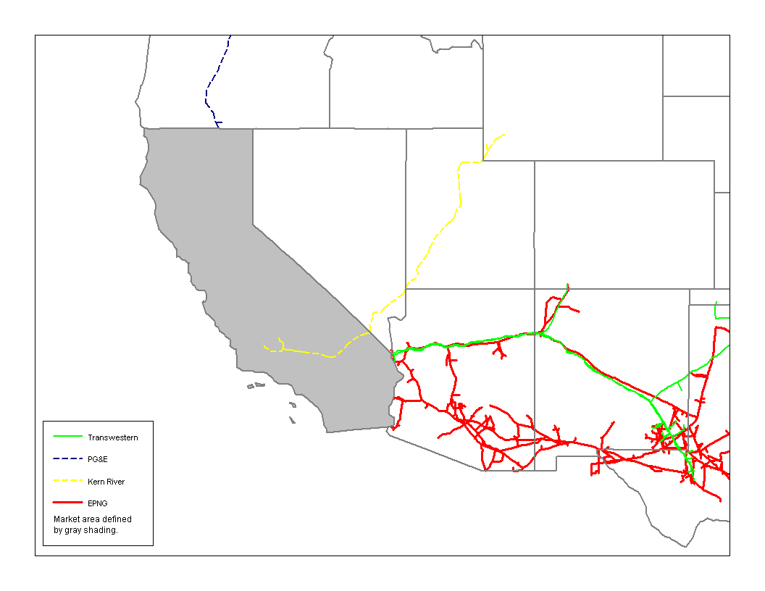
El Paso Natural Gas (EPNG), PG&E Gas Transmission—Northwest (PG&E Transmission), Transwestern Pipeline (Transwestern), and Kern River Gas Transmission (Kern River) serve California. EPNG, owned by El Paso, has about 3,242 MDth/d of contracted capacity into California. PG&E Transmission, owned by PG&E Corporation, has 1,977 MDth/d of contracted capacity into California. For PG&E Transmission we include all shippers with capacity through compressor station 14, the southern most compressor station on the system. This includes shippers with delivery points on the Medford lateral and the Paiute Pipeline. The reason is that these shippers can use secondary nominations to deliver to California because their capacity takes them through the station 14 constraint point on the system. Transwestern is owned by Enron, and it has 1,090 MDth/d of contracted capacity into Arizona and California. Kern River, owned by Williams, has 669 MDth/d of contracted capacity into California. In addition, California has about 1,000 MDth/d of local production. This local production is conservatively excluded from the market shares and concentration calculated here.
Table 16 shows the market concentration based upon primary holdings of capacity. As the table indicates, only Sempra, El Paso, and PG&E have market shares above 10 percent. The largest share is Sempra’s 24.4 percent, and the market concentration is 1,200. Therefore, no single company has a share indicating market power, and the California gas delivery market is not highly concentrated. This indicates that market power by firm shippers is unlikely to be a concern in California. Pipeline affiliates have larger shares in California than in other locations. The two main factors are El Paso’s marketing affiliate having 1,249 MDth/d of capacity on EPNG and PG&E’s distribution affiliate having 609 MDth/d of capacity on PG&E Transmission. Marketing affiliates on affiliated pipelines are a bit less than total affiliate shares because El Paso Merchant Energy and PG&E both have contracted capacity on Enron’s Transwestern pipeline.
Table 16 — Concentration of Primary Shipper Capacity in California
A comparison of Tables 16 and 17 shows that pipeline affiliates have acquired 2.6 percent of pipeline capacity into California through capacity release. This difference is calculated by taking the total corporate affiliate share from Table 16 and subtracting the total corporate affiliate share from Table 17. the total HHI is actually lower in Table 17 than in Table 16, indicating that capacity release on net has lowered concentration in the market. As in Table 16, El Paso has the most affiliated-held capacity in California. Yet, its share is 21.7 percent, well below the 35 percent threshold level of concern for unilateral market power. Market concentration as measured by the HHI is only 1,011, which is well below the level of concern for collusion or interdependent action. Therefore, pipeline affiliates to not have market power into the California market.
Table 17 — Concentration of Shipper Capacity in California Accounting for Released Capacity
Table 18 shows the market concentration if agents held capacity. Taking account of agents does not materially change the results. Neither of the top three shippers have agents or act as agents for other shippers; therefore, concentration changes very little. Enron acts as an agent for 30 MDth/d of capacity. Otherwise, affiliate shares remain unchanged.
Table 18 — Concentration of Shipper Capacity in California if Agents Held Capacity

Production Areas
We studied market concentration of interstate pipeline capacity from three producing regions: the Anadarko Basin, the San Juan Basin, and the Gulf Coast. None of these areas are highly concentrated, and affiliates of the interstate pipelines do not have substantial shares.
The relevant product market is different for production markets as compared to delivery markets. Whereas the relevant product market is delivery of gas to a delivery market, the relevant product is taking gas from a production market. The perspective of good alternatives is also different. In delivery markets, a good alternative is considered from the prospective of a buyer of gas in wholesale or retail markets. In producing area, good alternatives are taken from the perspective a producer or seller of gas. That is, purchasers that are able to move gas from producing areas to consumption, or market, areas at comparable net-back prices to the producers are good alternatives.
Our study is limited to interstate pipelines. Excluding intrastate pipelines means that the market concentration figures presented here actually overstate the current competitive situations of interstate pipeline affiliates in these areas. Therefore, for the purposes of this study, excluding buyers on intrastate pipelines taking gas to local markets is a conservative assumption.

Anadarko Basin
For the Anadarko Basin we examine shares of pipeline capacity moving north and east from the basin. This is a conservative approach because at times gas flows south from the basin toward California or toward Houston, and the shares of the marketing affiliates included will be higher. Figure 11 shows the Anadarko Basin market.
Figure 11 — Anadarko Basin Market
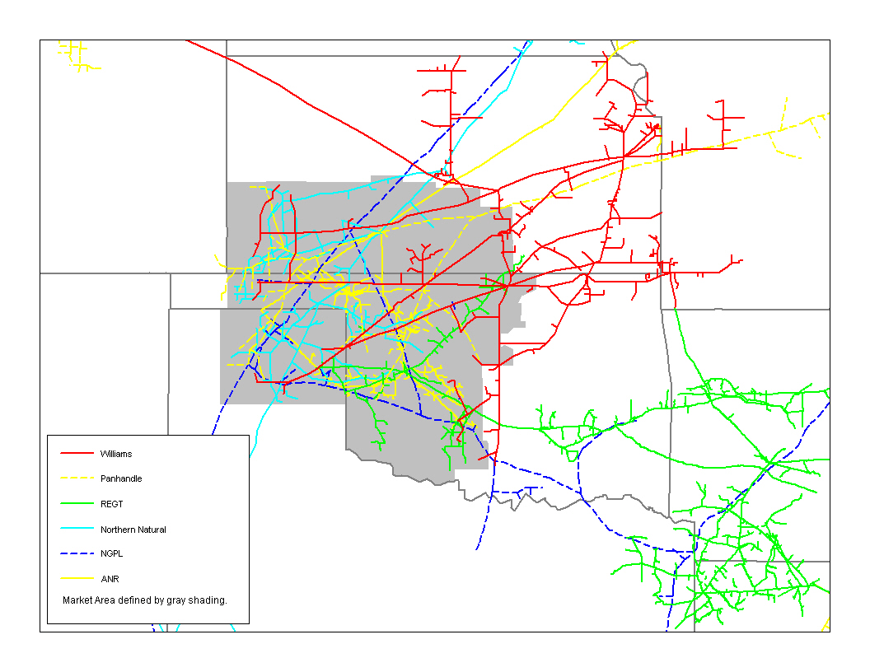
CMS Panhandle Eastern Pipe Line (Panhandle), ANR Pipeline (ANR), Natural Gas Pipeline Company of America (NGPL), Reliant Energy Gas Transmission (Reliant), Williams Pipeline Central (Williams), and Northern Natural Gas (Northern Natural) currently transport natural gas from the Anadarko Basin. Panhandle is owned by CMS Energy and has 1,501 MDth/d of contracted capacity. ANR, owned by El Paso, has about 871 MDth/d of contracted capacity from the basin. NGPL, owned by Kinder-Morgan, has 711 MDth/d of contracted capacity. Reliant is owned by Reliant Energy and has 653 MDth/d of contracted capacity from the Anadarko Basin. Williams is owned by The Williams Companies, Inc. and has 511 MDth/d of contracted capacity from the Anadarko Market. Northern Natural, owned by Enron, has 253 MDth/d of unsubscribed capacity going into its Bushton station and has 247 MDth/d of contracted capacity.
Table 19 shows the market concentration based upon primary holdings of capacity. As the table indicates, no firm has a market share of more than 10 percent, and the market concentration is only 336, which is unconcentrated. This indicates that firm shippers are unlikely to exercise market power in transporting gas from the Anadarko Basin. Affiliates have small shares. No pipeline owner has corporate affiliates with more than 6 percent of exiting capacity and the combined shares of all corporate affiliates is only 13.8 percent.
Table 19 — Concentration of Primary Shipper Capacity from the Anadarko Basin
A comparison of Tables 19 and 20 shows that pipeline affiliates have acquired 1.2 percent of pipeline capacity from the Anadarko Basin through capacity release. This difference is calculated by taking the total affiliate share from Table 20 and subtracting the total affiliate share from Table 19. In total, corporate affiliates (marketing affiliates and other affiliates) combined have 15 percent of capacity when accounting for capacity release. Therefore, pipeline marketing affiliates and other affiliates do not have market power from the Anadarko Basin.
Table 20 — Concentration of Shipper Capacity from the Anadarko Basin Accounting for Released Capacity
Table 21 shows the market concentration if agents held capacity. Taking account of agents does not materially change the results. Market concentration increases slightly to 359, but this is not material from a competitive standpoint. Although some marketing affiliates act as agents, the combined shares of all marketing affiliates and other affiliates of pipelines is only 18.7 percent, and no pipeline company in the market has a combined marketing affiliate and other affiliate share over 8 percent. Marketers acting as an agent on an affiliated pipeline account for only 6.6 percent of the market size.
Table 21 — Concentration of Shipper Capacity from the Anadarko Basin if Agents Held Capacity

San Juan Basin
For the San Juan Basin we examine shares of pipeline capacity moving from the basin in all directions. El Paso Natural Gas (EPNG), Northwest Pipeline (Northwest), and Transwestern Pipeline (Transwestern) take gas from the San Juan Basin. We exclude the TransColorado pipeline that is designed to take gas into the basin from producing areas to the north rather than to take gas from the basin. As in the Anadarko Basin, we conservatively exclude intrastate capacity to take gas from the basin as being a good alternative. Figure 12 shows the San Juan market.
Figure 12 — San Juan Market
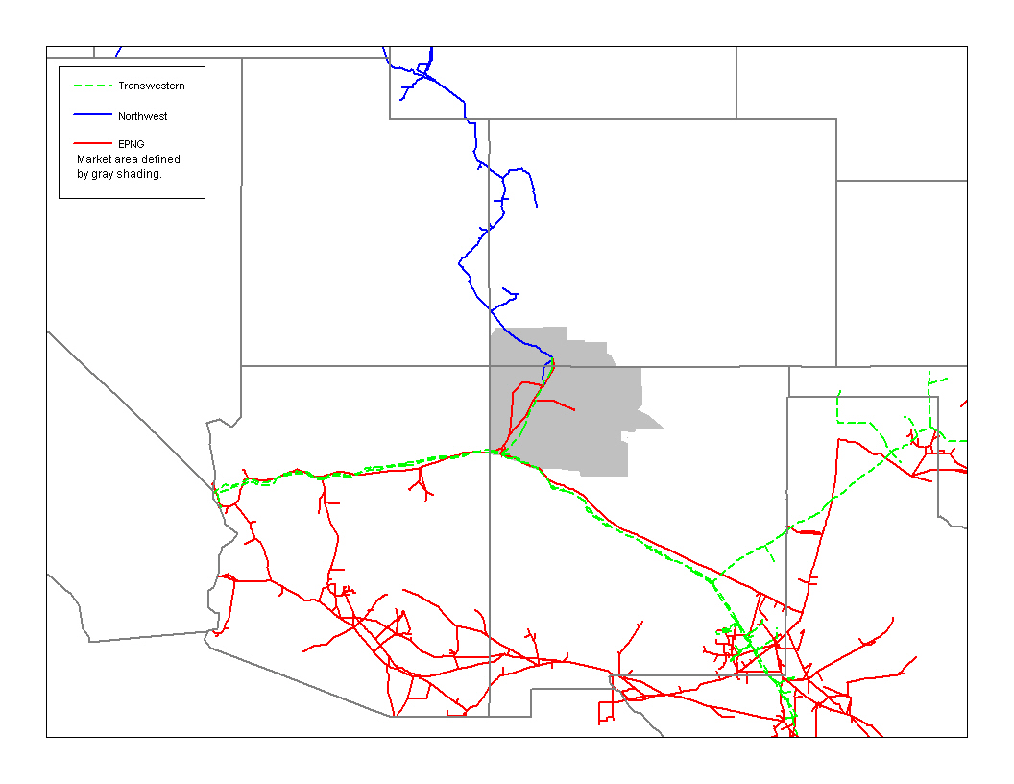
Full requirement shippers account for about 1,000 MDth/d of capacity leaving the basin, and capacities for these shippers were based upon November 2000 billing quantities. The remaining 1,900 MDth/d of capacity leaving the basin was allocated prorata based upon firm contract demand. Transwestern has 849 MDth/d of contracted capacity through its Gallup compressor station for gas leaving the station. Northwest Pipeline, owned by Williams, has 460 MDth/d of contracted capacity from the basin.
Table 22 shows the market concentration based upon primary holdings of capacity. As the table indicates, only Sempra, Southwest Gas, and El Paso have a market share above 10 percent. Sempra has the largest share, 20 percent, and the market concentration is only 902, which is unconcentrated. This indicates that firm shippers are unlikely to exercise market power in the purchase of gas from the San Juan Basin. El Paso Merchant Energy is the largest affiliated shipper with an 11.5 percent share and all pipeline marketing affiliates and other affiliates combined account for only 14 percent of capacity. Marketing affiliates on affiliated pipelines account for about 10 of this 14 percent share of interstate pipeline capacity.
Table 22 — Concentration of Primary Shipper Capacity from the San Juan Basin
A comparison of Tables 22 and 23 shows that pipeline affiliates have acquired 5.7 percent of pipeline capacity from the San Juan Basin through capacity release. This difference is calculated by taking the total affiliate share from Table 23 and subtracting the total affiliate share from Table 22. In total, marketing affiliates and other affiliates combined have less than 20 percent of capacity when accounting for capacity release. Therefore, pipeline marketing affiliates and other affiliates do not have market power from the San Juan Basin.
Table 23 — Concentration of Shipper Capacity from the San Juan Basin Accounting for Released Capacity

Table 24 shows the market concentration if agents held capacity. Taking account of agents does not materially change the results. Market concentration increases slightly to 930, but this is not material from a competitive standpoint. Although some affiliates act as agents, the combined shares of all marketing and other affiliates is only 15 percent. Enron acting as an agent for 32 MDth/d of capacity on Transwestern is the only marketing affiliate acting as an agent on an affiliated pipeline.
Table 24 — Concentration of Shipper Capacity from the San Juan Basin if Agents Held Capacity

Gulf Coast
For the Gulf Coast we examine shares of interstate pipeline capacity moving north and east from the region. The market line begins in the Florida panhandle, extends up the Mississippi/Alabama border, extends westward across Mississippi to the Louisiana/Arkansas border to the Texas/Arkansas Border. We included interstate pipelines crossing this boundary plus the Gulf South (formerly Koch Gateway) pipeline which supplies gas to other pipelines, to local distribution companies and end users within the region. In other words, purchases and transportation of gas to buyers within the geographic area is considered, from a seller's perspective, to be a good alternative to purchases and transportation to destinations outside of the area. Figure 13 shows the Gulf Coast area.
Figure 13 — Gulf Coast Market
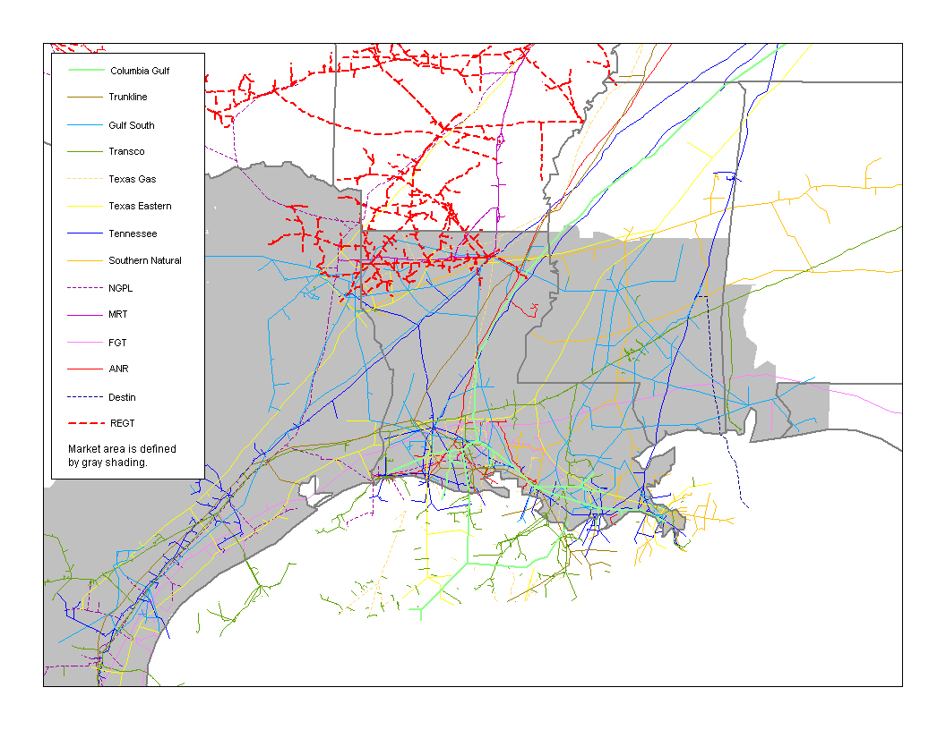
The study includes fourteen pipelines: ANR Pipeline (ANR), CMS Trunkline Gas (Trunkline), Columbia Gulf Transmission (Columbia Gulf), Destin, Florida Gas Transmission (FGT), Gulf South Pipeline (Gulf South), Mississippi River Transmission (MRT), Natural Gas Pipeline Company of America (NGPL), Reliant Energy Gas Transmission (REGT), Southern Natural Gas (Southern Natural), Tennessee Gas Pipeline (Tennessee), Texas Eastern Transmission (Texas Eastern), Texas Gas Transmission (Texas Gas), and Transcontinental Gas Pipe Line (Transco). These pipelines have ten separate owners: CMS Energy, Duke Energy, El Paso, Enron, Kinder-Morgan, EKLP, Nisource, Reliant Energy, Shell, and The Williams Companies.
Transco is owned by The Williams Companies, Inc. and has 3,972 MDth/d of contracted capacity. Tennessee is owned by El Paso and has 3,349 MDth/d of contracted capacity. El Paso also owns Southern Natural, which has 2,361 MDth/d of contracted capacity exiting the Gulf Coast. Texas Eastern is owned by Duke Energy and has 2,082 MDth/d of contracted capacity. Columbia Gulf, owned by Nisource, is fully subscribed out of the Gulf region and has 2,046 MDth/d of contracted capacity. Gulf South is owned by EKLP and has 1,963 MDth/d of contracted capacity with specific delivery points. Trunkline is owned by CMS Energy and has 1,645 MDth/d of contracted capacity from the Gulf region. NGPL, owned by Kinder-Morgan, has 1,469 MDth/d of contracted capacity. Texas Gas is owned by The Williams Companies, Inc. and has 1,376 MDth/d of contracted capacity. ANR, owned by El Paso, has about 1,280 MDth/d of contracted capacity from the basin. FGT is owned by Citrus Corporation, which is a 50-50 partnership of El Paso and Enron. It has 1,170 MDth/d of contracted capacity in the study. Destin is owned by Shell and has 395 of contracted capacity to end-users in the Gulf Coast region. MRT and REGT are owned by Reliant Energy and have 325 and 318 MDth/d of contracted capacity.
Table 25 shows the concentration based upon primary holdings of capacity. As the table indicates, no shippers have a share above 10 percent and concentration is only 176, which is unconcentrated. This indicates that firm shippers are unlikely to exercise market power in transporting gas from the Gulf Coast. Affiliates have small shares. No pipeline owner has corporate affiliates with more than 6 percent of primary capacity and the combined share of all corporate affiliates is only 18.5 percent.
Table 25 — Concentration of Primary Shipper Capacity from the Gulf Coast
A comparison of Tables 25 and 26 shows that pipeline affiliates have acquired 3.2 percent of pipeline capacity from the Gulf Coast through capacity release. This difference is calculated by taking the total corporate affiliate share from Table 26 and subtracting the total corporate affiliate share from Table 25. In total, all corporate affiliates hold less than 22 percent of capacity when capacity release transactions are included. This share is divided among ten companies, and no single affiliate has a share greater than five percent. Therefore, pipeline affiliates do not have market power from the Gulf Coast.
Table 26 — Concentration of Shipper Capacity from the Gulf Coast Accounting for Released Capacity
Table 27 shows the market concentration if agents held capacity. Taking account of agents does not materially change the results. HHI increases slightly to 198, but this is not material from a competitive standpoint. Although some affiliates act as agents, the combined shares of all affiliates is 26.3 percent, and no affiliate has a share over 6 percent. Corporate affiliates acting as agents represent only 7.8 percent of the total capacity, and virtually all of these agency agreements are by marketing affiliates. So, no corporate affiliates would have market power in the Gulf Coast if agents actually controlled capacity.
Table 27 — Concentration of Shipper Capacity from the Gulf Coast if Agents Held Capacity

Conclusion: There is No Reason to Expand the Marketing Affiliate Rules
The market evidence examined here supports the position that the overall market is growing larger and becoming more competitive. The fact that market shares of affiliated gas marketing companies have not increased appreciably over time at the expense of nonaffiliates indicates that marketing affiliates do not have an undue advantage in gas commodity markets. The fact that shares of pipeline capacity contracted to pipeline corporate affiliates have not increased indicates that there has been no general trend to greater amounts of capacity being held by corporate affiliates. In the relevant geographic areas examined here, firm shipper shares and concentration levels are sufficiently low so that market power concerns do not form a basis for expanding or strengthening the current marketing affiliate rules.
Commission staff asked for comments about expanding the marketing affiliate rules to cover other corporate affiliates of the pipelines such as local distribution companies or electric generation affiliates. Such an expansion is not warranted. The shares of local distribution companies on affiliated pipelines have not grown substantially in recent years. In addition, affiliated local distribution companies are regulated by state public service commissions and are given incentives by these bodies to ensure that capacity is being made readily available to the marketplace. Accordingly, any potential concerns about affiliated local distribution companies are likely to decline over time. Electric generation affiliates hold very small amounts of interstate pipeline capacity, and their shares have not increased dramatically. Therefore, electric generation affiliates do not present substantial market power concerns at this time.
Our examination did not reveal any cases where pipeline affiliates have market power based upon their current activities. Accordingly, we failed to find evidence that pipeline companies could exercise market power through pipeline affiliates.

When the term “affiliate” is used, it means all corporate affiliates engaged in everyday business. “Other affiliates” means those affiliates that are not currently identified as Part 161 marketing affiliates.
Natural Gas Intelligence reports shares of leading gas marketers back to 1995.
From the list of the largest 30 interstate pipelines based on contracted volume in 1996 we excluded Michigan Gas Storage and Great Lakes Transmission. Michigan Gas Storage was excluded because it is largely a storage company. Great Lakes Transmission was excluded because it is largely a joint venture pipeline with its two owners, ANR Pipeline Company and TransCanada, contracting for about two thirds of the Great Lakes Transmission capacity. For each shipper on the remaining 28 interstate pipelines we determined whether the shipper was affiliated to the interstate pipeline. We classified these affiliations as whether the shipper was a Part 161 marketing affiliate, generation company, local distribution company, transmission company, production company, or other. In order to prevent double-counting, if a generation company affiliate, for example, was identified by the pipeline as a Part 161 marketing affiliate, the study only counts the generation affiliate as a "marketing affiliate".
See FERC Stats. and Regs.¶ 32,528 at 33,380 (1998).
San Diego Gas & Elect. Co., 79 FERC ¶ 61,372 at 62,561 (1997).
The Distrigas LNG terminal and storage facility also supplies gas to New England but is not included in this study.
Iroquois Gas Transmission System, L.P., 78 FERC ¶ 61,108 (1997). Keyspan Energy owns 20.4 percent of Iroquois but it does not control any one voting block of the partnership.
The Alliance Pipeline also transports natural gas to Northern Illinois, but it was not in operation on November 1, 2000.
The Coastal Corporation and El Paso were waiting for regulatory approvals for their proposed merger on November 1, 2000, and the merger has since been consummated. Therefore, Coastal and its affiliates are considered part of El Paso for this study.
Midwestern has additional northward capacity with delivery points south of the Northern Illinois market area that was not included in the study.
The actual geographic market may extend into southern Nevada and Arizona because increases in demand for gas, particularly by electric generators, may move supply constraint points from the general vicinity of the state borders to locations further away. For example, Transwestern Pipeline has 1,090 MDth/d of capacity into Arizona and California combined, so customers in Arizona compete with customers in California for supplies on the Transwestern system.
El Paso Natural Gas Company, 88 FERC 61,139 at 61,409 (1999).
This report is not examining concentration in any delivery markets that may exist in the Gulf Coast area. It also does not include the purchase and transportation of gas by intrastate pipelines. Therefore, the shares presented here likely overstate the shares of firm shippers on interstate pipelines.

