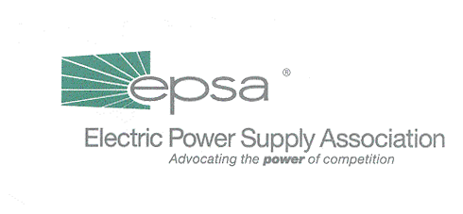
1401 New York Avenue, NW
11th Floor
Washington, DC 20005
202/628-8200
202/628-8260 fax
www.epsa.org
Memorandum
TO: | Regulatory Affairs Committee  Power Marketers Working Group
FROM: | Jim Steffes, Regulatory Affairs Committee Chair  Bob Reilley, Power Marketers Working Group Chair  Julie Simon, Vice President of Policy  Mark Bennett, Senior Manager of Policy  Erin Perrigo, Manager of Policy
DATE: | September 28, 2025
RE: | Workshop on Assuring Adequate Capacity in Competitive Markets—AGENDA

Please see the attached agenda for the Workshop on Assuring Adequate Capacity in Competitive Markets, on May 15th from 10:00 a.m. to 4 p.m. at EPSA’s offices at 1401 New York Avenue, NW, Washington, DC. If you would like to attend and not already done so, please fill out the registration below and fax it to Jackie Gallagher at 202-628-8260 or by email to jgallagher@epsa.org.

Please RSVP for the meeting by faxing the form below
to Jackie Gallagher at 202-628-8260

_____ Yes, I will attend the May 15th Regulatory Affairs Committee Meeting in Washington, D.C.

_____ No, I will not be able to attend the meeting.

Name:_________________________ Company:________________________

E-mail:_________________________ Fax:_____________________________

