How to Submit Day Ahead Schedules using eTerra Schedule Position Manager and QSE MOS

This document is intended to provide instruction to the ERCOT Real-Time Desk in the procedures necessary to submit day-ahead schedules to the ERCOT ISO. This is the procedure that should be followed on Saturday to submit Sunday’s schedule, etc. IMPORTANT: THE DEADLINE TO SUBMIT DAY AHEAD SCHEDULES IS 11:00 CPT, WITH ALL MISMATCHES CLEARED BY 11:15 CPT.

The necessary starting point (confirmed by one of the schedulers) is having all of the weekend’s CSV files imported into the eTerra Schedule Position mangaer.

- Using eTerra Schedule Position Manager (see printscreen below for hours 1-6, actual screen shows 24 hours).

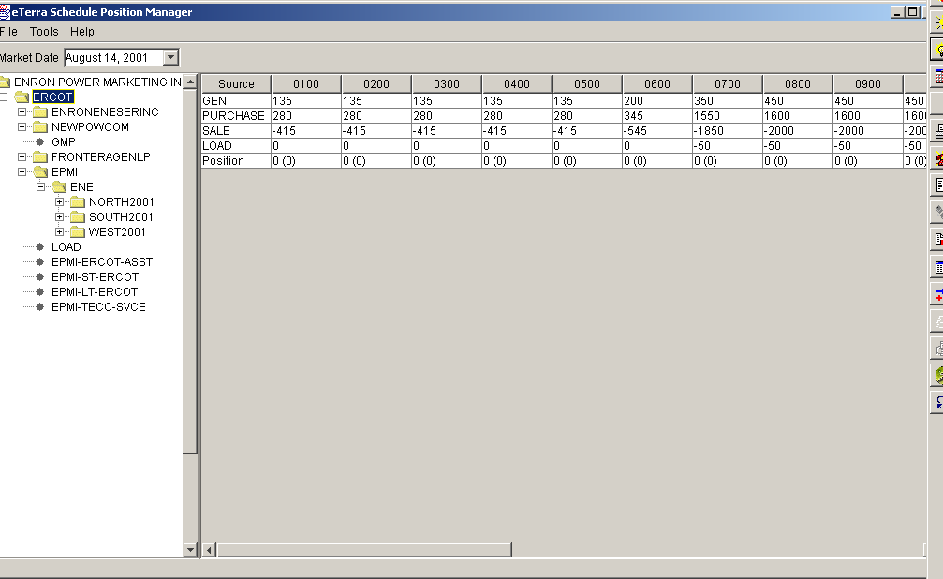
All Files Uploaded

Balanced

Ensure that the correct Market Date is selected (ie.the day ahead schedule for Sunday, Aug 19th would be selected on Saturday, August 18th). The first step is the check that all CSV files have been imported. In this case, as shown by the folder icons, we see that the files for EES, Newpower, Frontera, and EPMI have been uploaded. It is also important to ensure that this is a “balanced” schedule; that is generation + purchase = sales +load. This can be done by double clicking on the (blue highlighted) ERCOT folder in the Schedule Manager, and ensuing that the “position” for each hour reads zero (i.e. balanced).

- Using schedule manager to export to QSE MOS.

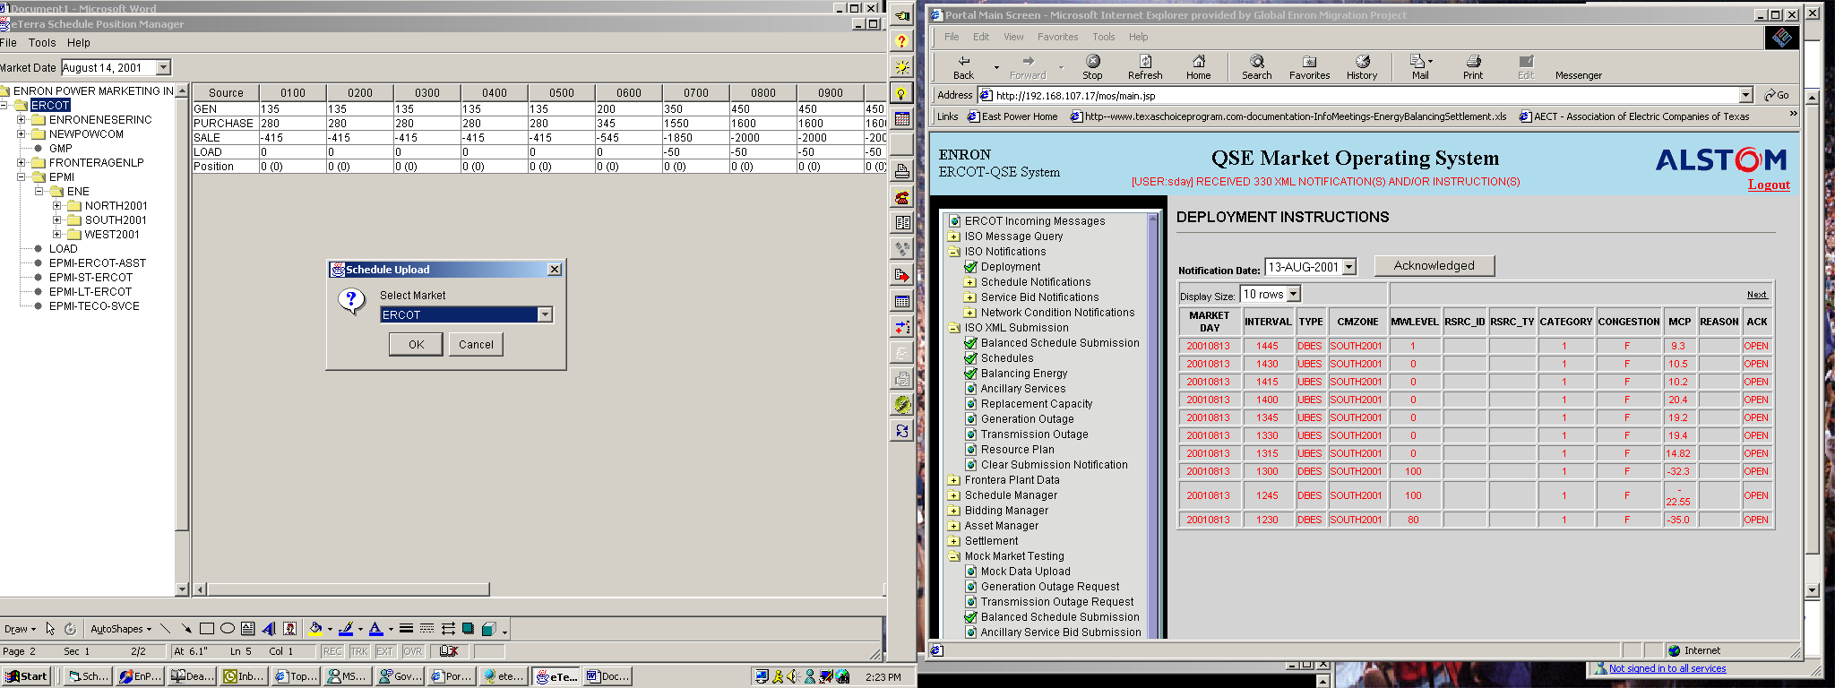
File/Export
Market Select

The next step is to take the aggregated schedule from eTerra Schedule Position Manger and export it to the Qualified Scheduling Entity Market Operating System. (QSE MOS) This is accomplished by choosing File/Export from the menu. The “Select Market” Dialogue box will pop up; click “OK” to begin exporting the files to QSE MOS.

- The exporting process will take a little while as each counter party’s total for 96 intervals is sent to QSE MOS. You will see this screen when the process is complete.

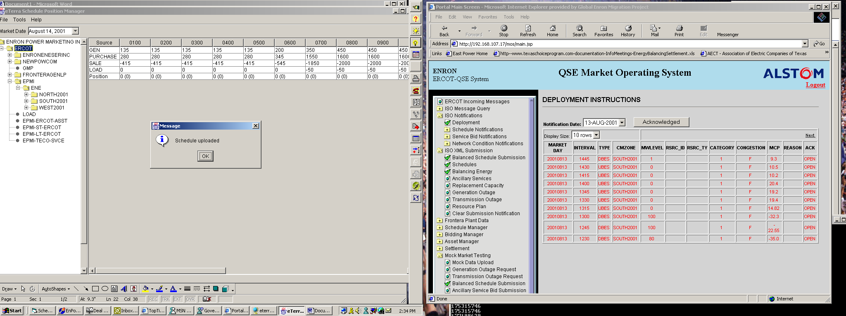

4). Open the QSE MOS. Go to ISO XML Submissions/Schedules. The screen will look like this.

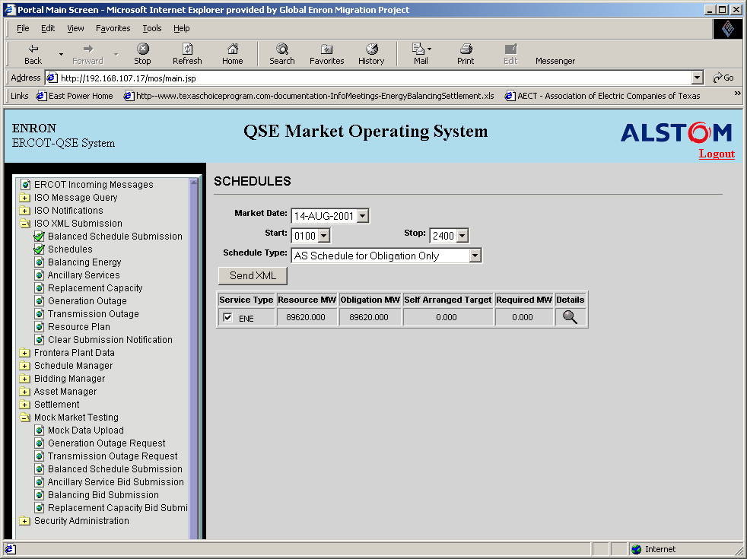
Balanced
Send to Portal
Date
Detail View

Verify that the correct market date is selected, and that this is a balanced (Resource MW=Obligation MW) schedule. If you wish to see the data for each hour, you can click on the hourglass to see more detail. Once all of these inputs have been verified, click on send XML. You will see [user: your username] **** “Sending Balanced Bilateral Schedule” in a red font shown in the line below the “QSE Market Operating System” title bar.

4a) Alternate Method. It is also possible to send the schedule to ERCOT from QSE MOS/ Mock Market Testing/ Balanced Schedule Submission. The screen will look like this:
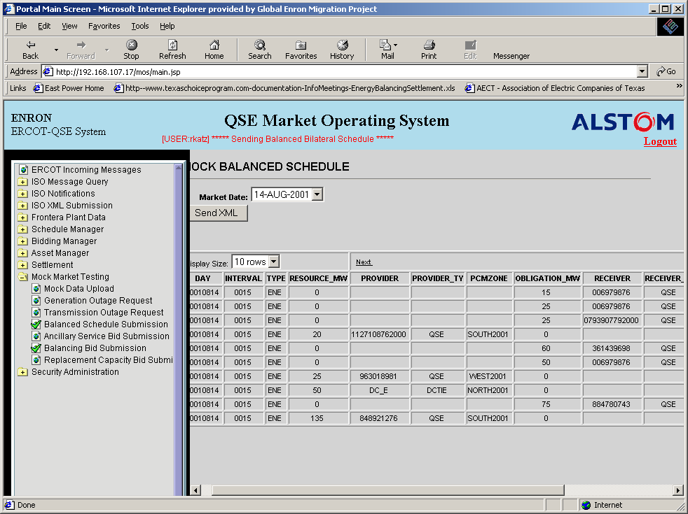
Send

The process is exactly the same: Hit “Send XML” to begin sending the schedule to ERCOT. As in this screen, you will see the message [user your username] **** Sending Balanced Bilateral Schedule.

5) Successful completion using either submission method: You will know you have successfully sent the day ahead schedule when you receive an “ACK” (acknowledgement) message. Any other “NAK” (non-acknowlegement) messages indicate a system problem that should be brought to the attention of Smith or Bill. The screen will look like this.

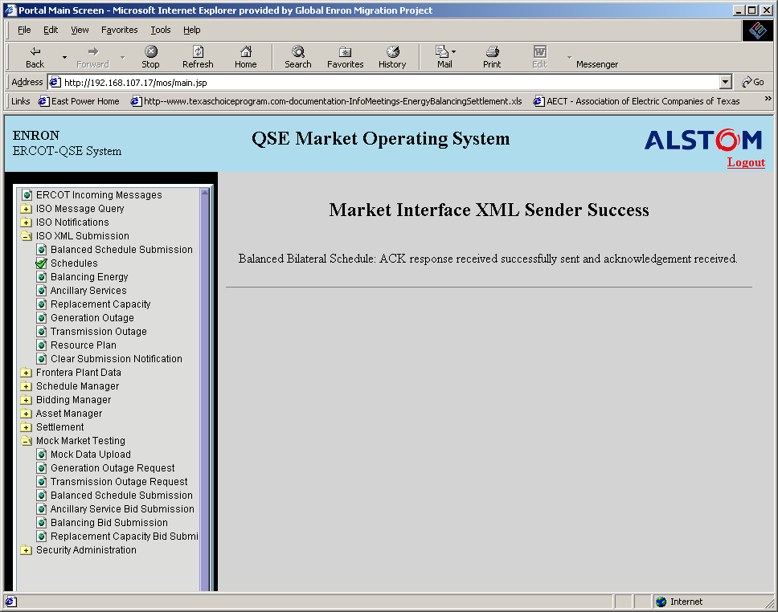

The final step is to verify that there are no “mismatches” in the schedule. Mismatches (i.e. our conter party did not enter the exact same schedule as we did) are indicated in the ERCOT portal (https://portal.ercot.com). Go to Website Components/My Tasks/ QSE Schedule and Bids/Submit/Bilateral Agreements. This is what you will see. Select the desired date and hour.

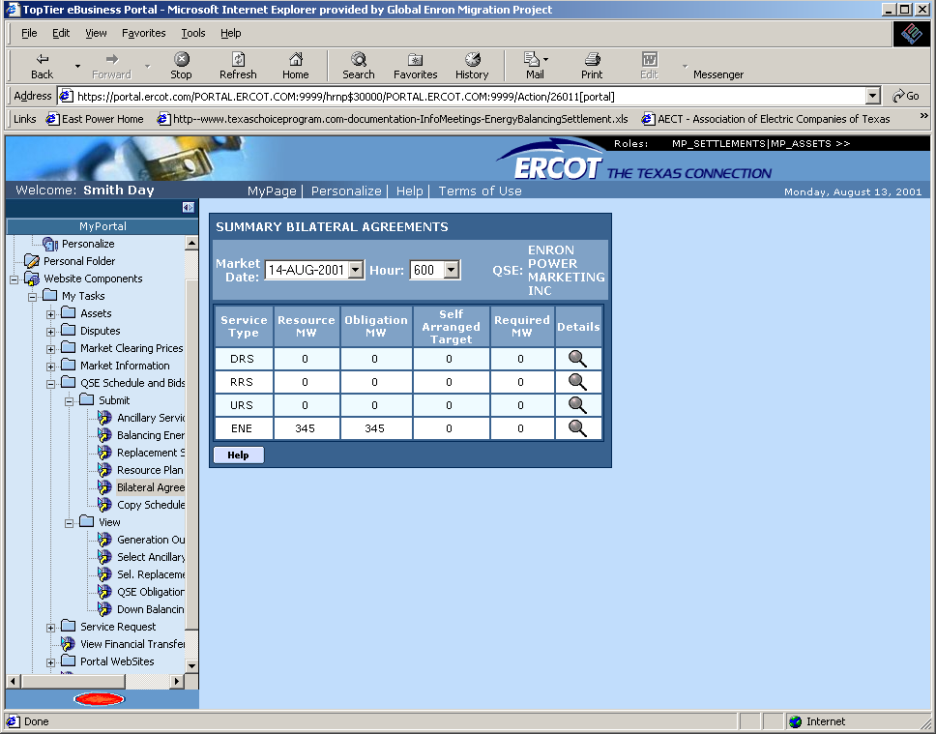

Detail View

7) Click on the hourglass to see this view:

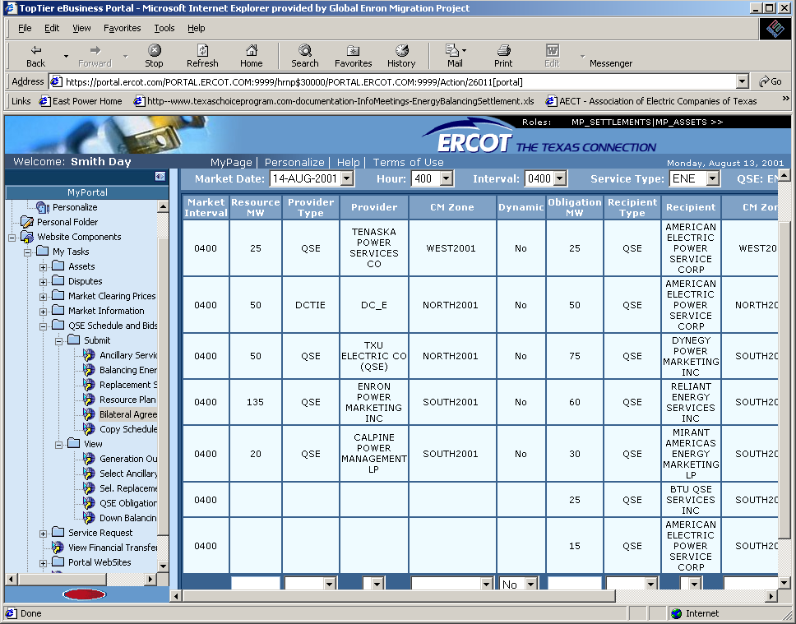

This is a balanced (resource mw = obligation mw) and non-mismatched schedule for market day 14 August, interval 0400. We can tell there are no mismatches because each counter party’s entry is in black font. Mismatches are indicated by Red Font, and must be investigated by calling the counter party to verify mw amounts and zones.

Once all mismatches have been corrected, the day ahead scheduling process is complete.

