How to Copy ERCOT Weekend Schedules.

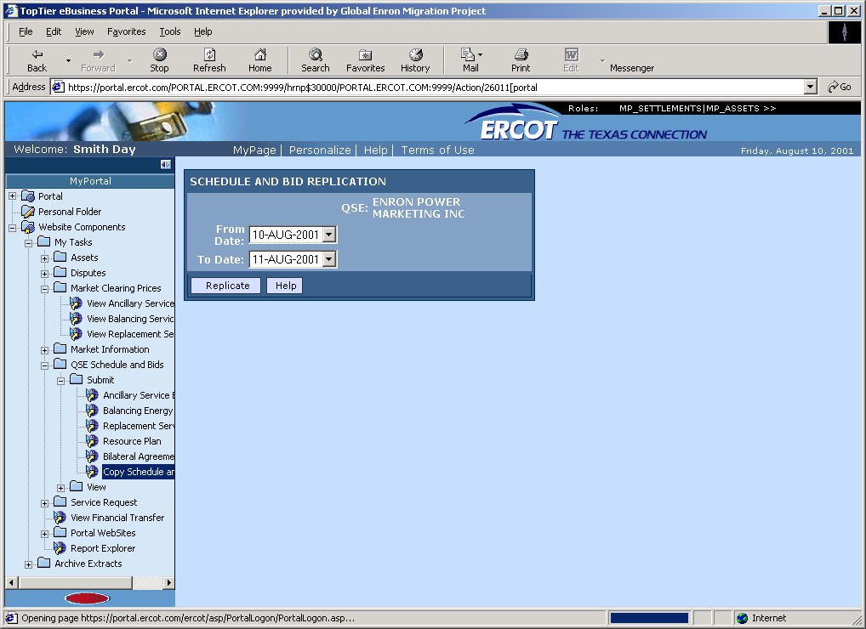

It is possible that the day ahead schedules for Saturday and Sunday will be exactly the same (as is the case for the period 8/11/2001 and 8/12/2001.) The ERCOT web portal (https://portal.ercot.com) allows for a simplified procedure to submit duplicate schedules. After entering your digital certificate, you’ll be at the main screen of the portal.

Choose the following options
-Website components
-QSE Schedule and Bids
-Submit
-Copy Schedule and Bids

The screen should look like what you see above. You should select the “From” date as the already entered schedule (this weekend it would be 8/11/2001)
The “To” date should be the date you want to enter a schedule for (this weekend it would be 8/12/2001).

After getting the dates entered correctly, hit the replicate key to send the schedule to ERCOT. Go to “Bilateral Agreements” to check for schedule matches. If any counter parties are in red font, you should call the “mismatched counter party” to determine the reason.

