Re: High prices from a hot economy, hot weather, and hot politics
From: Fred Pickel; Tabors Caramanis & Associates
Date: August 11, 2000

Two to three months of high residential electric bills in San Diego have triggered a storm of political concern over deregulation and potential electricity market aberrations in California. High western US wholesale electricity prices have been the driver for these high residential prices – but the wholesale prices reflect market fundamentals. Extraordinarily hot weather in the inland Desert Southwest and hot economic growth have created a capacity pinch – price caps imposed on the California ISO have created panic buying that has exaggerate the situation throughout the west.

High Prices
Wholesale electricity prices spiked up in California and the west early this summer, starting in the usually lower price period in May. As shown in Figure 1, two major price spikes also occurred in June, with an extended spike in late July.

Figure 1: California PX Prices
Note: These are California Power Exchange Peak and Off-Peak Index prices through August 11, 2000, with CalPX Block Forward On-Peak Price quotes and estimated Off-Peak prices after August 11.

The overall electric market supply/demand balance for the West and California were forecast to be tight under normal conditions.

- The reserve margin between planned capacity resources and peak summer demand for California and northern Nevada was 12%, without load management and interruptions, and 17.7% allowing for the interruption of major customers. Developed in late 1999/early 2000, these estimates assume a normal weather forecast and normal operating conditions. A typical industry standard is a 20% reserve margin to allow for major outages and extreme weather.
- This is much tighter than the 19% to 24% reserve margin planned for 2000 in the pre-California restructuring 1993 plan.

The forecasts for the West overall and California allow for normal weather and electricity demand growth rates of about 2% per year. BUT both weather and growth are far above normal.

Hot Economy
The electric demand forecasts made in 1999 for 2000, under even normal weather conditions, are now too low.

- The overall US economy has been growing very fast. Gross Domestic Product grew at 6% per year in constant 1996 real dollars between the 2nd quarter of 1999 and the 2nd quarter of 2000.
- While regional GDP growth estimates are not available, West region employment growth has been growing at 2.8% between June 1999 and June 2000, far above the average of 1.69% for the rest of the U.S. California’s employment growth is 2.7% over this period. This implies a West and California GDP growth of 8% per year or more.
- In the short run, rapid increases in economic activity translate into electricity usage on almost a 1:1 basis – even with conservation, the longer term impact of this 8% per year economic growth is unlikely to be less than 4% over this period.

This means electricity usage has grown at DOUBLE or QUADRUPLE the forecast under even normal weather – this demand increase alone would cut 4% to 8% off the 12% “no interruptions” reserve margin down to 4% to 8% without hot weather or plant outages.

Hot Weather
Western weather has not been normal, especially in the desert Southwest.

While the coastal weather has been near normal, the summer temperatures throughout the desert Southwest have been near record breaking over the last 3 months (See the attached Appendix).

- For the “Four Corner” states of Arizona, New Mexico, Utah, and Colorado, the temperatures for May through July were the 2nd hottest in the 106-year record. The combined California and Nevada temperatures were 4th hottest in the 106 year record.
- All the other western states except Washington were also significantly hotter than average – and Washington was average, not below average.

This means that not only is the inland California demand higher, but key traditional exporters of power to California, the Four Corner states, have had extreme demands of their own to serve. Thus, California has had high demand of its own and could not draw on any surpluses from one its key electricity partners.

Hot Politics
Political and regulatory uncertainties over California’s extended and vacillating restructuring of its electric industry have exaggerated these weather and growth problems in both the short and long term:

- California and northern Nevada have dropped over 8000 MW out of roughly 60,000 MW summer peak electricity supply plan for the year 2000 between the 1993 plan and the 2000 plan. This change reflects investor’s caution over the uncertain economics of investment in new generation and long-term capacity contracts.
- Price caps imposed on the California ISO this summer have resulted in unintended results. Buyers have been under-scheduling electricity purchases in the standard day-ahead market to avoid uncapped PX prices and transfer load to the capped ISO short-term market. This requires the ISO to do more last hour buying – sometimes on a panic basis, driving up intraday prices to very high levels.

These political uncertainties and price restraints have exaggerated the weather and economic conditions to make this summer’s price spikes higher than they would have other wise been.

Hot, Hot, Hot Conditions Make High Prices
Hot weather and a hot economy have made an already constrained electricity market even tighter in both California and throughout the West. The extended California deregulation followed the current hot political storm of attempted “quick fixes” has made this situation even worse – exaggerating price spikes in the short-run and discouraging investment in new generation in the long-run.

Appendix:
Temperature Maps for May-July 2000 Versus the 106-Year Historical Record

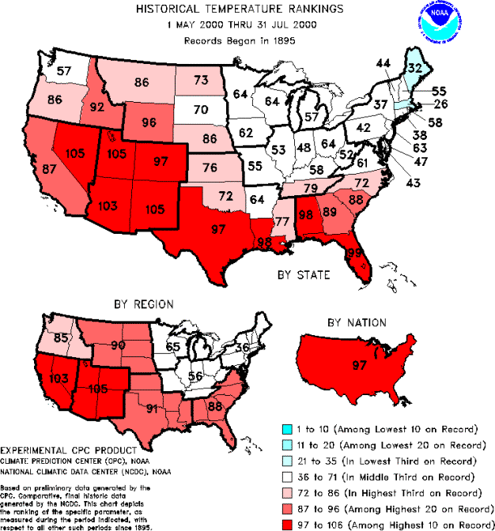

Technical Notes

- Economic statistics are from the US Bureau of Labor Statistics and the US Dept of Commerce Bureau of Economic Analysis.
- Weather data is from NOAA.
- Electricity supply demand information is from NERC annual supply/demand compilations in 1993 and 2000, which are typically prepared from regional forecasts during the prior year.

The US western power system or Western Systems Coordinating Council (WSCC) includes the 11 western states (Arizona, California, Colorado, Idaho, Montana, Nevada, New Mexico, Oregon, Utah, Washington, and Wyoming) plus small portions of western Texas. The federal economic data for this “West” region also includes Alaska and Hawaii.

