http://continental.coolvacations.com/mexico.asp

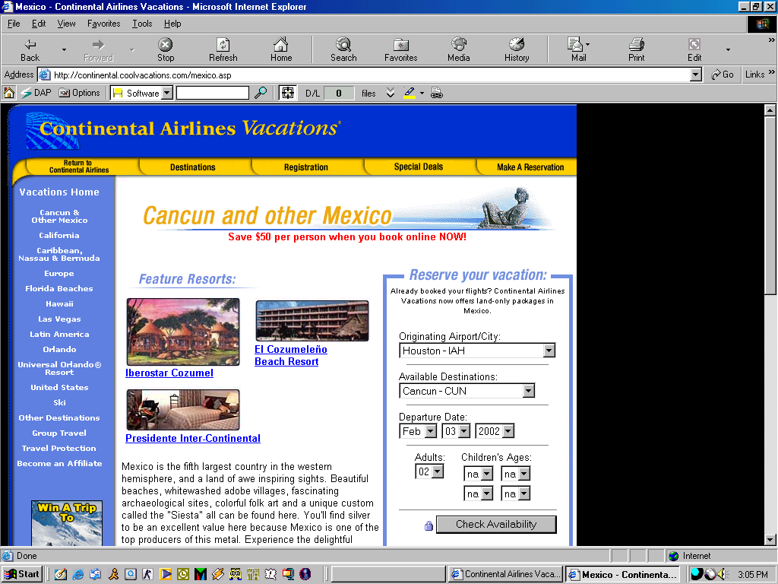

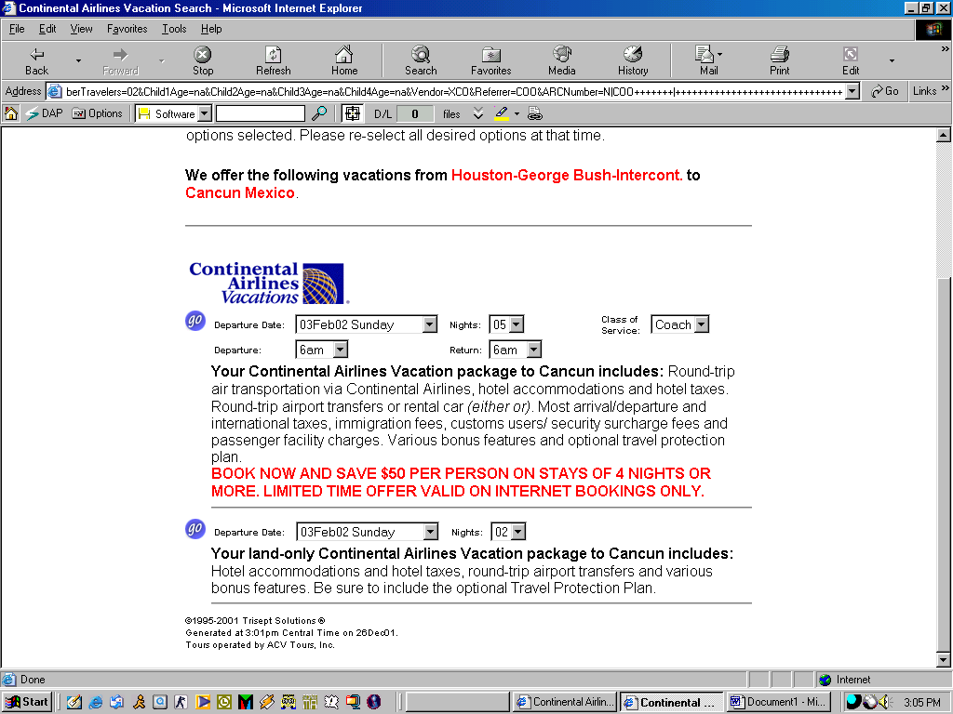

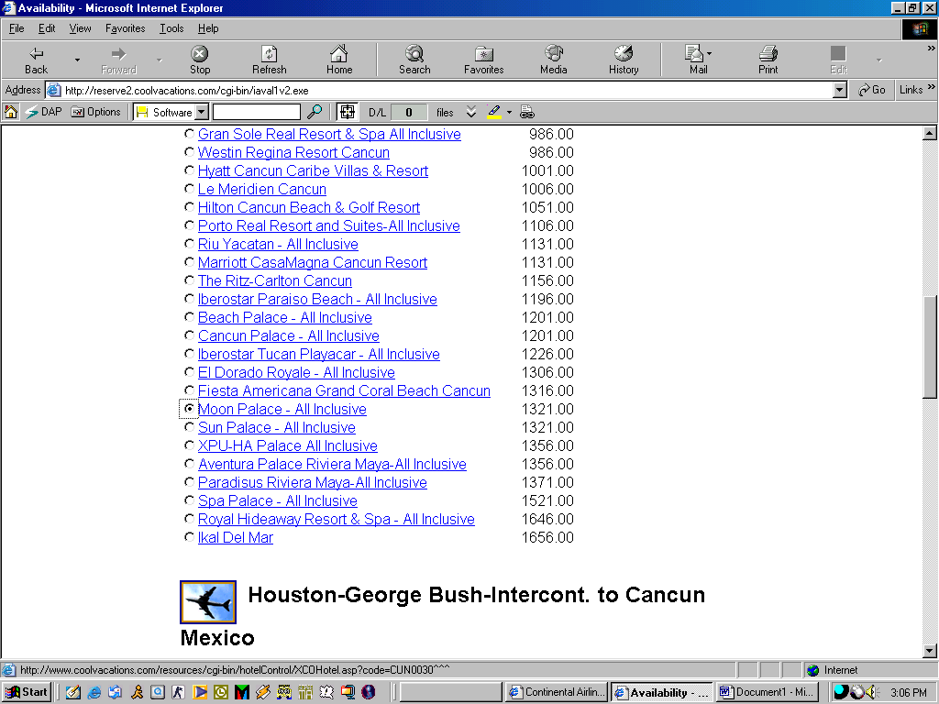

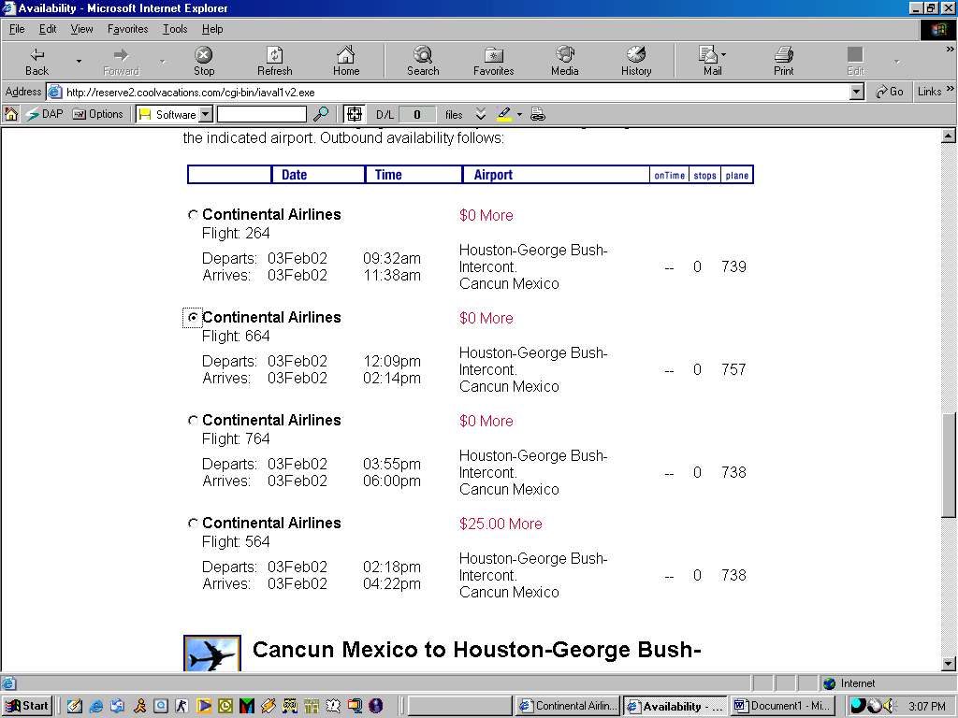

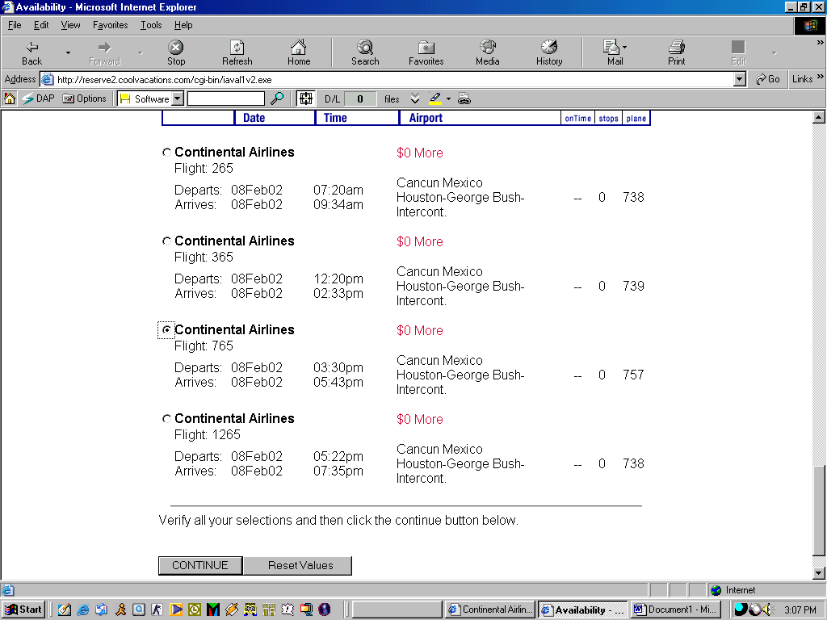

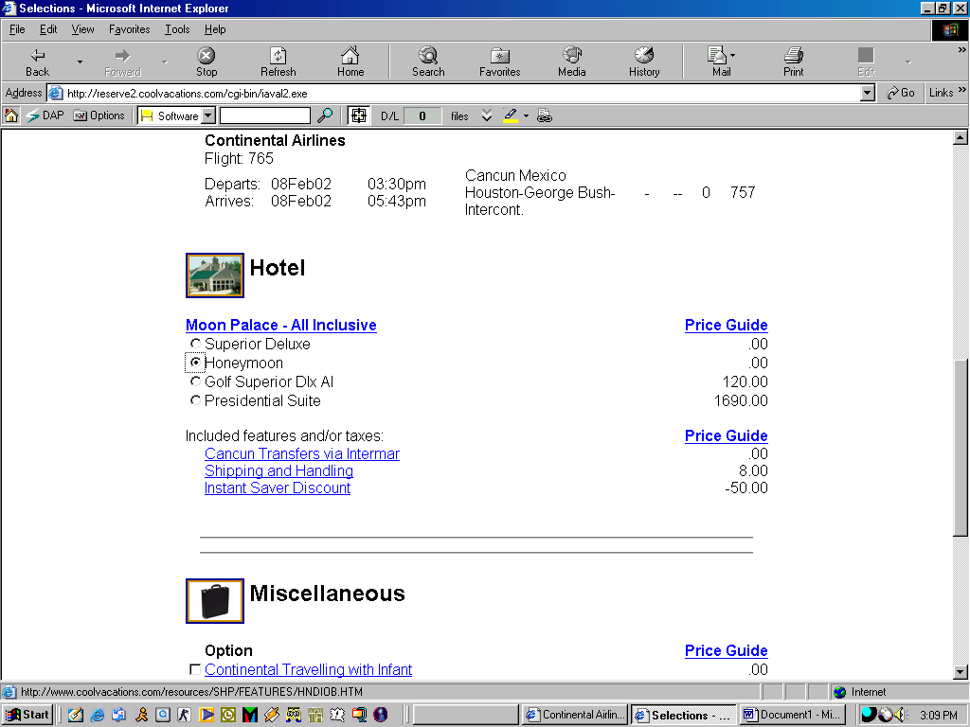



Each item selected has been priced for the quantity indicated. All prices are in U.S. Dollars and all taxes are included in the total price. The total price is listed below.

Houston-George Bush-Intercont. to Cancun Mexico

Continental Airlines
 | Flight: 664 - |  |  |  | 2 Seats
 | Departs:  Arrives: | 03Feb02  03Feb02 | 12:09pm  02:14pm | Houston-George Bush-Intercont.  Cancun Mexico |  | - | -- | 0 | 757

Cancun Mexico to Houston-George Bush-Intercont.

Continental Airlines
 | Flight: 765 - |  |  |  | 2 Seats
 | Departs:  Arrives: | 08Feb02  08Feb02 | 03:30pm  05:43pm | Cancun Mexico  Houston-George Bush-Intercont. |  | - | -- | 0 | 757

Hotel

 |  |  |  |  | Quantity
 | Moon Palace - All Inclusive |  |  |  | 1 Room | 2642.00
 |  | Check-in:  Check-out: | 03Feb02  08Feb02 | Room Category:  Honeymoon

Included features and/or taxes (prices listed not reflected above): |  | Quantity
 | Cancun Transfers via Intermar | 2 Adult | .00
 | Shipping and Handling | 1 Adult | 8.00
 | Instant Saver Discount | 2 Adult | - 100.00

Travel Protection

 |  | Quantity
 | Travel Protection-Published Air Not Covered | 2 Adult | 118.00

Total Price

 | Total | 2668.00

Buy it Now.
To buy this vacation now, please fill in the information requested on the form below. If you choose not to buy this vacation now, please be advised that prices and availability are subject to change at any time without notice.
Top of Form

Product and Destination Advisories:
MOON PALACE AI
PASSPORT PROMO.
BOOK DATES: 11/30/01-12/23/02.
TRAVEL DATES: 12/24/01-12/23/02.
CLIENTS WILL RECEIVE A COUPON
BOOKLET FOR GOLF FEES, SPA
SERVICES, TOURS, and CAR RENTALS.

To book this reservation, fill out the information requested on the form below:
Please Note:
- A secure form is used to protect your personal information.
- The password you choose will be required to review, change or cancel your reservation.
- The address requested is the billing address of the credit card which must be issued to a U.S. billing/mailing address.
- Your credit card will be charged immediately for the total price of the reservation. We accept Mastercard, Visa, Discover, American Express and Diners Club. You are RESPONSIBLE for any CHANGE OR CANCELLATION penalties as stated in our Terms and Conditions
- For customer service, call Continental Airlines Vacations toll-free reservations line at 1-800-772-4622 and ask for ID COO.
- The 24-Hour Payment Hold Option located in the payment dropdown menu below is only valid if your departure date is more than thirty-one (31) days from the day you make your reservations. If you choose this option and meet the travel requirements, your reservation will be held for 24 hours.Your reservation will automatically be cancelled if payment is not made within this 24-hour period. You do not need to enter a credit card number or expiration date with this option. Note: If you are traveling thirty (30) days or less and choose this option, your reservation will require full payment or it may be subject to cancellation.
Bottom of Form

Adult 01
First Name Last Name
Frequent Flyer
MemberType
CardType
Adult 02
First Name Last Name
Frequent Flyer
MemberType
CardType

Payment
Credit Card # Expiration Date Example: MAY01
Address
City State Zip
Country
Telephone (no punctuation)
Password (Your own secret word.)
Password (again, for verification)
E-mail

If you want to book this reservation now, please read the Terms and Conditions of Continental Airlines Vacations at this time. By clicking on the confirmation button below, you are acknowledging that you have read and agree to the Terms and Conditions of Continental Airlines Vacations. You will receive a confirmation number and your travel documents will be mailed 30 days prior to your departure date, to the billing address on your credit card.
Note:
Please press the confirmation button only once. If you hit the stop button and then hit confirm reservation again, you may end up with more than one reservation and double charges on your credit card.

©1995-2001 Trisept Solutions ®
Generated at 3:04pm Central Time on 26Dec01.
Tours operated by ACV Tours, Inc.
Bottom of Form

