October 31, 2000

The Honorable James J. Hoecker
Chairman
Federal Energy Regulatory Commission
888 First Street, NE
Washington, DC 20426

Dear Chairman Hoecker:

On October 26, 2000, the California ISO voted to implement a bid cap formula. Among other things, that formula:

- caps prices below the cost of gas-fired generation, making obvious errors such as failing to take into account gas transportation costs between the Henry Hub and power plants in California; in so doing, the bid cap makes it more economic for generators to sell their gas supply, rather than use it to make electricity in California.
- forces the ISO into the market to buy power on an ad hoc basis to keep the lights on when the capped market fails to attract sufficient supplies (which it inevitably will do).
- invites generators to shut in production, export power out of state, and deploy their turbines in other states or countries.

The Chairman of the ISO voted against the measure, but every monopoly utility representative voted for it, presumably while knowing full well that it simply will not work.

This is just the latest failure of partial or compromised open access. It’s time for the Commission to reject this approach.

The Commission has two very clear choices before it. It can fall into the same trap of political expediency as California’s ISO, leaving the nation’s electric system to lurch from one crisis to the next. Or, it can take a big step toward fundamental structural reform.

The power industry – the nation’s most essential industry – is mired in the transition from regulated monopoly to open access and customer choice. Every step forward has been compromised out of concern for alienating one vested interest or another: As a result, utilities are free to slow the interconnection of new generation, withhold equal access to the transmission system, favor their own sales over those of competitors, miscalculate available transmission capacity, and exercise control over supposedly “independent” system operators and reliability organizations. To deal with these problems policy makers are placing price cap “band aids” over hemorrhaging wounds instead of fixing the underlying structural problems.

It may be politically expedient to extend price caps or threaten refunds, but it would plunge power markets into greater uncertainty and discourage new supplies and conservation methods from coming to the market.

The system is in need of bold action. The industry is halfway across a busy street in its transition from monopoly to competition. It can’t stand where it is. The transition to full and open markets must be completed quickly. First, FERC must complete its work to ensure that all parties have equal and fair access to the nation’s transmission network by ending the special priority for utility uses of the system. Second, FERC must require transmission owners to separate operation of the monopoly transmission assets from their other businesses. Third, FERC must take politics out of transmission system operations by revising governance structures to ensure independence. Finally, FERC must end its reliance upon shortsighted price caps by putting in place the necessary reforms to allow these markets to operate efficiently to encourage conservation and attract new supplies.

The Commission’s leadership is required. This week you decide whether we will begin to make a 21st century electric market or continue the industry’s decline. I urge you to forego politically expedient price caps or refunds in favor of sound open access policy. I urge you to push the industry beyond band aid solutions and get at the deep structural fixes the industry needs. The industry should finally be ready for it, reliability of the grid depends on it, and the Commission remains the best hope for making it happen.

Sincerely,
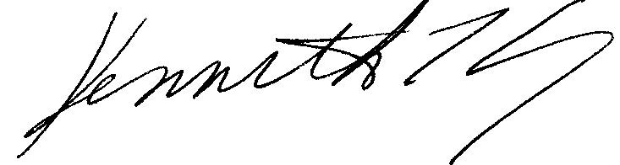

cc: The Honorable Linda Key Breathitt
The Honorable Curt Hebert, Jr.
The Honorable William L. Massey

