Table of Contents
About this Online Help Guide 5
How to use the Online Help Guide 5
Contents 5
Index 5
Search 5
Help Resources 5
Contact Enron Online 6
MyQuotes - The Quotes Screen 6
Quotes Overview 6
Navigating the Quotes Screen 7
Products 7
Product Short Description 7
Product Long Description Window 7
Bid Price Column 8
Offer Price Column 8
Today's Transactions 8
Update Product List 8
Colors on Quote Screen 9
GTC Window 9
View General Terms & Conditions 9
Product Description 10
Product Long Description Window 10
Today's Transactions Section 11
Transaction History 11
Personalize MyQuotes 12
Add Products to your Quotes Screen 12
To add a product page: 12
Remove a Product Page from your Quotes Screen 13
Transacting 13
Transact 13
Transacting Overview 14
Submission Window View 15
Submission Window Fields Explained 16
Purchase or Sale Quantity 16
Offer Fulfillment Option 17
Set Price Range Limit 18
Price Limit Orders 18
Cancel a Price Limit Order 19
Status of Price Limit Order 20
Cancel a Price Limit Order 20
Transaction Search 20
General 20
Date Search 21
Sort By 21
Transaction Search View All 21
Transaction Related Features 22
MyContent - News and Content 23
MyContent 23
Select Content Sections to Display 23
Edit a Content Section 23
Price Reports 24
View EnronOnline Price Reports 24
Personalize MyContent 24
Reports 26
Position Report 26
Transaction Summary Report 26
Customizing EnronOnline 27
Customization 27
Float Windows—Sorting, Detaching, Docking Windows 27
Sorting and Grouping 27
To Detach Windows 27
To Dock Floated Windows 28
Stay on Top 28
Frequently Asked Questions 28
Transacting Online 28
Products & Prices 30
Registration and User Administration 32
Technical Questions 34
Legal Contracts 36
Glossary 36
Glossary 36
Administration 38
Administration Overview 38
Administration 38
Master User ID 38
Setting up Other Users 38
User Information 39
Master User ID 39
Setting up Other Users 39
Preferences 40
Change Your Own Password 40
Language Preference 41
Time Zone Preference 41
Add a User 41
Add a Back Office User 42
Company Information 43
Copy User 44
Copy Master User 44
Product Authorizaton 45
Delete User 46
Change a User or Back Office User Password 46
Market Information 47
Market Information 47
Auctions 47
Auctions 48
System Requirements 48
System Requirements 48
Product Long Description 49
Contact Details 49
Product Details 49
Bid Price 49
Bid Quantity 49
Offer Price 50
Offer Quantity 50
ID Column 50
Price Column 50
Product Description Column 50
Search By Date 50
Sort By 51
Time Stamp Column 51
Type Column 51
User Column 51
Volume Column 52

About this Online Help Guide

How to use the Online Help Guide
The Help is organized into three tabs, Contents, Index, and Search. Maximize your browser window for optimal viewing.

Contents
The Contents tab contains Folders (chapters) and Topics (subjects).
The Folders in this Help file are logically organized like the chapters in a book. These books appear in the table of contents section. To open a book and see it's contents:
- Double-click the book icon , or single click the plus (+) icon to the left of the book. Once opened, the icon will change into an open book and the topics will all be displayed underneath.
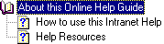
- A single-click on any of the topic icons will display it's contents in the Help window.

Index
The Index tab contains a list of all indexed words, subjects, and phrases contained in this help section. To find a specific topic.
- Type in the topic you want to find, or select the topic from the indexed list.
- As you type, your selection is moved to the top of the indexed list.
- Click the appropriate topic.
- The topic is displayed in the topic window to the right.

Search
Click the Search tab to use the search feature to find a specific topic.
- Type in the word(s) to search for.
- Press the Enter key.
- A list of topics display.
- From the list, click the appropriate topic.
- The topic is displayed in the topic window to the right.

Help Resources
The Help Desk is available to answer your calls personally. You can either dial + 01 (713) 853-4357 for the Americas, +61 2 9229 2300 for Asia and Australia, or +44 (0)20 7783 7783 for all other regions, or email your help request to help@enrononline.com.

Contact Enron Online
The Americas | Europe & Other Regions | Asia & Australia
Mail | Mail | Mail
EnronOnline | EnronOnline | EnronOnline
P.O. Box 4656 | Enron House | Level 21
1400 Smith Street | 40 Grosvenor Place | 9 Castlereagh Street
Houston, TX 77002 | London SW1X7EN | Sydney NSW 2000
USA | UK | Australia
Phone | Phone | Phone
713 853 4357 | +44 (0) 20 7783 7783 | +61 2 9229 2300
713 853 HELP
Fax | Fax | Fax
713 646 8511 | +44 (0) 20 7783 8281 | +61 2 9229 2450

MyQuotes - The Quotes Screen

Quotes Overview
MyQuotes, the quotes screen, is the main transacting interface for EnronOnline users. Here is where you can see the real-time products and prices which Enron is making available to you for submitting your offer to buy or sell.
Above the MyQuotes area you will see links to other areas of EnronOnline including: Administration, Contact Us, Read ETA, Legal & Privacy, Help, Personalize MyQuotes, Positions, Transaction History and Auctions.
Click on any part of the screen below, for more detailed instruction on that particular area.
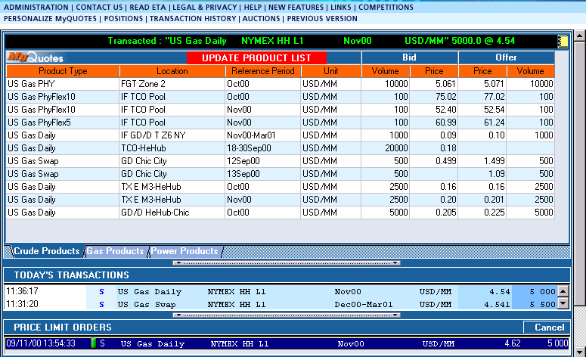

Navigating the Quotes Screen
MyQuotes, the quotes screen, is the main transacting interface for EnronOnline users. Here is where you can see the real-time products and prices which Enron is making available to you for submitting your offer to buy or sell.
Following is an explantion of the areas that make up the quotes screen:

Products
The quotes screen consists primarily of a list of products together with corresponding bid and offer prices and volumes. A product is a unique combination of commodity attributes. These include commodity group, region, deal type, tenor, location etc.

Product Short Description
The line on the quotes screen that displays a short description of the product including, product type, location, reference period, unit, bid/offer price and volume. Click on the Product Short Description to go to the Product Long Description window.

Product Long Description Window
The Product Long Description window displays:
- Full description of the product
- The relevant trading hours for the product
- The minimum offer quantity for the product
- The increments by which the offer quantity of the product can be adjusted
- Information on the Enron Contacts for that product
- The General Terms and Conditions for the product which can be viewed and subsequently accepted by clicking on the View GTC button at the bottom of the Product Long Description window.

Bid Price Column
This column displays the bid price, i.e. the price at which you may offer to sell to Enron the product described for the quantity given in the column to the left. The price notification function will cause the price cells to flash into a green color if the price moves up. If the price moves down then the price will flash into red. Once the price has stopped moving then the text will revert back to the normal color scheme and stop flashing. Clicking on the price will initiate the process of offering to transact.

Offer Price Column
This column displays the offer price, i.e. the price at which you may offer to buy from Enron the product described for the quantity given in the column to the right. The price notification function will cause the price cells to flash into a green color if the price moves up. If the price moves down then the price will flash into red. Once the price has stopped moving then the text will revert back to the normal color scheme and stop flashing. Clicking on the price will initiate the process of offering to transact.

Today's Transactions
This section shows transactions which have occured during the current session and is normally updated when new transactions are done. Please note that an interruption in Internet communication could mean that the transaction list does not update for a particular transaction. For a comprehensive list of completed transactions, please use the Transaction Search function. A User can only see their own transactions while a Back Office User cannot see any transactions in this window. The following details are shown for each transaction:
- Transaction time stamp. This will show the time when the transaction was executed, in the local time preference specified by you . To set local time preference, click the Administration link from the Quotes screen and select Preferences.
- Transaction Buy or Sell. A buy will be denoted with a "B" and a Sell with an "S" in the column to the right of the time stamp.
- The product short description
- Transaction volume
- Transaction price
- All historic transactions can be searched from the Transaction Search function.

Update Product List
Clicking on the "Update Product List" button will add products which have become available since you last clicked on the button, remove products that are no longer available and re-arrange your products by type and tenor.
The "Update Product List" button will appear whenever there are products to be added or removed from all the products available on EnronOnline. The prices and volume cells will be blanked out for products that are removed but the description will remain until the "Update Product List" button is depressed, at which time the short description will also be removed from the product list.
There may be occasions when the button appears in red but clicking on it does not visibly alter your product list. This will be because you have filtered and reduced the list to exclude any products that were either removed or added.

Colors on Quote Screen
When prices in the Bid and Offer columns change, they will flash either red or green. If the price moves up then the price will flash to green. If the price moves down then the price will flash into red. Once the price has stopped moving, the text will revert back to the normal color scheme and stop flashing.

GTC Window
General Terms & Conditions
This window displays the General Terms & Conditions for trading a product on EnronOnline, for counterparties who have not already accepted a Master Agreement that covers the product. If only viewing the GTC for informational purposes, read the GTC and then click Close. If this is your first time, please read the GTC, and if acceptable to you click 'I accept'. Otherwise if you do not accept, click 'I do not accept.'
Note that you will not be able to trade online until you have accepted the GTC for the relevant product or completed a Master Agreement to cover the product.
If you have already accepted the GTC for the product or are governed by a Master Agreement, then a line of text informing you of this will be displayed in the GTC window. The "I accept" and "I do not accept" buttons will not be shown. You will only see a 'Close' button. To close the window and return to the Quotes screen click on the 'Close' button.
You can print out a copy of the GTC by selecting File, Print from the top menubar within the GTC window.

View General Terms & Conditions
You can view and/or accept the GTC for a product by clicking on the link in the Product Long Description window.
- From the quotes screen (MyQuotes), click on the product description line.
- The Product Long Description window displays.
- Click the View GTC button to launch a window containing the General Terms & Conditions governing the product.
This window displays the General Terms & Conditions for trading the product on EnronOnline, for counterparties who have not already accepted a Master Agreement that covers the product. If only viewing the GTC for informational purposes read the GTC and then click Close. If this is your first time, please read the GTC and if acceptable to you click 'I accept' otherwise if you do not accept click 'I do not accept.'
Note that you will not be able to trade online until you have accepted the GTC for the relevant product or completed a Master Agreement to cover the product.
If you have already accepted the GTC for the product or are governed by a Master Agreement then a line of text informing you of this will be displayed in the GTC window. The "I accept" and "I do not accept" buttons will not be shown. You will only see a 'Close' button. To close the window and return to the Quotes screen click on the 'Close' button.
You can print out a copy of the GTC by selecting File, Print from the top menubar within the GTC window.

Product Description
The line that displays a short description of the product including, product type, location, reference period, unit, Bid/Offer price and volume. If you require more information prior to transacting, click on the Product Short Description to go to the Long Description window.
The Long Description window displays the following information:
- Full description of the product
- The relevant trading hours for the product
- The minimum offer quantity for the product
- The increments by which the offer quantity of the product can be adjusted
- Information on the Enron Contacts for that product
- The General Terms & Conditions (GTCs) for the product which can be viewed and subsequently accepted by clicking on the link in this window

Product Long Description Window
If you require more detailed information about a product, prior to transacting, open the Product Long Description window. To do so, click on the product short description line on the Quotes screen. In addition to the long description of the product, this window contains additional product-specific information. The additional information includes trading hours for the product, minimum volume, and contact details within Enron. If you do not have a Master Agreement in place, you will be able to access the relevant GTC from this location by clicking the View GTC button pictured below.
Click on any part of the screen below, for a detailed explanation.
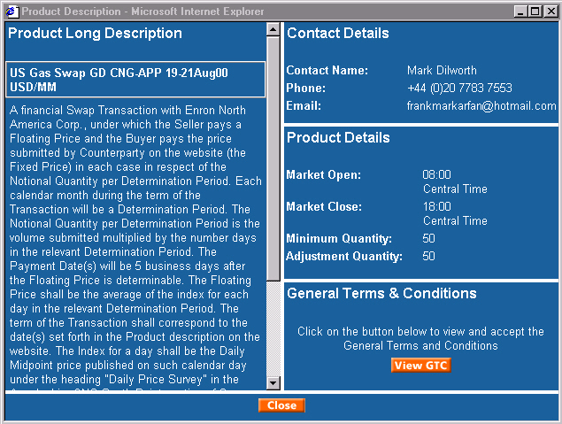

Today's Transactions Section
This section details the offers to buy and sell that have been successfully accepted (transactions), in the current session and is updated continually as and when new transactions are done. A User can only see their own transactions while a Back Office User cannot see any transactions in this window. The following details are shown for each trade:
- The product short description
- Transaction volume
- Transaction price
- Transaction time stamp - this will show in the local time preference specified by you, the time when the trade was executed. The local time preference can be altered within the Preferences section of the Administration menu.
- Transaction Buy or Sell.

Transaction History
Click the Transaction History link that displays on the global navigation above the MyQuotes screen to open the Transaction History window. Click the Related Topic button below for direction on executing a Transaction Search.

Personalize MyQuotes
This function allows you to create page tabs that display your customized product listings based on product attributes such as country/commodity, region, location/index, deal type, currency and others. You can also select products individually.
- Click the Personalize MyQuotes link that displays at the top left of the Quotes screen. The Personalize MyQuotes window opens and here is where you can make your filter selections.
- Click on the drop down arrow and make your selection for each of the following:
- Country/Commodity
- Region
- Location/Index
- Currency
- Deal Type
- Product Category
- If you wish to add individual products in addition to those which you selected in step 2 above, click the Add Products button to access the Add Products menu.
- Click the (+) plus sign next to a type of product to expand or display associated products.
- Make product selections by clicking associated checkboxes.
- Click the Save icon and choose a name for your customized page.
- Click the New Filter button to create additional pages.
- Click the Close button.
- This name will display on a tab at the bottom of the MyQuotes screen.

Add Products to your Quotes Screen
To add individual products to your Quotes screen view, or create custom pages filtered to your trading needs, click the Personalize MyQuotes link that displays at the top of the quotes screen.

To add a product page:
- Click the Personalize MyQuotes link that displays at the top left of the quotes screen to access the Personalize MyQuotes window.
- Click on the drop down arrow and make your selection for each of the following:
- Country/Commodity
- Region
- Location/Index
- Currency
- Deal Type
- Product Category
- If you wish to add individual products in addition to those which you selected in step 2 above, click the Add Products button to access the Add Products menu.
- Click the (+) plus sign next to a type of product to expand or display associated products.
- Make product selections by clicking associated checkboxes.
- Click the Save icon and choose a name for your customized page.
- Click the New Filter button to create additional pages.
- Click the Close button.
- This name will display on a tab at the bottom of the My Quotes screen.

Remove a Product Page from your Quotes Screen
To remove a product page from your quotes screen:
- Click the Personalize MyQuotes link.
- Select the page you wish to delete.
- Click the Delete button.

Transacting

Transact
1. CLICK THE PRICE.
- To offer to buy or sell a particular product via EnronOnline, move your mouse over the bid or offer price cell for that product and click on the price. The Submission window opens.
- If you have not read and accepted the General Terms Contract (GTC) for that product, or the transaction is not yet governed by an existing Master Agreement, you will be asked to read and accept the GTC via EnronOnline. Click the Read GTC button to access the GTC, review and accept.
- Once you have read and accepted the GTC the Read GTC button will be substituted with the Submit button.
- If the price is grey in color, then your ID does not allow transactions on that product. If this is the case, please see your Master User or call the EnronOnline Help Desk.
2. COMPLETE THE SUBMISSION WINDOW.
Volume Adjustment Field
- You can adjust the volume of the product you offer to transact by decreasing the quantity shown for this product on the Quotes screen. Increments of adjustments are different for various products. Please note that you cannot increase the quantity for transaction requests above the amount that appears in the Quotes screen.
Volume Choice Field
There are two options available: "All or Nothing" or "Accept Partial Volume".
- The "All or Nothing" option allows you to specify that you want your offer to be processed only if the entire volume you require is available at the specified price.
- Under the "Accept Partial Volume" option, EnronOnline will process your offer even if some of the requested volume is no longer available. In this case the system will respond with as much volume as remains available at the requested price, up to the maximum volume you have specified.
Price Limit Orders
- You can place a Price Limit Order for products on EnronOnline. If the price you specified becomes available, EOL will automatically try to fill your order and a transaction may result. Price Limit Orders can be cancelled at any time. Price limit orders expire at earlier of user-initiated cancellation or twelve hours.
- To set a price limit order, click the Create Price Limit Order radio button. This action activates a field for you to enter the limit price and volume (up to the maximum product volume) and the expiration time. The Volume Choice will always be Accept Partial Volume when you place a Price Limit Order.
3. CLICK THE SUBMIT BUTTON
- To proceed in making the offer, click the Submit button.
4. VIEW YOUR TRANSACTION
- If your bid or offer has been successfully processed, you will see the transaction appear at the top of the Transactions summary window at the bottom of the Quotes screen.
- If your bid or offer has not been successful, you will receive a message indicating that this is the case.
- Transactions concluded via EnronOnline can be viewed using the Transaction Search functionality accessible through the Transaction History link at the top of the quotes screen. The Transaction Search function can be used to confirm whether or not a transaction completed even if your Internet connection was interrupted during a submission.
- Master Users and Back Office Users can search all transactions completed by the Users in your company. Other Users may only search their own transactions.

Transacting Overview
This is the Transaction interface that you will use to submit an offer to buy or sell via EnronOnline. To find out more, click on any part of the picture below for a description of that section of the Quotes screen.

Submission Window View
The Submission window displays when you offer to buy or sell a particular product via EnronOnline, by moving your mouse over the bid or offer price cell for that product and clicking on the price.
Click on any part of the picture below for an explanation of the fields on the Trade Submission window:
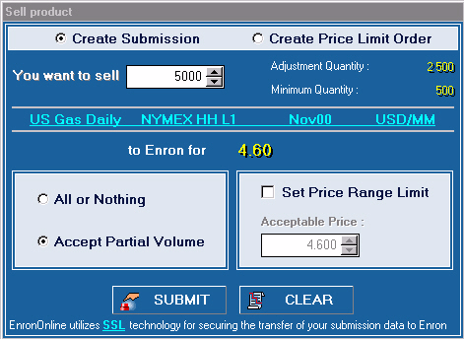

Submission Window Fields Explained
The Submission window displays when you offer to buy or sell a particular product via EnronOnline, by moving your mouse over the bid or offer price cell for that product and clicking on the price.
Following is an explanation of the fields on the Trade Submission window:
Create Submission
Radio button field that displays in the upper left of the Submission window. This will be the default selecton checked, unless you select Price Limit Order.
Price Limit Order
Radio button field. Click in this field to activate the Price Limit Order fields and place a Price Limit Order. The Price Limit Order fields enable you to select a price and set an expiration time.
Volume Adjustment Field
You can adjust the volume of the product you offer to transact by decreasing the quantity shown for this product on the Quotes screen. Increments of adjustments are different for various products. Please note that you cannot increase the quantity for transaction requests above the amount that appears in the Quotes screen.
Volume Choice Field
There are two options available: "All or Nothing" or "Accept Partial Volume".
- The "All or Nothing" option allows you to specify that you want your offer to be processed only if the entire volume you require is available at the specified price.
- Under the "Accept Partial Volume" option, EnronOnline will process your offer even if some of the requested volume is no longer available. In this case the system will respond with as much volume as remains available at the requested price, up to the maximum volume you have specified.

Purchase or Sale Quantity
The Submission window displays when you offer to buy or sell a particular product via EnronOnline, by moving your mouse over the bid or offer price cell for that product and clicking on the price.
Quantity Specification
The quantity shown in the cell is the maximum quantity for the product you can offer to buy or sell at the specified price. This is the quantity that is shown in the columns adjacent to the Bid and Offer prices in the Quotes area.
The volume can be adjusted using the arrows next to the cell. If you want to offer to buy or sell a quantity of product less than the maximum volume click on the down arrow until the quantity cell displays the correct amount that you wish to offer to buy or sell. If you click too far on the down arrow, click on the up arrow to get back to the quantity you require. Selection of the quantity using the arrows will move the volume up or down by the incremental quantity. You can only submit an offer to buy or sell for a volume that meets the quantity specification, i.e. is at or equal to the minimum or maximum volume and if between these then is equal to the maximum volume less a multiple times the volume increment.
The incremental quantity by which the original maximum quantity can be adjusted differs between products. The quantity cannot be less than the specified minimum quantity for the product. You can find the incremental and minimum quantity for the product in the Long Description Window. Click on the product description in the quotes area to go to this window.

Offer Fulfillment Option
The Submission window displays when you offer to buy or sell a particular product via EnronOnline, by moving your mouse over the bid or offer price cell for that product and clicking on the price.
After having selected the quantity that you intend to offer to buy or sell, you need to select the type of submission.
You have to select one of two available options:
All or Nothing
The Partial option is the default option. Selecting this option means that the offer may only be accepted if there is sufficient quantity of the product available to meet the full quantity requested at the price specified. Offers may only be accepted if there is sufficient quantity available to accept your offer.
There might be insufficient quantity because another User has taken some of the quantity of the product or the Enron trader has adjusted the quantity.
Accept Partial Volume
Selecting this option means that the offer to buy or sell may be accepted if there is not sufficient quantity of the product available to meet the full requested quantity. If this option is selected, your offer to buy or sell quantity may be accepted in respect of a lesser quantity than requested.
Example:
A Bid price of 2.30 $/MMBtu for a Henry Hub Forward gas is displayed at a quantity of 10,000 MMBtu on the quotes screen. You see this and decide to submit an offer to sell at the price shown for the whole quantity, and you specify "All or Nothing" submission option.
There is only 9,000 MMBtu of the product available by the time your offer reaches Enron at the displayed price of 2.30 $/MMBtu. The offer will not be accepted because there was insufficient quantity of the product available at the time your offer to sell reached Enron.
The quantity of the product varied from the initial quantity seen in the quotes area because another User's offer was accepted by Enron before your offer. This offer specified only 1,000 MMBtu and not the whole 10,000 MMBtu leaving 9,000 MMBtu at a price of 2.30 $/MMBtu.
If you had selected the "Partial" quantity submission option the above offer to sell may be accepted by Enron for 9,000 MMBtu.

Set Price Range Limit
The Submission window displays when you offer to buy or sell a particular product via EnronOnline, by moving your mouse over the bid or offer price cell for that product and clicking on the price.
Designating an Acceptable Price Range
As a combination of rapid movements in prices in markets and the time delay caused by information flowing over the Internet, your offer to buy or sell may not be accepted as the price may have changed. The Price Range function addresses this, by allowing you to select a price range. To use this function, click on the "Acceptable Price Range" check box.
If you make an offer to sell to Enron, i.e. click on Enron's Bid price, an "Acceptable Price or Higher" box will appear with up and down arrows.
If you make an offer to buy from Enron, i.e. click on Enron's Offer price, an "Acceptable Price or Lower" box will appear with up and down arrows.
Enter the lowest or highest acceptable price depending on whether the offer is at the Bid price or at the Offer price respectively, by clicking on the up or down arrows. The price will move up or down in increments of the price unit. Note that the price units will differ between products.

Price Limit Orders
You can place a Price Limit Order for products on EnronOnline. If the price you specified becomes available, EnronOnline will automatically try to fill your order and a transaction may result. Price Limit Orders can be cancelled at any time. Price Limit Orders may be set for periods up to 12 hours. To set a price limit order:
- To offer to buy or sell a particular product via EnronOnline, move your mouse over the bid or offer price cell for that product and click on the price.
- The Submission window appears.
- Click the Create Price Limit Order radio button.
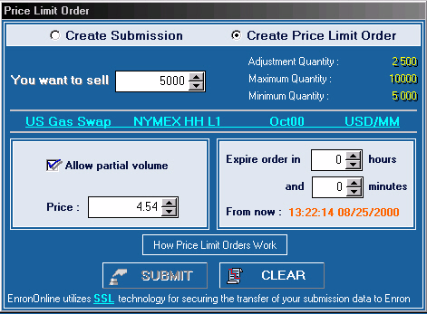
- Enter the quantity you wish to buy/sell up to the maximum quantity shown.
- With the Price Limit Order option you have to Allow partial volume so this option will be automatically selected.
- Enter the price.
- Enter the Expire order in hours and or minutes.
- Complete the order by clicking the Submit button.
- This price limit order will display in the Price Limit Orders section below the quotes screen with the following status indicators:
Status of Price Limit Order | Status Indicator
Filled | F and orange icon
Active | A and green icon
Cancelled | C and red hour glass
Expired | E and red cross
Partial | P and orange and green icon
Please Note
- When there is a change in the status of a price limit order, a scrolling message will display stating, "Price Limit Order Status Changed." Right click on the status bar to clear the message.
- The Status Key button displays next to the Cancel button in the Price Limit Orders section. Press the Status Key button for an explanation of the status indicators.

Cancel a Price Limit Order
You can cancel an order before it is filled.
- Select the order to be canceled from the Price Limit Orders section that displays on the quotes screen beneath the Today's Transactions section.
- Click the Cancel button.
Please Note
- You may set one price limit order per price per product per user.
- Price limit orders expire at earlier of user-initiated cancellation or twelve hours.

Status of Price Limit Order
When you place a price limit order, it will display in the Price Limit Orders section below the quotes screen. The status of your limit order will be denoted with the following status indicators:
Status of Price Limit Order | Status Indicator
Filled | F and orange icon
Active | A and green icon
Cancelled | C and red hour glass
Expired | E and red cross
Partial | P and orange and green icon
Please Note
- When there is a change in the status of a price limit order, a scrolling message will display stating, "Price Limit Order Status Changed." Right click on the status bar to clear the message.
- The Status Key button displays next to the Cancel button in the Price Limit Orders section. Press the Status Key button for an explanation of the status indicators.

Cancel a Price Limit Order
You can cancel an order before it is filled.
- Select the order to be canceled from the Price Limit Orders section that displays on the quotes screen beneath the Today's Transactions section.
- Click the Cancel button.

Transaction Search
To view historical transactions, you will perform a transaction search by clicking the Transaction History link that displays above the quotes screen.

General
- A Master User can search all transactions completed by Users s/he has set up.
- A User can only search for its own transactions.
- A Back Office User can search all transactions completed by Users who were also set up by the Master User who set up the Back Office User.

Date Search
The main method for querying EnronOnline transactions is by the date of the transaction. You can query for transactions between two specified dates.
- The dates must be entered in the following format: Month, Day, Year
- The month, day and year are selected by clicking on the drop down box which will present you with the options for that item.
- To query all transactions between two dates enter the later date in the "On or Before" date box and the earlier date in the "On or After" date box and then click the 'Search' button.
- This will return all transactions that occurred during the specified period. If no transactions are found for the search specified no transaction data will be returned. Transactions will be shown in Timestamp order.
The timestamp is shown with the time zone you have selected as your preference. To view and alter the time zone click the Administration link and select User Information.

Sort By
Retrieved data can be sorted by one of the following attributes:
- Transaction ID
- Transaction Type
- Product Description
- Transaction Commodity
- Transaction Currency
- Transaction Volume
- Transaction Price
- Timestamp
- User
Simply click on the appropriate radio button.
Transactions are sorted by the attribute selected and then in chronological order within each attribute group, i.e. the most recent transactions are shown first within each sub-group.

Transaction Search View All
A Master User can search all transactions completed by Users s/he has set up.
A User can only search for its own transactions.
A Back Office User can search all transactions completed by Users who were also set up by the Master User who set up the Back Office User.
Click on any part of the screen below for a detailed description:
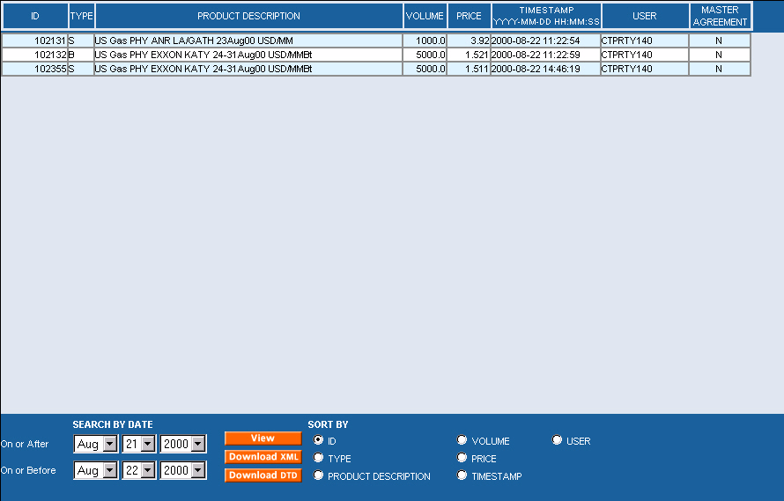

Transaction Related Features
- Configure your quotes screen to display according to your needs. To sort products by a single column, click on the column header, or use the shift key to sort by multiple columns.
- You can float and resize multiple pop-up windows to display all your information at once. To float windows, right click in the MyQuotes window and select Float Windows. Widen or hide columns on floated windows by clicking and dragging to the desired width.
- Click on the product short description on the quotes screen to access a window containing the long description for this product and additional product-specific information. The additional information includes trading hours for the product, minimum volume, and contact details for the Enron trader managing the project. If you do not have a Master Agreement in place, you will be able to access the relevant GTC from this location.
- Click the Update Product List button on the quotes screen to get the most current list of active products.
- You can place a Price Limit Order for products on EnronOnline. If the price you specified becomes available, EnronOnline will automatically try to fill your order and a transaction may result. Price Limit Orders can be cancelled at any time. Price limit orders expire at earlier of user-initiated cancellation or twelve hours.

- Click the Positions link from the quotes screen to access a Position Report. Position reports will be available for only those products on which your company has transacted. Users in a company may access reports for only those products for which they have read only or execute rights. For a particular product you can obtain a position report resulting from only your transactions, or company wide positions resulting from all transactions by all traders within the company.
- Click the Transaction History link from the quotes screen to view transactions, or download transactional data into back office/trading systems.

MyContent - News and Content

MyContent
MyContent is the non-transaction information section that displays in a frame to the right of the quotes Screen. MyContent provides access to Headline, Industry, Weather, and Sports News, Stock Quotes, Publications, Enron Analysis Data, EnronOnline Price Reports, and Weather Maps.
- This section is completely customizable so that you can select to display all, none or some of the available information and features. Click the Personalize MyContent link to access available categories.
- Each information section you have selected to display can be collapsed to take up less space on the screen. To expand or collapse, click the arrow to the left of the section heading.
- To customize a particular section to include the type of information you want as well as the amount, click the Edit button, and then check the associated checkboxes.

Select Content Sections to Display
- Click the Personalize MyContent link that displays above the MyContent section to the right of the quotes screen.
- The Personalize Content page displays and has two main fields:
Available Categories and Selected Categories
- Make your choices from the Available Categories field by clicking on a selection then click the Add button to move the selection from Available Categories to Selected Categories.
- Use the Up and Down arrows to the right of the Selected Categories field to designate the order that you want the content sections to display. Highlight your selection from the Selected Categories field then click the Up or Down arrow to arrange the sections.
- Click the Submit button.

Edit a Content Section
Each of the sections under MyContent contains an Edit button.
- Click the Edit button to access the Personalize Content menu for an individual section.
- The Personalize Content page displays with various checkboxes for you to make your selections.
- Click the checkboxes to specify regions or area of interest.
- Click the drop-down arrow in the View Headlines field and select the number of headlines you want to display on your screen.
- Click the Submit button.
- Remember to periodically click the Update Content button pictured below, to refresh your content selections with the most current information.
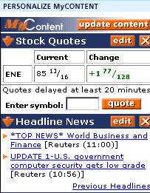

Price Reports
EnronOnline provides daily price reports for various commodity markets. These reports are calculated and published daily at 12:05 pm Central Prevailing Time (CPT). EnronOnline price reports are based on the weighted average price of transactions completed on EnronOnline from the beginning of the trading day in each market until 12:00 pm CPT.
EnronOnline also provides Cash Basis from Henry Hub for US Dollar denominated products. The cash basis is calculated by subtracting the weighted average transaction price for each product (EnronOnline Index) from EnronOnline's Henry Hub prices at 12:00 noon (CPT) on each trading day.

View EnronOnline Price Reports
EnronOnline Price Reports will display in the MyContent area of your screen; the right side. You must chose to display them the same as you would any of your content selections, from the Personalize MyContent link that displays on top of the MyContent area.

Personalize MyContent
To choose the content categories you wish to display in the MyContent area, begin by clicking the Personalize MyContent link that displays above the MyContent section. More detailed instruction continues below this picture.
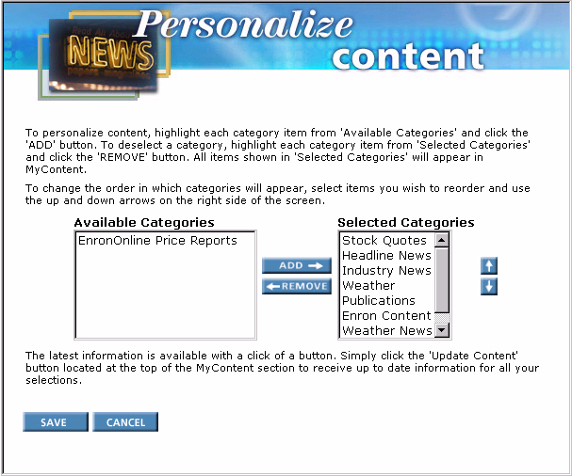
- Click the Personalize MyContent link that displays above the MyContent section to the right of the quotes screen.
- The Personalize Content page displays and has two main fields:
Available Categories and Selected Categories.
- Make your choices from the Available Categories field by clicking on a selection then click the Add button to move the selection from Available Categories to Selected Categories.
- Use the Up and Down arrows to the right of the Selected Categories field to designate the order that you want the content sections to display. Highlight your selection from the Selected Categories field then click the Up or Down arrow to arrange the sections.
- Click the Submit button.

Reports

Position Report
- Click the Positions link from the Quotes screen to access a Position Report.
- Click the (+) plus sign to the left of the product to display time, buy/sell, price, and volume.
- Position reports will be available for only those products on which a company has transacted and for which a person has read only or execute rights.
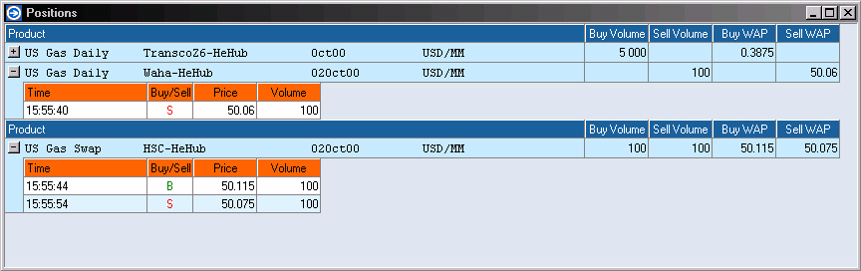

Transaction Summary Report
- Click the Transaction History link that displays above the MyQuotes screen
- The Transaction Search window displays.
- Select dates and sort order.
- To view Transaction Summary details, click the View button.
- To download transactional data into back office/trading systems, use the Download XML and Download DTD buttons.
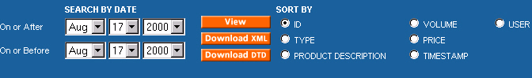

Customizing EnronOnline

Customization
EnronOnline has been designed so that you can personalize or customize each area of your workspace to display according to your needs and tastes. Customize the quotes area (MyQuotes) to show just the products that you trade and customize the content area (MyContent) to display the type and amount of information that interests you.

Float Windows—Sorting, Detaching, Docking Windows
You can further customize you're MyQuotes area by using the float windows function. This feature allows you to detach and display the various quotes tables/pages that you have set up, and also to be able to resize them as you would any other individual window. Now you can display all your customized quotes information at once, anywhere on your computer screen, in addition to the page tabs on the quotes screen which you have to view one at a time.

Sorting and Grouping
- Select your sort order by clicking on a column heading.
- To sort by multiple columns, select the first column by clicking the column header, then select press the shift key and select additional columns.
- To display products in groups, right-click in a quotes page and select the desired filters. To ungroup, deselect the filter. You can only use the group function in a floated window.

To Detach Windows
- In the MyQuotes window, move your mouse pointer over a product.
- Right-click and select Float Window.
- You can move this window by clicking and dragging.
- Resize, if desired, by clicking and dragging any of the corners.
- Widen or hide columns by clicking and dragging it to the desired width.
- To make a floated window remain active, right click in the floated window and select Stay on Top. To cancel this setting, deselect Stay on Top.

To Dock Floated Windows
The docking function allows you to detach or float multiple quotes pages and lock them together. This way you can move them anywhere on your computer screen without having them take up too much space.
- Drag the individual pages one on top of the other. This locks them together. You can now move the docked pages as you would any other window, by clicking and dragging.
- To undock the pages, right click on a product and select Undock from the context menu.

Stay on Top
Once you float, or detach a window, you can fix the position such that it stays active as you move to various applications.
- Right click in the 'floated window'.
- Select Stay on Top from the context menu.
- This window will stay on top, or active, as you switch between applications, until you cancel this setting.
- To cancel this setting, right-click in the 'floated window' and deselect Stay on Top.

Frequently Asked Questions

Transacting Online
- Does EnronOnline affect my ability to transact with Enron over the phone?
No. EnronOnline provides another way to do business with Enron in addition to traditional methods. We believe transacting online is an easier and faster way for our customers to do business with Enron, and is a complimentary method of transacting.
- What costs are associated with transacting via EnronOnline?
EnronOnline can be accessed free of charge. There are no transaction or subscription fees. You will need to make your own arrangements with an Internet service provider, who may charge you for Internet access.
- Are you going to charge for EnronOnline in the future?
Enron has no current plans to charge for transacting via EnronOnline.
- Does EnronOnline support 24-Hour transactions?
EnronOnline staff will be available to support transactions wherever the particular market is open. It is a worldwide trading system, so almost every moment EnronOnline is serving a market somewhere. However, when a market for a particular commodity and region closes, you will be unable to transact in this market.
- When will I know if EnronOnline has accepted the transaction?
When your offer to buy from or sell to Enron is submitted, it is processed by the EnronOnline database, without human intervention. If your offer to buy or sell is accepted by Enron, the completed transaction will appear in the Transactions Window at the bottom of your browser. You can view transactions completed in other sessions using the Transaction Search function. If you are ever in doubt as to whether a transaction completed or not, please use the Transaction Search functionality.
- What happens if the price moves as I am trying to select it? Will my offer fail?
If you select "Immediate Execute or Cancel" and the price moves in a manner favorable to you between the time you submit the offer to buy or sell to Enron, and the time the EnronOnline system processes that offer, then Enron will treat the offer as being made at the price more favorable to you. If you are concerned about price movements then one option is to select the Price Range option when you submit an offer to buy or sell. This option will allow you to submit an offer up to the price limit you specify, based on whatever quantity of product is available at that price. To use the Price Range option, you need to click on the "Acceptable Price Range" check box. Naturally, if the price falls out of that range in a manner that is unfavorable to you, then your offer to buy or sell will not be accepted by Enron. Your submitted offer is not held in the EnronOnline database but is automatically accepted or rejected immediately upon receipt by the EnronOnline system.
- What happens if another customer makes an offer to buy or sell at a particular price or quantity at the same time as I am trying to select it? Will my offer fail?
It depends on whose offer to buy or sell is processed by the EnronOnline system first, yours or the other customer's. To minimize this possibility, we suggest selecting the "Accept Partial Volume" option when submitting your offer to buy or sell. By selecting this option, your offer to buy or sell may be accepted by Enron for any quantity up to the amount requested in the submission window. Your submitted offer is not held in the EnronOnline database but is automatically accepted or rejected immediately upon receipt by the EnronOnline system. If you do not wish to offer to buy or sell less than the quantity specified in your offer, then the "All or Nothing" option should be selected.
- How are my transactions affected in the event of EnronOnline system failure?
Due to the level of technology and capacity redundancy built into EnronOnline, system failures are a rare occurance. It is possible, however, for outside factors to impact your ability to access EnronOnline, such as your Internet connection being terminated prematurely (for example, if someone were to pick up a telephone on the same line as your Internet connection). If your submission reached the EnronOnline database before your Internet connection failed, then this failure will not have any effect on your submission. However, if the Internet connection failure occurred before your offer reached the EnronOnline database, no transaction will be completed. You can view all completed transactions using the Transaction Search function. If you are ever in doubt about whether or not a transaction completed, please use the Transaction Search function.
- Is Enron obligated to accept offers to buy or sell that I submit?
EnronOnline will automatically process the offers you submit. Enron traders themselves will not be able to choose whether to accept the offer or not. When the system checks your offer it examines three things: 1) Is the price still available? 2) Is the volume still available? 3) Would completion of this transaction exceed your line of credit? If your offer passes all of these checks, then a transaction will result.
- If my offer to buy or sell is not accepted by EnronOnline, does it remain open for acceptance at a later time?
You have a choice when submitting an offer to buy or sell to Enron, "Fill or Kill" or "Good Until Canceled" which is a price limit order. If you select "Fill or Kill", when your offer to buy or sell is submitted, it will be processed by the EnronOnline system and either accepted or rejected automatically. If your submitted offer is rejected, it cannot be used in relation to any other transaction. If you place a price limit offer by selecting the "Good Unitl Canceled" option, and the price you specified becomes available, EnronOnline will automatically try to fill your order and a transaction may result. Price Limit Orders can be canceled at any time. Price Limit Orders will expire at the end of the day.
- What may cause a transaction not to be completed?
Reasons why your offer to buy or sell may not be accepted by Enron include:
- you used the "All or Nothing" function, but there was insufficient quantity of the product available at the price you specified;
- you used the "Good Until Canceled" function, but the price never fell within specified limits and the order expired at the end of the day;
- you used the "Accept Partial Volume" option but other customers took the entire quantity between the time you selected it and the time your offer to buy or sell reached the EnronOnline database;
- the transaction, if accepted by Enron, would take you outside your established trading or credit limits;
- there has been a change in the price for the product that is not favorable to you. That is, an unfavorable movement away from the price you selected or, where you used the "Acceptable Price Range" function, outside the price range you specified. If the reason for failure is not clear, please reach us via the Contact Us page.
- Can other customers view my transactions?
No, only you, the Master User(s) and the Back Office Users in your company can see the transactions you completed via EnronOnline.
- When will I receive an invoice for transactions done via EnronOnline?
You will receive our invoice for your online transactions at the same time as you would for transactions done over the telephone, as specified in your Master Agreement or the online documents.

Products & Prices
- What products and regions can I transact in?
Your trading access depends on the products and regions your Master User approved for you. It is also possible that your company is unable to transact with Enron in particular products or regions for legal, tax, credit or regulatory reasons. Beyond this, you should be able to transact in a wide selection of worldwide energy commodities. If you wish to transact in additional products/regions, please call the EnronOnline Help Desk who will inform you how to make this change if it is possible. More information on the products can be found in the EnronOnline Markes section.
- Are EnronOnline prices and transacting capability truly real time?
EnronOnline uses advanced technology to refresh the trading and pricing information at an optimal level. Enron makes available real time prices for viewing on your screen. Information received by Enron is automatically processed, but there can be delays as the information travels across the Internet.
- I want to know more about a particular product. Who do I talk to?
You can ask us about products through the Contact Us page. Alternatively, you can speak directly to the Enron trading desk that posted the product price. You can look up who to contact by left-clicking on the Product Short Description on the quotes screen.
- Can I alter the quantity of product I want to transact?
For certain products, EnronOnline gives you a choice to specify the quantity of the product you want up to a maximum quantity posted on the quotes screen. You can use the arrows near the quantity box in the Create Submission window to input your chosen quantity. The minimum quantity increments the original quantity can be adjusted, appear in the Create Submission window and can vary by product. You can also see them by clicking on the Product Short Description. In addition, you can choose between "All or Nothing" and "Accept Partial Volume" prior to transaction execution. You can also alter the quantity of product when you place a price limit order.
- Are prices I see on the screen firm? Does Enron show the same prices to all users?
Yes. Prices are firm when posted online by Enron traders. However, there are reasons why the offer to buy or sell you submitted to Enron may be not accepted, for example, if your company reaches its credit limit.
Yes, all users see the same prices.
- What happens if I accidentally enter a wrong price?
You can only select prices that appear within the EnronOnline system. This protects you from some possible errors caused by an accidental number entry. If you do not use the Price Range functionality or Price Limit Orders, then you can only select the price on the screen. If you utilize the Price Range functionality the price you buy or sell at will be at best price available on the EnronOnline system (if it is within the range you specify). If you place a Price Limit Order, the system will automatically try to fill your submission.
- Normally I can see prices for a particular product, but I can't now. Why?
If you cannot see prices for a particular product, press the "Update Product List" button if available (highlighted in red). If you cannot see a particular product, check whether the market is open by referring to the EnronOnline home page. If the market is open, and you cannot see products, check with the Master User in your company to find out if you are still authorized to view prices for that product. If you are authorized by your Master User, but cannot see particular products, please Contact Us.
- Are there any limits on the minimum prices or volumes that appear on EnronOnline?
The minimum and maximum volumes are different for each product and are set by the Enron trader who is responsible for that product. There are no minimum price levels.
- How do Price Limit Orders Work?
You can place a Price Limit Order for products on EnronOnline. If the price you specified becomes available, EnronOnline will automatically try to fill your order and a transaction may result. Price Limit Orders can be cancelled at any time. Price Limit Orders may be set for periods up to 12 hours.
- How do I place a Price Limit Order?
  - To offer to buy or sell a particular product via EnronOnline, move your mouse over the bid or offer price cell for that product and click on the price.
  - The Submission window appears.
  - Click the Create Price Limit Order radio button.
  - Enter the quantity you wish to buy/sell up to the maximum quantity shown.
  - With the Price Limit Order option you have to Allow partial volume so this option will be automatically selected.
  - Enter the price.
  - Enter the Expire order in hours and or minutes.
  - Complete the order by clicking the Submit button.
- Where will my Price Limit Orders display?
Your price limit orders will display in the Price Limit Orders section below the quotes screen until the end of the day.
- How do I know if my Price Limit Order has been filled?
The status of your limit order will be denoted with the following status indicators.
Status of Price Limit Order | Status Indicator
Filled | F and orange icon
Active | A and green icon
Cancelled | C and red hour glass
Expired | E and red cross
Partial | P and orange and green icon
There is a Status Key button that displays in the Price Limit Orders section.
- Will I be informed if my Price Limit Order is filled?
When a price limit order is filled, or partially filled, a scrolling message will display stating, "Price Limit Order Status Changed." Right click on the status bar to clear the message. Also, when a price limit order is filled, or partially filled, it will display as a transaction in the Today's Transaction section below the quotes screen.
- Will I be informed if my Price Limit Order has expired?
When a price limit order is expired, a scrolling message will display stating, "Price Limit Order Status Changed." Right click on the status bar to clear the message.

Registration and User Administration
- How do I register to become an EnronOnline User?
To register you need to complete three simple steps:
- Complete the one page Registration Form
- Complete and sign the Password Application
- Mail or fax both forms to EnronOnline
Americas: | Europe & Other Regions: | Asia & Australia:
EnronOnline | EnronOnline | EnronOnline
PO Box 4656 | Enron House | Level 21
1400 Smith Street | 40 Grosvenor Place | 9 Castlereagh Street
Houston, Texas 77002 | London, SW1X 7EN | Sydney NSW 2000
USA | UK | Australia
Fax: 713 646 8511 | Fax: +44 (0) 20 7783 8281 | Fax: +61 2 9229 2450
All forms are printable from the EnronOnline home page.
- I sent you my Password Application. How long will it take to start transacting via EnronOnline?
We try to process applications as quickly as possible. If accepted, you will normally receive your User ID and Password within four working days, depending on where you are located.
- Who is a Master User? What level of access do Users have compared to Master Users?
A Master User authorizes other Users within your company to transact via EnronOnline and view transactions completed by other Users within the company. A Master User can grant another User access to all products and regions to which the Master User has access. However, Users will not be able to change other Users' rights to transact or rights to view transactions completed by other Users.
- How many Users can a Master User set up?
Up to ten. But if you want to set up more Users, Enron has the capability to extend this number. To request that more Users be set up, please call the Helpdesk:
The Americas: 713 853 HELP (4357)
Europe & Other Regions: +44 (0) 20 7783 7783
Asia & Australia: +61 2 9229 2300
Email: help@enrononline.com
- Can we have more than one Master User in the same company?
Yes, it is possible and is done to make it easier for you to manage Users' authorization internally.
- I am a Master User and have forgotten my Password. What do I do now?
If you are a Master User you need to Contact Us and let us know. You should print out the PA from the EnronOnline web site, or we'll send it to you upon request. After you sign and return (by mail or fax) the PA with your new requested password, we will change your password and contact you by telephone or email to let you know that it has been activated. Please note that without a Master User ID and Password you will not be able to control access to EnronOnline of other Users within your company. If you wish to suspend other Users until you get a new Password, please Contact Us and we will do it for you.
- I forgot my User Password. How do I get a new one?
If you are not a Master User, please contact the Master User in your company. EnronOnline is designed to make it easy for your Master User to reissue you a new password without contacting Enron. The Master User will need to go into the Administration screen (accessible to Master Users from the quotes page) and reset your password.
- Can a Master User set up other Users in a satellite office?
Only if the satellite office is in the same country as the Master User. You need to have a Master User in each country in which you transact, and you need to complete an additional password application and registration form for each country.
- If I change User details, when will they take effect?
Changes take effect immediately after they are processed by the EnronOnline database.
- What is the difference between a Master User and a Guest User?
Guest User accounts provide temporary access to EnronOnline and are a great way for you to learn more about EnronOnline prior to becoming a registered User. Guest Users can view real time prices posted by Enron traders, while Users can also transact via EnronOnline by clicking on these prices. To apply to be a Guest User you need to complete the form found in Contact Us. To apply to be a Master User you are also required to complete the Registration Form and sign the Password Application.
- You sent me a new User ID for the Password I specified in the Password Application. What happens to my Guest User ID?
Your Guest User ID you used earlier for viewing prices is no longer needed as your new User ID will do everything the old one did, and more. Your previous Guest User ID will expire.
- My account just stopped working. What is wrong?
If you only have a Guest User ID, then your access may have expired. Please register for a Master User ID or Contact Us for further information. If you are a User, please contact your Master User to discuss why you cannot access your account. If you are a Master User, please Contact Us for further information.
- The security of my Master User ID and Password has been compromised. What do I do? How do I close down my account immediately?
Users and Master Users can change their own passwords. If this is not sufficient, then the Master User in each company can delete the Users old User ID and create a new User ID and Password.
If your Password has not been changed already by someone else, then you can change your password to something unique. If your Password has already been changed by someone else, then you can request that we disable your old ID and issue a new one. Please contact the EnronOnline Helpdesk. You will be asked to fax a letter from an authorized representative of your company to instruct the disabling of the account. To obtain a new User ID and Password, you will need to complete a new Password Application.
- Can brokers have access to EnronOnline?
EnronOnline is available only to companies, which can transact online for their own account. Companies which cannot transact online on their own behalf are not eligible for registration as Master Users or as Guest Users with EnronOnline.

Technical Questions
- What hardware and software do I need to use EnronOnline?
Because EnronOnline is a Web-based Application, essentially all you need is an Internet connection and a Web browser. You will need either Microsoft® Internet Explorer 4.0 or Netscape Navigator® 4.5, or higher versions, a Macromedia® ShockwaveTM plug-in. The Shockwave plug-in is freely available and may already be included in your browser. You can also download it from Macromedia, Inc. by following the links on the EnronOnline site.
- What are the hardware specifications for better EnronOnline performance?
In addition to having a 4.0 level Web browser, for better performance we recommend you meet or exceed the following system hardware specifications:
- Windows® 95 on a Pentium® Class PC, 64MB RAM
- 56K or faster connection speed is recommended
- 11371 color support
- 1024 x 768 screen resolution
- What kind of technology does EnronOnline use behind the application?
The EnronOnline system uses various technologies to deliver the site to your screen. This includes an Oracle database, weblogic servers, Macromedia Shockwave, HTML, Java, Active X, and Secure Socket Layer (SSL), among others.
- How secure is trading with EnronOnline?
Secure. We have dedicated a lot of effort to provide a safe, secure method of completing online transactions via EnronOnline. Of course, it is still important that you take appropriate internal security precautions within your own company. To provide the comfort you need, EnronOnline utilizes Secure Socket Layer (SSL), secured servers and encryption technology when you transact with Enron.
- What is SSL?
SSL stands for Secure Socket Layer. SSL is information technology that allows secure transfer of sensitive information over the Internet. We use it to help ensure that your transactions done via EnronOnline are safe, secure and confidential. SSL is a protocol, i.e. a set of rules or procedures. This protocol provides data encryption, server authentication, message integrity, and client authentication. It takes a message and runs it through a set of steps that "scramble" the message so that the message is secured for transfer. This "scrambling" is called encryption. When the message is received by the intended recipient, SSL "unscrambles" the message, checks that it came from the correct sender and then verifies that it has not been tampered with.
- What is Shockwave?
Macromedia® Shockwave TM is a free software plug-in available from Macromedia, Inc. by following the links on the EnronOnline site. It allows Netscape Navigator® or Microsoft® Internet Explorer to use the full functionality of EnronOnline. Shockwave is a Web standard tool for viewing interactive, engaging, rich media content from your Web browser. Shockwave allows you to experience the dynamic multimedia effects of the EnronOnline site. In order to see real time prices on the screen, and to transact via EnronOnline you need to have Shockwave installed.
- What support functions will I have to add to trade via EnronOnline (retraining existing personnel or hiring extra IT staff etc.)?
Most likely none. EnronOnline is designed to reduce your workload, not to increase it. In fact, you may find that with EnronOnline, you have more time to concentrate on other things, such as market analysis or origination of new deals, as you spend less time closing transactions.
- Who do I contact with other technical questions about EnronOnline?
If you have a question not answered in these FAQ's, please feel free to Contact Us and we will do our best to answer your question. You can call our Helpdesk any time:
The Americas: 713 853 HELP (4357)
Europe & Other Regions: +44 (0) 20 7783 7783
Asia & Australia: +61 2 9229 2300
Email: help@EnronOnline.com

Legal Contracts
- My company does not have any commodity contracts with Enron in place. How can I transact?
EnronOnline has online contracts, known as General Terms and Conditions (GTC), which will govern your transactions done online. The first time a User in your company wants to transact online in a relevant product, there will not be a submission button available on the screen. Instead, you will be prompted to read and accept the GTCs for that product. The GTCs must be accepted in order for you to be able to transact via EnronOnline in that product. GTCs can be printed out and accepted by clicking on the Product Short Description in the quotes screen, even if you do not intend to transact in that particular product.
- How do I know that you haven't changed GTCs without informing me?
If we revise the GTCs for a particular product, we will notify you by showing new GTCs on the relevant product screen. You will not be able to transact via EnronOnline until you have accepted the revised GTCs. Furthermore, there is a version number and issue date on each GTCs. You have to accept the revised version of the GTCs online to be able to transact in that particular product online.
- What is the Electronic Trading Agreement (ETA)? How can I see and print the ETA?
The Electronic Trading Agreement combined with the Password Application signed offline provides the legal framework for transactions carried out via EnronOnline. Master Users will see the ETA at the first login stage and will have to accept it to be able to transact online. The ETA can also be viewed at all times after it has been accepted and is available for printing from the bottom left hand corner of the quotes screen.
- How can I see and print the General Terms and Conditions (GTCs) for a Product?
You can see the GTCs for a product by clicking on the GTCs link available when your mouse is on the Product Short Description on the quotes screen. You can print out a copy of the GTCs for each product.
©1999 Enron Corp. All rights reserved.

Glossary

Glossary
The Glossary lists all the terms and phrases that are used throughout EnronOnline to define a particular person, process, action or state.
 | Back Office Users | Individuals who are set up by the Master User to use the Transaction Reporting functionality of EnronOnline. Back Office Users cannot trade any commodities or products.
 | Composite | An amalgam of quotes for Products from various commodity groups and geographical regions.
 | ETA | The Electronic Trading Agreement, which combined with the Password Application, establishes the terms and conditions relating to the use of EnronOnline.
 | Filters | Filters are used to reduce the number of Products that are displayed on the screen at any one time. They are accessed by pressing "Personalize MyQuotes" on the main quotes screen.
 | GTC | The General Terms and Conditions provide the contractual framework for transacting in a specific Product or group of Products where there is no Master Agreement in place.
 | Master Agreement | An agreement, other than the online GTC which has been entered into between Enron and the company, which governs transactions in certain Products with certain counterparties.
 | Master User | The User who has submitted the Password Application, accepts the ETA for the company, and is able to use the Administration functionality in EnronOnline to set up and control both Users and Back Office Users.
 | Offer to buy or sell | When an EnronOnline user submits to Enron the details of a product together with a specified price or price range and quantity at which the company is willing to transact.
 | Product | A Product is a unique combination of commodity attributes. These include commodity group, region, deal type, tenor, location.
 | Quotes screen | The screen which displays the list of Products, prices and volumes. It also displays the Transaction summary section. The Quotes screen can be customized to display according to your business needs, and therefore this screen is labeled My Quotes. In this online help guide the terms quote screen and My Quotes are interchangeable.
 | Section | A set of filtered data that is saved within a named page (tab).
 | Transaction | An offer to buy or sell becomes a transaction when the offer reaches, and is accepted by, Enron.
 | Transaction Report | A report generated from the Transactions screen that shows previously completed Transactions.
 | Users | Users set up by the Master User to be able to trade Products for and on behalf of the company.

Administration

Administration Overview
The Administrative functions you can access from the Administration section will be different depending on the type of EnronOnline user you are. There are three types of EnronOnline users as follows:
- User - can transact on EnronOnline, designate individual time zone preference and language preference, change your password and view company details.
- Back Office User - can retrieve transactional data from EnronOnline, designate individual time zone preference and language preference, change your password and view company details.
- Master User - also known as system administrator, has full system rights and access. The Master User can transact on EnronOnline, designate individual time zone preference and language preference, change their own password and view company details. In addition to these rights, the Master User can view the preferences of each User and Back Office User, add new Users/Back Office Users, delete Users/Back Office Users, assign product authorization to Users and reset User/Back Office User passwords.
The Administration menu can be accessed from the global navigational section on the quote screen.
The Master Users will be able to perform all of the following functions from the Administration menu:
- Add, maintain and delete Users (Click List Users button)
- Maintain and edit User default preferences (Click List Users button)
- View Company Information (Click Company Information button)
- Add, maintain and delete Back Office Users (Click List Back Office Users button)
To find out more about Administration features and functionality, click on the Related Topics button below.

Administration

Master User ID
The Master User ID allows you to set up other Users within your company to transact via EnronOnline. This provides considerable flexibility, as you do not need to contact Enron to set up new Users. You can also set up Users with different types of access to view or trade according to your company structure.
To transact via EnronOnline your company has to have at least one Master User ID. However, you may also have multiple Master User ID's if required. The Master User ID is issued by Enron upon approval of a Password Application (PA).

Setting up Other Users
Select Administration from the bottom of the Quotes screen. The administration functionality allows you to:
- Add new Users (and Back Office Users)
- Update User access levels
- Add and update User Passwords
As a Master User you control access or viewing rights of other (non-Master) Users in your company.
Users can be set up with read-only or execution rights up to the same level as the Master User.
Back Office Users will be able to view all transactions completed by other Users in your company, but they cannot transact via EnronOnline.

User Information
Set your preferred time zone, language, password, and Chat availability. From the Quotes screen select Administration, User Information.
- Time zone - sets the time zone for transactions timestamping in EnronOnline. This does not affect time referenced in the product descriptions.
- Language - sets the language for the General Terms and Conditions (GTC's). Note that not all GTC's are available in all languages.
- Password - allows password reset whenever required.

Master User ID
The Master User ID allows you to set up other Users and Back Office Users within your company to transact via EnronOnline. This provides considerable flexibility, as you do not need to contact Enron to set up new Users. You can also set up Users with different types of access to view or trade according to your company structure.
To access the various Master User functions, click the Administration link that displays above the quotes screen. Click on any of the buttons below for detailed instruction on the associated tasks. Note that the buttons below are for administration of the User ID (select Administration, List Users). A similar set of buttons will be available for administration of the Back Office User ID (select Administration, List Back Office Users).
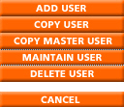
To transact via EnronOnline your company has to have at least one Master User ID. However, you may also have multiple Master User ID's if required. The Master User ID is issued by Enron upon approval of a Password Application (PA).

Setting up Other Users
Select the Administration link from the navigation above the Quotes screen to access the various administrative functions. The administration functionality allows the Master User to:
- Add new Users (and Back Office Users)
- Update User access levels
- Add and update User Passwords
As a Master User you control access or viewing rights of other (non-Master) Users in your company.
Users can be set up with read-only or execution rights up to the same level as the Master User.
Back Office Users will be able to view all transactions completed by other Users in your company, but they cannot transact via EnronOnline.

Preferences
The Preferences feature allows a user to specify:
- Time Zone Preference
- Language Preference
- Change Password
To access the Preferences screen, click the Administration link that displays above the quote screen, then click the Preferences button. The Preferences screen is pictured below.
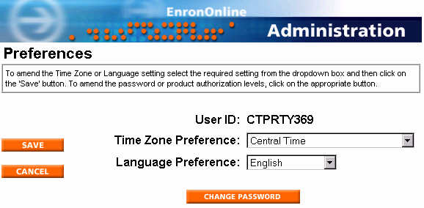

Change Your Own Password
To change your password:
- Click the Administration link that displays on the Quotes screen.
- Click the Preferences button. This will display the Preferences screen.
- Click the Change Password button.
- The Change Password screen displays.
- Enter your old password in the Old Password field.
- Enter your new password in the New Password field. This should be a minimum of 8 and no more than 10 characters long. Please note that passwords are case sensitive.
- Retype the new password in the Confirm New Password field to verify.
- Click the Save button. If the Old password is incorrect or the verification of the new password and the new password do not match, you will receive an error message. Click the Cancel button to return to the preferences screen.

Language Preference
To change the language in which the product specific GTC are viewed on EnronOnline:
- Click the Administration link that displays on the Quotes screen.
- Click the Preferences button. This will display the Preferences screen.
- Click the drop-down arrow in the Language Preferences field to access a selection list of languages and select the appropriate language.
- Click the Save button to send the change in the default language preference to EnronOnline.

Time Zone Preference
You can designate the time zone which will be used to display date and time information within the site. Note that the time zone setting will not affect the terms of any of the transactions.
- Click the Administration link that displays on the Quotes screen.
- Click the Preferences button. This will display the Preferences screen.
- Click the drop-down arrow in the Time Zone Preferences field to access a selection list of time zones and select the appropriate time zone.
- Click the Save button to send the amendment in time zone information to EnronOnline.

Add a User
You must have Master User rights to add a user, and with these rights, the Administration Menu pictured below will be visible to you when you click the Administration link above the quotes screen.
To add a user:
- Click the Administration link that displays above the quotes screen.
- The Administration menu displays.
- Click the List Users Button.
- The next menu contains a drop-down list of the User IDs for the Master User logged into the system.
- Click the Add User button.
- You will be presented with a screen containing fields for User ID, Password and Confirm Password.
- Enter the details of the new User. Both the User ID and Password fields are case sensitive and must be at least 8 and no more than 10 characters in length. The User ID must be made up of alpha numeric characters only.
- Click the Save button when done.

. 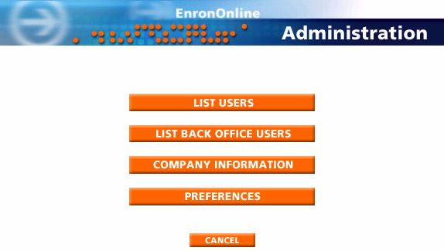

Add a Back Office User
You must have Master User rights to add a back office user, and with these rights, the Administration Menu pictured below will be visible to you when you click the Administration link above the quotes screen.
To add a back office user:
- Click the Administration link that displays above the quotes screen.
- The Administration menu displays.
- Click the List Back Office Users Button.
- The next menu contains a drop-down list of the Back Office User IDs for the Master User logged into the system.
- Click the Add User button.
- You will be presented with a screen containing fields for User ID, Password and Confirm Password.
- Enter the details of the new User. Both the User ID and Password fields are case sensitive and must be at least 8 and no more than 10 characters in length. The User ID must be made up of alpha numeric characters only.
- Click the Save button when done.

.

Company Information
To view your company information contained within the EnronOnline system, follow the steps below.
- Click the Administration link that displays above the quotes screen.
- The Administration menu displays.
- Click the Company Information button.
- The Company Information screen displays as pictured below.
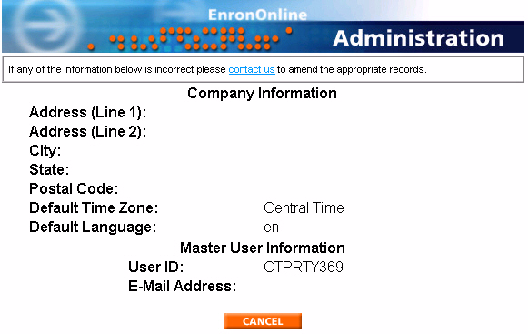

Copy User
The Copy User function allows a Master User to bring over all of the rights and authorizations of an existing User to a new User. This way you do not need to manually add product authorizations, just assign User ID and Password to the new User.
- Click the Administration link that displays above the quotes screen.
- The Administration menu displays.
- Click the List Users Button.
- The next menu contains a drop-down list of the User IDs for the Master User logged into the system.
- Click on the drop-down arrow in the User IDs field and select the ID of the user whose profile you wish to copy.
- Click the Copy User button.
- You will be presented with a screen containing fields for User ID, Password and Confirm Password.
- Enter the details of the new User. Both the User ID and Password fields are case sensitive and must be at least 8 and no more than 10 characters in length. The User ID must be made up of alpha numeric characters only.
- Click the Save button when done.

Copy Master User
The Copy Master User function allows a Master User to bring over all of the rights and authorizations of an existing Master User to a new Master User. This way you do not need to manually add product authorizations, just assign User ID and Password to the new Master User.
- Click the Administration link that displays above the quotes screen.
- The Administration menu displays.
- Click the List Users Button.
- The next menu contains a drop-down list of the User IDs for the Master User logged into the system.
- Click the Copy Master User button.
- You will be presented with a screen containing fields for User ID, Password and Confirm Password.
- Enter the details of the new User. Both the User ID and Password fields are case sensitive and must be at least 8 and no more than 10 characters in length. The User ID must be made up of alpha numeric characters only.
- Click the Save button when done.

Product Authorizaton
The Master User will assign product authorization levels to Users and Back Office Users.
- Click the Administration link that displays above the quotes screen.
- The Administration menu displays.
- Click the List Users Button.
- Click on the drop-down arrow in the User IDs field and select a user.
- Click the Maintain User button.
- The User Details window displays.
- Click the Product Authorization button.
- The Preferences window opens. Here you will select country(s) and commodity(s). You have the option to select all countries and all commodities.
- Click the GO button.
- The Product Authorization window opens. A picture of the Product Authorization window displays below.
- To add or amend a user's product access level and transaction term limit, select the option from the drop-down boxes. To apply the same access rights to all the products listed on the page, make the appropriate selections within the "Apply to all" option at the top of the page, and then click the Apply button.
- Click the Save button.
- Changes take effect at the user's next login.
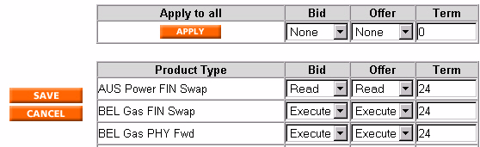

Delete User
You must have Master User rights to delete a user, and with these rights, the Administration Menu pictured below will be visible to you when you click the Administration link above the quotes screen.
To delete a user:
- Click the Administration link that displays above the quotes screen.
- The Administration menu displays.
- Click the List Users Button.
- The next menu contains a drop-down list of the User IDs for the Master User logged into the system.
- Click on the drop-down arrow in the User IDs field and select the ID of the user you wish to delete.
- Click the Delete User button.

Change a User or Back Office User Password
The person with Master User rights can change a password for Users and Back Office Users.
- Click the Administration link that displays above the quotes screen.
- The Administration menu displays.
- Click the List Users Button.
- Click on the drop-down arrow in the User IDs field and select a user.
- Click the Maintain User button.
- The User Details window displays.
- Click the Change Password button.
- The Change User Password screen displays.
- Enter the new password in the New Password field. This should be a minimum of 8 and no more than 10 characters long. Please note that passwords are case sensitive.
- Retype the new password in the Confirm New Password field to verify.
- Click the Save button.
- Click the Cancel button to return to the User Details window.

Market Information

Market Information
EnronOnline provides global market coverage across multiple commodities, including Enron market hours and background information. If you'd like to find out more about the individual markets that EnronOnline covers, click on the EnronOnline Markets link on the home page.


Auctions

Auctions
Click on the Auctions link that displays on the navigation above the quotes screen. EnronOnline Auctions furnish the ability to bid on some of the more structured products and services offered by Enron worldwide.
EnronOnline Auctions provide convenient access to many of Enron's products and services, with the added advantage of a streamlined bidding process, giving greater efficiency than traditional delivery methods.
Products and Services will be added to EnronOnline Auctions on a regular basis, so check back often to see what's new.

System Requirements

System Requirements
EnronOnline requires an Internet connection, a Web browser (Microsoft® Internet Explorer 4.0 or Netscape Navigator® 4.5, or higher versions), and a Macromedia® Shockwave™ plug-in (freely available and may already be included in your browser). EnronOnline works with a PC (Microsoft® Windows® 95 / Windows NT®).
If you do not currently have Shockwave installed on your computer it will normally download automatically the first time you log in. If this does not happen, you may download it by following the "Download Shockwave" link on the EnronOnline home page. This should enable you to see real time prices via EnronOnline and benefit from all that EnronOnline has to offer.
If you are using Netscape, you will need a plug-in to allow Netscape to run Active X components. This will normally download automatically when you upgrade to the new version of EnronOnline while using Netscape. If this does not happen, you may download the plug-in from the "Download Active X Plug-in" on the EnronOnline home page.
Although not required to transact, a soundcard is required for audio streaming within EnronOnline.
Back Office Users
Individuals who are set up by the Master User to use the Transaction Reporting functionality of EnronOnline. Back Office Users cannot trade any commodities or products.
GTC
The General Terms and Conditions provide the contractual framework for transacting in a specific Product or group of Products where there is no Master Agreement in place.
Master Agreement
An agreement, other than the online GTC which has been entered into between Enron and the company, which governs transactions in certain Products with certain counterparties.
Master User
The User who has submitted the Password Application, accepts the ETA for the company, and is able to use the Administration functionality in EnronOnline to set up and control both Users and Back Office Users.
Offer to buy or sell
When an EnronOnline user submits to Enron the details of a product together with a specified price or price range and quantity at which the company is willing to transact.
Product
A Product is a unique combination of commodity attributes. These include commodity group, region, deal type, tenor, location etc.
Transaction
An offer to buy or sell becomes a transaction when the offer reaches, and is accepted by, Enron.
Users
Users set up by the Master User to be able to trade Products for and on behalf of the company.

Product Long Description
Detailed description of the product.

Contact Details
Contact Information contained on the Product Long Description window:
If you have any specific questions about the product then feel free to contact the person detailed here by either phone, mail or email your request or question by simply clicking on the email link shown.

Product Details
The Product Details section of the Product Long Description window displays:
Trading Hours
This shows the hours during which the product described above normally trades. However, this does not mean prices will always be published during these hours.
Minimum Quantity
This is the minimum quantity that can be transacted in the product described above. The minimum quantity is product specific.
Increment Quantity
The quantity of a product to be transacted can be varied downwards from the maximum quantity by the increments displayed. The incremental quantity is product specific.

Bid Price
This column displays the Bid price, i.e. the price at which you may offer to sell to Enron the product described for the quantity given in the column to the left. The price notification function will cause the price cells to flash into a green color if the price moves up. If the price moves down then the price will flash into red. Once the price has stopped moving then the text will revert back to the normal color scheme and stop flashing.

Bid Quantity
This column displays the maximum quantity of the product that you may offer to sell to Enron at the displayed Bid price.
The volume notification function will cause the volume cells to flash into a green color if the volume moves up. If the volume moves down then the volume will flash into red. Once the volume has stopped moving then the text will revert back to the normal color scheme and stop flashing.

Offer Price
This column displays the Offer price, i.e. the price at which you may offer to buy from Enron the product described for the quantity given in the column to the right. The price notification function will cause the price cells to flash into a green color if the price moves up. If the price moves down then the price will flash into red. Once the price has stopped moving then the text will revert back to the normal color scheme and stop flashing.

Offer Quantity
This column displays the maximum quantity of the product described which you may offer to buy from Enron at the displayed Offer price. The volume notification function will cause the volume cells to flash into a green color if the volume moves up. If the volume moves down then the volume will flash into red. Once the volume has stopped moving then the text will revert back to the normal color scheme and stop flashing.

ID Column
Transaction ID
This column displays the unique identification code for the EnronOnline Transaction.

Price Column
Transaction Price
This column displays the price at which each transaction was accepted. The price units are specified within the product Short and Long Descriptions.
Example
The product short description is:
UK Gas Fin Swap Jun 00 IPE p/therm.
The volume is in therms and the price is quoted as pence/therm.

Product Description Column
Product Short Description
This column displays a Short Description of the product that was either bought or sold.

Search By Date
Time Stamp Search
Date Search
The main method for querying EnronOnline transactions is by the date of the transaction. You can query for transactions between two specified dates.
The dates must be entered in the following format: Month, Day, Year
The month, day and year are selected by clicking on the drop down box which will present you with the options for that item.
To query all transactions between two dates enter the later date in the "On or Before" date box and the earlier date in the "On or After" date box and then click the 'Search' button.
This will return all transactions that occurred during the specified period. If no transactions are found for the search specified no transaction data will be returned. Transactions will be shown in Timestamp order.
The timestamp is shown with the time zone you have selected as your preference. To learn how to alter the local time zone click on the Related Topics button below and select Time Zone:

Sort By
Sort By
Retrieved data can be sorted by one of the following attributes.
- Transaction ID
- Transaction Type
- Product Description
- Transaction Commodity
- Transaction Currency
- Transaction Volume
- Transaction Price
- Timestamp
- User
Simply click on the appropriate radio button.
Transactions are sorted by the attribute selected and then in chronological order within each attribute group, i.e. the most recent transactions are shown first within each sub-group.

Time Stamp Column
Transaction Time Stamp
This column displays the Time when the transaction was executed. This is stated in the local time zone set in the Preference Section. To learn how to alter the local time zone click on the Related Topics button below and select Time Zone:

Type Column
Transaction Type
This column displays whether the transaction was a Buy or Sell. If you bought the product from Enron, then the product will be described as a Buy. If you sold the product to Enron then the product will be described as a Sell.

User Column
User
This column displays the User ID of the person who performed the transaction shown in that row.

Volume Column
Transaction Volume
This column displays the volume associated with each transaction. The units for the volume are described within the product Short and Long Descriptions.
Example
The product Short Description is:
UK Gas Fin Swap Jun 00 IPE p/therm.
The volume is in therms and the price is quoted as pence/therm.

