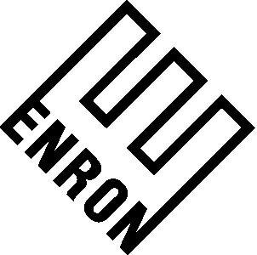

To: | John Lavorato
From: | Jean Mrha | Department: | Upstream
Subject: | Hedging of Pad Gas from Wells 13 & 14 | Date: | September 28, 2025

Enron owns 3.877 BCF of pad gas in salt storage caverns leased from Dow Hydrocarbons and Resources Inc. The anticipated date to begin pad gas removal is 8/1/02. This memorandum outlines the forward hedge for this pad gas against its current cost basis ($ 2.2373/MMBtu).

- The start date for pad gas removal is projected to be 8/1/02 and is assumed to continue for a period of eight months at which point approximately 2.820 of the 3.877 BCF shall have been removed. The remaining 1.057 BCF of pad gas shall be held as operational prudency with the associated value reflected in accrual earnings.

- The eight month duration reflects recovering the pad gas under an assumed aggressive case of .487 BCF/Month (reflecting a delivery rate of 1800 gallons per minute (gpm) for the brine).

- The total pad gas in storage is expressed in terms of Mcf and converted to MMBtu using a conversion factor of 1.0299.

- Based on engineering analysis, we have assumed a conservative withdrawal rate of .352 BCF/Month (reflecting a delivery rate of 1300 gpm for the brine).

- As such, the pad gas owned by ENA at $2.2373 shall be hedged by selling Henry Hub for Gas Daily forward from August 2002 – March 2003 for 36.2525 Contracts / Month. This number of contracts will hedge 2.82 BCF of the 3.877 BCF of pad gas.

Against the 12/27/00 natural gas forward curve, a value of $3 million was reflected in fourth quarter ENA earnings. In addition, a residual value of $1.6 million was categorized into a Schedule C reserve. This reserve is for probable operational risk associated with the withdrawal of the pad gas since Dow will supply the brine on a “best efforts” delivery.

After selling forward the contracts, $1 million of the Schedule C Reserve will be reflected in 1st quarter ENA earnings and the residual amount will be allocated for operational risk.

CC: Wesley Colwell

