< HUGS
OK, THIS IS A TEST TO SEE HOW MANY FRIENDS
YOU HAVE ON THE INTERNET!!!!!
DON'T BE HURT BY THIS IS IF NO ONE SENDS IT BACK,
IT'S JUST A TEST. OK, HERE GOES.
INSTANTLY, WHEN YOU RECEIVE THIS LETTER,
YOU MUST SEND IT TO AT LEAST 10 PEOPLE,
INCLUDING THE PERSON WHO SENT IT TO YOU.
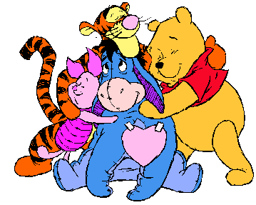

*Hug* *Hug* *Hug* *Hug* *Hug* *Hug*
*Hug* *Hug* *Hug* *Hug* *Hug* *Hug*
*Hug* *Hug* *Hug* *Hug* *Hug* *Hug
*Hug* *Hug* *Hug* *Hug* *Hug*
*Hug* Hug *Hug* *Hug* *Hug* *Hug* *Hug*
*Hug* *Hug* *Hug* *Hug* *Hug* *Hug*
*Hug* *Hug* *Hug* *Hug* *Hug* *Hug*
*Hug* *Hug* *Hug* *Hug* *Hug* *Hug*
*Hug* *Hug* *Hug* *Hug* *Hug* *Hug*
*Hug* *Hug* *Hug* * Hug* *Hug*

You have just been hugged!!
That's right, there's no getting out of it this time!!
This is the start of a full-scale Hug O' War!
So hug everyone you know!!!
Hug your friends, your enemies, everyone!!
With all the other forwards out there, I thought this
would be a good one to start.
The hug is my favorite sign of affection.
It can mean so much, and many things at the same time.
It can be a sign of love, friendship, comfort or anything
So here you go.
All I can say it will do is brighten someone's day.
I mean, we all need a hug once in a while. So send this on
if you'd like, to anyone who may need a hug, send it
back to whoever sent it to you, send it back to me!!
Goodness knows, we could all REALLY use a hug sometimes.
So send this on and show someone you care!! >>

