HOWARD UNIVERSITY BOARD OF
TRUSTEES

DEVELOPMENT COMMITTEE MEETING
January 18, 2002
3:00 p.m.
Trustee’s Board Room
Agenda
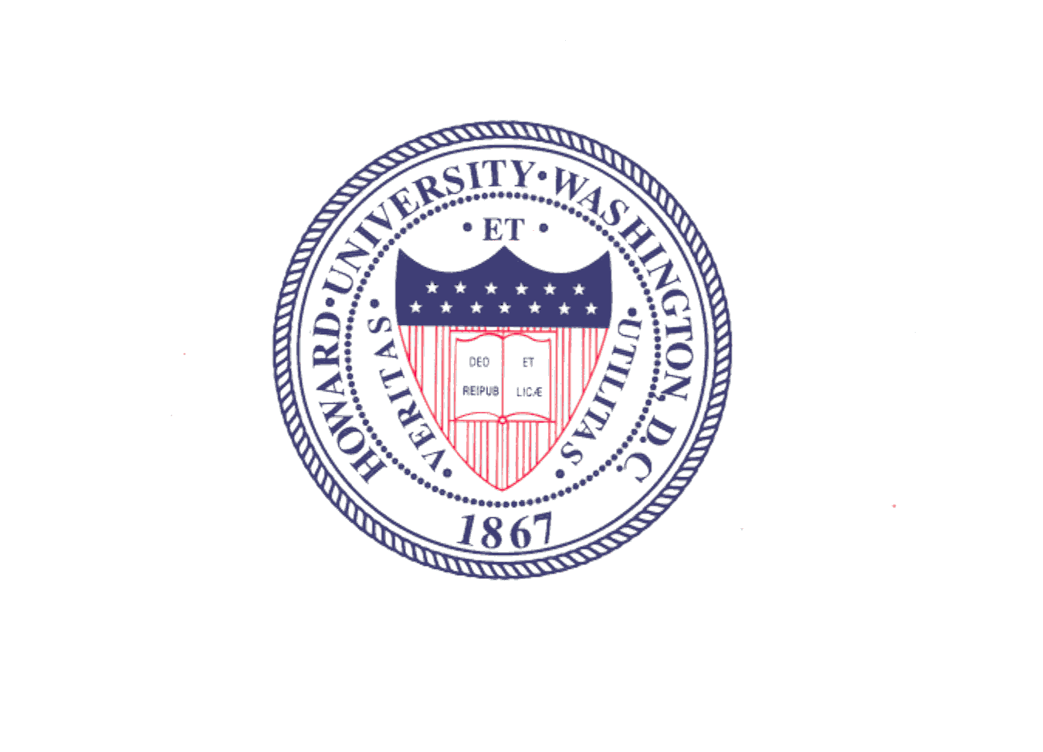

Report of the Vice President for University Advancement

- Campaign Quarterly Report
- Capital Campaign Readiness

Howard University Compared to Other Institutions

Next Steps

