Gasoline Technical Commentary
Monday, 30 July 2001

Energy Desk

Tel. 1 212 859 1350

Near Term (Basis September): Neutral, looking higher

Monday’s inside range bar on the daily chart looks to be a short-term consolidation effort on the part of the market prior to an important technical breakout. We continue to feel the double bottom chart pattern that will require a trade above 77.40 cents represents the bull’s best chance to make a statement on the chart. Bears will stay with the trend lower and view the recent strength as a sideways corrective action that is working off the prior oversold momentum condition. With the open interest figures showing a meaningful liquidation since last Wednesday when the board pushed up through the 18-day MA, it is a fair bet that the large specs are much closer to being small net-shorts to flat in spite of the COT data from Friday showing them to have added a small amount of shorts. This helps put the market in a neutral position where an extension up through the 40-day MA and 77.40 cent level creates a need to get long on the part of the ‘fund-types’. On the contrary, a pullback through the 18-day MA and a corresponding cross over in the daily stochastic for a fresh sell signal should be followed by more aggressive technical selling as the bears get their lost position back. We continue to ‘lean’ higher here.

Long Term: Bearish
Our long-term technical model remains bearish. Major resistance is at 77.00 and 85.10 cents, while support is at 65.40 and 58.30 cents.
Daily Numbers
Settlement: | 74.81
Change: | -.48
9-Day Stoch: | K= 73.56 D= 61.65
18-Day MA: | 73.82
40-Day MA: | 61.65
Resistance 2nd: | 76.25
Resistance 1st: | 75.95
Support 1st: | 74.30
Support 2nd: | 73.20

Commitments of Traders Data (futures only) as of July 24, 2001
Trader Group | Long | Short | Net
Large Spec | 2,911 | 10,907 | -7,996
Commercial | 87,678 | 75,723 | 11,955
Small Trader | 9,676 | 13,635 | -3,959

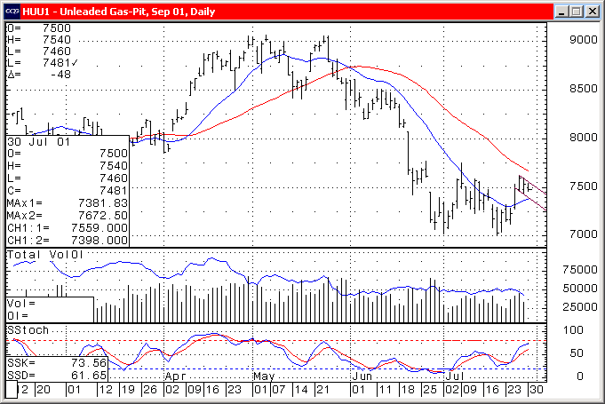

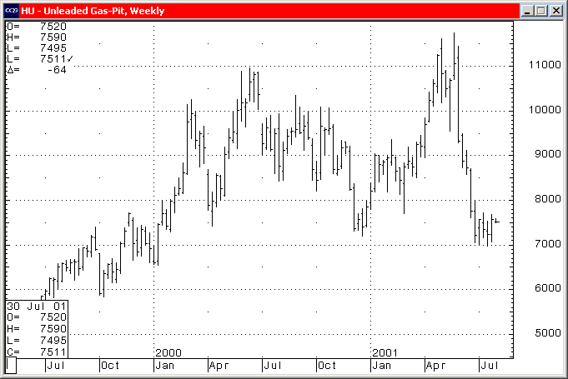
Charts courtesy of CQG, Inc.

