My Friends, I give you… THE DUMBEST GUY ON EARTH!

This picture is real - not doctored in anyway - and was taken last week by a
Transportation Supervisor for a company that delivers building materials
for 84 Lumber. When he saw it in the parking lot of IHOP, he went
and bought a camera to take pictures.

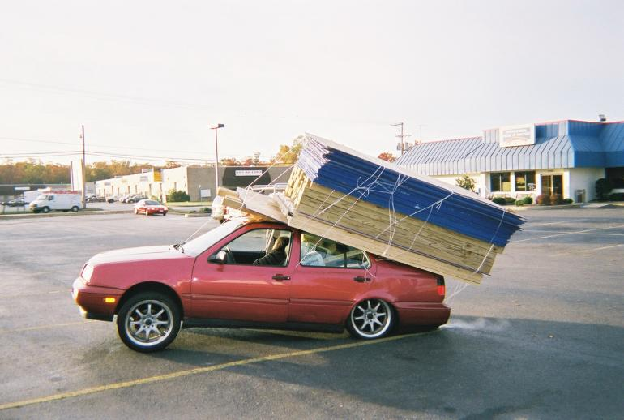

The car is still running, as can be witnessed by the exhaust. A woman is
either asleep or otherwise out in the front seat passenger side. The guy
driving it was jogging up and down on Rt. 925. (in the background)
Witnesses said their physical state was OTHER than normal. The driver
finally came back after the police were called, and was found crouched
behind the rear of the car, attempting to cut the twine around the
load! Luckily, the police stopped him and had the load removed.

The materials were loaded at Home Depot. Their store manager said they
had the customer sign a waiver. While the plywood and 2X4s are fairly obvious,
what you can’t see is the back seat, which contains -- are you ready for this? --
10 bags of concrete @ 80 lbs. each. They estimated the load weight at 3000 lbs.

Both back tires exploded, the wheels bent and the back shocks were driven through
the floorboard. The car, with FL plates (naturally), was headed for Annapolis, where
the couple presumably planned to build a new house in which to smoke their crack.

