Heating Oil Technical Commentary
Monday, 30 July 2001

Energy Desk

Tel. 1 212 859 1350

Near Term (Basis September): Neutral

Monday’s small losses did little to influence the chart in our view. We still see a board stuck between the moving averages. The bulls will see a daily stochastic buy signal, a small uptrend line as support and a failed downside breakout on the weekly chart, all within the framework of a large spec trader group that has increased its net-short into the current rally. This creates the look of a bear trap in the process of unfolding. The bears can counter with a small ABC-corrective rally so far that has been unable to push decisively through the MA resistance zone. With the daily stochastic correcting back to mid-range readings from an oversold condition, this makes for a logical selling opportunity Tuesday that would transition the chart read back into a bearish bias. We like the neutral stance here, but feel the ‘lean’ in the chart has swung back to favor the bears after today’s session failed to follow through higher in reaction to the inside range consolidation session on Friday. We look for more aggressive technical selling to develop just below the combined 180day MA and the trendline, making best support now in the 71.00 to 70.50 cent area.

Long Term: Bearish
Our long-term technical model remains bearish, but a trade above 72.90 cents will have us back in a neutral stance. Major resistance is at 83.50 and 85.00 cents, while support is 67.35 and then 62.75 cents.
Daily Numbers
Settlement: | 71.17
Change: | -.44
9-Day Stoch: | K= 66.89 D= 54.70
18-Day MA: | 70.83
40-Day MA: | 73.98
Resistance 2nd: | 72.80
Resistance 1st: | 71.75
Support 1st: | 70.40
Support 2nd: | 70.00

Commitments of Traders Data (futures only) as of July 24, 2001
Trader Group | Long | Short | Net
Large Spec | 2,522 | 17,786 | -15,264
Commercial | 114,633 | 102,957 | 11,676
Small Trader | 29,313 | 25,725 | 3,588

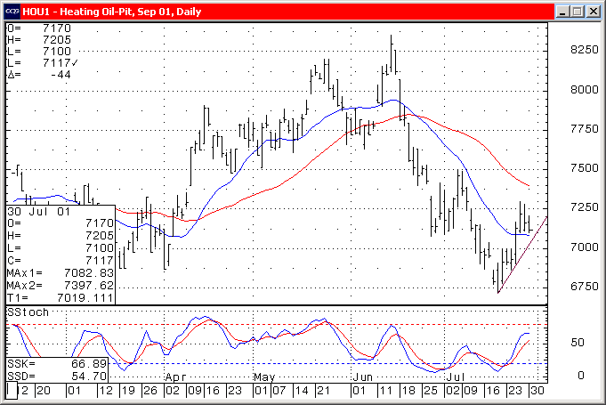

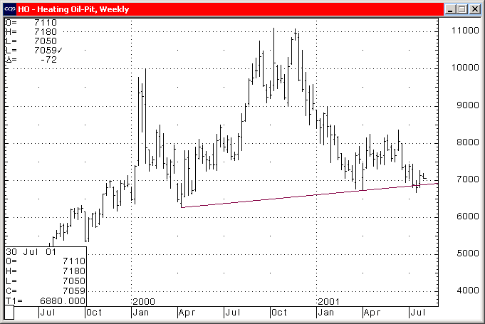
Charts courtesy of CQG, Inc.

