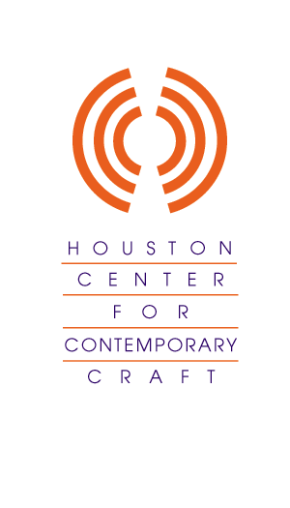

SEEK THE UNIQUE

PLEASE JOIN US FOR A PRIVATE VIEWING FOR

THE YOUNG FRIENDS OF THE HOUSTON CENTER FOR CONTEMPORARY CRAFT, MEMBERS AND GUESTS

THE HCCC IS THE LATEST AND MOST UNIQUE ADDITION TO THE
HOUSTON MUSEUM DISTRICT

DISCOVER THOSE HARD TO FIND GIFTS AT THE
ASHER GALLERY OF THE
HOUSTON CENTER FOR CONTEMPORARY CRAFT

INTERACTIVE DEMONSTRATIONS BY RESIDENT ARTISTS

RAFFLE FOR DELUXE WEEKEND PACKAGE AT THE
STYLISH HOTEL DEREK

Cocktails and Hors d’oeurve by Carrabas
Thursday, November 29
6pm –8pm
The Houston Center for Contemporary Craft
4848 MAIN
(valet parking in front or self park around back of building)

RSVP: 713 529 4848 x101 COST: $25.00
Raffle tickets available at the event for $20
Host Committee: Liz and José Luis Vittor, Chrissi and Mike Morgan, Kara and Aaron Howes, Sarah and David Pesikoff, Catherine Morgan, Rachael Tobor, Jason Presley

Houston Center for Contemporary Craft is a nonprofit organization with a mission to advance education about the process, product and history of craft.

