QUICK START

⏐ logging on⏐

- Point your Internet browser to http://www.EnronOnline.com

- You may be prompted to download the Shockwave plug-in first – see Section xxx of this guide for help.

- Enter your User ID and Password (these are case sensitive).

- Click on GO

- If this is your first time logging in with a Master User ID, the Electronic Trading Agreement (ETA) will appear. It must be read and accepted to proceed into the pricing application. In order to read and accept the agreement, scroll through the agreement and click on the “I accept” button. The ETA will always be available through a link inside the pricing application in the bottom left hand corner.

- The commodities will then appear after a few seconds on your web-page.

⏐filtering & creating composites⏐

- To view your choice of quotations, EnronOnline allows for composite screens to be created.

- To filter the quotations and create your own favorite pages use the navigation on the left hand side of the Quotes Page. Further instructions can be found in this guide.

⏐transacting⏐

- After logging in, the Quotes Page will appear. You should see a list of products together with their corresponding bid and offer quotes and volumes.

- To offer to buy or sell a particular product to or from Enron, simply move your mouse over the bid or offer price cell for that Product and click on the price.

- A submission window will appear.

- Clicking on the ‘Submit’ button will send your offer to Enron (other features of the Submission Box are outlined in detail in Section xxxxxxxxxx of this Guide).

- If a ‘Submit’ button is not visible this will be replaced by a ‘Read GTC’ button which means that you will need to read and accept the General Terms & Conditions prior to submitting an offer to Enron.

- If your transaction was successful, you will see it appear at the top of the Transactions section on the lower part of the Quotes Page.

⏐help⏐

- There is a comprehensive Help Guide available on the Quotes Page which is accessible by clicking on the Help bar on the left hand side of the Quotes Page.

- There are also HelpDesks available to personally answer your calls + 01 713 853 4357 for the Americas and +44 (0) 20 7783 7783 for other regions.

⏐master user functionality⏐

The Master User ID which allows you to set up other traders within your company. This gives you considerable flexibility as you do not need to contact Enron to set up new Users and allows you to set up Users with appropriate access according to how your organization is structured.
In order for your company to transact with EnronOnline, you need to have at least one Master User ID but may have multiple Master User ID’s as required. The Master User ID is issued by Enron to your company once we have approved your Password Application (PA).

Setting up other Users
Select “Administration” from the bottom of the quotes screen (only you and other Master Users in your company (legal entity) will be able to see or access this feature), the functionality allows you to:
- Add New Users (and Back Office Users)
- Update User Access Levels
- Add and Update User Passwords

Your Master User ID will allow you to create new Users or Back Office Users. A User may also have trading rights on the system. We have provided you with a Master User ID to let you be in control of your own Users. As a Master User, you control which access rights a particular User in your company has, within the limits of the overall rights which Enron has granted to you. You can create up to 10 Users or Back Office Users.
A Back Office User will only be able to view transactions which Users in your company have completed. Back Office Users do not have any rights to trade Products.

⏐preferences⏐

Within the “Preferences” option at the bottom of the Quotes screen, you can select your preferred:
• Time zone – this sets the time zone for timestamping of transactions only within EnronOnline and does not affect the any of the times referenced in the commodities.
- Language – where the General Terms and Conditions are available in the language you have selected these will be made available to you.
- Notifications On/Off - notifications related to price, volume, and product changes can be activated or deactivated.

⏐ electronic trading agreement⏐

When you log in to EnronOnline with your new Master User ID, you will be presented with the Electronic Trading Agreement (ETA). The ETA provides the framework for electronic trading.

The ETA is available for viewing and printing at any time through clicking on the link in the bottom left hand corner of the Quotes Page.

⏐ commodity contracts⏐

Each transaction you enter into via EnronOnline is either governed by the General Terms and Conditions (GTC) which have been accepted by your company on the web-site or via an agreement as set out in the Electronic Trading Agreement.

To see the General Terms and Conditions at any time for a product, click on a short description and a link will be available to the web-site.

⏐transacting⏐

Provided your company is registered for transaction status with EnronOnline, you can offer to buy from or sell to Enron commodities directly from the Quotes Page.

⏐clicking on the short description⏐

By clicking on the relevant Product short description you will be presented with a long description window containing the long description for the Product together with additional Product-specific information such as the trading hours, the minimum quantity, and contact details within Enron for that specific Product. From this window you will also be able to access the General Terms and Conditions which govern the transactions in that particular product, if you do not have a Master contract governing such transactions.

In order to transact with Enron via EnronOnline, all you need to do is the following:

1. Click on the Price

Move your mouse over the Product bid or offer price and click once. When your mouse rolls over a given price, the background color of the box surrounding the price is highlighted.

2. The Submission Window

- The “Submission” window will appear. You will be prompted to confirm your offer to buy from or sell to Enron.

- Note that if you have not yet read and accepted the General Terms & Conditions (GTC) for that Product or the transaction is not governed by a Master agreement, you will be asked to read and accept them online. You will see a window similar to the following if this applies to you:

- Once you have accepted the GTC you the “Read GTC” button will now appear as a “Submit” button.

3. Reviewing your submission window options

- Prior to submitting your offer to buy or sell to EnronOnline, you have several additional options as depicted above.

Option A – Volume
The volume can be adjusted, below the amount visible on the screen in increments set by the Enron marketer for that product. You can adjust the amount down to the amount you want.

Option B – Volume choices
There are two options, either “All or Nothing” or “Price Range”. Prior to submitting your offer to buy or sell to EnronOnline, you have several additional options as depicted above.

- The “All or Nothing” option allows you to specify that your offer may only be accepted if there is the entire volume you require remaining at the price you specify.
- You can select the alternative option: “Accept Partial Volume”, in which case the system will attempt to meet your offer with as much volume up to the maximum available on the screen as is available at the price which you specify.

Option C – Price Range
The “Price Range” option allows you to specify a range of prices at which your offer may be accepted by Enron. By specifying a range of prices, your offer could be filled if the requested price ceases to be available by the time your offer arrives, but another price is available which meets your range. This submission or offer does not act as an order in the EnronOnline system the transaction is either completely successfully or rejected immediately.

3. Click the Submit button
To proceed in making the offer, click on the “Submit” button.

4. View Your Transaction
If your transaction has been successfully processed, you will see the transaction appear at the top of the Transactions summary near the bottom of the page.

If your transaction has not been successful, you will receive a message indicating that this is the case.

⏐transaction search⏐

Transactions you have entered into via the EnronOnline system with Enron can be viewed using the Transaction Search functionality accessed through the navigation at the bottom of the page.

Master Users and Back Office Users can search all transactions completed by all users in your company, other users may only search their own transactions.
⏐filtering and composite pages⏐

EnronOnline facilitates the online buying and selling of hundreds of products. To help you organize this large volume of data, EnronOnline allows for Products to be filtered and organized into user-specified “Composite Pages”.

Products can be filtered on country, region, deal type, commodity, currency or category. Once filters are created, the results can be saved into named sections within the Composite Pages, and the Composite Pages themselves can be named.

You can create up to eight sections within each of up to five Composite pages. You can also select individual Products and add them to the Composite Pages. By combining the individual products and filters, the many EnronOnline Products can be displayed in much smaller, more groups which are more meaningful to your business.

Selecting & Applying filters

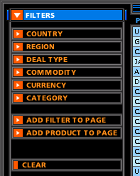

- You can create different filters to view just those products you need.
- Click on the “Filters” title in the navigation list on the left. This will show you a list of different filter types. A filter is simply a set of product attributes that are applied to the list of quotes to reduce the number of displayed quotes according to the chosen filter(s).
- You can apply any of the following six product attributes to filter the list of all products available. Each of the six filters can be applied in isolation or in any combination.

2. Clearing Filters

In order to deactivate the filters chosen and view all the quotes again click on the “Clear” button on the navigational section on the left. You can then select a new set of filters to apply to the list of all quotes.

3. Putting your filtered products into a composite⏐

You can create up to five different composite pages, each of which may contain up to eight sections (a saved filter or an individual product). This gives you significant flexibility in setting up your customized quotes pages. You can also set any one of your composite pages as your default page so that each time you login to EnronOnline, that page appears first.

(i) To add a filtered section to a composite page
- Go to “Filters”, select the composite page to which the filter will be added.
- Click on the “Add Filter to Page” button. The saved filter becomes a “Section” in a new or existing Composite page.

(ii) To add products to a composite page

- In addition to filters, you can also add individual products to your Composite Page. These will become another Section in your Composite Page once added.
- Click on the products you wish to add to the section. Each product you select will then be highlighted in a different color to identify the items to be added. A tool tip box will inform you when you mouse over the short description of the product that you must click on it to add it to the section.

- After you have selected all the products you wish to add to the section click on the button labeled “Stop Adding”. Your section will now be created within the composite selected and you will now be out of the “adding products mode”.
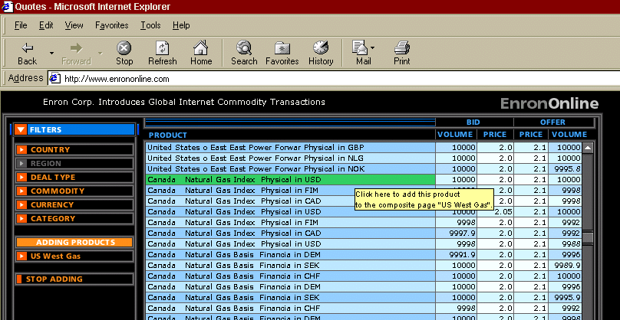

⏐system requirements⏐

Because EnronOnline is a Web-based application, it has very simple system requirements. All you need is an Internet connection, a Web browser (Microsoft® Internet Explorer 4.0 or Netscape Navigator® 4.0, or higher versions), and a Macromedia® Shockwave™ plug-in (freely available and may already be included in your browser). For your convenience, EnronOnline works with either a PC (Microsoft® Windows® 95 / Windows NT®) or an Apple Mac®.

If you do not currently have Shockwave installed on your computer, you should download it now from http://www.shockwave.com . This will enable you to see Enron prices in real time and benefit from all that EnronOnline has to offer.

⏐logging off from EnronOnline⏐

- To log off EnronOnline at any time, click on “Log off” . Your session will be terminated immediately.

