

Instructions for the

Fried Wire Tool
Fried Wire Tool
Introduction 3
Logging In 3
Front Page 4
Power Flows 4
Market Notices 4
Available Transmission 4

Introduction

The friedwire application is a tool that is used to monitor real time power flows and transmission reservation information.

Logging In

To access the friedwire aite you must log into the following site.

http://www.friedwire.com/

The following account and passwords have been set up:

Users: enron01-5
Password: enron

Enron01-04 logins are reserved for the Enron East staff.
Login 01 Midwest
Login 02 North East
Login 03 South East
Login 04 Ercot

Enron05 logins are reserved for Enron West staff.
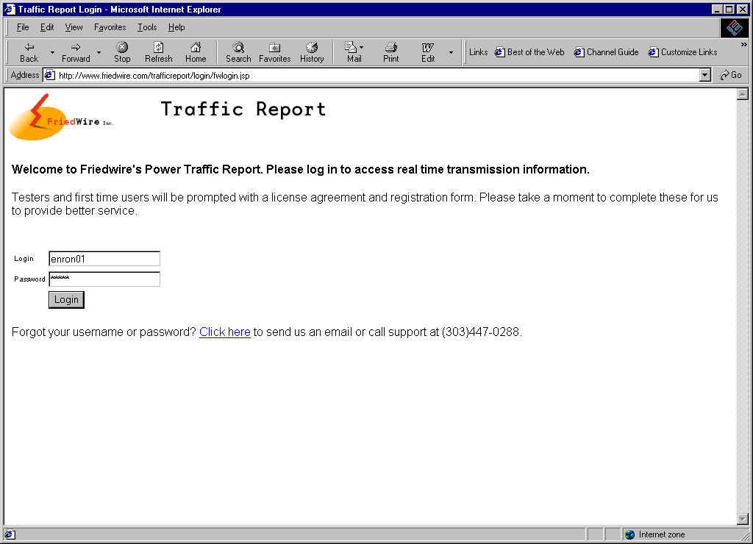
Login 05 Western

Front Page
Description:
The front page contains a navigation panel to system loads, key market notices and is a entry point to key displays.

Power Flows
Description:
IS a tabular display of available information that you can access to customise other views.

Market Notices
Description:
This is a display of all available market notices. From this display you can customise your views.

Available Transmission
Description:
This is a display that can be used to display available transmission products.

