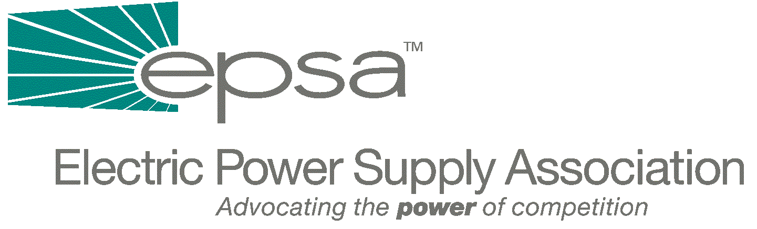

1401 New York Avenue, NW
11th Floor
Washington, DC 20005
202/628-8200
202/628-8260 fax
www.epsa.org

Memorandum
TO: | International Affairs Committee
FROM: | Yamin Afshar, International Affairs Committee Chair  Donn J. Salvosa, Manager of Government Affairs
DATE: | September 28, 2025
RE: | Follow Up Memo on October 5th Meeting

On October 5th, EPSA convened a meeting of the International Issues Committee. Approximately 15 members were present to discuss a number of initiatives that the Committee should take. A copy of the attendance list and agenda is attached. At the conclusion of the meeting, it was decided that EPSA should increase its visibility with the foreign relations committees in the U.S. Congress, as well as other government agencies (Department of Commerce, Treasury, IRS, OPIC, EXIM) and other international trade associations similar to EPSA. Each member present will send EPSA a description of their companies’ activities and their outlook on international development. This information will be used to develop an overall profile of EPSA members’ international activities, which will be used during various meetings.
At the meeting we decided on the following specific action items:
- Begin with outreach to government officials, particularly those on the congressional foreign relations committees in the House and Senate to introduce EPSA and its member companies. Actions may include formal meetings and hosting lunches and dinners for members/staff. If you have any with recommendations on whom specifically to target, please contact me.
- Increase awareness of EPSA in the administration, including the Department of Commerce, Department of Energy, OPIC, EXIM, IRS, Asian Development Bank, etc. Advocate adoption of our policies in Congress and the administration, including full funding for U.S. export credit agencies, OPIC and EXIM in order to enhance the international development efforts of our industry.
- Promote information exchanges with international associations similar to EPSA.
- Outreach to foreign embassies and trade officials. In order to introduce EPSA and serve as an avenue for foreign officials who may want to channel information to EPSA member companies
To develop EPSA members’ overall profile, please provide the following information as applicable:
- Total investments
- For distribution companies – number of customers, both international and domestic
- Total number of MW overseas
- How long your company has been involved in international markets
- Specific markets in which you are you active
- For power marketers – how much power is traded in $ and MW
- For lenders and insurers – total investment and insurance in the power sector in $ terms
Following receipt of information from the membership, I will e-mail you a description of EPSA members’ international activities along with a proposed action plan for the Committee’s review. We may schedule a conference call in order to discuss this plan. In order to further discuss and gauge the plan’s effectiveness, a meeting of the International Committee will be convened in conjunction with EPSA’s membership meeting in March of 2002 in Washington, DC. In addition to our meeting, we intend to set up a panel of speakers to discuss timely international issues of interest.
For those with an interest in tax issues, EPSA’s Tax Policy Working Group holds a monthly conference call every third Thursday of the month at 3:00 PM eastern time. To access the call, dial 1-800-646-3603 and ask for the EPSA call moderated by Gene Peters.
If you have any suggested action items which should be added or if you have any questions, please contact Donn Salvosa at EPSA (dsalvosa@epsa.org or 202-628-8200).
Attachments

