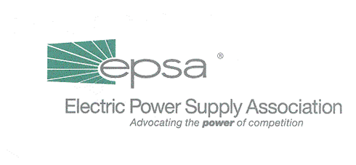
1401 New York Avenue, NW
11th Floor
Washington, DC 20005
202/628-8200
202/628-8260 fax
www.epsa.org
Memorandum
TO: | Legislative Affairs Committee
FROM: | Scott Weiner, Legislative Affairs Committee Chair  Gene Peters, Vice President of Legislative Affairs
DATE: | August 14, 2001
RE: | Follow-up from Meeting with Andy Black

Yesterday, EPSA met with Andy Black of the House Commerce Committee to discuss the prospects for electricity legislation in the near-term. Andy indicated that he is preparing a proposal for consideration by Subcommittee Chair Joe Barton (R-TX). If acceptable to Barton, Andy anticipated that the draft would be given wider distribution in early September. He also indicated that the Subcommittee will report out legislation “sometime this year.”
We presented Andy with a series of legislative recommendations that reflected recent Senate testimony and the outline of legislative issues that was used during the Committee’s discussion of strategy at the Summer Membership Meeting (attached). Andy indicated that the new draft will reflect the evolution in the marketplace and will be more aggressive and supportive of the interstate marketplace than H.R. 2944 from last Congress. In particular, the draft is likely to reflect the need for full participation by transmission owners in RTOs. Additionally, the draft will probably include a call for more uniform, non-discriminatory policies for interconnection to the transmission grid.

Andy asked us for additional comments in three specific areas:

- Non-discriminatory transmission tariffs – Andy indicated that Barton appears ready to affirm FERC’s authority to order broad participation in RTOs. We explained that our policy on transmission access could sidestep the question of “unbundled vs. bundled” uses of the grid by (1) supporting mandatory participation by all transmission owners in RTOs and (2) declaring that FERC-approved RTO transmission tariffs must be applicable to all uses (and users) of the transmission grid on a non-
discriminatory basis. Andy expressed interest in this approach (since, on its face, it did not appear to be a direct assault on “states rights”) and asked for further information and comments.
- TVA, BPA and the other PMAs – We were asked to provide comments on the language included in last year’s legislation (H.R. 2944) and other drafts that are now being developed. Given the growing interaction between EPSA members and these agencies, we will be developing detailed comments on the proposals. Andrea Spring will be staffing an EPSA effort to coordinate our response. Members who wish to participate in this review should indicate their interest in participation via e-mail (aspring@epsa.org).
- Analysis of Section 3 of the Sawyer/Burr transmission legislation (attached) – Section 3 allows for incentive rates in order to expand transmission capacity or to encourage voluntary participation in RTOs. The language also allows negotiated rates between the transmission owners and customers.

We will discuss our response to this request on our conference call next week, or at our strategy session should it occur sooner.

Attached: Sawyer/Burr Bill, H.R. 2814
Summary of EPSA Legislative Objectives

