Enron North America Corp.
Confidential Information Memorandum
August 2001

Information Memorandum
COPY #

This information memorandum (“Memorandum”) and the information contained herein are subject to the confidentiality agreement (“Confidentiality Agreement”) entered into between you on the one hand and Enron North America Corp. (“Enron North America” or "ENA") on the other hand.

Certain information included in this Memorandum contains forward-looking statements identified by such words as “expect,” "anticipate,” or “project.” Such statements are based on current expectations and involve a number of known and unknown risks and uncertainties that could cause the actual use, benefits, availability, results and performance of the equipment, permits, sites and other assets described herein (collectively, the “Projects”) to differ materially from any expected future use, benefits, availability, results or performance, expressed or implied, by the forward-looking statements, including expectations regarding the future use of the Projects for the purposes described herein. Enron North America has identified important factors that could cause actual usage of the Projects and any results thereof to differ materially from such expectations, including development uncertainty, operating uncertainty, acquisition uncertainty, uncertainties relating to power, gas and other fuel markets, weather, uncertainties relating to domestic and international economic and political conditions, and uncertainties regarding the impact of regulations, changes in government policy, industry deregulation and competition. You have an obligation to evaluate all such risks for yourself. Enron North America does not assume responsibility to update forward-looking information contained herein.
This Memorandum does not purport to be all-inclusive or to include all information that you may desire or need in investigating the Projects and the benefits and risks associated therewith. Any estimates, expectations and projections contained in this Memorandum involve significant elements of subjective judgment and analysis, which may or may not be correct. Neither Enron North America nor any of its affiliates, employees, shareholders, members or representatives makes any representation or warranty, express or implied, as to the accuracy or completeness of the information contained herein or any other information (whether communicated in written or oral form) transmitted or made available to you. Enron North America and its shareholders, affiliates, employees, members and representatives expressly disclaim any and all liability which may be based on the information contained herein (or any errors or omissions therefrom) or relating to or resulting from the use of this Memorandum, the information contained herein or such other information received by you or any of your affiliates or representatives.

Nothing in this Memorandum is, or shall be relied upon as, a promise or representation, whether as to the past or future. Enron North America does not intend to update or otherwise revise this Memorandum following its distribution, and you should not expect Enron North America to do so. You are expected to conduct an independent investigation and evaluation in connection with any proposed transaction.

Enron North America does not assume responsibility to update any projections or forward-looking statements contained herein. Enron North America expressly reserves the right, in its sole and absolute discretion, to: (1) reject any or all offers or terminate discussions with you for any reason or no reason; (2) negotiate with one or more potential purchasers at any time and enter into definitive agreements for the sale, or other transaction involving, the Projects without prior notice; and (3) discontinue, amend, or modify, at any time, any procedures relating to this process.

NEITHER THIS MEMORANDUM NOR ITS DELIVERY TO YOU SHALL CONSTITUTE AN OFFER TO SELL ANY SECURITY OR ENTER INTO ANY OTHER TRANSACTION OR COMMERCIAL AGREEMENT.

Table of Contents
- Investment Opportunity
- Transaction Process
- Key Investment Merits
- Project Overviews
- Market Overviews

Exhibits
Midway Energy Center
- Area Site Map
- Site Development Plan
- EPC Estimate and Construction Schedule
Ft. Pierce Repowering Project
- Area Site Map
- Site Development Plan
F. EPC Estimate and Construction Schedule
- Description of Equipment
- Electric Transmission System Map

Investment Opportunity

Transaction Process

Key Investment Merits

Project Overviews

Market Overviews
[THE INFORMATION IN THIS SECTION HAS BEEN INCLUDED BASED ON A VARIETY OF THIRD PARTY SOURCES. THE INFORMATION CONTAINED HEREIN HAS NOT BEEN INDEPENDENTLY VERIFIED.]

Investment Opportunity
A. Overview of the Proposed Transaction
By this Memorandum, ENA is soliciting offers to purchase the member interests in Midway Development Company, L.L.C. (“MDC”), and Fort Pierce Repowering Project, L.L.C. (“FPRP”). Each of MDC and FPRP are Delaware limited liability companies and wholly-owned by Enron North America.

MDC was formed for the purpose of developing the Midway Energy Center (the “Midway Energy Center” or “MEC”), a two-phase dual fuel (natural gas and No.2 fuel oil) merchant power generation facility, with an initial phase of 510MW operating in simple cycle and with an anticipated commercial operations date of June 2002, and a second phase consisting of a 280MW combined cycle expansion.

FPRP was formed for the purpose of developing the Fort Pierce Repowering Project (“FP Project), a 196MW merchant, combined-cycle facility with an anticipated commercial operations date of April 2003 that will sell the steam it produces to the Ft. Pierce Utility Authority (“FPUA”).

Substantially all of the development activities associated with both of the facilities that are to be constructed by each of MDC and FPRP, respectivelly (each a “Facility” and collectively the “Facilities”) are completed such that construction of the MEC can begin immediately, and construction of the FP Project can begin within the next several months. No legislative changes to the Florida Power Plant Siting Act are required as a precondition to such construction.

Furthemore, both the MEC and the FP Project are strategically located in Southeast Florida, which has not been subject to the frequent transmission bottlenecks experienced on Florida’s Gulf Coast electric grid or in the northern part of the state.

The MEC and the FP Project therefore offer a purchaser a significant merchant generation position and first-mover advantage that includes a blend of near term simple and combined cycle operations.
B. Summary
Name | cURRENT  STATUS | technology | NAMEPLATE  Capacity  (mw) | heat  rate⁽¹⁾  (Btu/kWh) | Electrical  Interconnect
Midway |  | 3 GE 7FA combustion turbines | 510
Fort Pierce |  | 1 MHI 501F combustion turbine  1 CMI HRSG | 196
(1) Anticipated heat rate @ 90°F, HHV.
Transaction Process
A. Overview
ENA is soliciting proposals from a select group of prospective purchasers. This Memorandum has been prepared for the sole use of Prospective Purchasers who have executed the Confidentiality Agreement.
The proposed transaction structure assumes a sale of 100% of the ownership interests in both MDC and FPRP (collectively the “Project LLC’s) owning Facilities for cash payable at closing. ENA’s main objectives in considering proposals for the purchase of the Facilities are to arrange for a transaction (or series of transactions) upon acceptable terms which reflect the highest possible value and to consummate such transaction(s) in a timely manner. To the extent consistent with these objectives, ENA will consider alternative structures and forms of consideration.
B. Summary of Process
Round I Proposals
Interested Prospective Purchasers will be required to submit written indications of interest in the form of preliminary proposals (“Round I Proposals”) to express interest in acquiring either or both of the Project LLC’s.
Detailed Due Diligence
On the basis of Round I Proposals, ENA expects to select a limited number of Prospective Purchasers to conduct further due diligence. Such Prospective Purchasers will have the opportunity to arrange for independent site tours, to have access to the virtual data provided by ENA and to direct questions to ENA in relation to the Facilities, prior to submitting final binding proposals (“Round II Proposals”). The representations and warranties in the key transaction documents will reflect that comprehensive due diligence has been performed, so Prospective Purchasers are encouraged to plan for and utilize the due diligence opportunity to the fullest. Round I Proposals should identify the due diligence team members, including outside consultants and advisors, and their function(s).
Round II Proposals
A short list of Prospective Purchasers who submitted Round I proposals will be notified in writing under separate cover of their selection to submit a second round proposal and the procedures for the Round II Proposal. Round II Proposals must be accompanied by a markup of key transaction documents and a binding confirmation that the Prospective Purchaser is prepared to promptly execute such transaction documents in the forms submitted. To be considered, Round II Proposals must (i) not be subject to any additional due diligence, (ii) not be subject to any financing contingencies or other material conditions (other than receipt of the regulatory approvals required for closing), and (iii) have all necessary board and other corporate or similar approvals prior to submission.
Each Prospective Purchaser is responsible for all of its costs incurred in connection with its due diligence, bid preparation and proposal, including fees and disbursements of its own counsel and advisors.
ENA reserves the right, in its sole discretion, to discontinue, modify, delay or accelerate the process with respect to any Prospective Purchaser at any time for any reason or no reason and without any liability on its part. The sale of MDC and FPRP is expected to close as soon as possible after receipt of all required regulatory approvals [are they any?] (fourth quarter 2001 or earlier). Prospective Purchasers must indicate their ability to meet the deadlines outlined within the transaction schedule below as part of their Round I Proposal due September 14, 2001.
C. Purchase Mechanics
Neither MDC or FPRP have any debt and each is owned 100% by ENA North America.
The preferred sales method is a transfer of 100% of the member interests in each of the Project LLCs, in order to minimize the number of required consents and approvals. It is expected that the financial close of the sales process for the Project LLC’s will occur as soon as possible following receipt of all required regulatory approvals.
D. Transaction Schedule
Action Item | timing
Execute Confidentiality Agreement | Week of August 13
Memorandum Delivered to Prospective Purchasers | Week of August 20
Initial Evaluation | August 20 – September 14
Submission of Round I Bids | September 14
Determination and Notification of Short-Listed Prospective Purchasers | Week of September 17
Access to Virtual Data Room / Key Transaction Documents Delivered | Week of September 17
Site Visits/Management Meetings | Week of September 24
Round II Bids Submitted | October 19
Selection of Preferred Purchaser | Week of October 22
Signing of Final Binding Purchase Agreements | Week of October 29
Closing following receipt of all regulatory approvals | By Q4, 2001

August 2001 |  |  |  |  |  |  |  | September 2001 |  |  |  |  |  |  |  | October 2001
S | M | T | W | T | F | S |  | S | M | T | W | T | F | S |  | S | M | T | W | T | F | S
 |  |  | 1 | 2 | 3 | 4 |  |  |  |  |  |  |  | 1 |  |  | 1 | 2 | 3 | 4 | 5 | 6
5 | 6 | 7 | 8 | 9 | 10 | 11 |  | 2 | 3 | 4 | 5 | 6 | 7 | 8 |  | 7 | 8 | 9 | 10 | 11 | 12 | 13
12 | 13 | 14 | 15 | 16 | 17 | 18 |  | 9 | 10 | 11 | 12 | 13 | 14 | 15 |  | 14 | 15 | 16 | 17 | 18 | 19 | 20
19 | 20 | 21 | 22 | 23 | 24 | 25 |  | 16 | 17 | 18 | 19 | 20 | 21 | 22 |  | 21 | 22 | 23 | 24 | 25 | 26 | 27
26 | 27 | 28 | 29 | 30 | 31 |  |  | 23 | 24 | 25 | 26 | 27 | 28 | 29 |  | 28 | 29 | 30 | 31
 |  |  |  |  |  |  |  | 30
E. Round I Bidding Instructions
Interested Prospective Purchasers should prepare Round I Proposals incorporating the following information:
- The identity of the Prospective Purchaser, the purchase price, and the Facility(s) to be purchased. If the Prospective Purchaser is a group, the identity of each group member, and the percentage of the amount to be paid for the Facility(s) committed to by each member of the group.
- Explanation of key assumptions supporting valuation and discussion of value drivers (alternative forms of consideration may also be proposed in Round I).
- The Prospective Purchaser’s source of funding for its proposed acquisition.
- A description of the Prospective Purchaser’s internal approval process, and an acknowledgement that the approval process can accommodate the transaction schedule.
- A description of specific due diligence activities required to consummate the transaction.
- The identity of the Prospective Purchaser’s counsel, including the identity of the lead counsel, together with a confirmation that such individual is available for the scheduled transaction timetable, and if the Prospective Purchaser is a group, an acknowledgement that such counsel will be common counsel for the group.
- The identity of the Prospective Purchaser’s financial advisor, if any, and if the Prospective Purchaser is a group, an acknowledgement that such financial advisor will be the only financial advisor for the group.
- The identity of any other advisors or consultants that the Prospective Purchaser expects to retain and the scope of their activities.
Round I Proposals should be sent by facsimile or by letter to the following address and be received no later than 3:00 pm, Central Daylight Time, on Friday, September 14, 2001:

ENA North America Corp.
1400 Smith Street – EB 3144c
Houston, TX 77002
Attn: Stuart Zisman
Facsimile: (713) 646-3059
F. Round II Bidding Instructions
Selected Prospective Purchasers should prepare Round II Proposals incorporating the following information:
- A binding purchase proposal including confirmation of the consideration to be paid.
- A mark-up of the key transaction documents, drafts of which will be provided to Prospective Purchasers at the close of Round I.
- Confirmation that all required due diligence activities have been completed.
- Confirmation that the Prospective Purchaser’s internal approvals have been obtained.
ENA’s final selection of purchaser(s) will be based, in part, on the economics, the extent to which changes to documents are requested, and various other matters. ENA reserves the right, in its sole discretion, to reject any proposal for any reason or no reason.
G. Communication
Questions or requests for additional information should be directed, preferably in writing by fax, to one of the following representatives:

Mr. L. Don Miller | Mr. Stuart R. Zisman
Tel: 713-853-0492 | Tel: 713-853-7493
Fax: 713-646-3059 | Fax: 713-646-3059

Key Investment Merits
- [Ben Jacoby to provide]

Project Overviews
- Location of the Plants
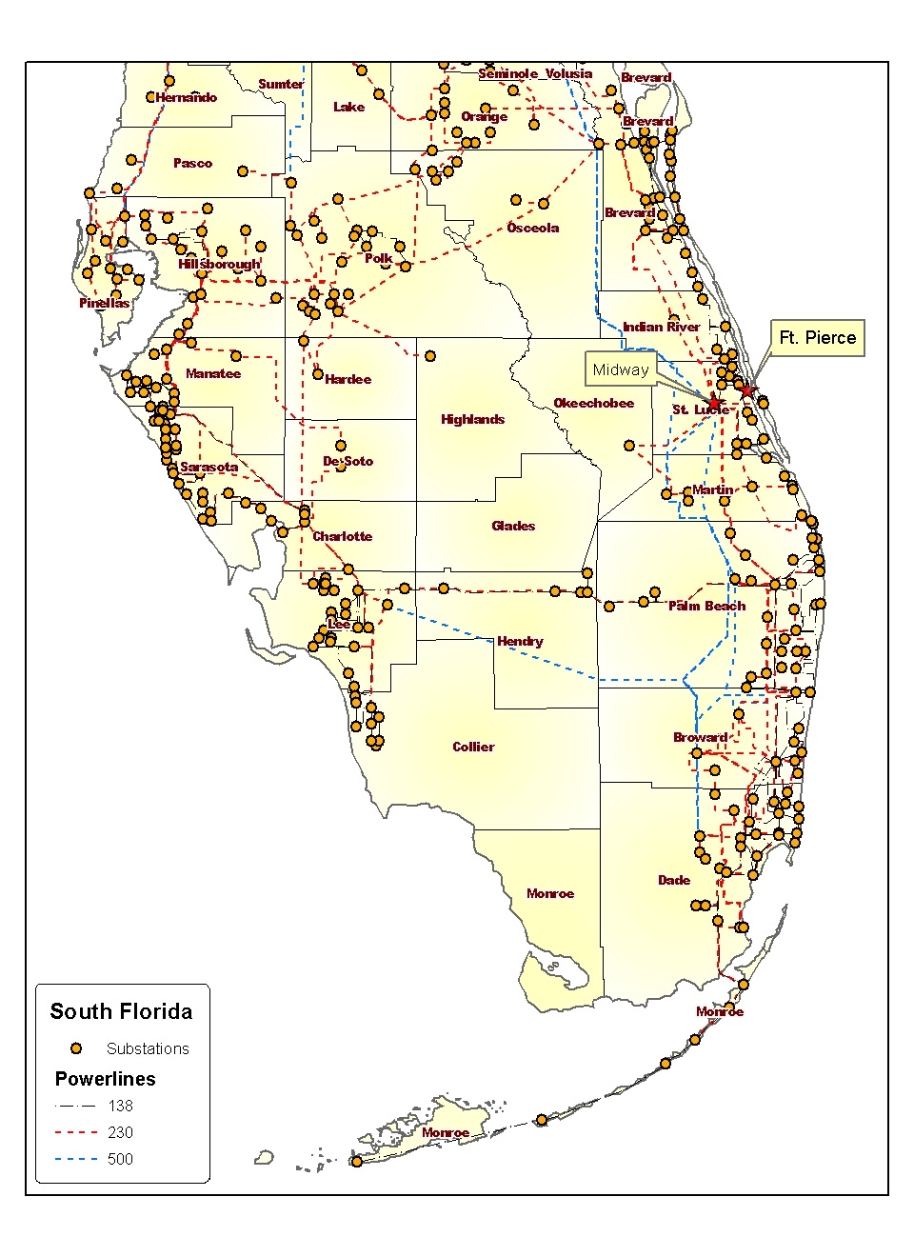
B. Operating Information
Summary of Key Data
 | Midway | fort pierce
Region | FRCC | SERC
Interconnected Area
Boiler No./Type
Turbine No./Type
NO_{x} Level Allowed (lb/mmBtu, PSD Permit)
NO_{x} Level Produced (lb/mmBtu, Most recent stack test)
Capacity @ 90⁰ degrees (MW)
Heat Rate @ 90⁰ (HHV, Btu/kWh)
Approximate Maximum Annual MWh
Normal Unit Ramp from Warm Boiler to Full Load
Operating Expenses
Estimated Variable O&M ($000)
Estimated Fixed O&M ($000)
Estimated Owner’s Expense ($000)
Tax Rates
State Income Tax Rate
Franchise Tax Rate
Operating Expenses
- Variable O&M: Includes estimates of water costs, variable maintenance expenditures and other variable O&M expenses.
- Fixed O&M: Includes estimates of payroll expenses and other fixed O&M expenses.
- Owner’s Expense: Includes estimates of insurance, interconnection fees, and miscellaneous expenses, and property tax liability.
Tax Rates

C. The Midway Energy Center - St. Lucie County, Florida
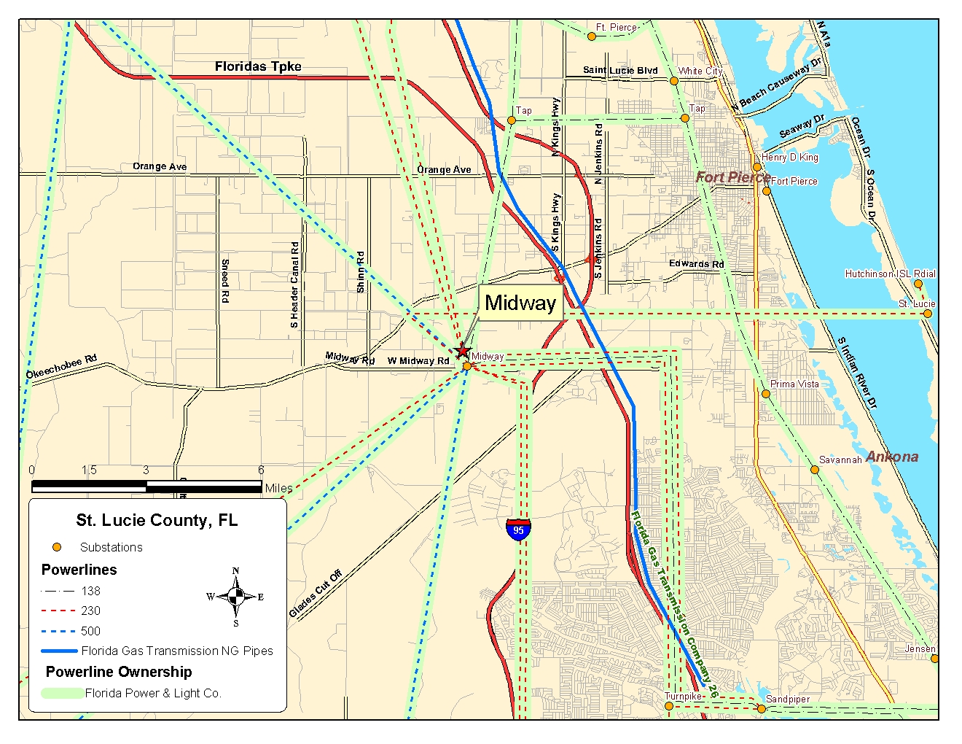

Overview
The MEC will be a 510 MW natural gas and fuel oil fired, simple-cycle merchant power generation facility using three (3) GE 7FA turbines. All of the development rights associated with the MEC as described herein are owned by MDC. The planned commercial operations date for the MEC is June 1, 2002. The site is being designed to accommodate a future conversion to combined cycle utilizing a 280 MW steam turbine. While GE 7FA combustion turbines are not being offered for sale with the other project assets described below, MEC has secured certain other long lead electrical components necessary to support the planned commercial operations date.
Location
The MEC site is comprised of approximately 67 acres, located 1.5 miles northwest of the intersection of US 95 and State Highway 712 (Midway Road) in St. Lucie County, Florida. The site is presently owned by Cooney-Midway Groves (“Cooney”), and was most recently used for citrus production. A purchase option for the site was executed with Cooney in May 2000, with an option term that continues through May 2002. Together with other minor adjacent parcels that will need to be purchased along with the Cooney parcel, the total land cost upon exercise is estimated to be approximately $1.8 million. A site map is included as Exhibit A.
Florida Power Plant Siting Act and Commencement of Construction
Under Florida law, MEC may operate a merchant power plant as a simple cycle facility, and should not be subject to the Florida Power Plant Siting Act. MEC has therefore applied for and obtained substantially all the required permits and other approvals necessary for construction and operation directly from the applicable federal, state and local agencies described below. While certain minor administrative approvals are pending (receipt of which is imminent), sufficient approvals have been obtained for MDC to immediately commence site mobilization, clearing, and grading. All permits required for construction are described below.

A. Zoning and Site Plan Approval: The St. Lucie County Planning and Zoning Commission recommended approval for both the re-zoning and the site plan on February 15, 2001. The St. Lucie Board of County Commissioners approved both the re-zoning and the final site plan on April 3, 2001. Such approvals remain valid provided that MEC commences construction by April 2003. As part of the re-zoning and site plan approval, MEC committed to the County that it would not seek a tax abatement agreement as a condition to construction. The approved site plan is included as Exhibit B.

B. Air Permit and Estimated Operating Hours: MEC is located in an attainment area for air permitting purposes. A PSD air permit application for three (3) GE 7FA turbines was submitted to the Florida Department of Environmental Protection (“FDEP”) on November 7, 2000. An air permit was issued on February 14, 2001.

No comments were received by the FDEP during the public comment period (except for customary comments from the U.S. EPA) and the air permit is now in a final and unappealable form. The air permit allows for 3,500 hours of annual operation at full load per turbine, which includes a maximum of 1,000 hours of annual operation on fuel oil per turbine. This number is reduced to 500 hours of annual operation on fuel oil per turbine after year three as a result of local restrictions. In any year, for every annual operating hour on fuel oil per turbine over 250, total annual operating hours are reduced by two hours.
C. Other Pre-Construction Authorizations:
1. Environmental Resource Permit (“ERP”) – In January 2001, MDC submitted its ERP application to the FDEP, and the final ERP was issued in July 2001.

2. U.S. Army Corps of Engineers Section 404 Permit (“404 Permit”) – MDC submitted its 404 Permit application in January 2001, and the final 404 permit is expected to be issued in early August 2001.

3. St. Lucie County Building Permit – MDC has prepared building permit applications based on the approved site plan and intends to submit these to St. Lucie County in early August 2001. It is anticipated that building permits will be issued by late August 2001.
Other Environmental
A Phase I and other environmental studies have been completed for the MEC site, which indicates that the MEC will not impact any endangered species or wetlands.
EPC Estimate and Construction Schedule
MDC has prepared preliminary engineering, procurement and construction bids. Estimated construction costs and a construction schedule are included in Exhibit C.
Electrical Interconnection
The MEC will be interconnected to Florida Power & Light’s (“FPL”) 500 kV transmission line that is adjacent to the site. This proposed point of interconnection is approximately 2,000 feet from FPL’s Midway substation. Between April and September 2000, MDC submitted three separate Generation Interconnection Requests (“GIR”) to FPL to accommodate up to 3 GE 7FA combustion turbines operating in simple cycle, plus a 280MW steam turbine for combined cycle operations. As of late July 2001, these GIRs were request numbers 16, 25, and 30 in FPL’s GIR priority queue. MDC has received its Feasibility and Facility Studies, which show that the cost for all network upgrades is estimated to cost $4 million. Any costs associated with such upgrades will qualify for transmission credits under FERC regulations to be used by MDC to offset the costs of transmission service over FPL’s system. MDC has received a proposed form of interconnection agreement from FPL, and is presently negotiating this agreement.
Fuel
The MEC has been designed, and permits have been obtained to allow for operation on both natural gas and fuel oil. The facility may either be interconnected into a Florida Gas Transmission (“FGT”) pipeline located within 2.5 miles of the site, or the Gulfstream Natural Gas Pipeline that has been proposed to be located adjacent to the MEC site. MDC submitted a Level A study request to FGT on Nov 15, 2000, and a Level B study request on Dec 19, 2000. MDC has received from FGT the results of the both the Level A and Level B requests, which indicates that the total interconnection costs should be $2.2 million, and that no gas compression will be required.
Water Supply
As a simple cycle facility, MEC will utilize groundwater resources drawn from the Floridan Aquifer for emissions control purposes when operating on fuel oil. MDC submitted a Water Use Permit application on January 11, 2001 to the South Florida Water Management District (“SFWMD”). The permit has been deemed complete by the SFWMD and issuance is expected in early August 2001. For future conversion to combined cycle operations, MDC has identified sufficient local water supply and wastewater treatment resources and is currently negotiating an agreement with a potential supplier.

D. Fort Pierce Repowering Project - City of Fort Pierce, Florida
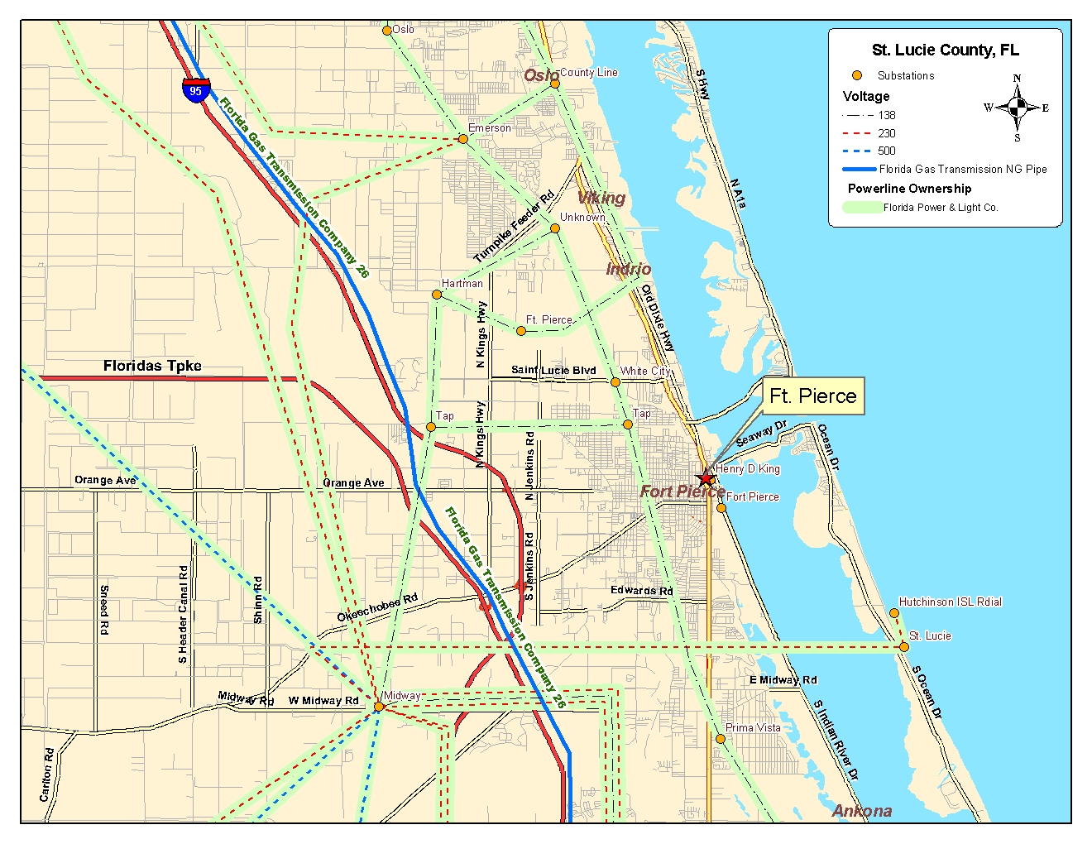

Overview
A 196 MW natural gas fired combined-cycle merchant power generation facility using one (1) Mitsubushi Heavy Industries (“MHI”) 501F turbine. The steam produced by the FP Project’s heat recovery steam generator (“HRSG”) will be sold to the FPUA pursuant to a long-term contract. All of the development rights and equipment associated with the FP Project as described herein are owned by FPRP. The planned commercial operations date for FPRP is April 2003. The MHI 501F combustion turbine, and a Cockerill Mechanical Industries (“CMI”) HRSG are included in the assets being offered for sale. A complete description of the MHI combustion turbine and the CMI HRSG are attached as Exhibit G.
Project Agreements with FPUA and Ft. Pierce
FPRP has entered into several agreements with the FPUA and the city of Fort Pierce regarding steam sales, site lease, operations and maintenance, and other matters. These agreements are described below.
[Add descriptions here]
Location
The The FP Project site is comprised of approximately 2.5 acres, and is located adjacent to the FPUA’s H.D. King power generation facility at 311 N. Indian River Drive, Ft. Pierce, Florida. The site is owned by FPUA, and FPUA and FPRP are expected to enter into an option to lease the site in October 2000, with a lease option term that continues through October 1, 2002. Upon exercise of the lease option, FPRP will be entilted to lease the site for a period of 25 years at an annual cost of $48,000 (???), with annual fair market renewals thereafter [For how long?]. A site map is attached as Exhibit D.
Florida Power Plant Siting Act and Commencement of Construction
Because the FP Project will not be using the steam it produces to generate electricity, FPRP may operate as a merchant combined cycle power plant under Florida law without being subject to the Florida Power Plant Siting Act. FPRP is therefore required to individually apply for all the required permits and other approvals necessary for construction and operation directly from the applicable federal, state and local agencies. All permits required for construction are described below.
A. Zoning and Site Plan Approval: The Ft. Pierce Planning and Zoning Commission recommended approval for both the re-zoning and the site plan on [ ]. The Ft. Pierce Board of Commissioners approved both the re-zoning and the final site plan on [ ]. Such approvals remain valid provided that FPRP commences construction by [ ]. FPRP is presently seeking various minor modifications to the site plan to accommodate certain design changes to the approved site plan. It is expected that the Ft. Pierce [Board of Commissioners] will approve the proposed changes in September 2001. As part of the re-zoning and site plan approval, FPRP committed to the County that it would not seek a tax abatement agreement as a condition to construction. The approved site development plan is included as Exhibit E.
B. Air Permit and Estimated Operating Hours: FPRP is located in an attainment area for air permitting purposes. A PSD air permit application was submitted by FPRP to the FDEP on April 18, 2001, and is expected to be issued in August 2001. It is anticipated that, when issued, the air permit will allows for 8,760 hours of annual operation at full load per turbine, and a maximum of 1,000 hours of annual operation on fuel oil.
C. Other Pre-Construction Authorizations:
1. Environmental Resource Permit – In February 2001, FPRP submitted its ERP application to the FDEP, and the final ERP was issued in July 2001.

An amendment to the ERP will be filed to incorporate the site development plan changes described above.

2. City of Ft. Pierce Building Permit – FPRP is preparing building permit applications and intends to submit these to the City of Ft. Pierce in September 2001. It is anticipated that the city of Ft. Pierce’s review and approval period of building permit applications will be approximately [ ] weeks.
Other Environmental
Phase I environmental site assessments were performed for all areas within the lease and easement property boundaries. A Phase II environmental site assessments was subsequently performed on the lease area due to the presence of a historical fuel oil tank release. The extent of the release was subsequently defined and remediated. A tank closure report was prepared and submitted to the FDEP by an independent third party contractor, and it is expected that a determination of “ no further action” by the state will be issued shortly.
EPC Estimate and Construction Schedule
FPRP has prepared preliminary engineering, procurement and construction estimates. Estimated construction costs and a construction schedule are included as Exhibit F.
Electrical Interconnection
FPRP will interconnect to the FPUA’s Garden City Substation via a 2.5 mile, 138kV transmission line. FPRP will be responsible for the construction cost of this transmission line. The Garden City Substation interconnects to FPL’s system at the Emerson Substation. In [ ] 2001, FPRP submitted a GIR to FPL. As of late July 2001, this GIR was request number [ ] in FPL’s GIR priority queue. FPRP expects to receive its Feasibility Studies from FPL in August 2001, and it is anticipated that no significant network upgrades will be required. An area electric transmission system map showing the interconnection point to FPUA and FPL is attached as Exhibit H.
Fuel
FPRP will be interconnected into FGT pipeline located at the FPRP site, and may also in the future interconnect into the proposed Gulfstream Natural Gas Pipeline that may be located as close as [ ] miles from the site. FPRP submitted a Level I study request to FGT on [ ], and a Level II study request on [ ]. FPRP has received from FGT the results of the both the Level I and Level II requests, which indicated that the existing pipeline will require expansion. [Need more info on this]
Water Supply
FPUA has agreed to provide FPRP with sufficient water supply and wastewater discharge resources for combined cycle operations. [Any more details?]

