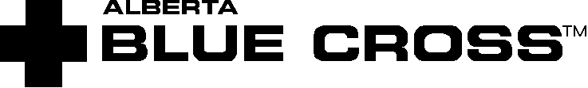

ENRON CANADA CORP.

FLEXIBLE SPENDING ACCOUNT
Employee Allocation Form

Group Plan #20798 For Policy Year: 2002/01/01 to 2002/12/31

Employee Name: | Blue Cross ID Number:

Available in Flexible Spending Account: $1,000

Total Amount to be placed in my Health Spending Account $_______________

Total Amount to be placed in my Wellness Spending Account $_______________

I would like all unpaid balances from core plan claims to be paid automatically from my Health Spending Account: Yes No

__________________________ _______________
Employee Signature Date

___________________________ _______________
Group Administrator’s Signature Date

Health Spending Account (H S A) | Wellness Spending Account (W S A)

- Major dental co-insurance · Fitness club membership (non-taxable)
- Orthodontic co-insurance · Bus pass (taxable)
- Vision care (over core plan max.) · Education fees (non-occupational) (taxable)
- Laser eye surgery · Recreation lessons (taxable)
- Prescribed over-the-counter drugs · Elder care (taxable)
- Paramedical costs (over core plan max.) · Child care (taxable)
- Medical expenses allowable by CCRA · Parking (taxable)

