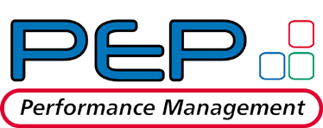

Performance Feedback
Self Evaluation

YOUR NAME:

YOUR SUPERVISOR: |  | YOUR DEPARTMENT:

YOUR JOB GROUP: |  | YOUR POSITION:

Skills / Behaviors Descriptions

ACCOMPLISHMENTS
Please list up to 5 accomplishments you feel you have achieved this review period. This should be a concise list of achievements - no more than 2 – 2 1/2 lines each.

Note: The following information from the Self Evaluation may be viewed during PRC meetings.
1. | Dynamically expandable window up to 200 characters
2. | Dynamically expandable window up to 200 characters
3. | Dynamically expandable window up to 200 characters
4. | Dynamically expandable window up to 200 characters
5. | Dynamically expandable window up to 200 characters

GENERAL QUESTIONS | COMMENTS
Choose one of the accomplishments listed above and describe how you achieved this. | Dynamically expandable window
Describe a project or activity you have worked on during this period and how your performance affected the end result. | Dynamically expandable window
Describe your major strengths that contributed to achieving your projects and accomplishments. | Dynamically expandable window
Describe areas of your knowledge and skills set where you need greater understanding or exposure. | Dynamically expandable window

Top of Form

