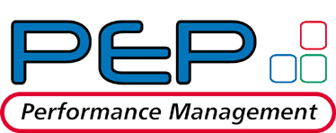

Performance Feedback
Associate / Analyst

THIS FEEDBACK IS ABOUT:

EMPLOYEE’S SUPERVISOR: |  | DEPARTMENT:

JOB GROUP: |  | POSITION:

This employee is my: |  | Degree of interaction with employee:

General Questions:

Describe your observations of the employee’s performance, citing specific examples of accomplishments and impact.
Dynamically expandable window

Describe employee’s major strengths in performing their role.
Dynamically expandable window

Describe areas for development that would enhance the employee’s overall effectiveness.
Dynamically expandable window

Evaluation of Enron Core Competencies
Please indicate this employee’s performance level in each area. Further information can be provided in the comments box.
Skills / Behaviors Descriptions | Performance Level Descriptions
 | Highly Effective  Effective  Acceptable  Ineffective  Not Applicable | Comments
BUSINESS SKILLS/ORGANIZATION SKILLS |  | Dynamically expandable window
INNOVATION |  | Dynamically expandable window
COMMUNICATION |  | Dynamically expandable window
LEADERSHIP/VISION & VALUES |  | Dynamically expandable window
TEAMWORK & INTERPERSONAL SKILLS |  | Dynamically expandable window
ANALYTICAL/TECHNICAL |  | Dynamically expandable window
PROFESSIONAL AND CAREER DEVELOPMENT |  | Dynamically expandable window
JOB PERFORMANCE |  | Dynamically expandable window

Thank you for completing feedback on this individual. The information contained in this feedback form is confidential between you and the employee's supervisor. This information is used to compile the final evaluation but will not be directly shown to the employee. Disregard for this confidentiality could result in disciplinary action.
Highly effective - Consistently exceeds skills and behaviors in all aspects
Effective - Exceeds skills and behaviors in some cases
Acceptable – Generally meets overall skills and behaviors
Ineffective - Does not meet skills and behaviors in several areas and requires improvement

