Family Concert !
Saturday, January 19th 2:00 p.m. The Americas Society

Classical and Jazz Music with a Brazilian flavor

680 Park Avenue (at 68th St across from Hunter College)
(1 block west of 68th & Lex., #6 subway)

Brazilian Guitar Quartet
and
Richard Boukas /
Jovino Santos Neto Brazilian Jazz Duo

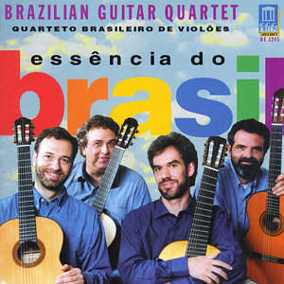

for ages 3 and up! Enjoyable ! Accessible! ____________________________________________________________________________________________

"Come to our first ever Family Concert, a 1-hour performance featuring lighter pieces by masters in classical and jazz in a family-friendly atmosphere. Richard Boukas/Jovino Santos Neto are well-known throughout South America for their engaging jazz performances that will get the whole family dancing. The Brazilian Guitar Quartet will interact with parents and children. We hope to see you there!"

Selections by J.S. Bach, Isaac Albéniz and Brazilian composers Heitor Villa-Lobos,
Antonio Carlos Gomez, Jovino Santos Neto, and Francisco Mignone.

General admission $5 !
____________________________________________________________________________________________

For ticket reservations call: 212. 249. 8950 x 463 or e-mail: music@as-coa.org

The Americas Society makes its programs accessible to people with disabilities.
Please call to make arrangements for special needs.

The Americas Society is a national not-for- profit institution dedicated to informing people in the United States about the societies and cultures of its Western Hemisphere neighbors.

This event is made possible with the generous support of the
