THE ENRON BODY SHOP FALL FIESTA
Member Appreciation Day
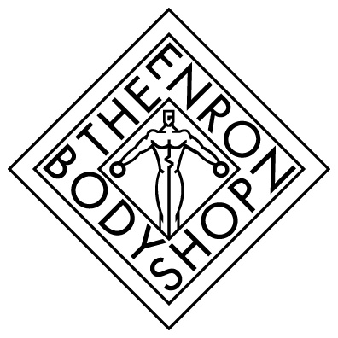
Wednesday, September 26th
Member Evaluation

Select One: Body Shop Member Enron Guest Visitor
If you would like to be entered in the drawing for a complimentary massage, please include your name and extension: Name:____________________________________ Ext. _______________________
Circle the number that best applies.
(1) No Response (2) Agree (3) Strongly Agree (4) Disagree (5) Strongly Disagree

1. The program was informative & well presented. 1 2 3 4 5

2. I learned something new. 1 2 3 4 5

3. The health assessments were beneficial. 1 2 3 4 5

4. Staff was available and helpful. 1 2 3 4 5

5. Overall, the program was informative & educational. 1 2 3 4 5

6. Offer more of these types of programs in the future. 1 2 3 4 5

7. What did you enjoy most? _________________________________________________________________ _________________________________________________________________________________________
8. What did you enjoy least? __________________________________________________________________ __________________________________________________________________________________________
9. Comments and suggestions for future programs_________________________________________________
__________________________________________________________________________________________
__________________________________________________________________________________________
Please return completed surveys to the Body Shop Reception Desk
By Wednesday, October 3rd.

