THE ENRON BODY SHOP FALL FIESTA
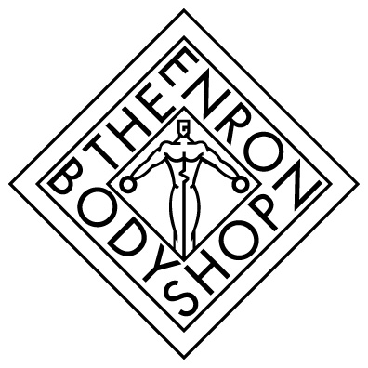
Member Appreciation Day
Wednesday, September 26th
Test Your Knowledge Quiz Results

Responses with 80% correct answers were entered into a drawing for prizes.
.
False 1. Thirst is the best way to determine the need for hydration.
An adequate way to determine fluid loss is to weigh yourself before and after your workout. For every pound you lose drink at least 2 cups of water. Also, if you feel chronically fatigued, headachy or lethargic you may be dehydrated.
True 2. Caffeine can interfere with the absorption of iron.
A cup of coffee consumed with a hamburger patty can reduce the absorption of iron by
approximately 40%. Sweating heavily results in a loss of this nutrient.
True 3. Exercise along with protein is the key to developing larger muscles.
In theory, if you want to gain 1 pound of muscle per week, you need only 14 extra grams of protein per day, the amount in 2 ounces of meat. However, you must also perform strength-training exercises.

True 4. Consuming excessive amounts of protein can lead to kidney and liver damage.

A person who eats excessive amounts of protein may overload these organs. This can also cause dehydration, as the body has to work harder to eliminate the extra protein.

False 5. Hot water is the best hydration fluid when it is warm outside.
During hot weather, or when sweating heavily drinking cold water will cool you off much faster.
False 6. To lose body fat, you must perform low intensity fat burning exercise.

High intensity exercise performed for the same duration of time will burn more calories

and help decrease body fat.

True 7. By the time the brain signals thirst, you may have lost 1% of your body weight.
T Thirst can be blunted by exercise or overridden by the mind. To insure you remain property hydrated,
drink 8 oz. of water for every 20 minutes of exercise and at least 1 quart of water for every 1, 000 calories expended. Most people voluntarily replace only two-thirds of their sweat loss. To be safe, always drink to quench your thirst and a little more. .

False 8. Performing sit-ups reduces body fat in the abdominal area.
Spot reducing sounds like a good idea; however, you can’t reduce fat cells in one localized area of the
body. It is the burning of fat along with a calorie deficit for the entire day that reduces body fat.
True 9. The amount of sodium increases in your blood during exercise.
When you sweat you lose significant amounts of water from your blood. The remaining blood becomes more concentrated and has an abnormally high sodium level. This triggers the thirst mechanism and increases your desire to drink. To quench your thirst you have to replace the water loss to bring your blood back to its normal concentration.

- True 10. Water helps to cushion joints.
Water has a very important role in helping to insure that joints are well lubricated.

