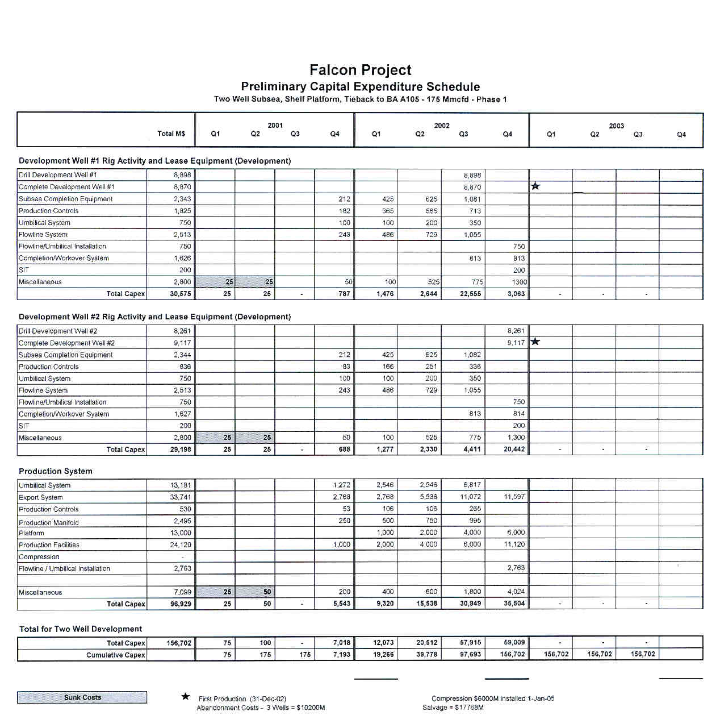

Figure 9 - Falcon Capital Expenditure Schedule.

